Ex.No : 2 | Music Streaming Web Application | Name : Sanjeevitha C S
Date: 02.04.2025 | Music Streaming Web Application | Roll no : 23AD123

Aim:
To develop a music streaming web application to provide users with a seamless and interactive music listening experience.
Procedure:
- Set up React project and install dependencies.
- Create components: Auth, Navbar, Home, Playlist, Profile, MusicPlayer.
- Implement user authentication and store username.
- Display 17 songs with play, pause, and add to playlist features.
- Manage playlist with add, remove, and play functionality.
- Build profile with user image and displayed username.
- Apply styling, enable scrolling, and finalize the app.

Program:

MUSIC-APP/src/
Main.jsx
import { StrictMode } from 'react'
import { createRoot } from 'react-dom/client'
import './index.css'
import App from './App.jsx'
createRoot(document.getElementById('root')).render(
<StrictMode>
<App />
</StrictMode>,
)

App.jsx
import React, { useState } from "react";
import { BrowserRouter as Router, Route, Routes, Navigate } from "react-router-dom";
import Navbar from "./components/Navbar";
import Home from "./components/Home";
import Playlist from "./components/Playlist";
import Auth from "./components/Auth";
import MusicPlayer from "./components/MusicPlayer";
import Profile from "./components/Profile";
import "./styles/app.css";
const App = () => {
const [isAuthenticated, setIsAuthenticated] = useState(false);
const [playlist, setPlaylist] = useState([]);
const [currentSong, setCurrentSong] = useState(null);
const [username, setUsername] = useState("");
return (
<Router>
<div className="app-container">
{isAuthenticated && <Navbar />}
<Routes>
<Route
path="/"
element={
isAuthenticated ? (
<Home setPlaylist={setPlaylist} playlist={playlist} setCurrentSong={setCurrentSong} />
) : (
<Auth setIsAuthenticated={setIsAuthenticated} setUsername={setUsername} />
)}/>
<Route path="/playlist" element={
isAuthenticated ? (
<Playlist playlist={playlist} setPlaylist={setPlaylist} setCurrentSong={setCurrentSong} />
) : (
<Navigate to="/" />
)}/>
<Route path="/profile" element={
isAuthenticated ? (
<Profile username={username} />
) : (
<Navigate to="/" />
)}/>
</Routes>
{isAuthenticated && currentSong && <MusicPlayer song={currentSong} />}
</div>
</Router>
);};
export default App;

MUSIC-APP/src/Components/
Auth.jsx
import React, { useState } from "react";
const Auth = ({ setIsAuthenticated, setUsername }) => {
const [username, setUser] = useState("");
const [password, setPassword] = useState("");
const handleLogin = () => {
if (username && password) {
setIsAuthenticated(true);
setUsername(username); // Store username
} else alert("Enter valid credentials");
};
return (
<div className="auth">
<h2>Login</h2>
<input type="text" placeholder="Username" onChange={(e) => setUser(e.target.value)} />
<input type="password" placeholder="Password" onChange={(e) => setPassword(e.target.value)} />
<button className="login-btn" onClick={handleLogin}>Login</button>
</div>
);};
export default Auth;

Home.jsx
import React from "react";
import SongCard from "./SongCard";
const Home = ({ setPlaylist, playlist, setCurrentSong }) => {
const songs = Array.from({ length: 17 }, (_, i) => ({
id: i + 1,
title: `Song ${i + 1}`,
src: `/music/song${i + 1}.mp3`,
image: "/images/image.jpg",
category: i % 2 === 0 ? "Vibe" : "Sad",
}));
return (
<div className="home-page" style={{ overflowY: "auto", maxHeight: "80vh", paddingBottom: "150px" }}>
<h2>🎵 "Feel the Beat, Live the Moment!"</h2>
<div className="song-grid">
{songs.slice(0, 17).map((song) => (
<SongCard
key={song.id}
song={song}
setPlaylist={setPlaylist}
playlist={playlist}
setCurrentSong={setCurrentSong}
/>
))}
</div>
</div>
);};
export default Home;

MusicPlayer.jsx
import React, { useRef, useEffect } from "react";
const MusicPlayer = ({ song }) => {
const audioRef = useRef(null);
useEffect(() => {
if (song) {
audioRef.current.src = song.src;
audioRef.current.play();
}}, [song]);
return (
<div className="music-player">
<p>Now Playing: {song?.title}</p>
<audio ref={audioRef} controls />
</div>
);};
export default MusicPlayer;

Navbar.jsx
import React from "react";
import { Link } from "react-router-dom";
const Navbar = () => (
<nav className="navbar">
<h1>🎵 MusicApp</h1>
<div className="nav-links">
<Link to="/">Home</Link>
<Link to="/playlist">Playlist</Link>
<Link to="/profile">Profile</Link>
</div>
</nav>
);
export default Navbar;

Playlist.jsx
import React from "react";
import SongCard from "./SongCard";
const Playlist = ({ playlist, setPlaylist, setCurrentSong }) => {
const removeSong = (id) => {
setPlaylist(playlist.filter((song) => song.id !== id));
};
return (
<div className="playlist-page" style={{ paddingBottom: '100px' }}>
<h2>🎵 "Your Playlist, Your Rhythm!"</h2>
<div className="song-grid">
{playlist.map((song) => (
<SongCard key={song.id} song={song} setCurrentSong={setCurrentSong} onRemove={removeSong} />
))}
</div>
</div>
);};
export default Playlist;

Profile.jsx
import React from "react";
import profileImage from "../assets/image.jpg"; // Ensure image is in /src/assets
const Profile = ({ username }) => (
<div className="profile">
<h2>🎵 "Your Sound, Your Story."</h2>
<img src={profileImage} alt="Profile" className="profile-image" />
<p>Username: {username}</p>
<p>Subscription: Premium</p>
<style jsx="true">{`
.profile-image {
width: 80px; /* Reduced size */
height: 80px;
border-radius: 50%; /* Circular shape */
object-fit: cover; /* Maintain aspect ratio */
}
`}</style>
</div>
);
export default Profile;

SongCard.jsx
import React from "react";
const SongCard = ({ song, setPlaylist, playlist, setCurrentSong, onRemove }) => {
const addToPlaylist = () => {
if (!playlist.some((item) => item.id === song.id)) {
setPlaylist([...playlist, song]);
}
};
return (
<div className="song-card">
<img src={song.image} alt={song.title} className="song-image" />
<h3>{song.title}</h3>
<button onClick={() => setCurrentSong(song)}>▶ Play</button>
{onRemove ? (
<button onClick={() => onRemove(song.id)}>❌ Remove</button>
) : (
<button onClick={addToPlaylist}>➕ Add to Playlist</button>
)}
</div>
);};
export default SongCard;

MUSIC-APP/src/styles/
App.css
/* Navbar */
.navbar {
display: flex;
justify-content: space-between;
padding: 20px;
background: #1a1a2e;
box-shadow: 0 4px 10px rgba(0, 0, 0, 0.5);
}
.nav-links a {
margin: 0 15px;
text-decoration: none;
color: #e94560;
font-weight: bold;
}
.nav-links a:hover {
color: #ff7675;
}

/* Home Page */
.home-page {
text-align: center;
padding: 50px;
}

/* Playlist */
.playlist {
padding: 20px;
}
.playlist ul {
list-style: none;
padding: 0;
}
.play-btn {
margin: 5px 0;
padding: 10px;
border: none;
background: #4a90e2;
color: white;
cursor: pointer;
border-radius: 5px;
}
.play-btn:hover {
background: #3578a6;
}

/* Profile */
.profile {
padding: 20px;
}

/* Auth*/
.auth {
text-align: center;
padding: 40px;
}
.auth input {
margin: 10px;
padding: 10px;
width: 80%;
}
.login-btn {
padding: 10px 20px;
background: #e94560;
border: none;
color: white;
cursor: pointer;
}
.login-btn:hover {
background: #ff7675;
}

/* Music Player */
.music-player {
position: fixed;
bottom: 0;
width: 100%;
background: #1a1a2e;
text-align: center;
padding: 15px 0;
}
.music-player button {
padding: 10px 20px;
cursor: pointer;
background: #4a90e2;
color: white;
border: none;
border-radius: 5px;
}

/* Song Grid */
.song-grid {
display: grid;
grid-template-columns: repeat(3, 1fr);
gap: 20px;
}
.song-card {
padding: 15px;
background: #1a1a2e;
border-radius: 12px;
text-align: center;
}
.song-image {
width: 100%;
border-radius: 8px;
}

Output:
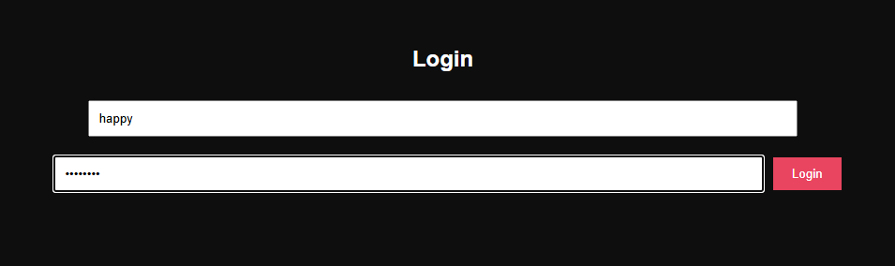

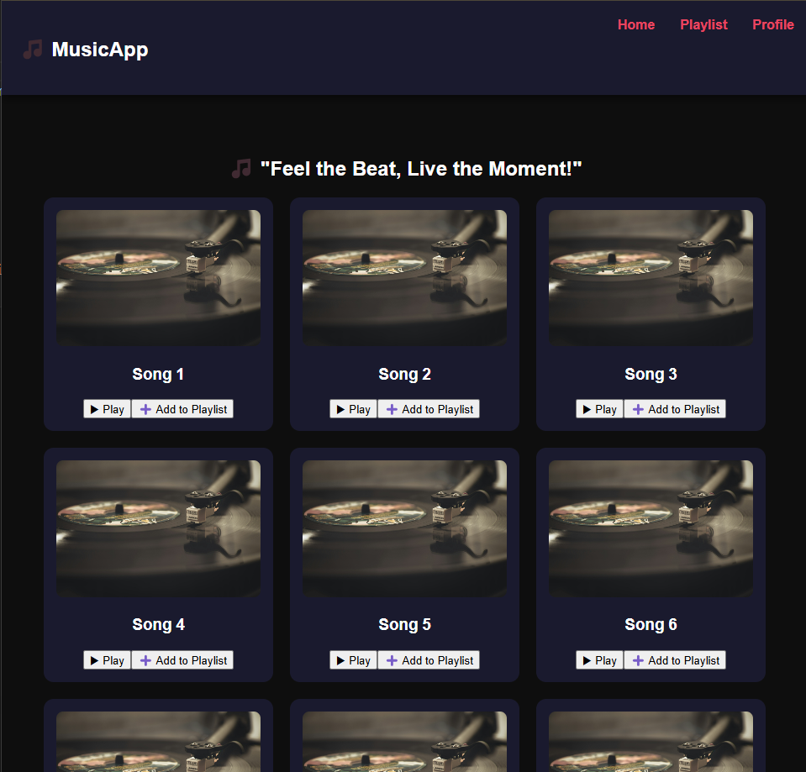

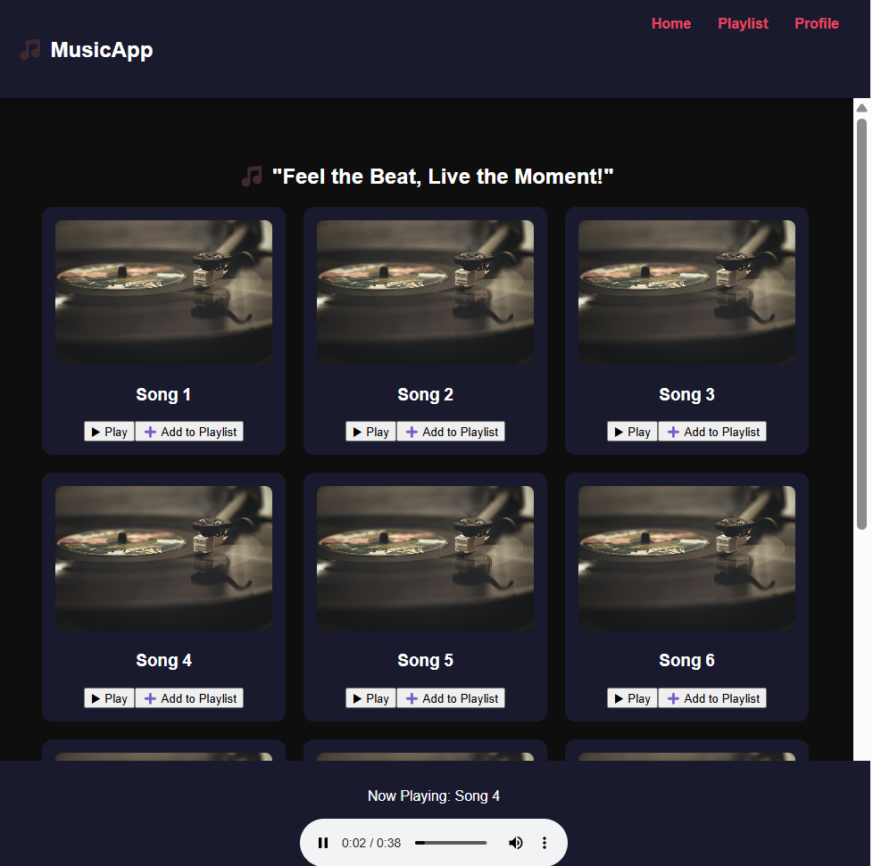

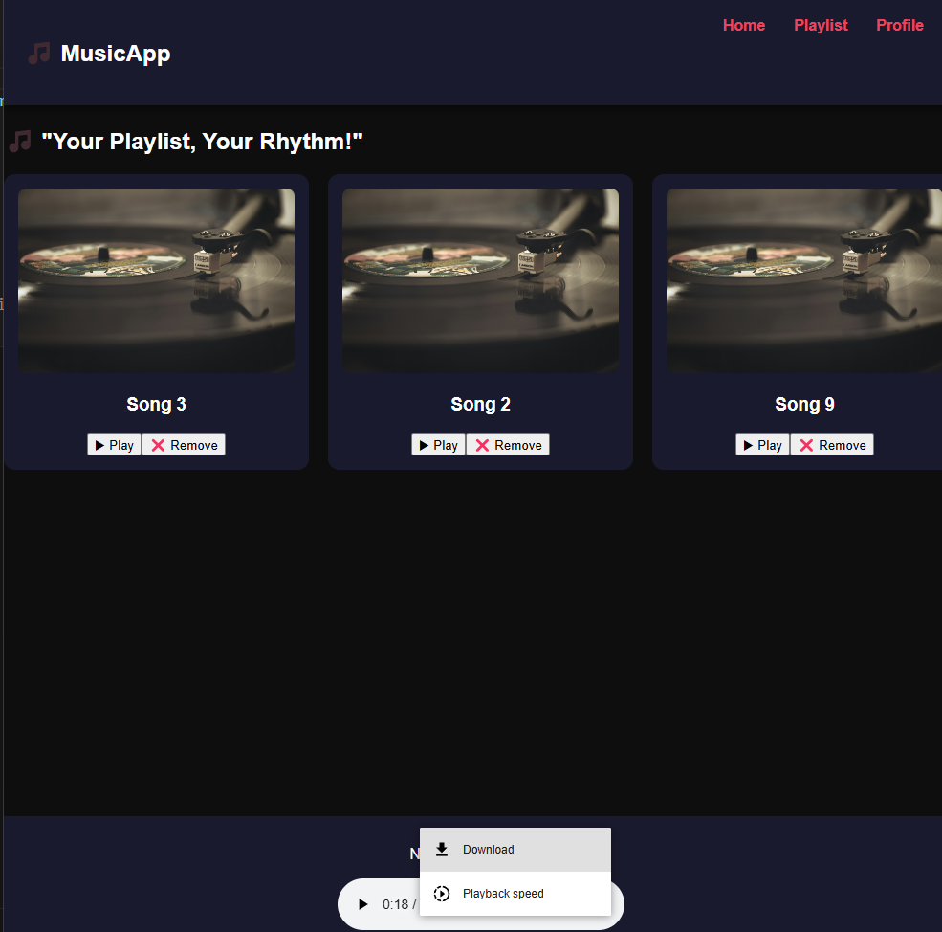

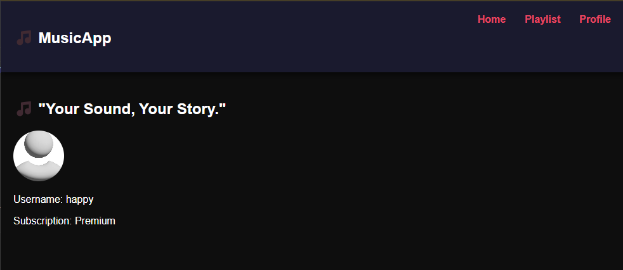

Result:
Thus, the music streaming web application to provide users with a seamless and interactive music listening experience was developed and the output was verified.

