SOLID Principles in Java

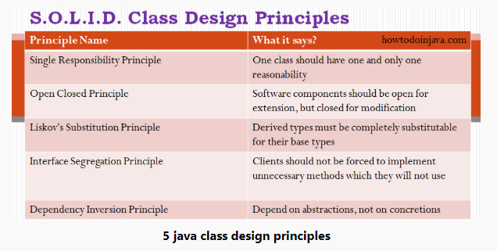

Single Responsibility Principle
One class should have one and only one responsibility
In other words, we should write, change and maintain a class for only one purpose. If it is model class then it should strictly represent only one actor/ entity. This will give we the flexibility to make changes in future without worrying the impacts of changes for another entity.
Similarly, If we are writing service/manager class then it should contain only that part of method calls and nothing else. Not even utility global functions related to module. Better separate them in another globally accessible class file. This will help in maintaining the class for that particular purpose, and we can decide the visibility of class to specific module only.

Single Responsibility Principle Example
We can plenty of classes in all popular Java libraries which follow single responsibility principle. For example, in log4j, we have different classes with logging methods, different classes are logging levels and so on.
In our application level code, we define model classes to represent real time entities such as person, employee, account etc. Most of these classes are examples of SRP principle because when we need to change the state of a person, only then we will modify a person class. and so on.
In given example, we have two classes Person and Account. Both have single responsibility to store their specific information. If we want to change state of Person then we do not need to modify the class Account and vice-versa.
public class Person
{
private Long personId;
private String firstName;
private String lastName;
private String age;
private List<Account> accounts;
}

public class Account
{
private Long guid;
private String accountNumber;
private String accountName;
private String status;
private String type;
}

Open Closed Principle
Software components should be open for extension, but closed for modification.
You can override the method but not modify the base class method.
What does this mean?? This means that our classes should be designed such a way that whenever fellow developer’s wants to change the flow of control in specific conditions in application, all they need to extend our class and override some functions and that’s it.

Open Closed Principle Example
If we take a look into any good framework like struts or spring, we will see that we cannot change their core logic and request processing, but we modify the desired application flow just by extending some classes and plugin them in configuration files.
For example, spring framework has class DispatcherServlet. This class acts as front controller for String based web applications. To use this class, we are not required to modify this class. All we need is to pass initialization parameters and we can extend it’s functionality the way we want.
Please note that apart from passing initialization parameters during application startup, we can override methods as well to modify the behavior of target class by extending the classes. For example, struts Action classes are extended to override the request processing logic.
public class HelloWorldAction extends Action
{
@Override
public ActionForward execute(ActionMapping mapping,
ActionForm form,
HttpServletRequest request,
HttpServletResponse response)
throws Exception
{

//Process the request

}
}

Liskov’s Substitution Principle
Derived types must be completely substitutable for their base types
It means that the class’s fellow developer created by extending our class should be able to fit in application without failure. This requires the objects of your subclasses to behave in the same way as the objects of your superclass. This is mostly seen in places where we do run time type identification and then cast it to appropriate reference type.

Liskov Substitution Principle Example
An example of LSP can be custom property editors in Spring framework. Spring provides property editors to represent properties in a different way than the object itself e.g. parsing human readable inputs from HTTP request parameters or displaying human readable values of pure java objects in view layer e.g. Currency or URL.
Spring can register one property editor for one data type and it is required to follow the constraint mandated by base class PropertyEditorSupport. So is any class extend PropertyEditorSupport class, then it can be substituted by everywhere base class is required.
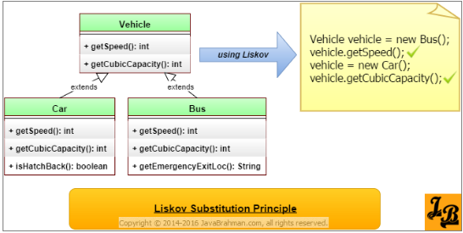

For example, every book has an ISBN number which is in always a fixed display format. You can have separate representations of ISBN in database and UI. For this requirement, we may write property editor in such a way –
import java.beans.PropertyEditorSupport;
import org.springframework.util.StringUtils;
import com.howtodoinjava.app.model.Isbn;

public class IsbnEditor extends PropertyEditorSupport {
@Override
public void setAsText(String text) throws IllegalArgumentException {
if (StringUtils.hasText(text)) {
setValue(new Isbn(text.trim()));
} else {
setValue(null);
}
}

@Override
public String getAsText() {
Isbn isbn = (Isbn) getValue();
if (isbn != null) {
return isbn.getIsbn();
} else {
return "";
}
}
}

Interface Segregation Principle
Clients should not be forced to implement unnecessary methods which they will not use.
Take an example. Developer Alex created an interface Reportable and added two methods generateExcel() and generatedPdf(). Now client ‘A’ wants to use this interface but he intend to use reports only in PDF format and not in excel. Will he be able to use the functionality easily?
NO. He will have to implement both the methods, out of which one is extra burden put on him by designer of software. Either he will implement another method or leave it blank. This is not a good design.
So what is the solution? Solution is to create two interfaces by breaking the existing one. They should be like PdfReportable and ExcelReportable. This will give the flexibility to user to use only required functionality only.

Interface Segregation Principle Example
The best place to look for IPS examples is Java AWT event handlers for handling GUI events fired from keyboard and mouse. It has different listener classes for each kind of event. We only need to write handlers for events, we wish to handle. Nothing is mandatory.
Some of the listeners are –
- FocusListener
- KeyListener
- MouseMotionListener
- MouseWheelListener
- TextListener
- WindowFocusListener
Anytime, we wish to handle any event, just find out corresponding listener and implement it.
public class MouseMotionListenerImpl implements MouseMotionListener
{
@Override
public void mouseDragged(MouseEvent e) {
//handler code
}

@Override
public void mouseMoved(MouseEvent e) {
//handler code
}
}

Dependency Inversion Principle
Depend on abstractions, not on creation of object.
Dependency inversion principal is known as decoupling of software module. All high level module should not be dependent on low level module. But both dependent on abstraction.

Dependency Inversion Principle Example

The classical use of this principle of bean configuration in Spring framework.
In spring framework, all modules are provided as separate components which can work together by simply injected dependencies in other module. This dependency is managed externally in XML files.
These separate components are so well closed in their boundaries that we can use them in other software modules apart from spring with same ease. This has been achieved by dependency inversion and open closed principles. All modules expose only abstraction which is useful in extending the functionality or plug-in in another module.
These were five class design principles, also known as SOLID principles, which makes the best practices to be followed to design our application classes.

