Prototype Design Pattern
Prototype Pattern says that cloning of an existing object instead of creating new one and can also be customized as per the requirement.
This pattern should be followed, if the cost of creating a new object is expensive and resource intensive.

Advantage of Prototype Pattern
The main advantages of prototype pattern are as follows:
- It reduces the need of sub-classing.
- It hides complexities of creating objects.
- The clients can get new objects without knowing which type of object it will be.
- It lets you add or remove objects at runtime.

Usage of Prototype Pattern
- When the classes are instantiated at runtime.
- When the cost of creating an object is expensive or complicated.
- When you want to keep the number of classes in an application minimum.
- When the client application needs to be unaware of object creation and representation.

UML for Prototype Pattern
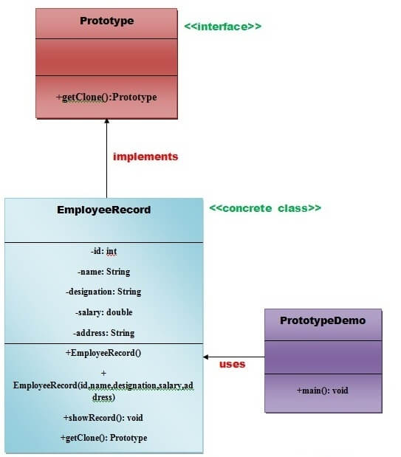
- We are going to create an interface Prototype that contains a method getClone() of Prototype type.
- Then, we create a concrete class EmployeeRecord which implements Prototype interface that does the cloning of EmployeeRecord object.
- PrototypeDemo class will uses this concrete class EmployeeRecord.
Example of Prototype Design Pattern

package com.test.prototype;

public interface Prototype {

Employee getClone();

}
package com.test.prototype;

public class Employee implements Prototype {

private String name;
private String address;
private String phone;
private String sex;

public Employee(String name, String address) {
super();
this.name = name;
this.address = address;
}

public Employee() {
}

public String getName() {
return name;
}

public void setName(String name) {
this.name = name;
}

public String getAddress() {
return address;
}

public void setAddress(String address) {
this.address = address;
}

public String getPhone() {
return phone;
}

public void setPhone(String phone) {
this.phone = phone; }

public String getSex() {
return sex;
}

public void setSex(String sex) {
this.sex = sex;
}

@Override
public String toString() {
return "Employee [name=" + name + ", address=" + address + ", phone="
+ phone + ", sex=" + sex + "]";
}

@Override
public Employee getClone() {
return new Employee(name, address);
}

}
package com.test.prototype;

public class ProtoTypeTest {

public static void main(String args[]) {

Employee empPrototype = new Employee();
empPrototype.setAddress("Gurgram");
empPrototype.setName("Sanjeev Rai");
empPrototype.setPhone("9876543210");
empPrototype.setSex("Male");

System.out.println("original employee Object : "+empPrototype.toString());

Employee employeePrototype = empPrototype.getClone();

System.out.println("prototype employee Object : "+employeePrototype.toString());

}

}

