**Some pictures of visualization from Tableau**

1.Cured cases state wise using line graph also filter there to choose state

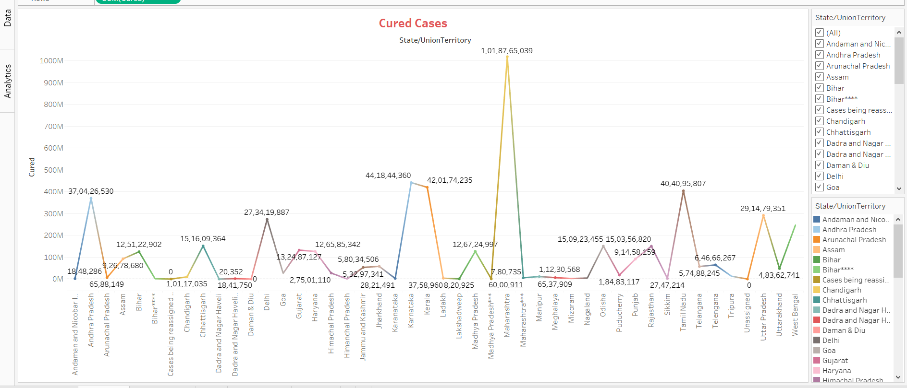

2.Confirmed cases state wise using bar graph also filter there to choose state

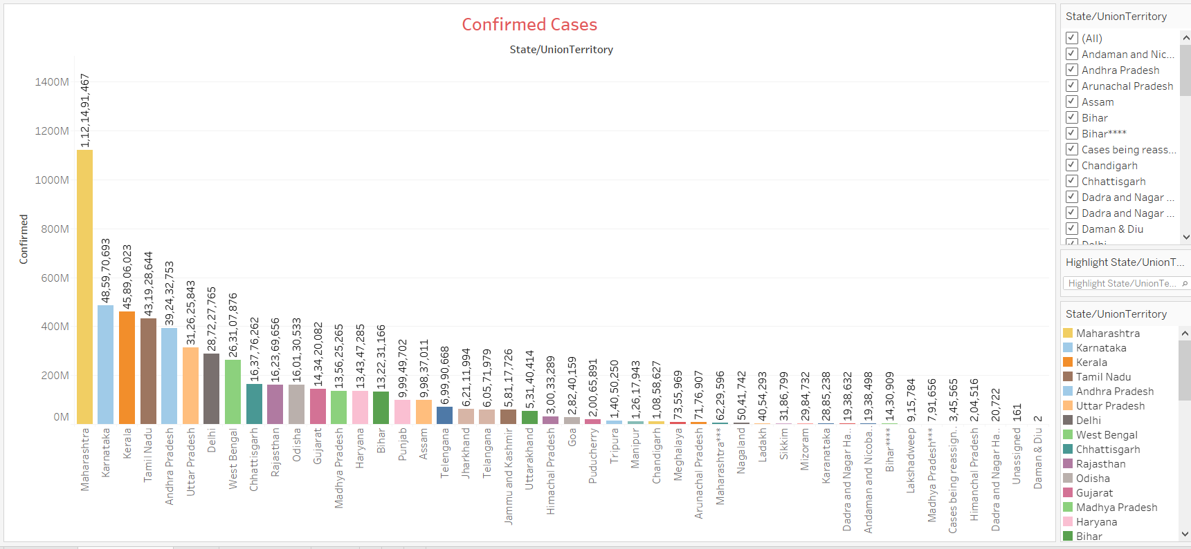

3.Death state wise using bar graph

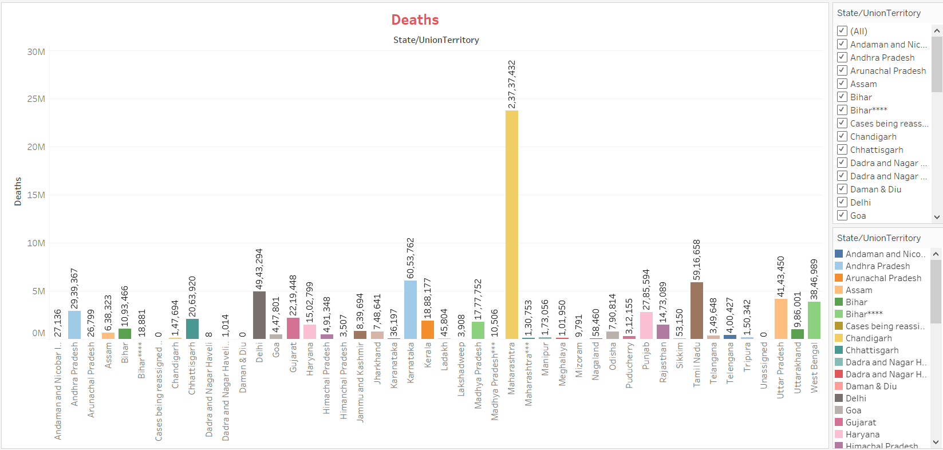

4. Confirmed cases Year wise

