**1.** In the below elements which of them are values or an expression? eg:- values can be integer or string and expressions will be mathematical operators.

*

'hello'

-87.8

-

/

6

**Ans:** There are 4 Operators and 3 Expressions and these are :-  
**Operators :**  *, -, /, +  
**Expressions :** 'hello', 87.8, 6

**2.** What is the difference between string and variable?

**Ans:** A Variable is used to store of information, and a String is a type of information you would store in a Variable.

A String is a group of characters or a single character usually enclosed in Double quotes " " or single quotes ' '.

**3**. Describe three different data types.

**Ans:** Three data types in python are Int, Float, Complex.

1. **Int data type**: Int data type to represent whole numbers (integral values). Ex: 12, 14, -43 etc
2. **Float data type**: Float data type to represent floating point values (decimal values). Ex: 12.23, 43.12 etc
3. **Complex data type**:  Complex number contains an ordered pair, i.e., x + iy where x and y denote the real and imaginary parts, respectively. Ex: 2.14j, 2.0 + 2.3j, etc

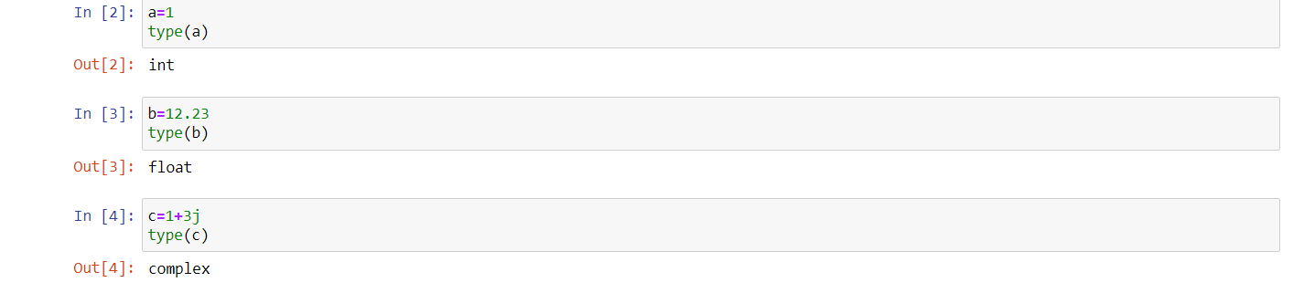

**4.** What is an expression made up of? What do all expressions do?

**Ans**: Expression is the collection of variables, values, operators and functions. When We write expression then means to evaluate. Ex: 2-4*21/42.

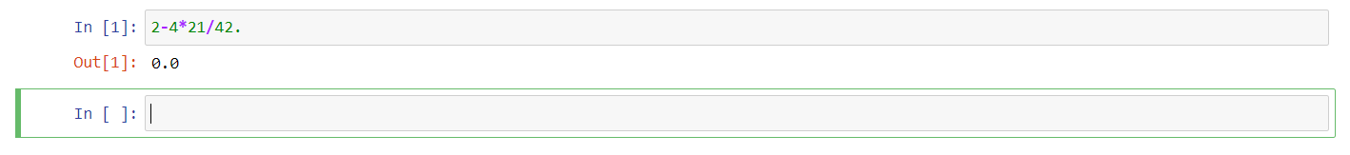**5.** This assignment statements, like spam = 10. What is the difference between an expression and a statement?

**Ans**: An expression is the collection of variables, values, operators and function. Like: 12/1*3+32 Whereas

A statement is like to create a variable and assign some values to that variable.

Like: courseName = ‘Full Stack Data Science’

**6**. After running the following code, what does the variable bacon contain?

bacon = 22

bacon + 1

**Ans:** After running the above code the variable bacon contains the same value that is 22 because It is not reassigning the value to bacon. For reassigning the expression should be bacon=bacon+1.

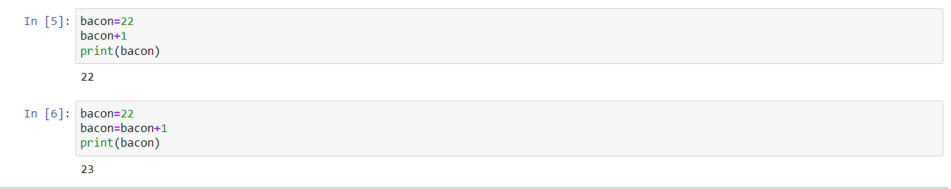

**7**. What should the values of the following two terms be?

'spam' + 'spamspam'00000000

'spam' * 3

**Ans:** Both terms will give the same result “spamspamspam”. 1st term is following string concatenation whereas 2nd term is following string multiplication.

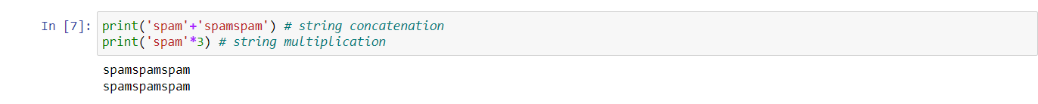

**8.** Why is eggs a valid variable name while 100 is invalid?

**Ans:** As per python variable name’s rule, We can not start a variable name with digits whereas We can start with alphabets that is why eggs is a valid variable name while 100 is invalid.

1. Variable name must start with a letter or the underscore character.
2. Variable name cannot start with a number.
3. Variable name can only contain alpha-numeric characters and underscores (A-z, 0-9, & _).
4. Variable names are case-sensitive like Sanjeev, SANJEEV and sanJEEV.
5. The reserved words(keywords) cannot be used naming the variable.

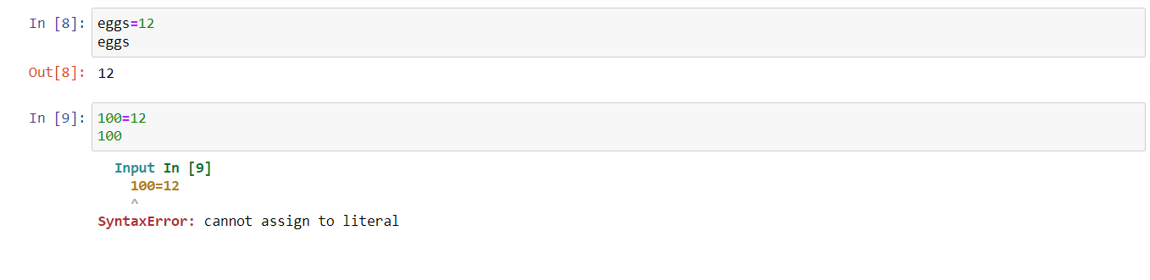

**9.** What three functions can be used to get the integer, floating-point number, or string version of a value?

Ans: int(), float() and str() functions will evaluate to the integer, floating-point number, string version of the value passed to them.

**10.** Why does this expression cause an error? How can you fix it?

'I have eaten ' + 99 + ' burritos.'

**Ans:** The cause of error is 99 because 99 is not a string. 99 must be typecasted to a string. Like:  
 'I have eaten ' + str(99) + 'burritos.'

