**1.**What are the two values of the Boolean data type? How do you write them?

**Ans:** True and False are two values of Boolean data type and We write capital T and F and then in small letters.

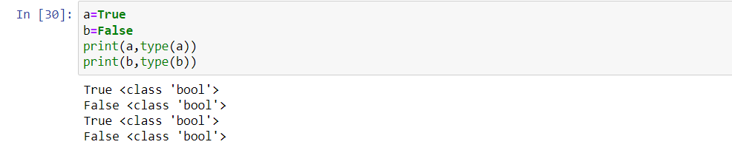

**2.** What are the three different types of Boolean operators?

**Ans:** Three different types of Boolean operators are and, or and not operator –

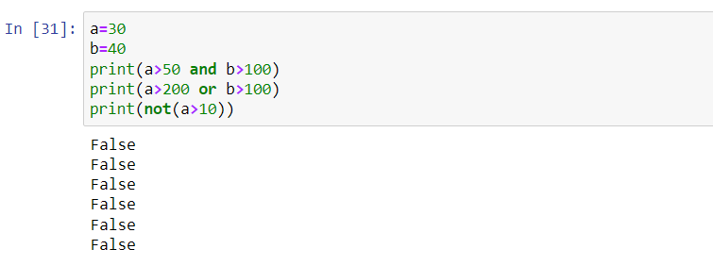

**3.** Make a list of each Boolean operator's truth tables (i.e. every possible combination of Boolean values for the operator and what it evaluate).

**Ans: Truth Table for and (&) operator –**

True and True= True

True and False=True

False and True=False

False and False=False

**Truth Table for OR (|) operator -**

True or True = True

True or False = True

False or False= False

False or True= True

**Truth Table for Not operator –**

True= false

False=True

**4.** What are the values of the following expressions?

(5 > 4) and (3 == 5)

not (5 > 4)

(5 > 4) or (3 == 5)

not ((5 > 4) or (3 == 5))

(True and True) and (True == False)

(not False) or (not True)

**Ans:**

(5 > 4) and (3 == 5) # False

not (5 > 4) # False

(5 > 4) or (3 == 5) # True

not ((5 > 4) or (3 == 5)) # False

(True and True) and (True == False) #False

(not False) or (not True) #True

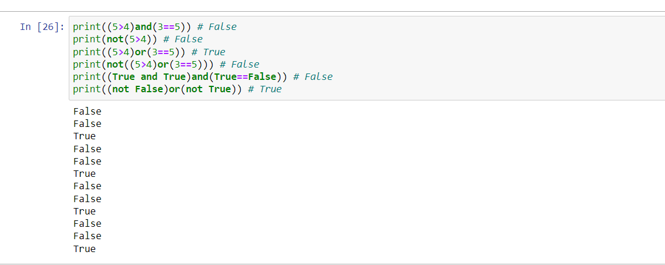

**5.** What are the six comparison operators?

**Ans:** The Six comparison operators are: == , != , < , > , <= , =>.

**6.** How do you tell the difference between the equal to and assignment operators? Describe a condition and when you would use one.

Ans: The difference between equal the and assignment operator is –

We use assignment operator when We need to assign any value to variable like a=12, Here a is variable, 12 is value and = is assignment operator Whereas

We use equal operator when We need to check the variables values are equal to that value or not like a==12, Here a is variable, 12 is value and == is equal operator.

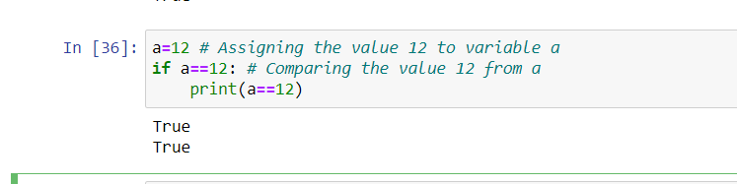

**7.** Identify the three blocks in this code:

spam = 0

if spam == 10:

print('eggs')

if spam > 5:

print('bacon')

else:

print('ham')

print('spam')

print('spam')

**Ans:** Three blocks in the above code is mentioned below:

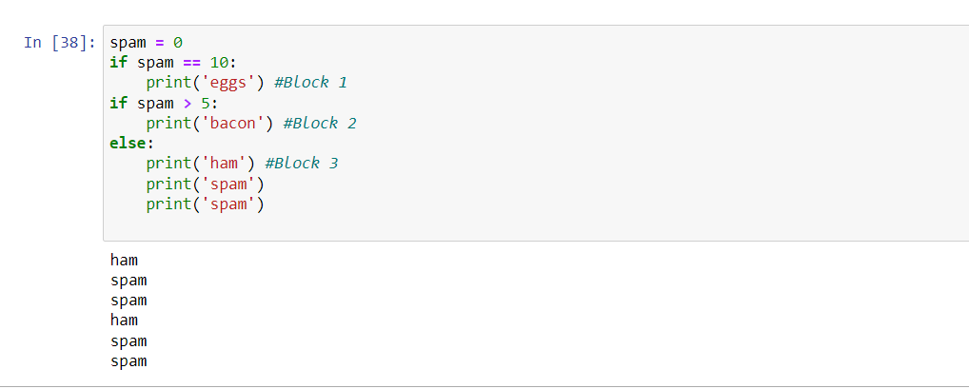

**8.** Write code that prints Hello if 1 is stored in spam, prints Howdy if 2 is stored in spam, and prints Greetings! if anything else is stored in spam.

**Ans:** The code is below mentioned:

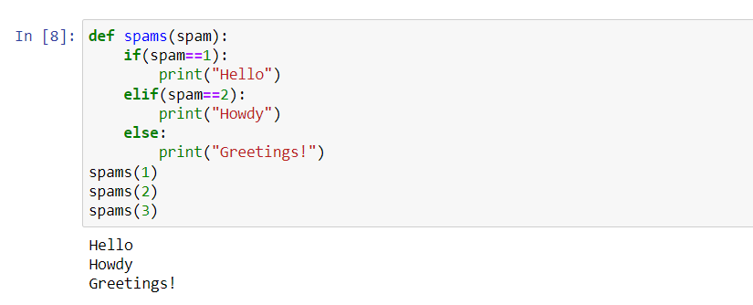

**9.** If your programme is stuck in an endless loop, what keys you’ll press?

**Ans:** If Our programme is stuck in an endless loop, We use **CTRL + C**.

**10.** How can you tell the difference between break and continue?

**Ans:** Break statement is used to break the loop Whereas Continue statement is used to skip that particular condition and again executing.

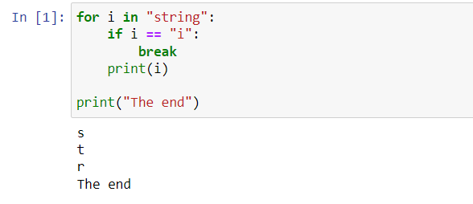

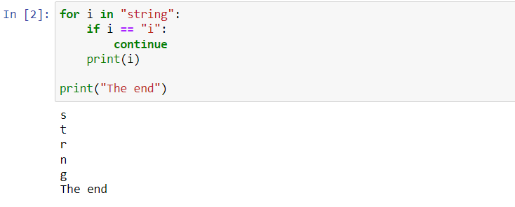

**11.** In a for loop, what is the difference between range (10), range (0, 10), and range (0, 10, 1)?

**Ans:** range (10) calls range from 0 to 9 not include 10

range (0,10) tells the range will start from 0 to 9 and

range (0,10,1) tells the range will start from 0 and will increase by 1 with every iteration.

**12.** Write a short program that prints the numbers 1 to 10 using a for loop. Then write an equivalent program that prints the numbers 1 to 10 using a while loop.

**Ans:** The program mentioned below :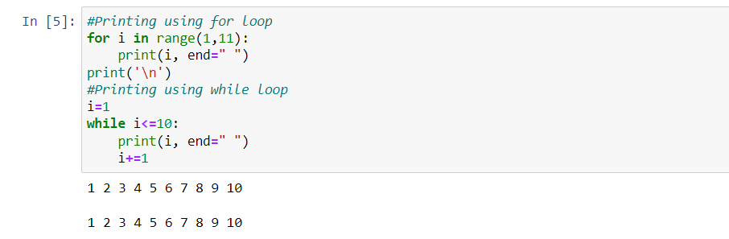

**13.** If you had a function named bacon() inside a module named spam, how would you call it after importing spam?

**Ans:** This function can be called with spam.bacon()