Q1. How are inline and block elements different from each other?

There are two types of elements in HTML page – INLINE and BLOCK:-

Block Elements

A block-level element always starts on a new line and takes up the full width
available (stretches out to the left and right as far as it can).

The <div> element is a block-level element.

Inline Elements

An inline element does not start on a new line and only takes up as much width
as necessary.

This <span> element is an inline-level element.

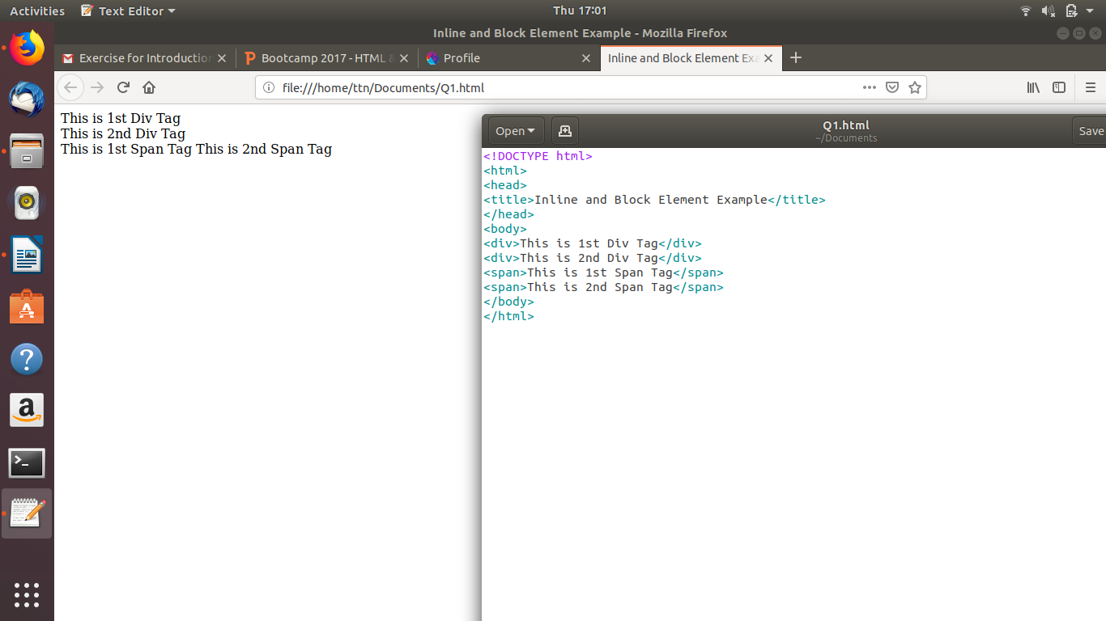

Q2. Explain the difference between visibility:hidden and display:none

Visibility:hidden

visibility:hidden hides an element. However, the element will still take up the same space as before. The element will be hidden, but still affect the layout.
Example:
<!DOCTYPE html>
<html>
<head>
<style>
.hidden{
visibility: hidden;
}
</style>
</head>
<body>
<h1>This is a visible heading</h1>
<h1 class="hidden">This is a hidden heading</h1>
<p>Notice that the hidden still takes up space.</p>
</body>
</html>

Output:
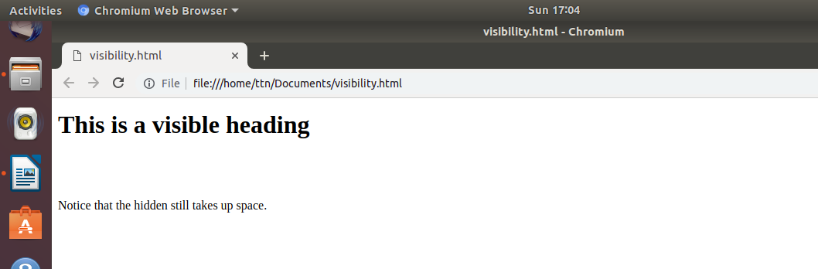

display:none

Hiding an element can also be done by setting the display property to none. The element will be hidden, and the page will be displayed as if the element is not there.

Example:

<!DOCTYPE html>
<html>
<head>
<style>
.hidden{
display:none;
}
</style>
</head>
<body>
<h1>This is a visible heading</h1>
<h1 class="hidden">This is a hidden heading</h1>
<p>Notice that the h1 element with display:none; does not takes any space.</p>
</body>
</html>

Output:

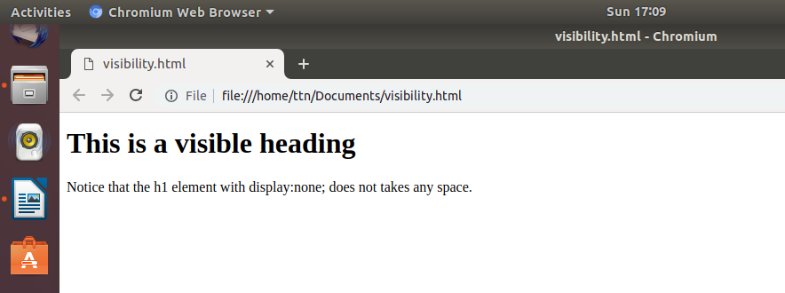

Q3. Explain the clear and float properties.

Clear Property

The clear property specifies what elements can float beside the cleared element and on which side.
The clear property can have one of the following values:
- none - Allows floating elements on both sides. This is default
- left - No floating elements allowed on the left side
- right- No floating elements allowed on the right side
- both - No floating elements allowed on either the left or the right side
- inherit - The element inherits the clear value of its parent
Example:

<!DOCTYPE html>
<html>
<head>
<style>
.div1 {
float: left;
width: 100px;
height: 50px;
margin: 10px;
border: 3px solid #73AD21;
}

.div2 {
border: 1px solid red;
}

.div3 {
border: 1px solid red;
clear: left;
}
</style>
</head>
<body>

<h2>Without clear</h2>
<div class="div1">div1</div>
<div class="div2">div2 - Notice that div2 is after div1 in the HTML code. However, since div1 floats to the left, the text in div2 flows around div1.</div>
<br><br>
<h2>With clear</h2>
<div class="div1">div1</div>
<div class="div3">div3 - Here, clear: left; moves div4 down below the floating div3. The value "left" clears elements floated to the left. You can also clear "right" and "both".</div>
</body>
</html>

Output:

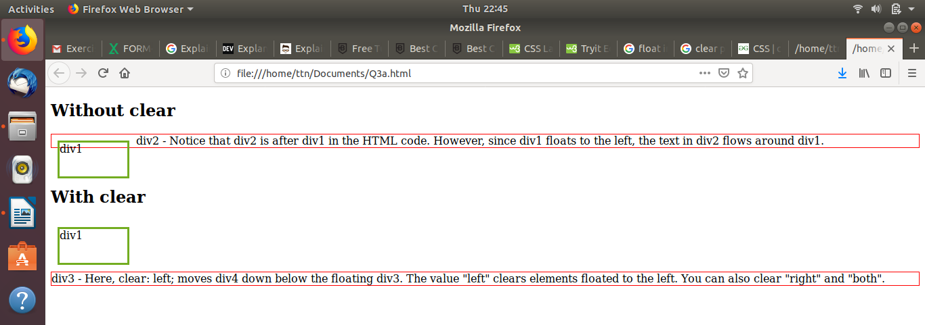

Float Property

The CSS float property specifies if an element should float or not; in other words, using float you determine where an element should appear inside a container.

The float property can have one of the following values:
- left - The element floats to the left of its container
- right- The element floats to the right of its container
- none - The element does not float (will be displayed just where it occurs in the text). This is default
- inherit - The element inherits the float value of its parent
“float:left” example
<!DOCTYPE html>
<html>
<head>
<title>Float Property</title>
</head>
<body>
<div style="font-size:50px; color:#886400; float:left;">
Float left propery.
</div>
</body>
</html>
Output:
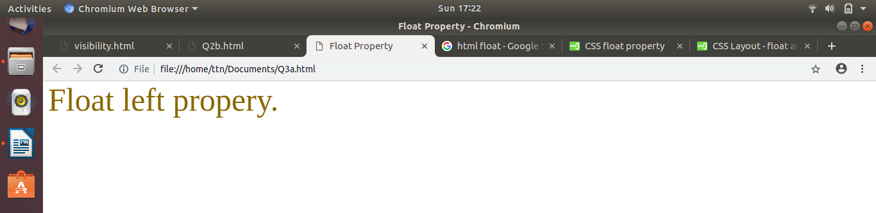
“float:right” example
<!DOCTYPE html>
<html>
<head>
<title>Float Property</title>
</head>
<body>
<div style="font-size:50px; color:#886400; float:right;">
Float right propery.
</div>
</body>
</html>
Output:
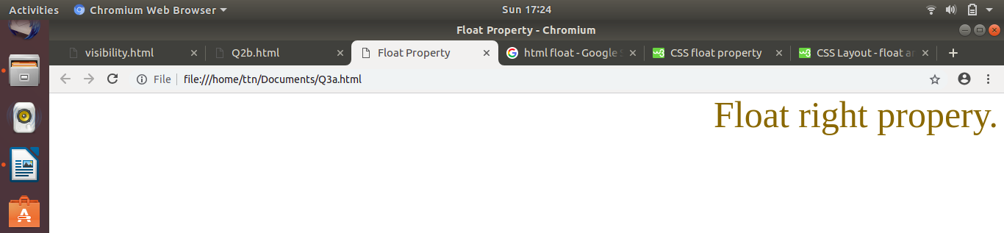
“float:none” example
<!DOCTYPE html>
<html>
<head>
<title>Float Property</title>
</head>
<body>
<div style="font-size:50px; color:#886400; float:none;">
Float none propery.
</div>
</body>
</html>
Output:
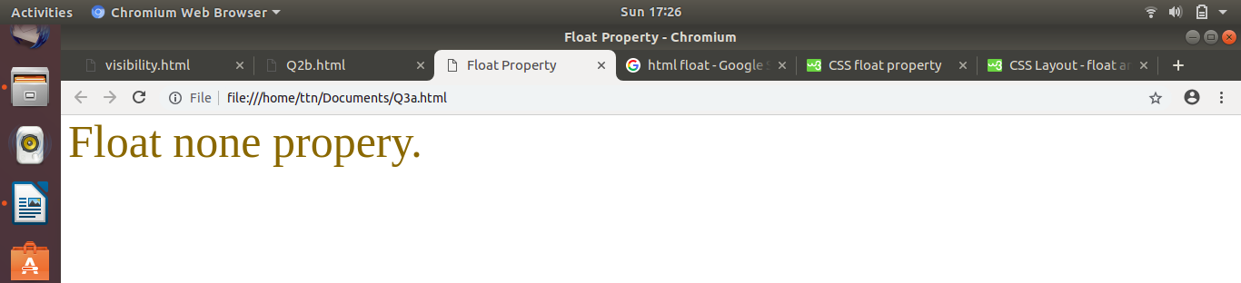
“float:inherit” example
<!DOCTYPE html>
<html>
<head>
<title>Float Property</title>
</head>
<body>
<div style="float:right;">
<div style="font-size:50px; color:#886400; float:inherit;">
Float inherit propery.
</div>
</div>
</body>
</html>
Output:
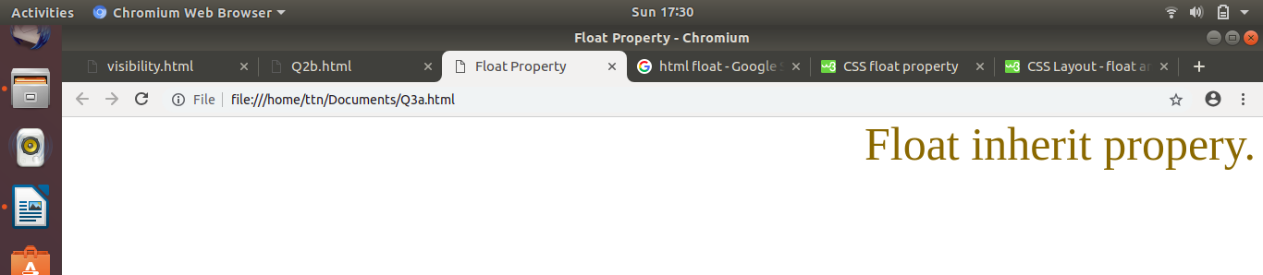

Q4. Explain difference between absolute, relative,fixed and static.
Absolute
An element with “position: absolute;” is positioned relative to the nearest positioned ancestor (instead of positioned relative to the viewport, like fixed).
However; if an absolute positioned element has no positioned ancestors, it uses the document body, and moves along with page scrolling.
Example:
<!DOCTYPE html>
<html>
<head>
<style>
div.relative {
position: relative;
width: 400px;
height: 200px;
border: 3px solid #73AD21;
}

div.absolute {
position: absolute;
top: 80px;
right: 0;
width: 200px;
height: 100px;
border: 3px solid #73AD21;
}
</style>
</head>
<body>
<h2>position: absolute;</h2>
<div class="relative">This div element has position: relative;
<div class="absolute">This div element has position: absolute;</div>
</div>
</body>
</html>
Output:
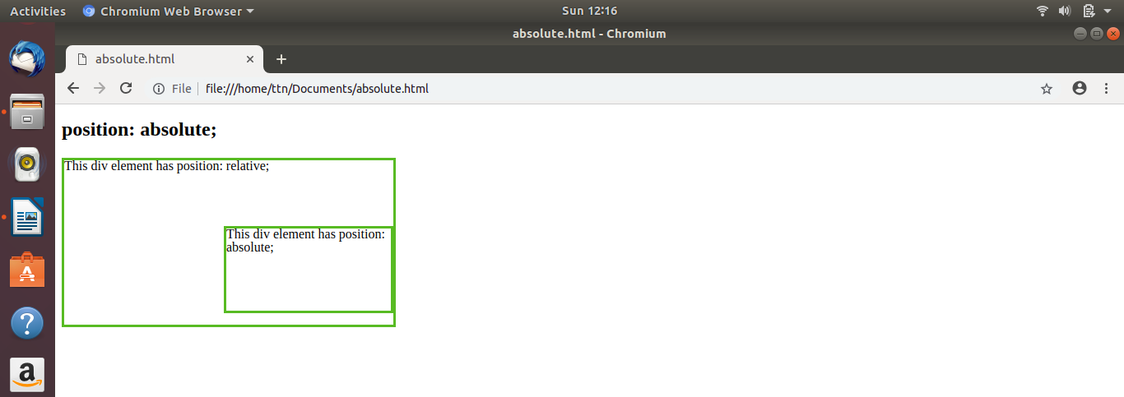
Relative
An element with “position: relative;” is positioned relative to its normal position.
Setting the top, right, bottom, and left properties of a relatively-positioned element will cause it to be adjusted away from its normal position. Other content will not be adjusted to fit into any gap left by the element.
Example
<!DOCTYPE html>
<html>
<head>
<style>
div.relative {
position: relative;
left: 30px;
border: 3px solid #73AD21;
}
</style>
</head>
<body>
<h2>position: relative;</h2>
<div class="relative">
This div element has position: relative;
</div>
</body>
</html>
Output:
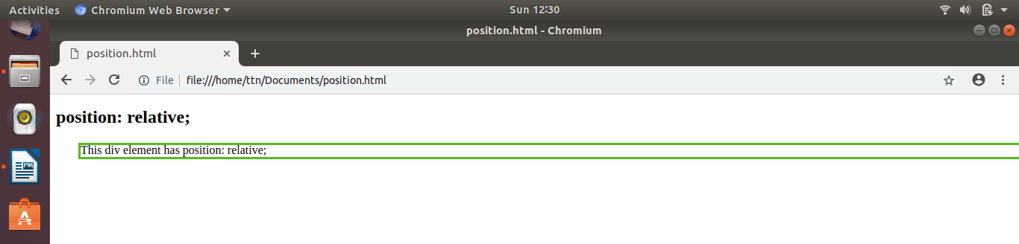
Fixed
An element with “position: fixed;” is positioned relative to the viewport, which means it always stays in the same place even if the page is scrolled. The top, right, bottom, and left properties are used to position the element.
A fixed element does not leave a gap in the page where it would normally have been located.

Example
<!DOCTYPE html>
<html>
<head>
<style>
div.fixed {
position: fixed;
bottom: 0;
right: 0;
width: 300px;
border: 3px solid #73AD21;
}
</style>
</head>
<body>
<h2>position: fixed;</h2>
<div class="fixed">
This div element has position: fixed;
</div>
</body>
</html>
Output:
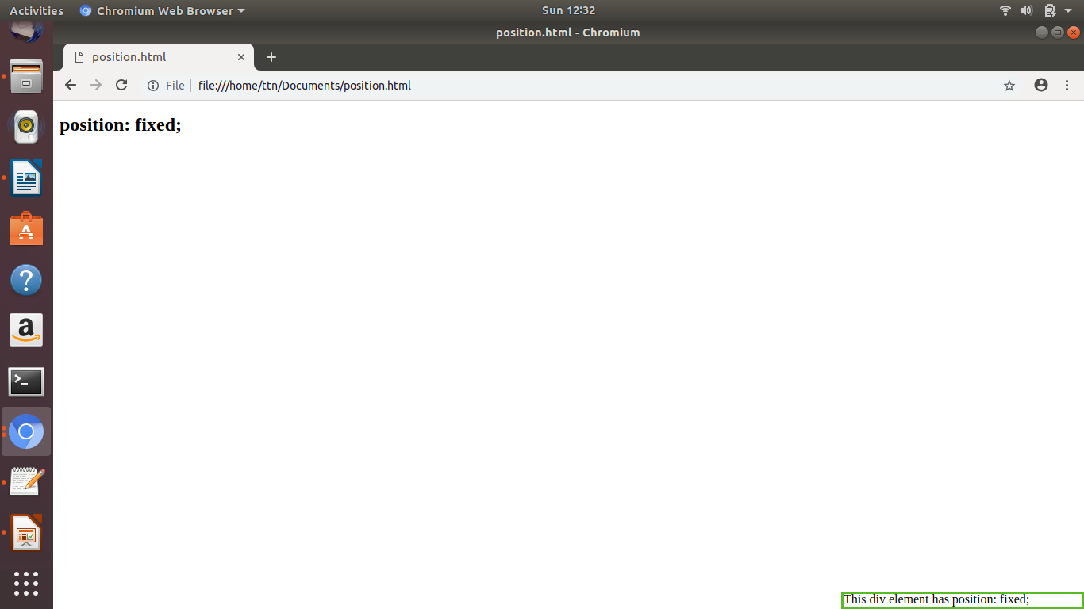
Static
HTML elements are positioned static by default.
Static positioned elements are not affected by the top, bottom, left, and right properties.
An element with “position : static;” is not positioned in any special way; it is always positioned according to the normal flow of the page.
Example
<!DOCTYPE html>
<html>
<head>
<style>
div.static {
position: static;
border: 3px solid #73AD21;
}
</style>
</head>
<body>
<h2>position: static;</h2>
<div class="static">
This div element has position: static;
</div>
</body>
</html>
Output:
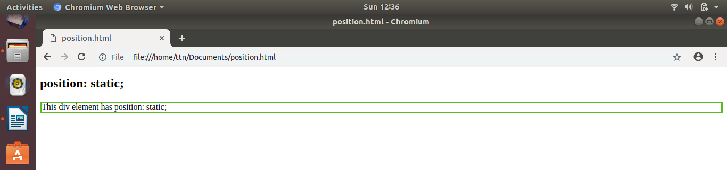

Q5. Write the HTML code to create a table in which there are 4 columns( ID , Employee Name, Designation, Department) and at least 6 rows. Also do some styling to it.
<!DOCTYPE html>
<html>
<head>
<title>Table Example</title>
<style>
table {
font-family: arial, sans-serif;
border-collapse: collapse;
width: 50%;
}

td, th {
border: 1px solid #dddddd;
text-align: left;
padding: 8px;
}

tr:nth-child(even) {
background-color: #dddddd;
}
</style>
</head>
<body>

<h2>HTML Table</h2>

<table>
<tr bgcolor="black" style="color: white" >
<th>ID</th>
<th>Employee Name</th>
<th>Designation</th>
<th>Department</th>
</tr>
<tr>
<td>11</td>
<td>Rohan Verma</td>
<td>Accounts Executive</td>
<td>Accounts</td>
</tr>
<tr>
<td>12</td>
<td>Ajitabha Das</td>
<td>HR</td>
<td>IT</td>
</tr>
<tr>
<td>13</td>
<td>Anjum Roy</td>
<td>Manager</td>
<td>Sales</td>
</tr>
<tr>
<td>14</td>
<td>Mohit Rana</td>
<td>QA</td>
<td>IT</td>
</tr>
<tr>
<td>15</td>
<td>Surabhi Sharma</td>
<td>Technical Assistant</td>
<td>JVM</td>
</tr>
<tr>
<td>16</td>
<td>Shubhan Saxena</td>
<td>Assistant Manager</td>
<td>Accounts</td>
</tr>
</table>
</body>
</html>
Output:
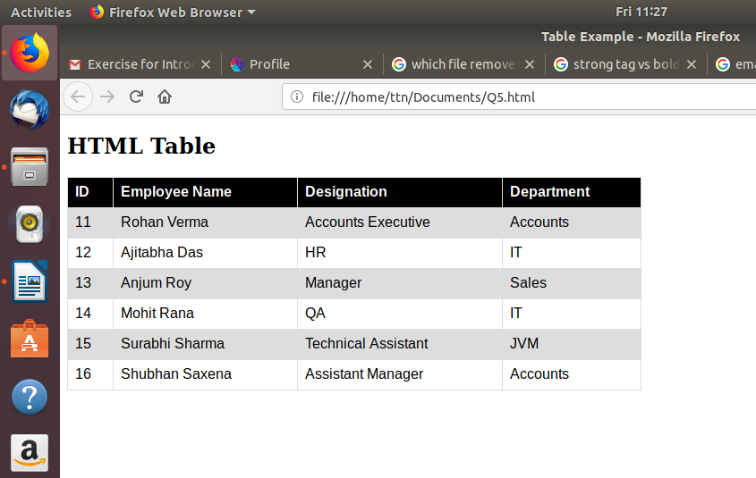

Q6. Why do we use meta tags?
- The <meta> tag provides metadata about the HTML document. Metadata will not be displayed on the page, but will be machine parsable.
- Meta elements are typically used to specify page description, keywords, author of the document, last modified, and other metadata. Also, it helps to improve the SEO( Search Engine Optimization) of a web page by using certain keywords related to the web page.
- <meta> tags always go inside the <head> element.

Following are few examples of <meta> tag with different attributes :
- For search engines-
<meta name="keywords" content="HTML, CSS, XML, XHTML, JavaScript">

- Description of web page-
<meta name="description" content="Free Web tutorials on HTML and CSS">

- Author of web page-
<meta name="author" content="John Doe">

- Responsiveness-
<meta name="viewport" content="width=device-width, initial-scale=1.0">

- Refresh Document-
<meta http-equiv="refresh" content="30">

Q7. Explain box model.

All HTML elements can be considered as boxes. In CSS, the term "box model" is used when talking about design and layout.
The CSS box model is essentially a box that wraps around every HTML element. It consists of: margins, borders, padding, and the actual content.
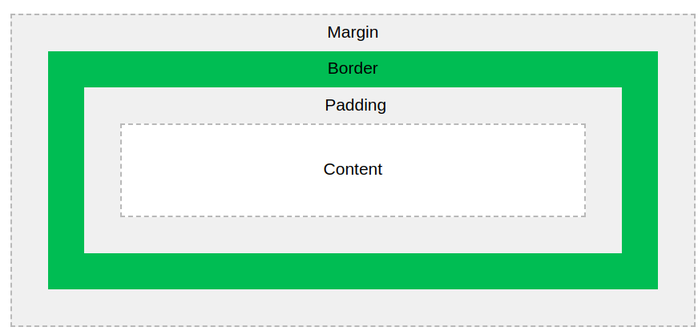

Explanation of the different parts:
- Content- The content of the box, where text and images appear
- Padding- Clears an area around the content. The padding is transparent
- Border- A border that goes around the padding and content
- Margin- Clears an area outside the border. The margin is transparent

Q8. What are the different types of CSS Selectors?

The selector points to the HTML element you want to style.
The declaration block contains one or more declarations separated by semicolons.
Each declaration includes a CSS property name and a value, separated by a colon.
A CSS declaration always ends with a semicolon, and declaration blocks are surrounded by curly braces.
Types of CSS Selectors are:-

- Id Selector
- The id selector uses the id attribute of an HTML element to select a specific element.
- The id of an element should be unique within a page, so the id selector is used to select one unique element!
- To select an element with a specific id, write a hash (#) character, followed by the id of the element.
Example:
<!DOCTYPE html>
<html>
<head>
<style>
#para1 {
text-align: center;
color: red;
}
</style>
</head>
<body>
<p id="para1">Hello World!</p>
<p>This paragraph is not affected by the style.</p>
</body>
</html>
Output:
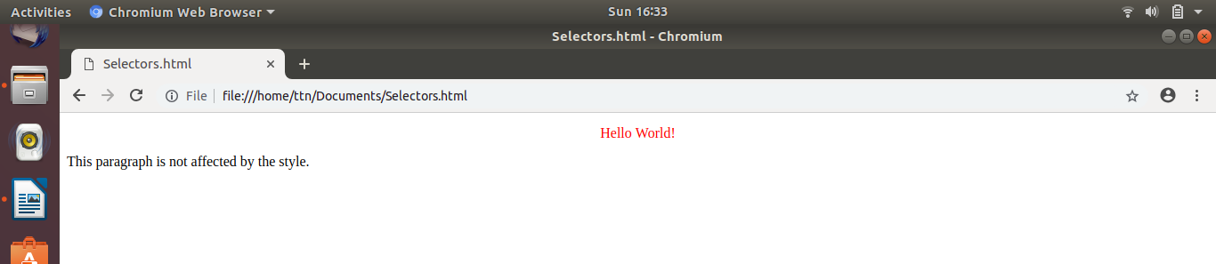
- Class Selector

- The class selector selects elements with a specific class attribute.
- To select elements with a specific class, write a period (.) character, followed by the name of the class.
Example:
<!DOCTYPE html>
<html>
<head>
<style>
.center {
text-align: center;
color: red;
}
</style>
</head>
<body>
<h1 class="center">Red and center-aligned heading</h1>
<p class="center">Red and center-aligned paragraph.</p>
</body>
</html>

Output:

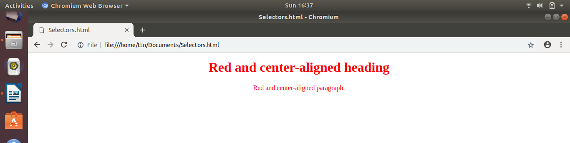
- Element Selector

- The element selector selects elements based on the element name.
- We can select all <p> elements on a page like this (in this case, all <p> elements will be center-aligned, with a red text color):
Example:

<!DOCTYPE html>
<html>
<head>
<style>
p {
text-align: center;
color: red;
}
</style>
</head>
<body>
<p>Every paragraph will be affected by the style.</p>
<p id="para1">Me too!</p>
<p>And me!</p>
</body>
</html>

Output:

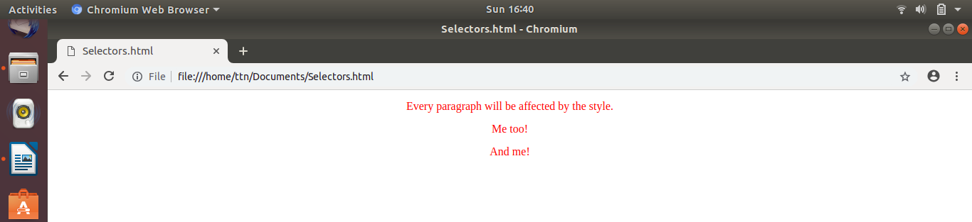
- Grouping Selectors

- If we have elements with the same style definitions, It will be better to group the selectors, to minimize the code.

- To group selectors, separate each selector with a comma.
Example:
<!DOCTYPE html>
<html>
<head>
<style>
h1, h2, p {
text-align: center;
color: red;
}
</style>
</head>
<body>

<h1>Hello World!</h1>
<h2>Smaller heading!</h2>
<p>This is a paragraph.</p>

</body>
</html>

Output:
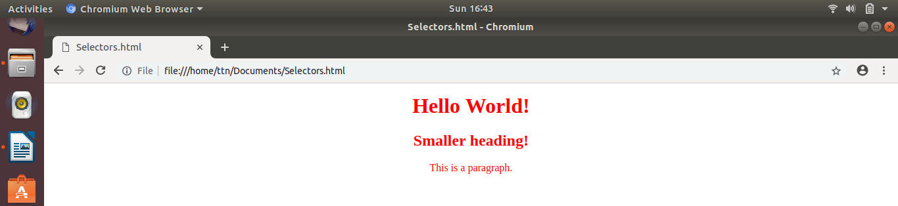

Q9. Define Doctype.

- The <!DOCTYPE> declaration must be the very first thing in your HTML document, before the <html> tag.
- The <!DOCTYPE> declaration is not an HTML tag; it is an instruction to the web browser about what version of HTML the page is written in.
- In HTML 4.01, the <!DOCTYPE> declaration refers to a DTD, because HTML 4.01 was based on SGML. The DTD specifies the rules for the markup language, so that the browsers render the content correctly.
- HTML5 is not based on SGML, and therefore does not require a reference to a DTD.
Example:

<!DOCTYPE html>
<html>
<head>
<title>Title of the document</title>
</head>
<body>
The content of the document......
</body>
</html>

Q10. Explain 5 HTML5 semantic tags.

- <section> tag

- The <section> element defines a section in a document.
- According to W3C's HTML5 documentation: "A section is a thematic grouping of content, typically with a heading."
- A home page could normally be split into sections for introduction, content, and contact information.
Example
<!DOCTYPE html>
<html>
<body>
<section>
<h1>WWF</h1>
<p>The World Wide Fund for Nature (WWF) is an international organization working on issues regarding the conservation, research and restoration of the environment, formerly named the World Wildlife Fund. WWF was founded in 1961.</p>
</section>
<section>
<h1>WWF's Panda symbol</h1>
<p>The Panda has become the symbol of WWF. The well-known panda logo of WWF originated from a panda named Chi Chi that was transferred from the Beijing Zoo to the London Zoo in the same year of the establishment of WWF.</p>
</section>
</body>
</html>

Output:

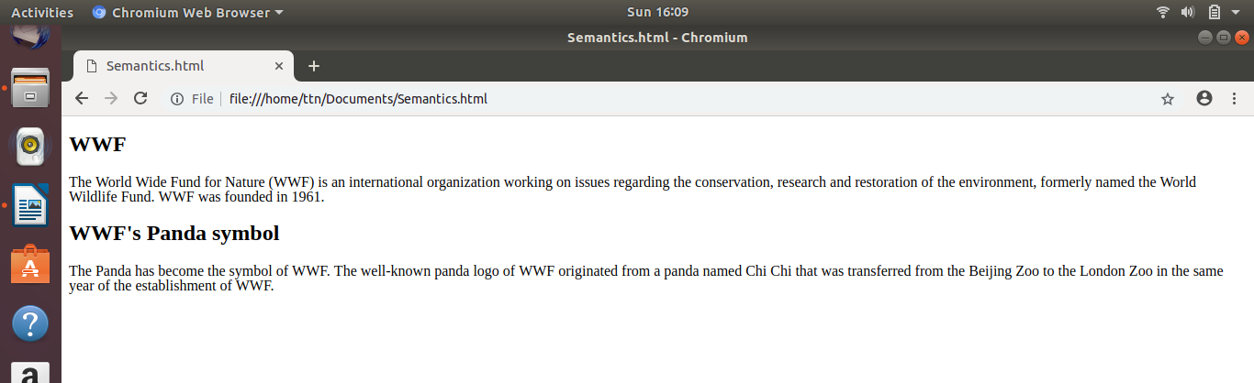
2. <article> tag
- The <article> element specifies independent, self-contained content.
- An article should make sense on its own, and it should be possible to read it independently from the rest of the web site.
- Examples of where an <article> element can be used:
- Forum post
- Blog post
- Newspaper article
Example:
<!DOCTYPE html>
<html>
<body>
<article>
<h1>What Does WWF Do?</h1>
<p>WWF's mission is to stop the degradation of our planet's natural environment, and build a future in which humans live in harmony with nature.</p>
</article>
</body>
</html>
Output:
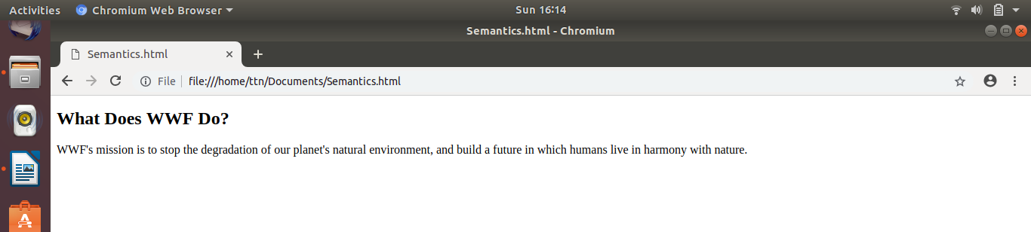
3. <header> tag

- The <header> element specifies a header for a document or section.
- The <header> element should be used as a container for introductory content.
- We can have several <header> elements in one document.
Example:

<!DOCTYPE html>
<html>
<body>
<article>
<header>
<h1>What Does WWF Do?</h1>
<p>WWF's mission:</p>
</header>
<p>WWF's mission is to stop the degradation of our planet's natural environment, and build a future in which humans live in harmony with nature.</p>
</article>
</body>
</html>

Output:

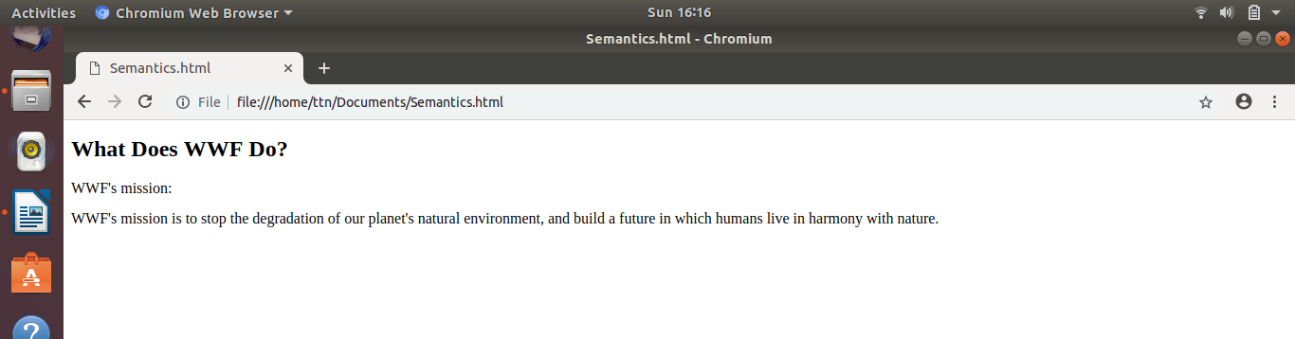
4. <footer> tag

- The <footer> element specifies a footer for a document or section.
- A <footer> element should contain information about its containing element.
- A footer typically contains the author of the document, copyright information, links to terms of use, contact information, etc.
- We may have several <footer> elements in one document.
Example:

<!DOCTYPE html>
<html>
<body>
<footer>
<p>Posted by: Hege Refsnes</p>
<p>Contact information: <a href="mailto:someone@example.com">
someone@example.com</a>.</p>
</footer>
</body>
</html>

Output:

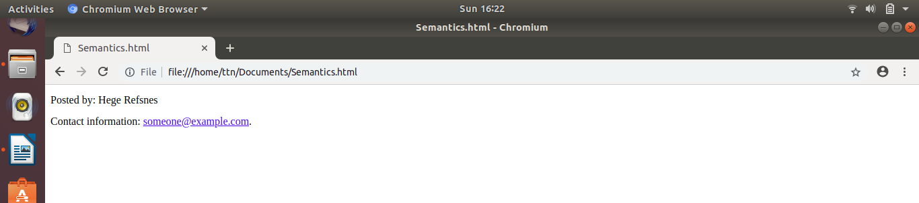
5. <nav> tag

The <nav> element defines a set of navigation links.

Example:

<!DOCTYPE html>
<html>
<body>
<nav>
<a href="/html/">HTML</a> |
<a href="/css/">CSS</a> |
<a href="/js/">JavaScript</a> |
<a href="/jquery/">jQuery</a>
</nav>
</body>
</html>

Output:
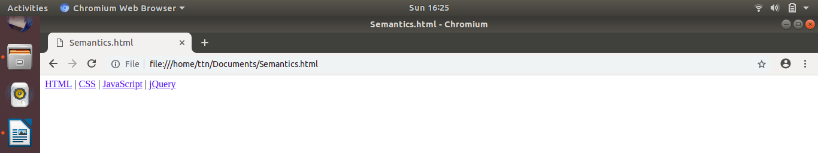
Q11. Create HTML for web-page.jpg

Exercise1.html

<!DOCTYPE html>
<html>
<head>
<title>Exercise 1</title>
<link rel="stylesheet" href="style.css">
</head>
<body>
<div class="container">
<div class="inner-container">
<header>
<span style="color:white">To the New</span>
<div class="topnav">
<a href="#">Text Link</a>
<a href="#">Text Link</a>
<a href="#">Text Link</a>
<a href="#">Text Link</a>
</div>
</header>

<div class="img_container">
<img src="b2.jpg" alt="Snow" style="width:100%;">
<div class="centered"><h1>Some text over the image</h1></div>
</div>

<div class="text" >
A narrative or story is a report of connected events, real or imaginary, presented in a sequence of written or spoken words, or still or moving images, or both. The word derives from the Latin verb narrare, "to tell", which is derived from the adjective gnarus, "knowing" or "skilled".
</div>

<div id="gal_heading">
<h3>LATEST FROM THE GALLERY</h3>
<hr style="margin-top:-15px">
</div>

<div class="gallery">

<div>
<div style="position:relative"><img src="IT.jpg"><div class="centered">Gallery-1</div></div>
<div class="img_caption">IMAGE CAPTION HERE</div>
</div>

<div>
<div style="position:relative"><img src="IT.jpg"><div class="centered">Gallery-2</div></div>
<div class="img_caption">IMAGE CAPTION HERE</div>
</div>

<div>
<div style="position:relative"><img src="IT.jpg"><div class="centered">Gallery-3</div></div>
<div class="img_caption">IMAGE CAPTION HERE</div>
</div>

</div>

<footer>
<div style="float:left">Copyright @ 2009-2007-All Right reserved-To the new</div>
<div style="float:right"> Web Layout by To the new</div>
</footer>
</div>
</div>
</body>
</html>

Style.css

body{
margin:0;
font-family: Arial, Helvetica, sans-serif;
}

.container{
width:100%;
background-color: #3D3838;
}

.inner-container{
width:95%;
background-color: #FFFFFF;
margin: 0 auto;
}

header{
background-color: #3A3636;
padding:10px 40px 10px;
color:#f2f2f2;
font-size:17px;

}

footer{
padding:10px 20px 25px;
background-color: #333;
color:#f2f2f2;
}

.topnav {
overflow: hidden;
background-color: #333;
margin-top:10px;
}

.topnav a {
float: left;
color: #f2f2f2;
text-align: center;
padding: 14px 16px;
text-decoration: none;
font-size: 17px;
}

.topnav a:hover {
background-color: #ddd;
color: black;
}

.img_container {
position: relative;
text-align: center;
color: white;
padding:10px 40px 10px;
width:93.5%;
}

.centered {
position: absolute;
top: 50%;
left: 50%;
transform: translate(-50%, -50%);
}

.text{
padding:10px 20px 10px;
background-color: #DCDCDC;
margin:10px 40px 10px;
text-transform: uppercase;
text-align: justify;
line-height: 1.6;
color:#2E2A2A;
}

#gal_heading{
margin:10px 40px 10px;
color:#2E2A2A;
}

.gallery{

display: flex;
flex-wrap: wrap;
padding:10px 30px 10px;
}

.gallery > div > div > img{
width: 335px;
margin: 10px 10px 10px;
}

.gallery > div{
padding:5px;
border-style: solid;
border-width: thin;
border-color: #808080;
margin:10px 10px 10px;
}

.img_caption{
padding:5px;
margin:0px 10px;
text-align:center;
background-color:#DCDCDC;
}

Output:

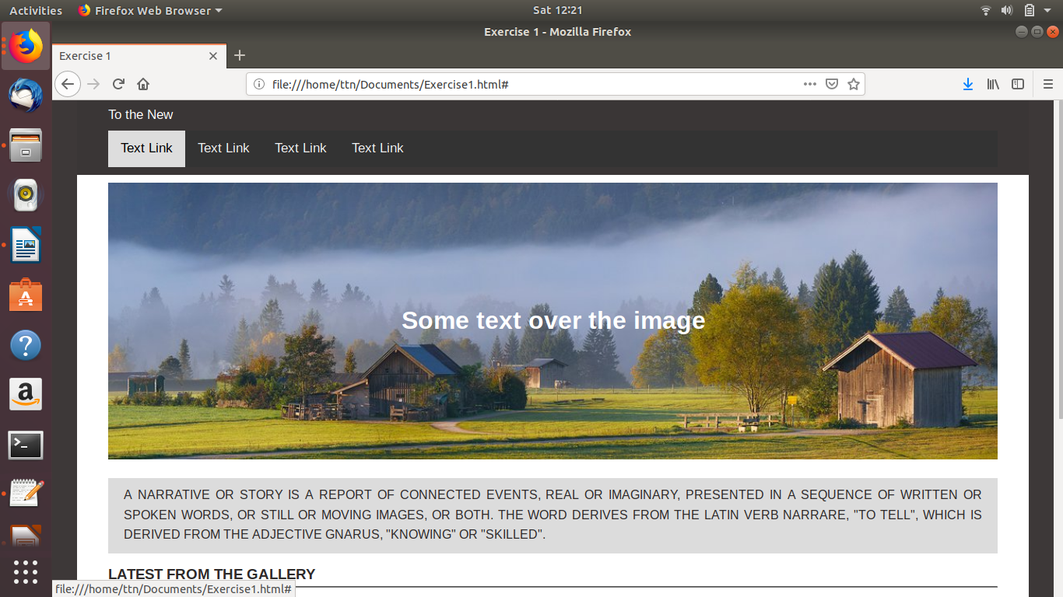

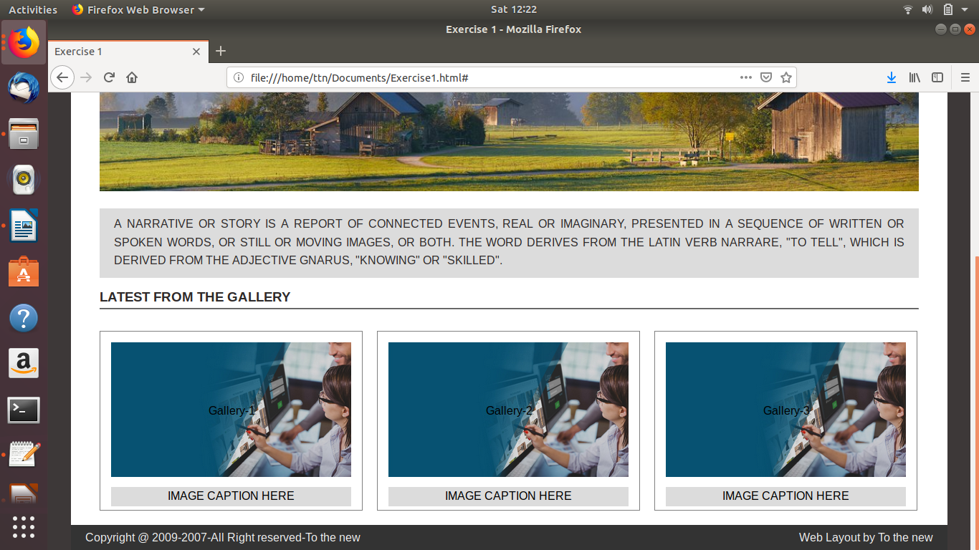

Q12. Create HTML for form.png

Exercise2.html

<DOCTYPE! html>
<html>
<head>
<title>Bug_Report</title>
<link rel="stylesheet" href="bug_report_style.css">

<script>
function uploadFile(target) {
document.getElementById("file-name").innerHTML = target.files[0].name;
}
</script>

</head>
<body>

<div class="container">
<header>
TO THE NEW
<div style="float:right"><sup>
<a href="#">Home</a>
<a href="#">Quick Help</a>
<sup>
</div>
</header>

<div class="inner-container">
<div class="inner_container_header">
<b>Bug Report</b>
</div>
<form>
<div style="margin:10px 20px 10px; width:500px;">
<span>Title:<sup>*</sup></span><br>
<input id="title" type="text">
</div>

<div style="margin:10px 20px 20px">
<span >Description:<sup>*</sup></span><br>
<textarea rows="5" cols="33" id="description"></textarea>
</div>

<div style="margin:10px 20px 10px;">
<span>Operating System:</span><br>
<select id="os" style="background-color:#4F9273; color:white;">
<option value="Windows">Windows</option>
<option value="Linux">Linux</option>
<option value="Macintos">Macintos</option>
</select>
</div>

<div style="margin:10px 20px 10px">
<span>Product:<sup>*</sup></span><br>
<select id="product" style="background-color:#4F9273; color:white">
<option value="Formoid">Formoid</option>
<option value="Linux">JotForm</option>
<option value="Macintos">pForm</option>
</select>
</div>

<div style="margin:10px 20px 10px">
<span>Version:<sup>*</sup></span><br>
<input type="text" style="width:30%">
</div>

<div style="margin:10px 20px 10px">
<span>Licence:</span><br>
<div style="margin: 8px 0px 15px;">
<input type="radio" name="licence" value="Free" checked> Free
<input type="radio" name="licence" value="Business" style="margin-left:40%"> Business
</div>
</div>

<div style="margin:10px 20px 10px">
<span>Severity:</span><br>
<select id="product" style="background-color:#4F9273; color:white">
<option value="Formoid">Critical</option>
<option value="Linux">High</option>
<option value="Macintos">Medium</option>
<option value="Macintos">Low</option>
</select>
</div>

<div style="margin:10px 20px 10px">
<span >Attachments:</span><br>
<div class="inputfile-box" style="margin-top:10px;">
<input type="file" id="file" class="inputfile" onchange='uploadFile(this)'>
<label for="file">
<span id="file-name" class="file-box"></span>
<span class="file-button">
Choose File
</span>
</label>
</div>

</div>

<div style="background-color:#E8E8E4; padding:30px; margin-bottom:-16px;">
<input type="submit" value="Send" style="float:right;">
</div>
</form>
</div>
</div>

</body>
</html>

bug_report_style.css

body{
margin:0;
font-family: Arial, Helvetica, sans-serif;
}

.container{
width:90%;
background-color: #fff;
margin: 0px auto;
}

header{
color:#4F9273;
padding:10px;
font-size:20px;
border-bottom: 2px solid #DCDCDC;
}

header > div > sup> a{
text-decoration:none;
color:#4F9273;
padding-left:10px;
}

.inner-container{
width:50%;
background-color: #fff;
margin: 0px auto;
border: 2px solid #c1c1c1;
margin-top:20px;
border-radius: 10px;
position:relative;

}

.inner_container_header{
background-color: #c1c1c1;
padding:20px 20px 20px;
color:#fff;
font-size:20px;

border-top-right-radius: 8px;
border-top-left-radius: 8px;
}

#title{
width:108%;
}

#description{
width:100%;
border-radius:4px;
border-color:#DCDCDC;
margin-top:10px;
max-width:100%;
}

input[type=text],select {
width: 100%;
padding: 12px 20px;
margin: 8px 0;
display: inline-block;
border: 1px solid #ccc;
border-radius: 4px;
box-sizing: border-box;
font-size:15px;
}

input[type=submit] {
width: 10%;
background-color: #4F9273;
color: white;
padding:10px;
margin-top:-20px;
border: none;
border-radius: 4px;
cursor: pointer;
}

.inputfile-box {
position: relative;

}

.inputfile {
display: none;
}

.file-container {
display: inline-block;
width: 100%;
}

.file-box {
display: inline-block;
width: 100%;
border: 1px solid;
padding:10px 10px;
border-color:#DCDCDC;
border-radius:5px;
box-sizing: border-box;
height:40px;
}

.file-button {
background: #c1c1c1;
padding: 11px 20px 11px 20px;
position: absolute;
border: 0px solid;
border-top-right-radius: 5px;
border-bottom-right-radius: 5px;
top: 0px;
right: 0px;
}

Output:

