1) Look up java plugin documentation. Make changes in manifest to make it executable with correct class. When run using java -jar JAR_NAME_HERE the output should be text "Hello World" on the console.

build.gradle

jar{
manifest.attributes 'Main-Class' : 'com.gradle.Main'
}
Question1
package com.gradle;
class Question1 {
void myFunction(){
System.out.println("Hello World");
}
}

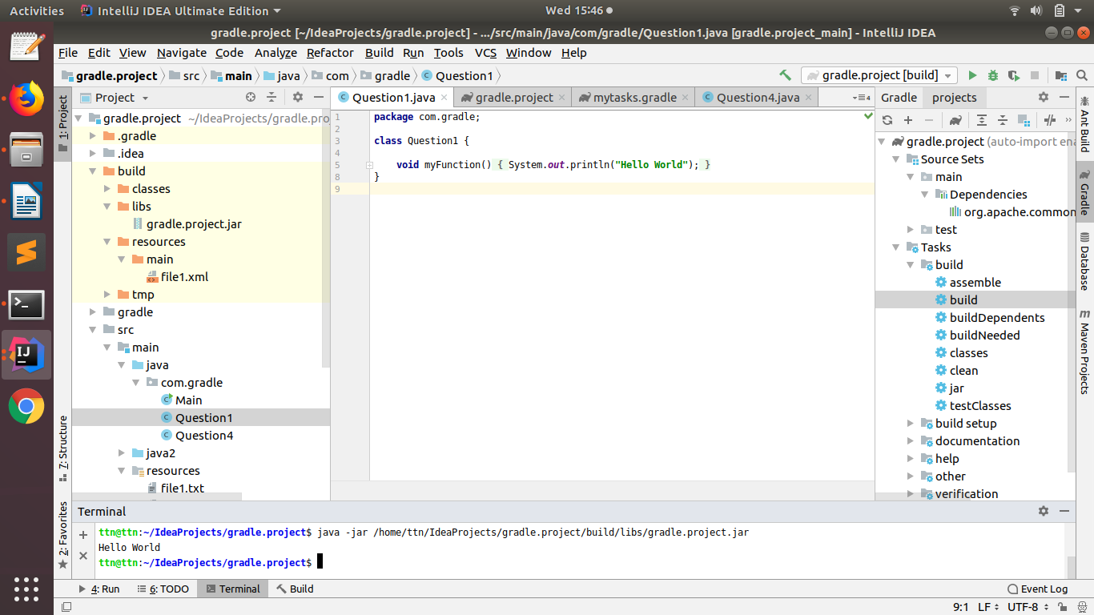
2) look up idea plugin. make changes in build.gradle so that the sources of src/main/java as well as src/main/java2 are taken as sources. Ensure that when you make JAR file class files in both are added to the JAR. This will teach you how projects with non-conventional structure can be used with gradle.

build.gradle
sourceSets {
main{
java{
srcDirs=['src/main/java','src/main/java2']
}
}
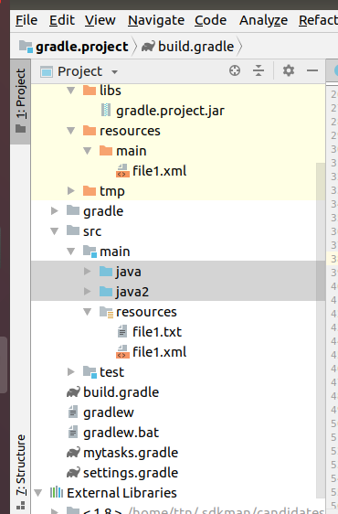
}

3) add 2 files file1.xml and file1.txt in src/main/resources manually. make changes so that when creating jar only file1.xml is added to the jar.

build.gradle

sourceSets {
main{
resources{
srcDirs=['src/main/resources']
exclude 'file1.txt'
}
}
}
build folder
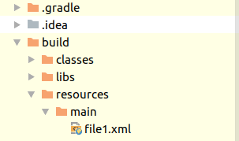

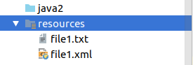

4) find how to and what is an uberjar. Make changes so you can use commons lang3 StringUtil in your jar. Make this uber jar executable. The output should be text but that should be using the StringUtils class of commons lang3
Uber jar :

ubar jar is also known as fat jar i.e. jar with dependencies.

Question 4 :

package com.gradle;
import org.apache.commons.lang3.StringUtils;
import java.util.Arrays;
import java.util.List;
class Question4 {
private List list = Arrays.asList("hello!", "How", "aRe", "yoU");
void convertToCapital() {
System.out.println("Using StringUtils class ...");
System.out.println("List before swapCase: " + list.toString());
System.out.println("List after swapCase: " + StringUtils.swapCase(list.toString()));
}
}

build.grade

repositories {
mavenCentral()
}
dependencies {
compile 'org.apache.commons:commons-lang3:3.8.1'
}

jar{
from configurations.compile.collect{ zipTree it }
}
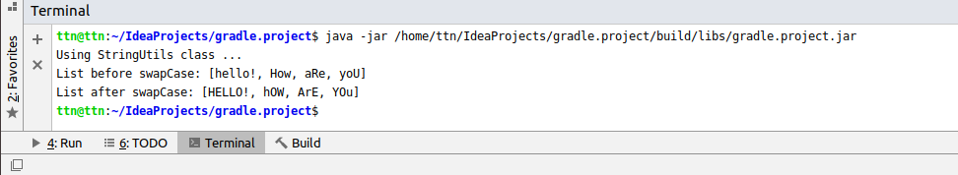

5) Find a maven repository and add it as a repository. You can use bintray, jcenter

build.grade

repositories {
jcenter()
}

6) Write a task in file "mytasks.gradle" and use it in your build.gradle

mytasks.gradle

task myTask{
doLast {
println("Hello! this is from mytasks side :D")
}
}

build.gradle

apply from :'mytasks.gradle'



build.gradle

plugins {
id 'java'
}

// Question1
jar{
manifest{
attributes 'Main-Class':'com.gradle.Main'
}
}

// Question2
sourceSets {
main {
java {
srcDirs = ['src/main/java', 'src/main/java2']
}
}
}

// Question3
sourceSets {
main{
resources {
srcDirs = ['src/main/resources']
exclude 'file1.txt'
}
}
}

//Question4
repositories {
mavenCentral()
}
dependencies {
compile 'org.apache.commons:commons-lang3:3.8.1'
}
jar{
from configurations.compile.collect{ zipTree it }
}

// Question5
repositories {
jcenter()
}

// Question6
apply from : 'mytasks.gradle'

Project-design
