Q1. Create a directory "exercise" inside your home directory and create nested(dir1/dir2/dir3) directory structure inside "excerise" with single command.

Output:

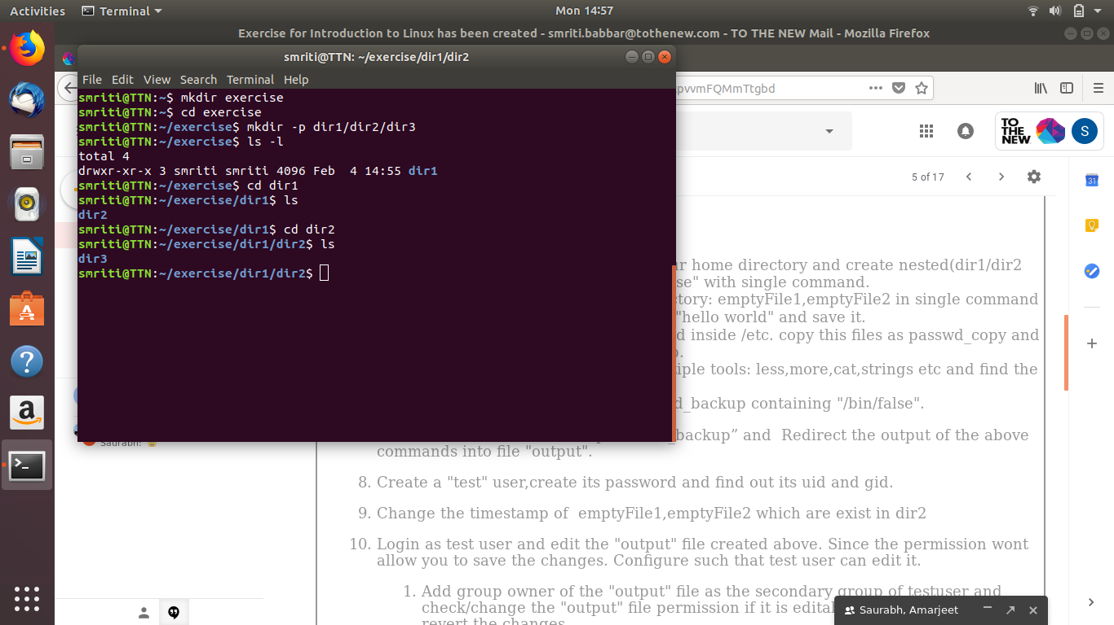

Q2. Create two empty files inside dir2 directory: emptyFile1,emptyFile2 in single command

Output:

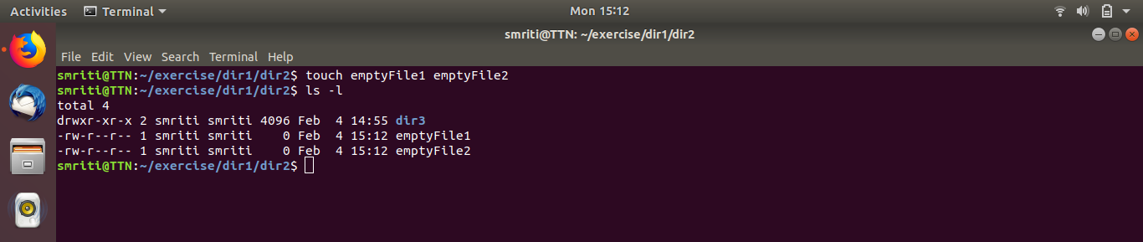
Q3. Create one file file1.txt containing text "hello world" and save it.

Output:

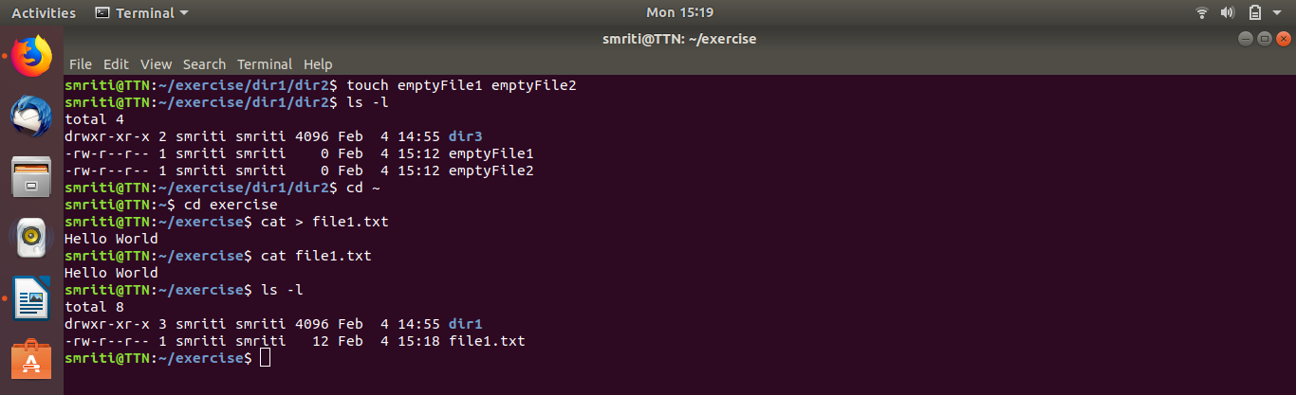

Q4. Find a "passwd" file using find command inside /etc. copy this files as passwd_copy and then rename this file as passwd_backup.

Output:

Q5. Try reading passwd_backup file in multiple tools: less,more,cat,strings etc and find the difference in their usage.

Output:

less

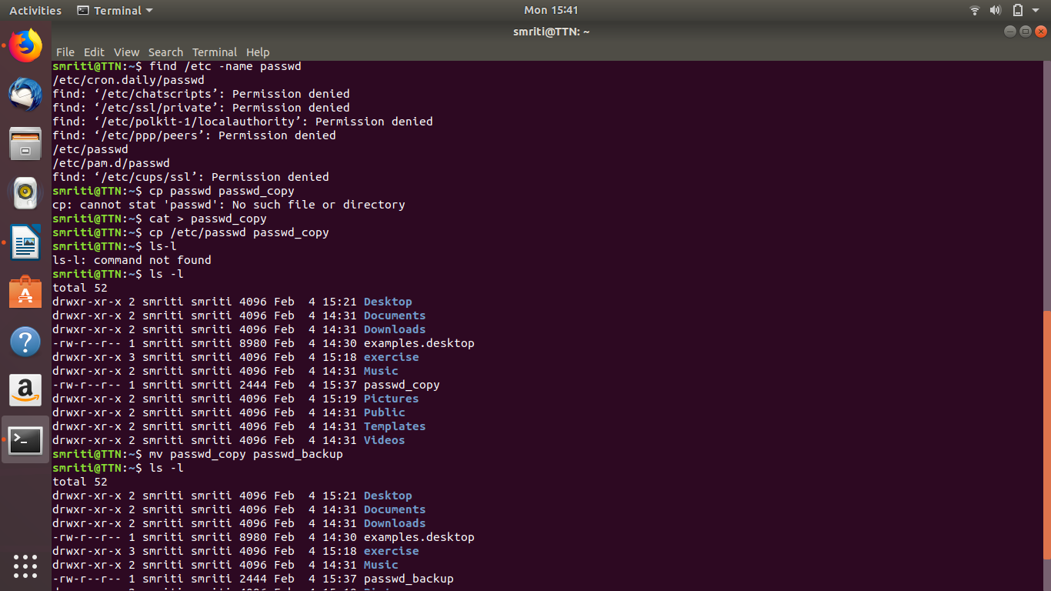
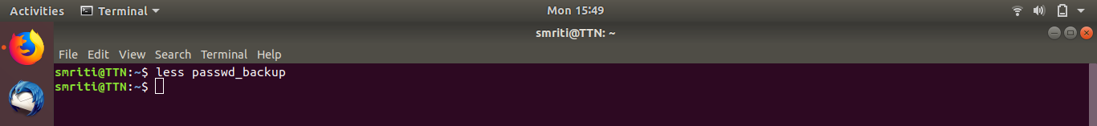
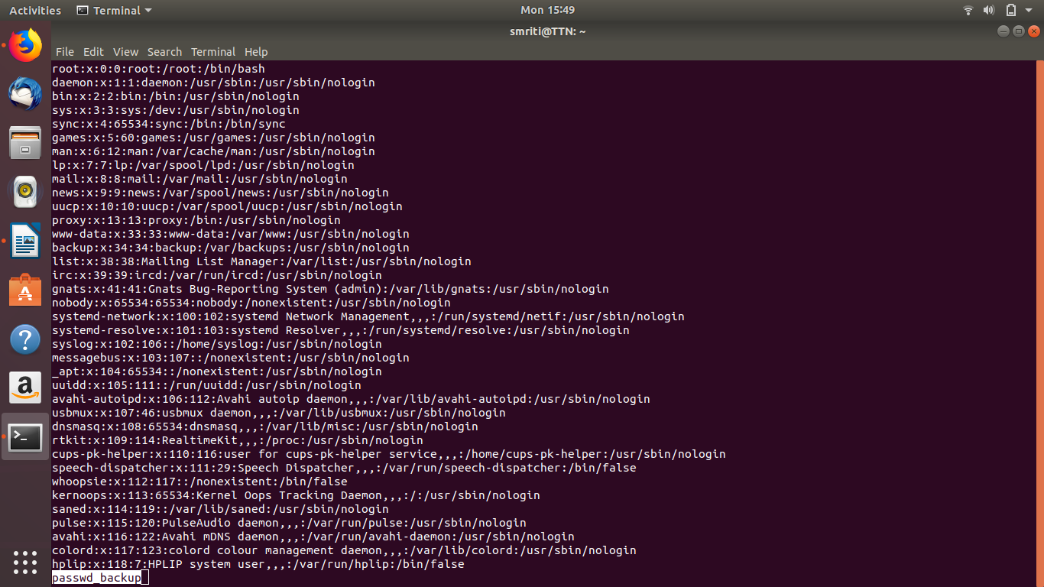

more

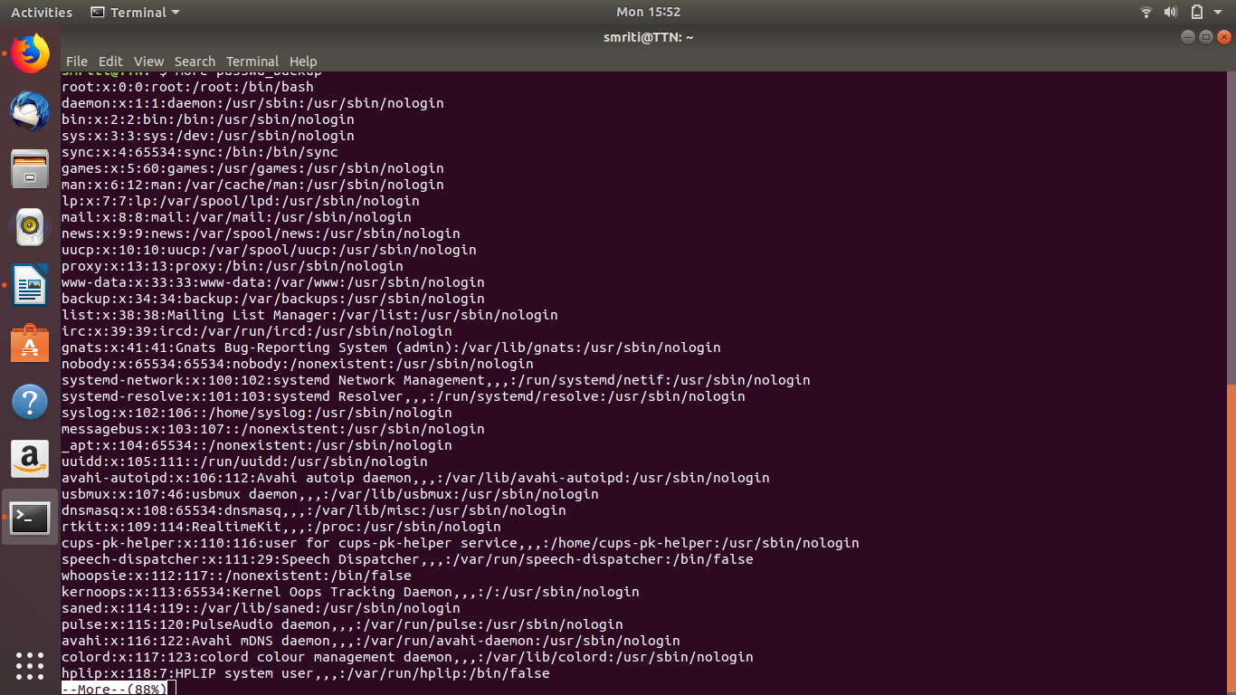
cat

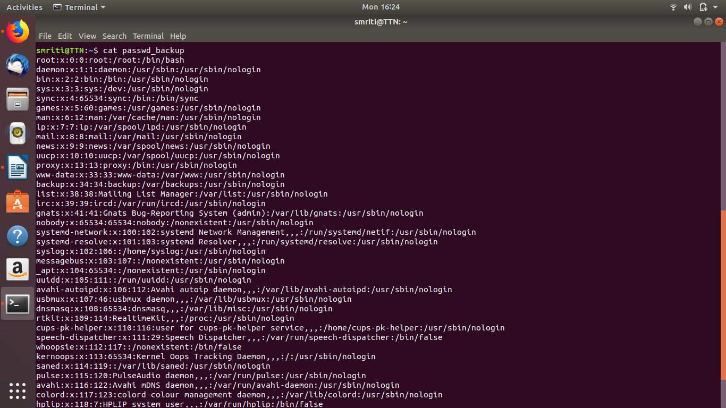
strings

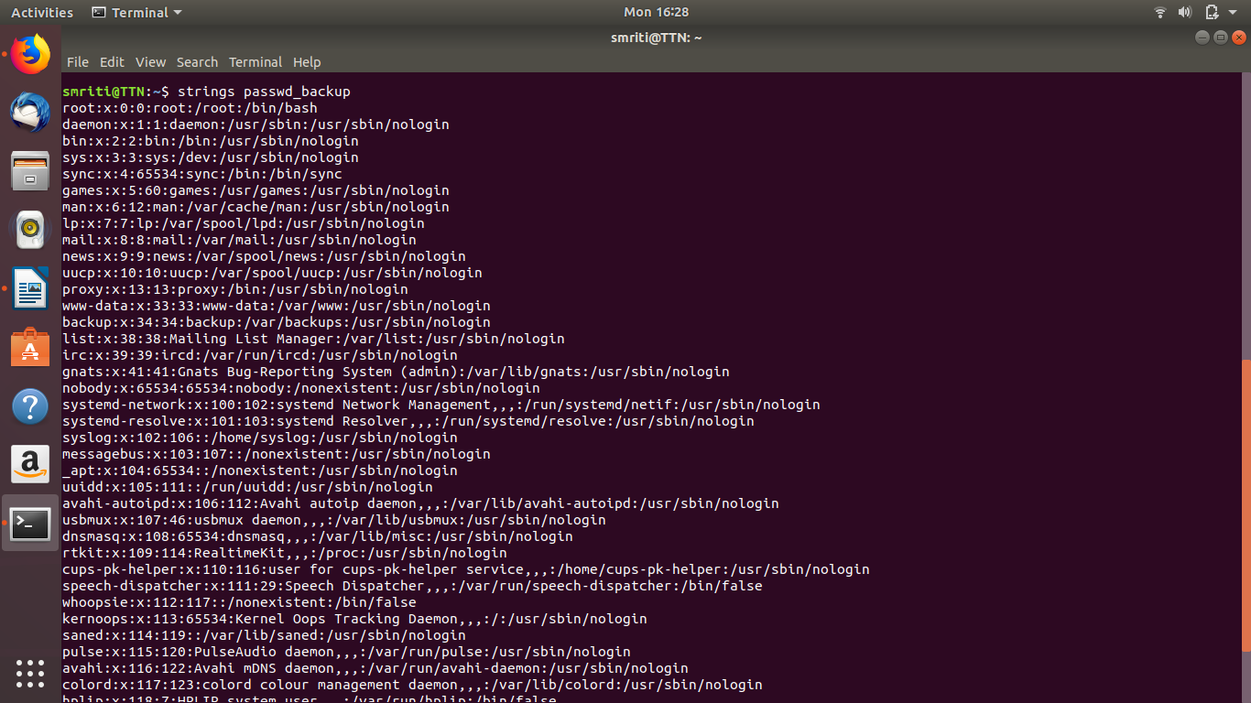
Q6. Find out the number of line in password_backup containing "/bin/false".

Output:

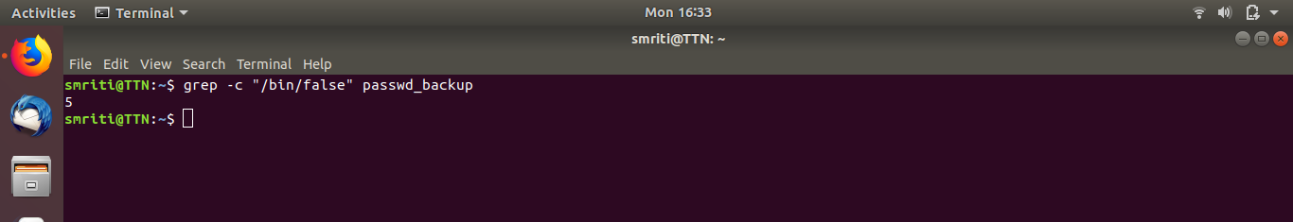
Q7. Get the first 5 lines of a file “password_backup” and Redirect the output of the above commands into file "output".

Output:

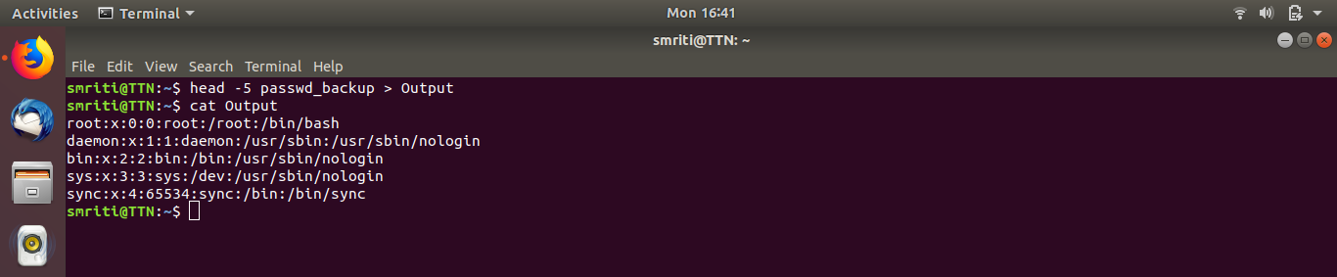

Q8. Create a "test" user,create its password and find out its uid and gid.

Output:

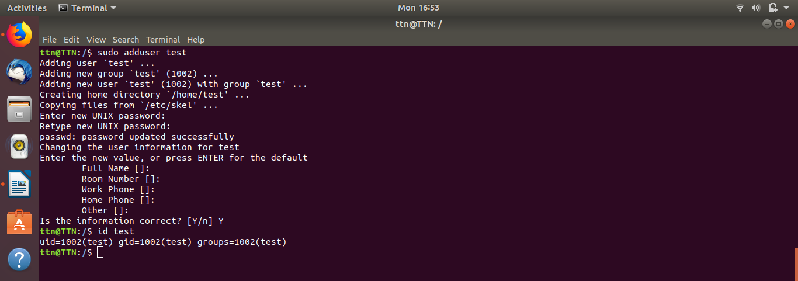

Q9. Change the timestamp of emptyFile1,emptyFile2 which are exist in dir2.

Output:

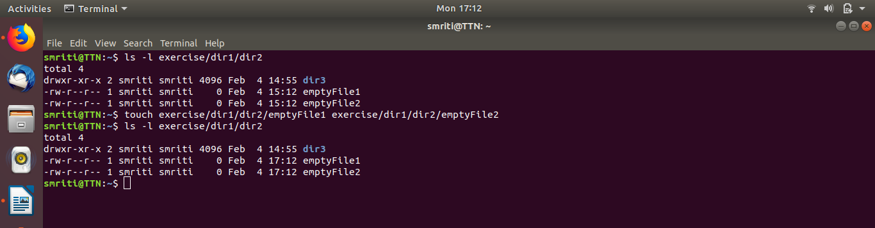

Q10. Login as test user and edit the "output" file created above. Since the permission wont allow you to save the changes. Configure such that test user can edit it.
- Add group owner of the "output" file as the secondary group of testuser and check/change the "output" file permission if it is editable by group. Once done revert the changes
- Make the file editable to the world so that test user can access it. Revert the changes after verification
- Change the ownership to edit the file.

Output:
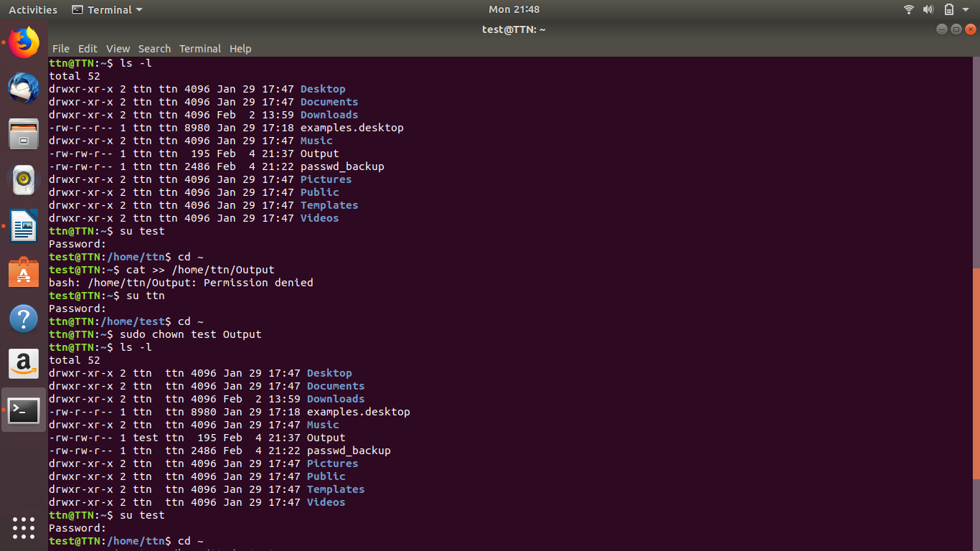
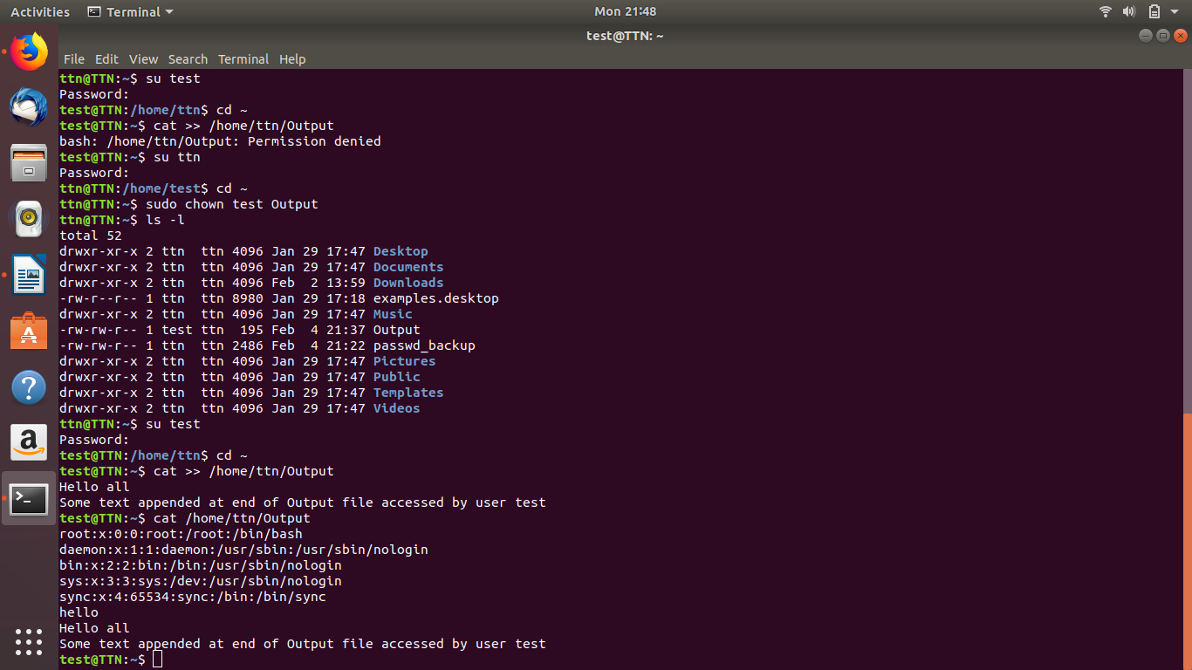
Output 1:
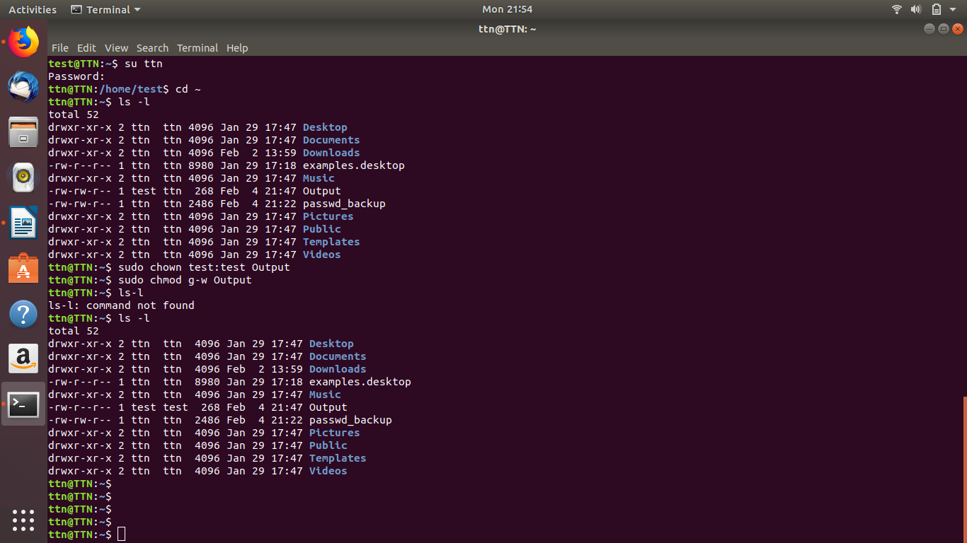
Output 2:
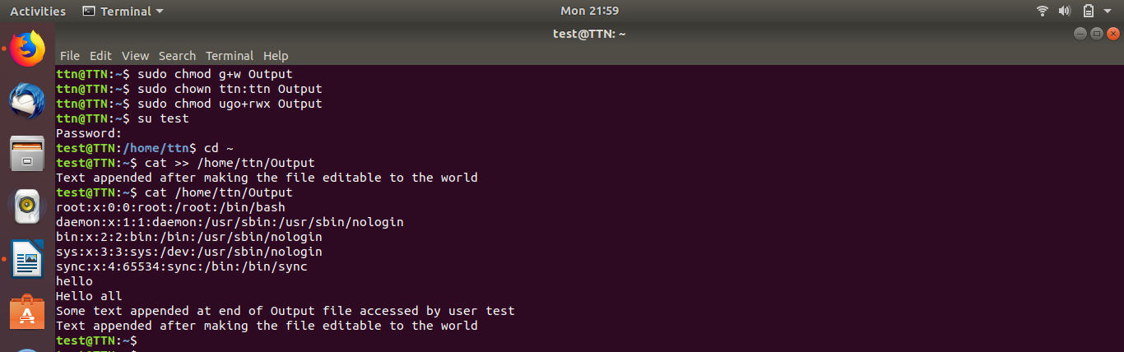
Output 3:
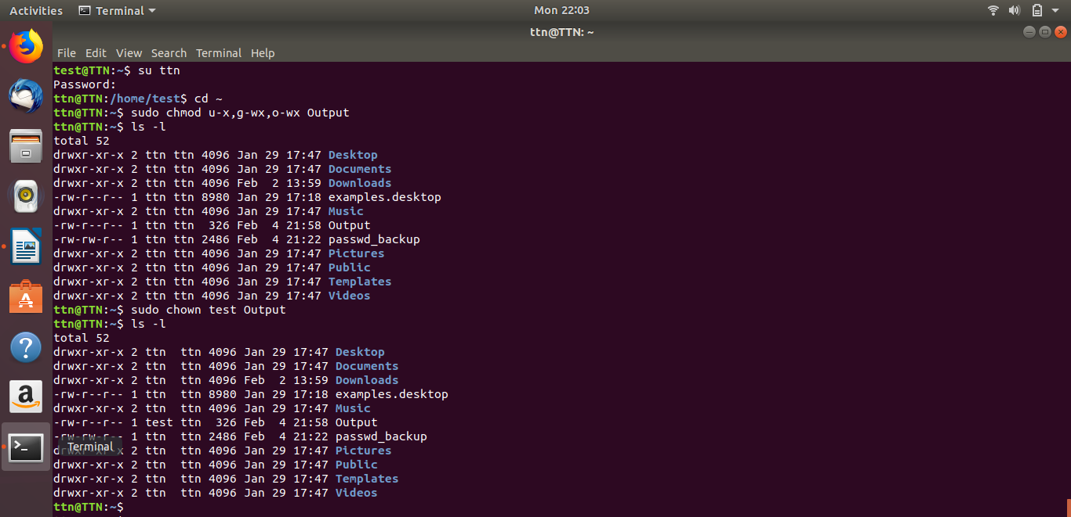
Q11.

