Exercise 1

Q1. Create a class Author with instance variables firstName, lastName and age.
Q2. Perform CRUD operation for Author class.

Author
package exercise1;
import org.hibernate.Session;
import org.hibernate.SessionFactory;
import org.hibernate.cfg.Configuration;
import javax.persistence.Entity;
import javax.persistence.Id;

@Entity
public class Author {
@Id
int id;
private String fname;
private String lname;
private int age;
public int getId() {
return id;
}
public void setId(int id) {
this.id = id;
}
public String getFname() {
return fname;
}
public void setFname(String fname) {
this.fname = fname;
}
public String getLname() {
return lname;
}
public void setLname(String lname) {
this.lname = lname;
}
public int getAge() {
return age;
}
public void setAge(int age) {
this.age = age;
}
@Override
public String toString() {
return "Author{" +
"id=" + id +
", fname='" + fname + '\'' +
", lname='" + lname + '\'' +
", age=" + age +
'}';
}
void insert(){
Author author = new Author();
author.setId(1);
author.setFname("Rohan");
author.setLname("Verma");
author.setAge(43);
SessionFactory sessionFactory = new Configuration().configure().buildSessionFactory();
Session session = sessionFactory.openSession();
session.beginTransaction();
session.save(author);
session.getTransaction().commit();
session.close();
}
void read(){
SessionFactory sessionFactory = new Configuration().configure().buildSessionFactory();
Session session = sessionFactory.openSession();
session.beginTransaction();
Author author = session.get(Author.class,1);
session.getTransaction().commit();
session.close();
System.out.println(author);
}
void update(){
SessionFactory sessionFactory = new Configuration().configure().buildSessionFactory();
Session session = sessionFactory.openSession();
session.beginTransaction();
Author author = session.get(Author.class,1);
author.setFname("Adhiraj");
session.update(author);
session.getTransaction().commit();
session.close();
}
void delete(){
SessionFactory sessionFactory = new Configuration().configure().buildSessionFactory();
Session session = sessionFactory.openSession();
session.beginTransaction();
Author author = session.get(Author.class,1);
session.delete(author);
session.getTransaction().commit();
session.close();
System.out.println("Deleted: "+author);
}
}
Main
package exercise1;
public class Main {
public static void main(String[] args) {
Author author = new Author();
//author.insert();
// author.read();
//author.update();
author.delete();
}
}

hibernate.cfg.xml
<?xml version="1.0" encoding="UTF-8"?>
<!DOCTYPE hibernate-configuration PUBLIC "-//Hibernate/Hibernate Configuration DTD 3.0//EN"
"http://hibernate.sourceforge.net/hibernate-configuration-3.0.dtd">
<hibernate-configuration>
<session-factory>
<!--Database connection settings -->
<property name="hibernate.connection.driver_class">com.mysql.jdbc.Driver</property>
<property name="hibernate.connection.url">jdbc:mysql://localhost:3306/SpringDemo</property>
<property name="hibernate.connection.username">root</property>
<property name="hibernate.connection.password">K96sanjeev@</property>
<!--JDBC connection pool-->
<property name="connection.pool_size">10</property>
<!-- SQL Dialect-->
<property name="hibernate.dialect">org.hibernate.dialect.MySQLDialect</property>
<!--echo all executed SQL-->
<property name="show_sql">true</property>
<!--drop or re-create database schema at startup-->
<!--<property name="hbm2ddl.auto">create</property>-->
<property name="hbm2ddl.auto">update</property>
<!--Annotated entity class-->
<mapping class="exercise1.Author"/>
</session-factory>
</hibernate-configuration>

Exercise 2
Q3. Use hbm2ddl create to introduce Date of Birth for Author.
Author
package exercise2;
import org.hibernate.Session;
import org.hibernate.SessionFactory;
import org.hibernate.cfg.Configuration;
import javax.persistence.Entity;
import javax.persistence.Id;

@Entity
public class Author {
@Id
int id;
private String fname;
private String lname;
private int age;
private String dob;
public Author(int id, String fname, String lname, int age, String dob) {
this.id = id;
this.fname = fname;
this.lname = lname;
this.age = age;
this.dob = dob;
}
@Override
public String toString() {
return "Author{" +
"id=" + id +
", fname='" + fname + '\'' +
", lname='" + lname + '\'' +
", age=" + age +
", dob='" + dob + '\'' +
'}';
}
public static void main(String[] args) {
Author author = new Author(1, "Renuka", "Anand", 34, "1984-11-23");
SessionFactory sessionFactory = new Configuration().configure().buildSessionFactory();
Session session = sessionFactory.openSession();
session.beginTransaction();
session.save(author);
session.getTransaction().commit();
session.close();
}
}
hibernate.cfg.xml
<?xml version="1.0" encoding="UTF-8"?>
<!DOCTYPE hibernate-configuration PUBLIC "-//Hibernate/Hibernate Configuration DTD 3.0//EN"
"http://hibernate.sourceforge.net/hibernate-configuration-3.0.dtd">
<hibernate-configuration>
<session-factory>
<!--Database connection settings -->
<property name="hibernate.connection.driver_class">com.mysql.jdbc.Driver</property>
<property name="hibernate.connection.url">jdbc:mysql://localhost:3306/SpringDemo</property>
<property name="hibernate.connection.username">root</property>
<property name="hibernate.connection.password">K96sanjeev@</property>
<!--JDBC connection pool-->
<property name="connection.pool_size">10</property>
<!-- SQL Dialect-->
<property name="hibernate.dialect">org.hibernate.dialect.MySQLDialect</property>
<!--echo all executed SQL-->
<property name="show_sql">true</property>
<!--drop or re-create database schema at startup-->
<property name="hbm2ddl.auto">create</property>
<!-- <property name="hbm2ddl.auto">update</property>-->
<!--Annotated entity class-->
<mapping class="exercise1.Author"/>
<mapping class="exercise2.Author"/>
</session-factory>
</hibernate-configuration>

Q4. Use hbm2dll update to insert at least 4 records for Author.
UpdateAuthor
package exercise2;
import org.hibernate.Session;
import org.hibernate.SessionFactory;
import org.hibernate.cfg.Configuration;

public class UpdateAuthor {
public static void main(String[] args) {
Author author1 = new Author(2,"Rohan","Verma",48,"1970-11-23");
Author author2 = new Author(3,"Sohan","Sharma",42,"1976-11-23");
Author author3 = new Author(4,"Mohan","Choudhary",52,"1966-11-23");
Author author4 = new Author(5,"Aman","Kumar",34,"1988-11-23");
SessionFactory sessionFactory = new Configuration().configure().buildSessionFactory();
Session session = sessionFactory.openSession();
session.beginTransaction();
session.save(author1);
session.save(author2);
session.save(author3);
session.save(author4);
session.getTransaction().commit();
session.close();
}
}

hibernate.cfg.xml
<?xml version="1.0" encoding="UTF-8"?>
<!DOCTYPE hibernate-configuration PUBLIC "-//Hibernate/Hibernate Configuration DTD 3.0//EN"
"http://hibernate.sourceforge.net/hibernate-configuration-3.0.dtd">
<hibernate-configuration>
<session-factory>
<!--Database connection settings -->
<property name="hibernate.connection.driver_class">com.mysql.jdbc.Driver</property>
<property name="hibernate.connection.url">jdbc:mysql://localhost:3306/SpringDemo</property>
<property name="hibernate.connection.username">root</property>
<property name="hibernate.connection.password">K96sanjeev@</property>
<!--JDBC connection pool-->
<property name="connection.pool_size">10</property>
<!-- SQL Dialect-->
<property name="hibernate.dialect">org.hibernate.dialect.MySQLDialect</property>
<!--echo all executed SQL-->
<property name="show_sql">true</property>
<!--drop or re-create database schema at startup-->
<!-- <property name="hbm2ddl.auto">create</property>-->
<property name="hbm2ddl.auto">update</property>
<!--Annotated entity class-->
<mapping class="exercise1.Author"/>
<mapping class="exercise2.Author"/>
</session-factory>
</hibernate-configuration>

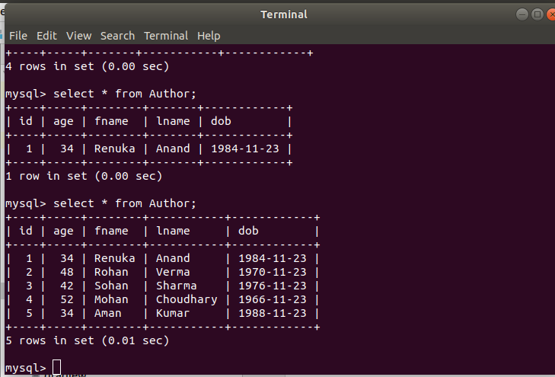

Exercise 3
Q5. Perform hbm2dll create-drop by closing session factory.
package exercise3;
import org.hibernate.Session;
import org.hibernate.SessionFactory;
import org.hibernate.cfg.Configuration;
import javax.persistence.Entity;
import javax.persistence.Id;

public class Main {
public static void main(String[] args) {
Author author = new Author(1, "Renuka", "Anand", 34, "1984-11-23");
SessionFactory sessionFactory = new Configuration().configure().buildSessionFactory();
Session session = sessionFactory.openSession();
session.beginTransaction();
session.save(author);
session.getTransaction().commit();
session.close();
sessionFactory.close();
}
}

@Entity
class Author {
@Id
int id;
private String fname;
private String lname;
private int age;
private String dob;
public Author(int id, String fname, String lname, int age, String dob) {
this.id = id;
this.fname = fname;
this.lname = lname;
this.age = age;
this.dob = dob;
}
@Override
public String toString() {
return "Author{" +
"id=" + id +
", fname='" + fname + '\'' +
", lname='" + lname + '\'' +
", age=" + age +
", dob='" + dob + '\'' +
'}';
}
}

hibernate.cfg.xml
<?xml version="1.0" encoding="UTF-8"?>
<!DOCTYPE hibernate-configuration PUBLIC "-//Hibernate/Hibernate Configuration DTD 3.0//EN"
"http://hibernate.sourceforge.net/hibernate-configuration-3.0.dtd">
<hibernate-configuration>
<session-factory>
<!--Database connection settings -->
<property name="hibernate.connection.driver_class">com.mysql.jdbc.Driver</property>
<property name="hibernate.connection.url">jdbc:mysql://localhost:3306/SpringDemo</property>
<property name="hibernate.connection.username">root</property>
<property name="hibernate.connection.password">K96sanjeev@</property>
<!--JDBC connection pool-->
<property name="connection.pool_size">10</property>
<!-- SQL Dialect-->
<property name="hibernate.dialect">org.hibernate.dialect.MySQLDialect</property>
<!--echo all executed SQL-->
<property name="show_sql">true</property>
<!--drop or re-create database schema at startup-->
<property name="hbm2ddl.auto">create-drop</property>
<!--Annotated entity class-->
<mapping class="exercise1.Author"/>
<mapping class="exercise2.Author"/>
<mapping class="exercise.Author"/>
</session-factory>
</hibernate-configuration>

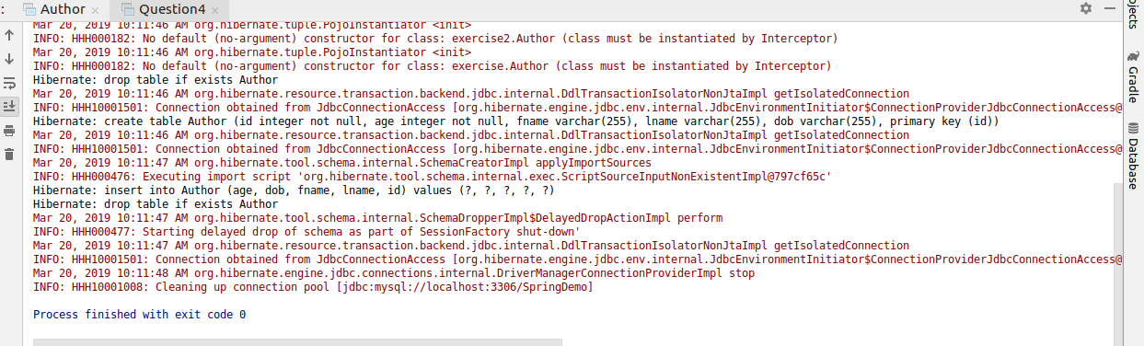

Exercise 4
Q6. Rename all the fields using column annotation.
package exercise4;
import org.hibernate.Session;
import org.hibernate.SessionFactory;
import org.hibernate.cfg.Configuration;
import javax.persistence.Column;
import javax.persistence.Entity;
import javax.persistence.Id;

@Entity
class Author {
@Id
@Column(name = "Id")
int id;
@Column(name = "First_Name")
private String fname;
@Column(name = "Last_Name")
private String lname;
@Column(name = "Age")
private int age;
@Column(name = "Date_of_Birth")
private String dob;
public int getId() {
return id;
}
public void setId(int id) {
this.id = id;
}
public String getFname() {
return fname;
}
public void setFname(String fname) {
this.fname = fname;
}
public String getLname() {
return lname;
}
public void setLname(String lname) {
this.lname = lname;
}
public int getAge() {
return age;
}
public void setAge(int age) {
this.age = age;
}
public String getDob() {
return dob;
}
public void setDob(String dob) {
this.dob = dob;
}
}

class Main {
public static void main(String[] args) {
Author author = new Author();
author.setId(1);
author.setFname("Ankur");
author.setLname("Kumar");
author.setAge(23);
author.setDob("1996-12-23");
SessionFactory sessionFactory = new Configuration().configure().buildSessionFactory();
Session session = sessionFactory.openSession();
session.beginTransaction();
session.save(author);
session.getTransaction().commit();
session.close();
sessionFactory.close();
}
}
hibernate.cfg.xml
<?xml version="1.0" encoding="UTF-8"?>
<!DOCTYPE hibernate-configuration PUBLIC "-//Hibernate/Hibernate Configuration DTD 3.0//EN"
"http://hibernate.sourceforge.net/hibernate-configuration-3.0.dtd">
<hibernate-configuration>
<session-factory>
<!--Database connection settings -->
<property name="hibernate.connection.driver_class">com.mysql.jdbc.Driver</property>
<property name="hibernate.connection.url">jdbc:mysql://localhost:3306/SpringDemo</property>
<property name="hibernate.connection.username">root</property>
<property name="hibernate.connection.password">K96sanjeev@</property>
<!--JDBC connection pool-->
<property name="connection.pool_size">10</property>
<!-- SQL Dialect-->
<property name="hibernate.dialect">org.hibernate.dialect.MySQLDialect</property>
<!--echo all executed SQL-->
<property name="show_sql">true</property>
<!--drop or re-create database schema at startup-->
<property name="hbm2ddl.auto">create</property>
<!--Annotated entity class-->
<mapping class="exercise4.Author"/>
</session-factory>
</hibernate-configuration>

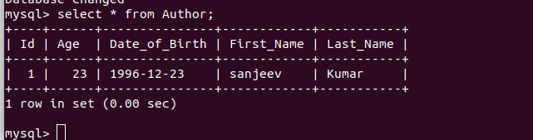

Q7. Mark lastName as @Transient.
package exercise4;
import org.hibernate.Session;
import org.hibernate.SessionFactory;
import org.hibernate.cfg.Configuration;
import javax.persistence.Column;
import javax.persistence.Entity;
import javax.persistence.Id;
import javax.persistence.Transient;

@Entity
class Author {
@Id
@Column(name = "Id")
int id;
@Column(name = "First_Name")
private String fname;
@Transient
@Column(name = "Last_Name")
private String lname;
@Column(name = "Age")
private int age;
@Column(name = "Date_of_Birth")
private String dob;
public int getId() {
return id;
}
public void setId(int id) {
this.id = id;
}
public String getFname() {
return fname;
}
public void setFname(String fname) {
this.fname = fname;
}
public String getLname() {
return lname;
}
public void setLname(String lname) {
this.lname = lname;
}
public int getAge() {
return age;
}
public void setAge(int age) {
this.age = age;
}
public String getDob() {
return dob;
}
public void setDob(String dob) {
this.dob = dob;
}
}
class Main {
public static void main(String[] args) {
Author author = new Author();
author.setId(1);
author.setFname("Ankur");
author.setLname("Kumar");
author.setAge(23);
author.setDob("1996-12-23");
SessionFactory sessionFactory = new Configuration().configure().buildSessionFactory();
Session session = sessionFactory.openSession();
session.beginTransaction();
session.save(author);
session.getTransaction().commit();
session.close();
sessionFactory.close();
}
}
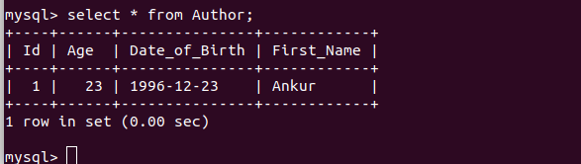

Q8. Use @Temporal for date of birth of Author.
package exercise4;
import org.hibernate.Session;
import org.hibernate.SessionFactory;
import org.hibernate.cfg.Configuration;
import javax.persistence.*;
import java.util.Date;

@Entity
class Author {
@Id
@Column(name = "Id")
int id;
@Column(name = "First_Name")
private String fname;
@Column(name = "Last_Name")
//@Transient
private String lname;
@Column(name = "Age")
private int age;
@Temporal(TemporalType.DATE)
@Column(name = "Date_of_Birth")
private Date dob;
public int getId() {
return id;
}
public void setId(int id) {
this.id = id;
}
public String getFname() {
return fname;
}
public void setFname(String fname) {
this.fname = fname;
}
public String getLname() {
return lname;
}
public void setLname(String lname) {
this.lname = lname;
}
public int getAge() {
return age;
}
public void setAge(int age) {
this.age = age;
}
public Date getDob() {
return dob;
}
public void setDob(Date dob) {
this.dob = dob;
}
}
class Main {
public static void main(String[] args) {
Author author = new Author();
author.setId(1);
author.setFname("Ankur");
author.setLname("Kumar");
author.setAge(23);
author.setDob(new Date());
SessionFactory sessionFactory = new Configuration().configure().buildSessionFactory();
Session session = sessionFactory.openSession();
session.beginTransaction();
session.save(author);
session.getTransaction().commit();
session.close();
sessionFactory.close();
}
}

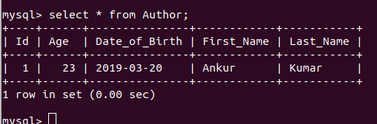

Q9. Generate Id for Author Using IDENTITY and TABLE starategy.
Using IDENTITY
package exercise4;
import org.hibernate.Session;
import org.hibernate.SessionFactory;
import org.hibernate.cfg.Configuration;
import javax.persistence.*;
import java.util.Date;

@Entity
class Author {
@Id
@GeneratedValue(strategy = GenerationType.IDENTITY)
//@GeneratedValue(strategy = GenerationType.TABLE)
@Column(name = "Id")
int id;
@Column(name = "First_Name")
private String fname;
@Column(name = "Last_Name")
//@Transient
private String lname;
@Column(name = "Age")
private int age;
@Temporal(TemporalType.DATE)
@Column(name = "Date_of_Birth")
private Date dob;
public int getId() {
return id;
}
public void setId(int id) {
this.id = id;
}
public String getFname() {
return fname;
}
public void setFname(String fname) {
this.fname = fname;
}
public String getLname() {
return lname;
}
public void setLname(String lname) {
this.lname = lname;
}
public int getAge() {
return age;
}
public void setAge(int age) {
this.age = age;
}
public Date getDob() {
return dob;
}
public void setDob(Date dob) {
this.dob = dob;
}
}
class Main {
public static void main(String[] args) {
Author author = new Author();
author.setFname("Ankur");
author.setLname("Kumar");
author.setAge(23);
author.setDob(new Date());
Author author1 = new Author();
author1.setFname("Rehman");
author1.setLname("Ahmad");
author1.setAge(29);
author1.setDob(new Date());
SessionFactory sessionFactory = new Configuration().configure().buildSessionFactory();
Session session = sessionFactory.openSession();
session.beginTransaction();
session.save(author);
session.save(author1);
session.getTransaction().commit();
session.close();
sessionFactory.close();
}
}
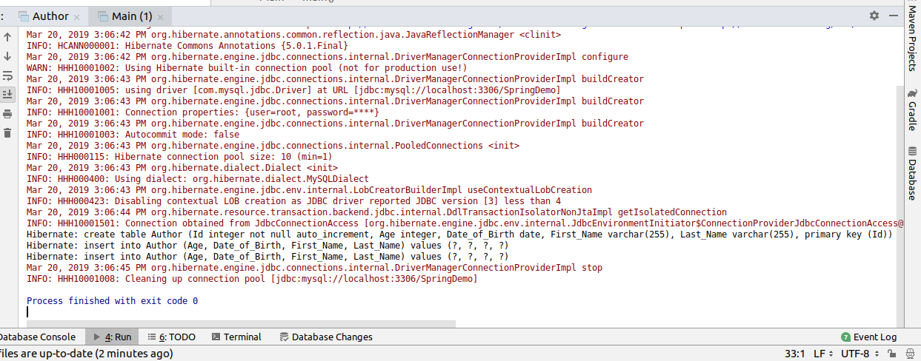
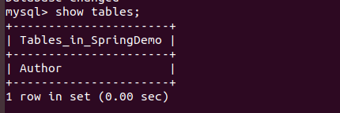

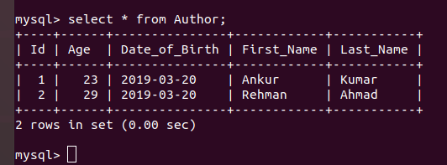

Using TABLE
package exercise4;
import org.hibernate.Session;
import org.hibernate.SessionFactory;
import org.hibernate.cfg.Configuration;
import javax.persistence.*;
import java.util.Date;

@Entity
class Author {
@Id
//@GeneratedValue(strategy = GenerationType.IDENTITY)
@GeneratedValue(strategy = GenerationType.TABLE)
@Column(name = "Id")
int id;
@Column(name = "First_Name")
private String fname;
@Column(name = "Last_Name")
//@Transient
private String lname;
@Column(name = "Age")
private int age;
@Temporal(TemporalType.DATE)
@Column(name = "Date_of_Birth")
private Date dob;
public int getId() {
return id;
}
public void setId(int id) {
this.id = id;
}
public String getFname() {
return fname;
}
public void setFname(String fname) {
this.fname = fname;
}
public String getLname() {
return lname;
}
public void setLname(String lname) {
this.lname = lname;
}
public int getAge() {
return age;
}
public void setAge(int age) {
this.age = age;
}
public Date getDob() {
return dob;
}
public void setDob(Date dob) {
this.dob = dob;
}
}
class Main {
public static void main(String[] args) {
Author author = new Author();
author.setFname("Ankur");
author.setLname("Kumar");
author.setAge(23);
author.setDob(new Date());
Author author1 = new Author();
author1.setFname("Rehman");
author1.setLname("Ahmad");
author1.setAge(29);
author1.setDob(new Date());
SessionFactory sessionFactory = new Configuration().configure().buildSessionFactory();
Session session = sessionFactory.openSession();
session.beginTransaction();
session.save(author);
session.save(author1);
session.getTransaction().commit();
session.close();
sessionFactory.close();
}
}
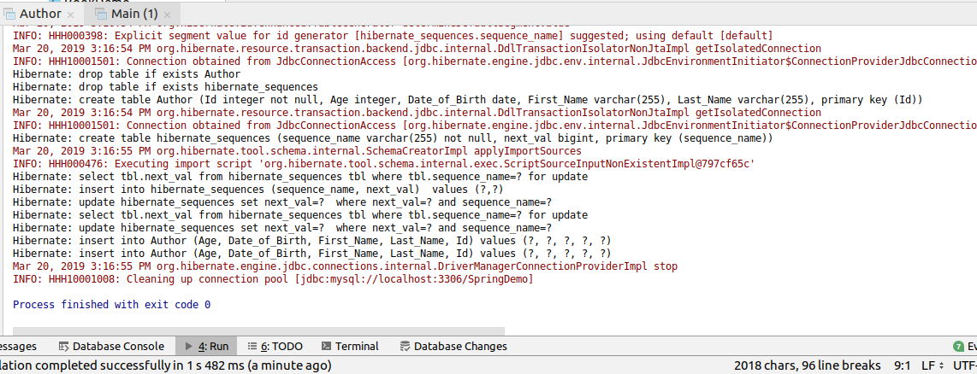
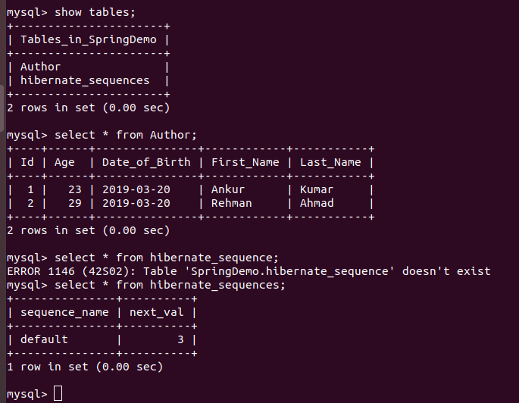

Exercise 5
Q10. Create a class Address for Author with instance variables streetNumber, location, State.
Q11. Create instance variable of Address class inside Author class and save it as embedded object.
Address
package exercise5;
import javax.persistence.Embeddable;
import javax.persistence.Embedded;

@Embeddable
public class Address {
String streetNumber;
String location;
String State;
public String getStreetNumber() {
return streetNumber;
}
public void setStreetNumber(String streetNumber) {
this.streetNumber = streetNumber;
}
public String getLocation() {
return location;
}
public void setLocation(String location) {
this.location = location;
}
public String getState() {
return State;
}
public void setState(String state) {
State = state;
}
}

Author
package exercise5;
import javax.persistence.*;
import java.util.Date;

@Entity
public class Author {
@Id
@GeneratedValue(strategy = GenerationType.IDENTITY)
@Column(name = "Id")
int id;
@Column(name = "First_Name")
private String fname;
@Column(name = "Last_Name")
private String lname;
@Column(name = "Age")
private int age;
@Temporal(TemporalType.DATE)
@Column(name = "Date_of_Birth")
private Date dob;
@Embedded
Address address;

public int getId() {
return id;
}
public void setId(int id) {
this.id = id;
}
public String getFname() {
return fname;
}
public void setFname(String fname) {
this.fname = fname;
}
public String getLname() {
return lname;
}
public void setLname(String lname) {
this.lname = lname;
}
public int getAge() {
return age;
}
public void setAge(int age) {
this.age = age;
}
public Date getDob() {
return dob;
}
public void setDob(Date dob) {
this.dob = dob;
}
public Address getAddress() {
return address;
}
public void setAddress(Address address) {
this.address = address;
}
}

Main
package exercise5;
import org.hibernate.Session;
import org.hibernate.SessionFactory;
import org.hibernate.cfg.Configuration;
import java.util.Date;
public class Main {
public static void main(String[] args) {
Author author = new Author();
author.setFname("Ankur");
author.setLname("Kumar");
author.setAge(23);
author.setDob(new Date());
Address address = new Address();
address.setStreetNumber("Japanese Park");
address.setLocation("Delhi");
address.setState("Delhi");
author.setAddress(address);
SessionFactory sessionFactory = new Configuration().configure().buildSessionFactory();
Session session = sessionFactory.openSession();
session.beginTransaction();
session.save(author);
session.getTransaction().commit();
session.close();
sessionFactory.close();
}
}

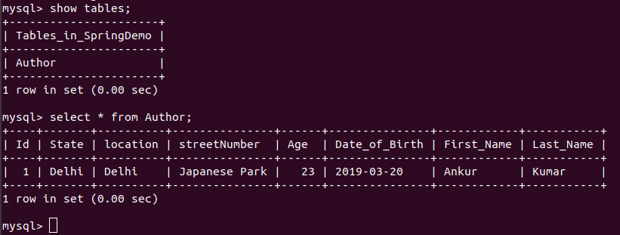

Exercise 6
Q12. Introduce a List of subjects for author.
Q13. Persist 3 subjects for each author.
Author
package exercise6;
import javax.persistence.*;
import java.util.Date;
import java.util.HashSet;
import java.util.Set;

@Entity
public class Author {
@Id
@GeneratedValue(strategy = GenerationType.IDENTITY)
@Column(name = "Id")
int id;
@Column(name = "First_Name")
private String fname;
@Column(name = "Last_Name")
private String lname;
@Column(name = "Age")
private int age;
@Temporal(TemporalType.DATE)
@Column(name = "Date_of_Birth")
private Date dob;
@ElementCollection
Set<String> subjects = new HashSet<>();
public Set<String> getSubjects() {
return subjects;
}
public void setSubjects(Set<String> subjects) {
this.subjects = subjects;
}
public int getId() {
return id;
}
public void setId(int id) {
this.id = id;
}
public String getFname() {
return fname;
}
public void setFname(String fname) {
this.fname = fname;
}
public String getLname() {
return lname;
}
public void setLname(String lname) {
this.lname = lname;
}
public int getAge() {
return age;
}
public void setAge(int age) {
this.age = age;
}
public Date getDob() {
return dob;
}
public void setDob(Date dob) {
this.dob = dob;
}
}
Main
package exercise6;
import org.hibernate.Session;
import org.hibernate.SessionFactory;
import org.hibernate.cfg.Configuration;
import java.util.Date;

public class Main {
public static void main(String[] args) {
Author author1 = new Author();
author1.setFname("Ankur");
author1.setLname("Kumar");
author1.setAge(23);
author1.setDob(new Date());
author1.getSubjects().add("Mathematics");
author1.getSubjects().add("chemistry");
Author author2 = new Author();
author2.setFname("Rehman");
author2.setLname("Ansari");
author2.setAge(33);
author2.setDob(new Date());
author2.getSubjects().add("History");
author2.getSubjects().add("Compuer Organization");
SessionFactory sessionFactory = new Configuration().configure().buildSessionFactory();
Session session = sessionFactory.openSession();
session.beginTransaction();
session.save(author1);
session.save(author2);
session.getTransaction().commit();
session.close();
sessionFactory.close();
}
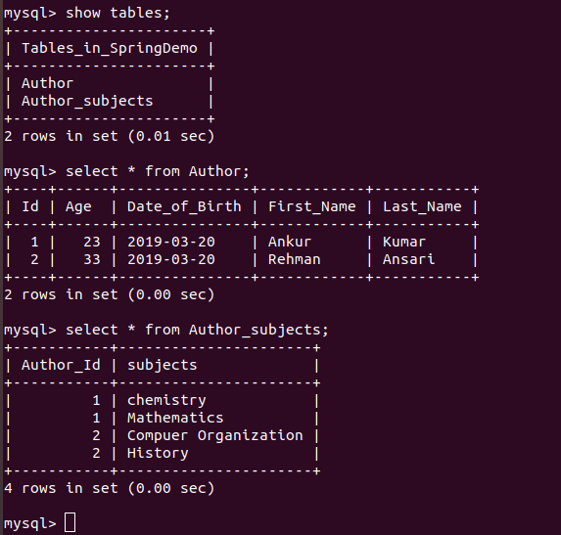
}

Exercise 7
Q14. Create an Entity book with an instance variable bookName.
Q15. Implement One to One mapping between Author and Book.
Book
package exercise7;
import javax.persistence.Entity;
import javax.persistence.GeneratedValue;
import javax.persistence.GenerationType;
import javax.persistence.Id;
@Entity
public class Book {
@Id
@GeneratedValue(strategy = GenerationType.IDENTITY )
private int id;
private String bookName;
public String getBookName() {
return bookName;
}
public void setBookName(String bookName) {
this.bookName = bookName;
}
}
Author
package exercise7;
import javax.persistence.*;
import java.util.Date;

@Entity
public class Author {
@Id
@GeneratedValue(strategy = GenerationType.IDENTITY)
@Column(name = "Id")
int id;
@Column(name = "First_Name")
private String fname;
@Column(name = "Last_Name")
private String lname;
@Column(name = "Age")
private int age;
@Temporal(TemporalType.DATE)
@Column(name = "Date_of_Birth")
private Date dob;
@OneToOne
@JoinColumn(name = "Author_Book_Id")
Book book;
public Book getBook() {
return book;
}
public void setBook(Book book) {
this.book = book;
}
public int getId() {
return id;
}
public void setId(int id) {
this.id = id;
}
public String getFname() {
return fname;
}
public void setFname(String fname) {
this.fname = fname;
}
public String getLname() {
return lname;
}
public void setLname(String lname) {
this.lname = lname;
}
public int getAge() {
return age;
}
public void setAge(int age) {
this.age = age;
}
public Date getDob() {
return dob;
}
public void setDob(Date dob) {
this.dob = dob;
}
}
Main
package exercise7;
import org.hibernate.Session;
import org.hibernate.SessionFactory;
import org.hibernate.cfg.Configuration;
import java.util.Date;

public class Main {
public static void main(String[] args) {
Author author = new Author();
author.setFname("Ankur");
author.setLname("Kumar");
author.setAge(23);
author.setDob(new Date());
Book book = new Book();
book.setBookName("Data Structure");
author.setBook(book);
SessionFactory sessionFactory = new Configuration().configure().buildSessionFactory();
Session session = sessionFactory.openSession();
session.beginTransaction();
session.save(author);
session.save(book);
session.getTransaction().commit();
session.close();
sessionFactory.close();
}
}
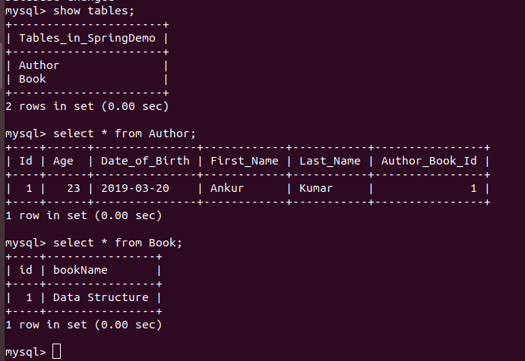

Exercise 8
Q16. Implement One to Many Mapping between Author and Book(Unidirectional, BiDirectional and without additional table ) and implement cascade save.
One to Many(Unidirectional)
Book
package exercise8;
import javax.persistence.Entity;
import javax.persistence.GeneratedValue;
import javax.persistence.GenerationType;
import javax.persistence.Id;

@Entity
public class Book {
@Id
@GeneratedValue(strategy = GenerationType.IDENTITY )
private int id;
private String bookName;
public String getBookName() {
return bookName;
}
public void setBookName(String bookName) {
this.bookName = bookName;
}
}
Author
package exercise8;
import javax.persistence.*;
import java.util.Date;
import java.util.HashSet;
import java.util.Set;

@Entity
public class Author {
@Id
@GeneratedValue(strategy = GenerationType.IDENTITY)
@Column(name = "Id")
int id;
@Column(name = "First_Name")
private String fname;
@Column(name = "Last_Name")
private String lname;
@Column(name = "Age")
private int age;
@Temporal(TemporalType.DATE)
@Column(name = "Date_of_Birth")
private Date dob;
@OneToMany(cascade = CascadeType.PERSIST)
@JoinTable(joinColumns = @JoinColumn(name="Author_Id")
,inverseJoinColumns = @JoinColumn(name = "Book_Id"))
Set<Book> books = new HashSet<>();
public Set<Book> getBooks() {
return books;
}
public void setBooks(Set<Book> books) {
this.books = books;
}
public String getFname() {
return fname;
}
public void setFname(String fname) {
this.fname = fname;
}
public String getLname() {
return lname;
}
public void setLname(String lname) {
this.lname = lname;
}
public int getAge() {
return age;
}
public void setAge(int age) {
this.age = age;
}
public Date getDob() {
return dob;
}
public void setDob(Date dob) {
this.dob = dob;
}
}

Main
package exercise8;
import org.hibernate.Session;
import org.hibernate.SessionFactory;
import org.hibernate.cfg.Configuration;
import java.util.Date;

public class Main {
public static void main(String[] args) {
Author author = new Author();
author.setFname("Anjali");
author.setLname("Sharma");
author.setAge(35);
author.setDob(new Date());
Book book1 = new Book();
book1.setBookName("Data Structure");
Book book2 = new Book();
book2.setBookName("Data Warehouse");
author.getBooks().add(book1);
author.getBooks().add(book2);
SessionFactory sessionFactory=new Configuration().configure().buildSessionFactory();
Session session=sessionFactory.openSession();
session.beginTransaction();
session.persist(author);
session.persist(book1);
session.persist(book2);
session.getTransaction().commit();
session.close();
}
}

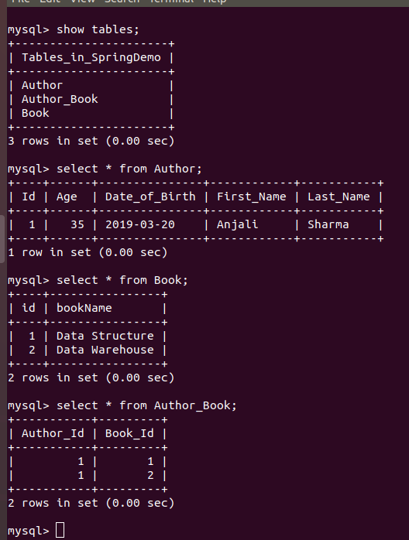

One to Many(BiDirectional)
Book
package exercise8;
import javax.persistence.*;

@Entity
public class Book {
@Id
@GeneratedValue(strategy = GenerationType.IDENTITY )
private int id;
private String bookName;
@ManyToOne
Author author;
public Author getAuthor() {
return author;
}
public void setAuthor(Author author) {
this.author = author;
}
public String getBookName() {
return bookName;
}
public void setBookName(String bookName) {
this.bookName = bookName;
}
}
Author
package exercise8;
import javax.persistence.*;
import java.util.Date;
import java.util.HashSet;
import java.util.Set;
@Entity
public class Author {
@Id
@GeneratedValue(strategy = GenerationType.IDENTITY)
@Column(name = "Id")
int id;
@Column(name = "First_Name")
private String fname;
@Column(name = "Last_Name")
private String lname;
@Column(name = "Age")
private int age;
@Temporal(TemporalType.DATE)
@Column(name = "Date_of_Birth")
private Date dob;
@OneToMany(cascade = CascadeType.PERSIST)
@JoinTable(joinColumns = @JoinColumn(name="Author_Id")
,inverseJoinColumns = @JoinColumn(name = "Book_Id"))
Set<Book> books = new HashSet<>();
public Set<Book> getBooks() {
return books;
}
public void setBooks(Set<Book> books) {
this.books = books;
}
public String getFname() {
return fname;
}
public void setFname(String fname) {
this.fname = fname;
}
public String getLname() {
return lname;
}
public void setLname(String lname) {
this.lname = lname;
}
public int getAge() {
return age;
}
public void setAge(int age) {
this.age = age;
}
public Date getDob() {
return dob;
}
public void setDob(Date dob) {
this.dob = dob;
}
}
Main
package exercise8;
import org.hibernate.Session;
import org.hibernate.SessionFactory;
import org.hibernate.cfg.Configuration;
import java.util.Date;

public class Main {
public static void main(String[] args) {
Author author = new Author();
author.setFname("Anjali");
author.setLname("Sharma");
author.setAge(35);
author.setDob(new Date());
Book book1 = new Book();
book1.setBookName("Data Structure");
book1.setAuthor(author);
Book book2 = new Book();
book2.setBookName("Data Warehouse");
book2.setAuthor(author);
author.getBooks().add(book1);
author.getBooks().add(book2);
SessionFactory sessionFactory=new Configuration().configure().buildSessionFactory();
Session session=sessionFactory.openSession();
session.beginTransaction();
session.persist(author);
session.persist(book1);
session.persist(book2);
session.getTransaction().commit();
session.close();
}
}

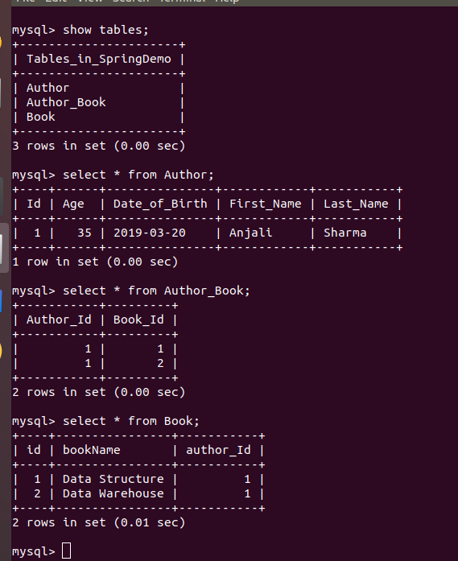

One to Many(without additional table)
Book
package exercise8;
import javax.persistence.*;
@Entity

public class Book {
@Id
@GeneratedValue(strategy = GenerationType.IDENTITY )
private int id;
private String bookName;
@ManyToOne
Author author;
public Author getAuthor() {
return author;
}
public void setAuthor(Author author) {
this.author = author;
}
public String getBookName() {
return bookName;
}
public void setBookName(String bookName) {
this.bookName = bookName;
}
}
Author
package exercise8;
import javax.persistence.*;
import java.util.Date;
import java.util.HashSet;
import java.util.Set;

@Entity
public class Author {
@Id
@GeneratedValue(strategy = GenerationType.IDENTITY)
@Column(name = "Id")
int id;
@Column(name = "First_Name")
private String fname;
@Column(name = "Last_Name")
private String lname;
@Column(name = "Age")
private int age;
@Temporal(TemporalType.DATE)
@Column(name = "Date_of_Birth")
private Date dob;
@OneToMany(cascade = CascadeType.PERSIST, mappedBy = "author")
Set<Book> books = new HashSet<>();
public Set<Book> getBooks() {
return books;
}
public void setBooks(Set<Book> books) {
this.books = books;
}
public String getFname() {
return fname;
}
public void setFname(String fname) {
this.fname = fname;
}
public String getLname() {
return lname;
}
public void setLname(String lname) {
this.lname = lname;
}
public int getAge() {
return age;
}
public void setAge(int age) {
this.age = age;
}
public Date getDob() {
return dob;
}
public void setDob(Date dob) {
this.dob = dob;
}
}
Main
package exercise8;
import org.hibernate.Session;
import org.hibernate.SessionFactory;
import org.hibernate.cfg.Configuration;
import java.util.Date;

public class Main {
public static void main(String[] args) {
Author author = new Author();
author.setFname("Anjali");
author.setLname("Sharma");
author.setAge(35);
author.setDob(new Date());
Book book1 = new Book();
book1.setBookName("Data Structure");
book1.setAuthor(author);
Book book2 = new Book();
book2.setBookName("Data Warehouse");
book2.setAuthor(author);
author.getBooks().add(book1);
author.getBooks().add(book2);
SessionFactory sessionFactory=new Configuration().configure().buildSessionFactory();
Session session=sessionFactory.openSession();
session.beginTransaction();
session.persist(author);
session.persist(book1);
session.persist(book2);
session.getTransaction().commit();
session.close();
}
}

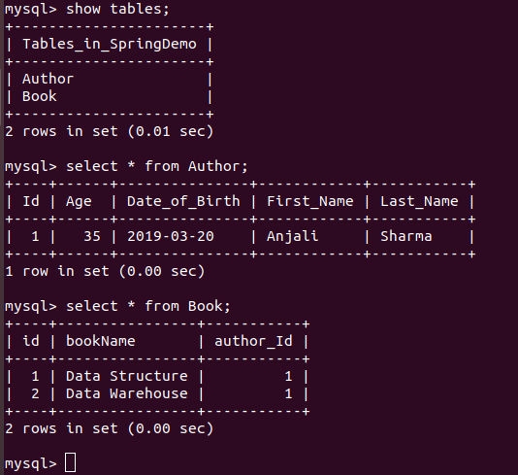

Exercise 9
Q17. Implement Many to Many Mapping between Author and Book.
Author
package exercise9;
import javax.persistence.*;
import java.util.*;

@Entity
public class Author {
@Id
@GeneratedValue(strategy = GenerationType.IDENTITY)
@Column(name = "Id")
int id;
@Column(name = "First_Name")
private String fname;
@Column(name = "Last_Name")
private String lname;
@Column(name = "Age")
private int age;
@Temporal(TemporalType.DATE)
@Column(name = "Date_of_Birth")
private Date dob;
@ManyToMany(cascade = CascadeType.PERSIST)
List<Book> books = new ArrayList<>();
public String getFname() {
return fname;
}
public void setFname(String fname) {
this.fname = fname;
}
public String getLname() {
return lname;
}
public void setLname(String lname) {
this.lname = lname;
}
public int getAge() {
return age;
}
public void setAge(int age) {
this.age = age;
}
public Date getDob() {
return dob;
}
public void setDob(Date dob) {
this.dob = dob;
}
public List<Book> getBooks() {
return books;
}
public void setBooks(List<Book> books) {
this.books = books;
}
}

Book
package exercise9;
import javax.persistence.*;
import java.util.ArrayList;
import java.util.List;

@Entity
public class Book {
@Id
@GeneratedValue(strategy = GenerationType.IDENTITY )
private int id;
private String bookName;
@ManyToMany
List<Author> authors = new ArrayList<>();
public String getBookName() {
return bookName;
}
public void setBookName(String bookName) {
this.bookName = bookName;
}
public List<Author> getAuthors() {
return authors;
}
public void setAuthors(List<Author> authors) {
this.authors = authors;
}
}
Main
package exercise9;
import org.hibernate.Session;
import org.hibernate.SessionFactory;
import org.hibernate.cfg.Configuration;
import java.util.Date;

public class Main {
public static void main(String[] args) {
Author author1 = new Author();
author1.setFname("Aman");
author1.setLname("Choudhary");
author1.setAge(34);
author1.setDob(new Date());
Author author2 = new Author();
author2.setFname("Rajeev");
author2.setLname("Verma");
author2.setAge(45);
author2.setDob(new Date());
Book book1 = new Book();
book1.setBookName("Computer Organization");
Book book2 = new Book();
book2.setBookName("Java Programming");
author1.getBooks().add(book1);
author1.getBooks().add(book2);
book1.getAuthors().add(author1);
book2.getAuthors().add(author1);
author2.getBooks().add(book1);
author2.getBooks().add(book2);
book1.getAuthors().add(author2);
book2.getAuthors().add(author2);
SessionFactory sessionFactory=new Configuration().configure().buildSessionFactory();
Session session=sessionFactory.openSession();
session.beginTransaction();
session.persist(author1);
session.persist(author2);
session.getTransaction().commit();
session.close();
}
}
