Q1. Create a Restful API using Spring Boot for Student.

Student

package com.springboot.SpringBoot.entity;

public class Student {
private int id;
private String name;
public Student(int id, String name) {
this.id = id;
this.name = name;
}
public int getId() {
return id;
}
public void setId(int id) {
this.id = id;
}
public String getName() {
return name;
}
public void setName(String name) {
this.name = name;
}
}
StudentService
package com.springboot.SpringBoot.service;
import com.springboot.SpringBoot.entity.Student;
import org.springframework.stereotype.Service;
import java.util.Arrays;
import java.util.List;
@Service
public class StudentService {
public List<Student> getStudents(){
return Arrays.asList(new Student(12,"Rohan"),
new Student(11,"Parv"),
new Student(13,"Aman"));
}
}
StudentController
package com.springboot.SpringBoot.controller;
import com.springboot.SpringBoot.entity.Student;
import org.springframework.beans.factory.annotation.Autowired;
import org.springframework.web.bind.annotation.GetMapping;
import org.springframework.web.bind.annotation.RestController;
import com.springboot.SpringBoot.service.StudentService;
import java.util.List;
@RestController
public class StudentController {
@Autowired
StudentService studentService;
@GetMapping("/")
public List<Student> getStudents(){
return studentService.getStudents();
}
}
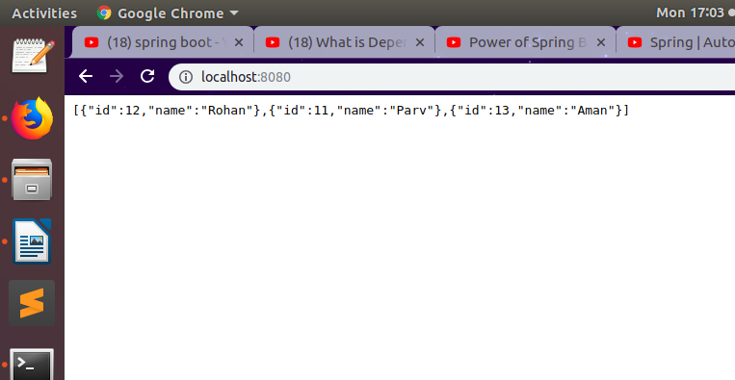

Q2. Run Spring Boot Application with all the three ways.
Step1: Run the Main java class marked with @SpringBootApplication Annotation and contains main method as below:
package com.springboot.SpringBoot;
import org.springframework.boot.SpringApplication;
import org.springframework.boot.autoconfigure.SpringBootApplication;
@SpringBootApplication
public class Application {
public static void main(String[] args) {
SpringApplication.run(Application.class, args);
}
}
Step2: Execute the bootRun Gradle tasks
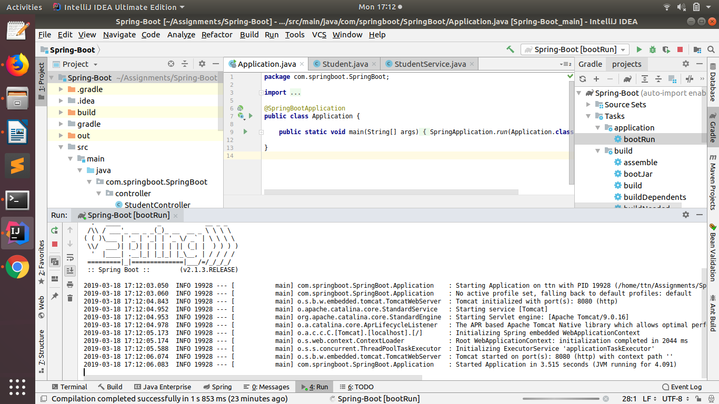
Step3: Create an Executable jar with the help of bootJar Gradle task.
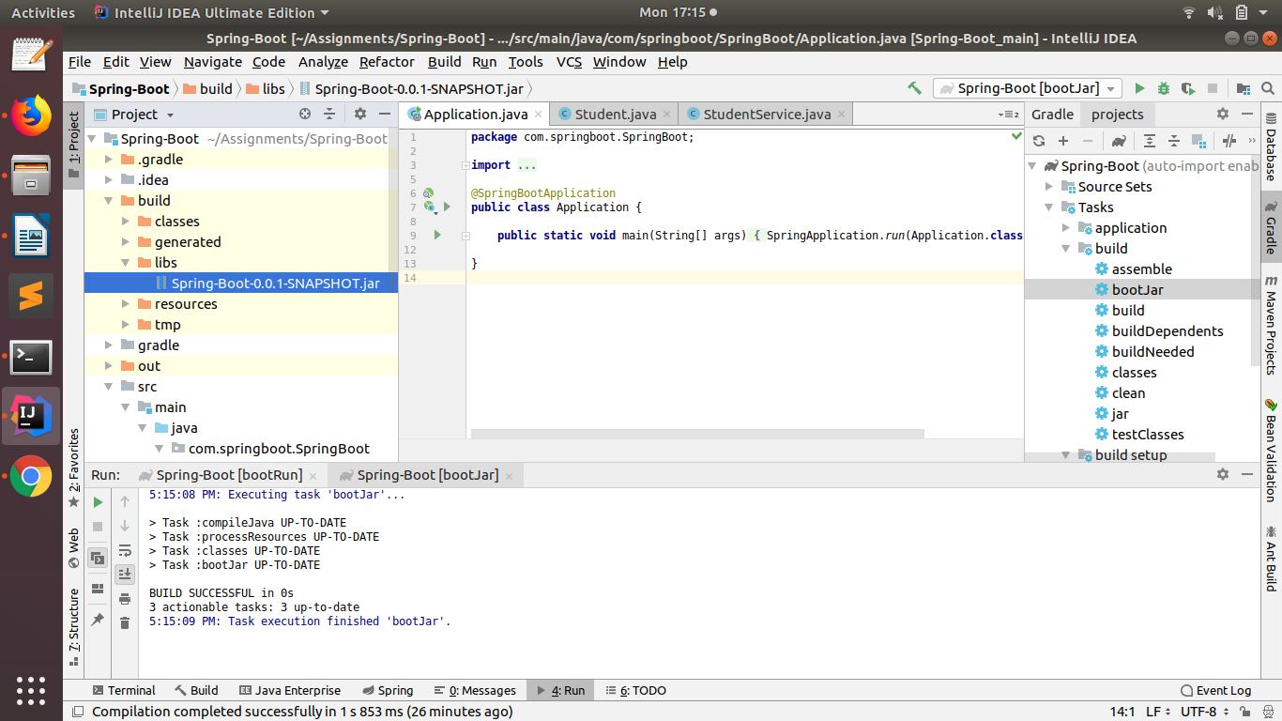
Now execute the jar files using command below:
java -jar basics-0.0.1-SNAPSHOT.jar
java -jar basics-0.0.1-SNAPSHOT.jar --spring.profiles.active=prod
java -jar basics-0.0.1-SNAPSHOT.jar --server.port=8080
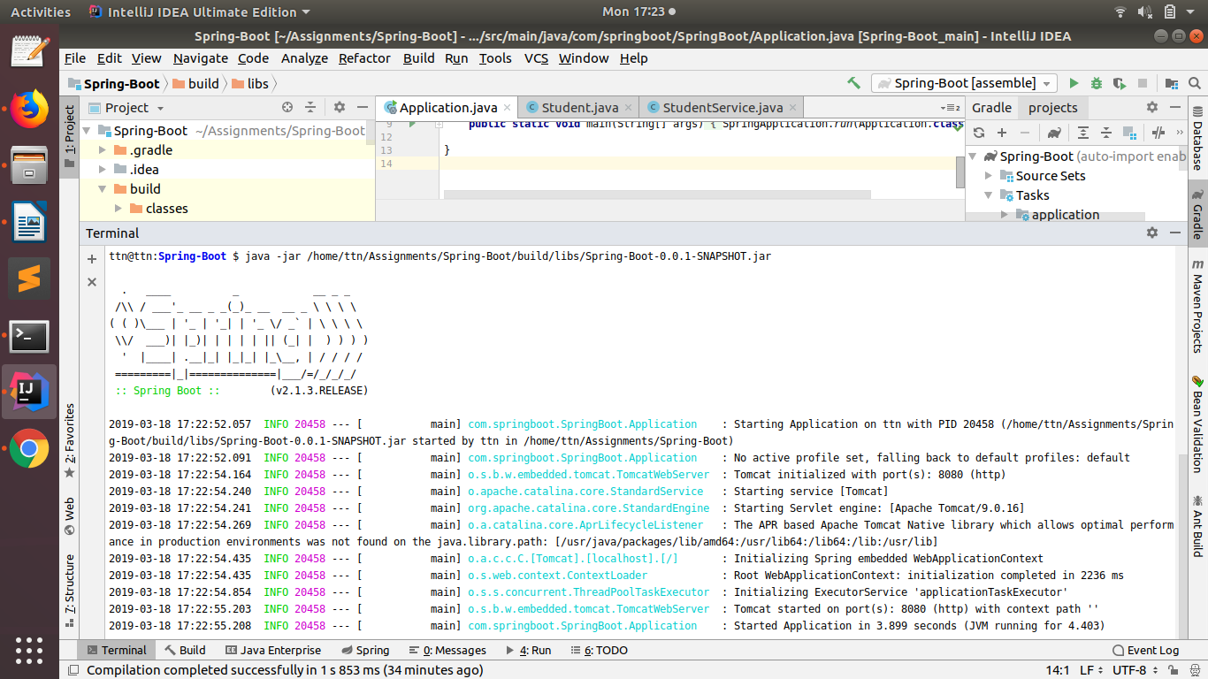

Q3. Create Bean User containing two field username and password with Spring Context File.

User

package com.springboot.SpringBoot.entity;
public class User {
private String username;
private String password;
public User() {
}
public User(String username, String password) {
this.username = username;
this.password = password;
}
public String getUsername() {
return username;
}
public void setUsername(String username) {
this.username = username;
}
public String getPassword() {
return password;
}
public void setPassword(String password) {
this.password = password;
}
@Override
public String toString() {
return "User{" +
"username='" + username + '\'' +
", password='" + password + '\'' +
'}';
}
}

Application

package com.springboot.SpringBoot;
import com.springboot.SpringBoot.entity.User;
import org.springframework.boot.SpringApplication;
import org.springframework.boot.autoconfigure.SpringBootApplication;
import org.springframework.context.annotation.Bean;
@SpringBootApplication
public class Application {
@Bean
public User user(){
return new User("sanjeev","12345");
}
public static void main(String[] args) {
SpringApplication.run(Application.class, args);
}
}
UserController

package com.springboot.SpringBoot.controller;
import com.springboot.SpringBoot.entity.User;
import org.springframework.beans.factory.annotation.Autowired;
import org.springframework.web.bind.annotation.GetMapping;
import org.springframework.web.bind.annotation.RestController;

@RestController
public class UserController {
@Autowired
User user;
@GetMapping("/user")
public String getUser(){
return user.toString();
}
}

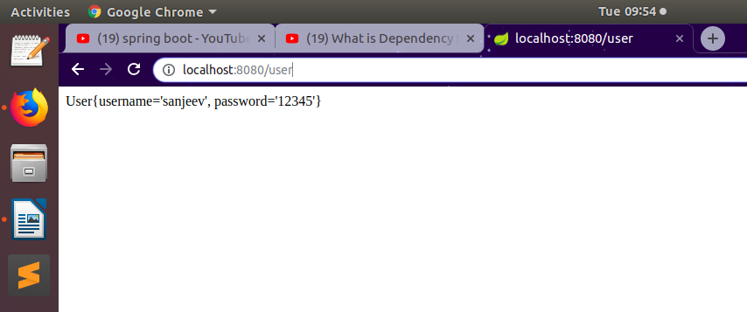

Q4. Create a Bean Database with two fields port and name and Access its values using application.properties.

Database

package com.springboot.SpringBoot.entity;
import org.springframework.beans.factory.annotation.Value;
import org.springframework.stereotype.Component;
@Component
public class Database {
@Value("${server.port}")
int port;
@Value("${server.name}")
String name;
public int getPort() {
return port;
}
public void setPort(int port) {
this.port = port;
}
public String getName() {
return name;
}
public void setName(String name) {
this.name = name;
}
@Override
public String toString() {
return "Database{" +
"port=" + port +
", name='" + name + '\'' +
'}';
}
}
DatabaseController

package com.springboot.SpringBoot.controller;
import com.springboot.SpringBoot.entity.Database;
import org.springframework.beans.factory.annotation.Autowired;
import org.springframework.web.bind.annotation.GetMapping;
import org.springframework.web.bind.annotation.RestController;
@RestController
public class DatabaseController {
@Autowired
Database database;
@GetMapping("/app")
public Database getDatabase(){
return database;
}
}

application-prod.properties

server.port=8080
server.name=mysql

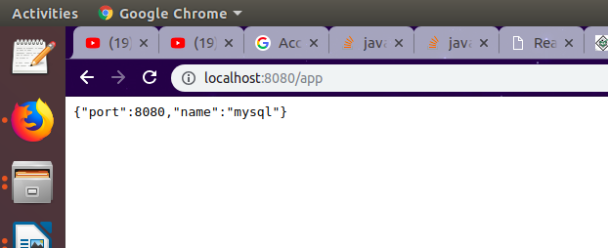

Q5. Configure environment specfic values form Database Bean.

application-prod.properties

server.port=9090
server.name=Tomcat

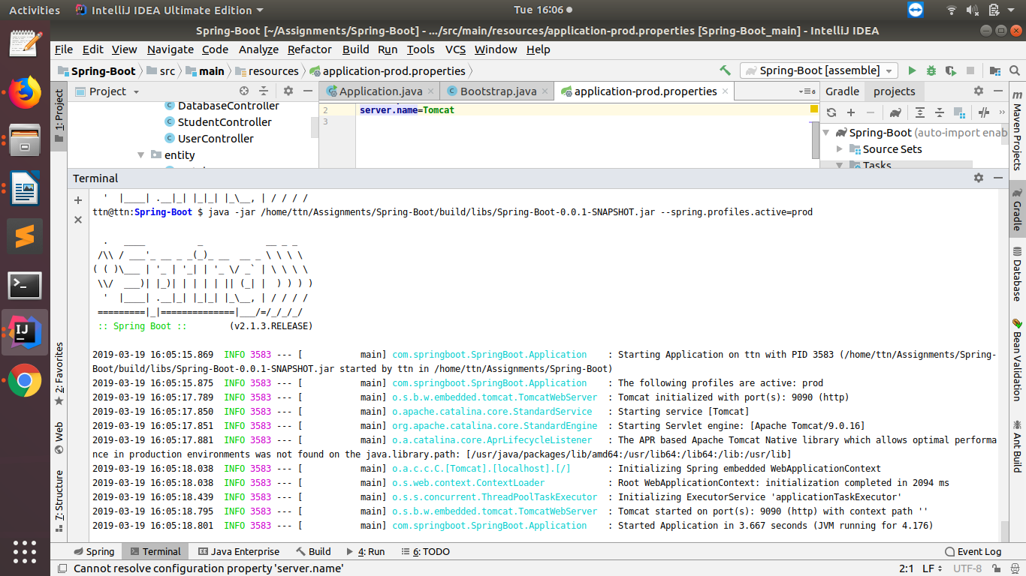
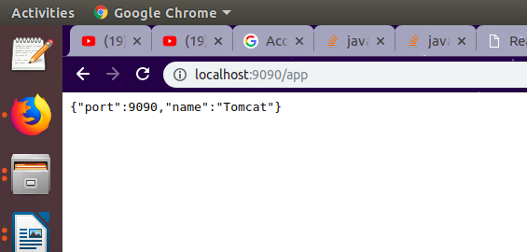

Q6. Apply Logging whereever you feel is necessity

StudentController

package com.springboot.SpringBoot.controller;
import com.springboot.SpringBoot.entity.Student;
import com.springboot.SpringBoot.service.StudentService;
import org.slf4j.Logger;
import org.slf4j.LoggerFactory;
import org.springframework.beans.factory.annotation.Autowired;
import org.springframework.web.bind.annotation.GetMapping;
import org.springframework.web.bind.annotation.RestController;
import java.util.List;
@RestController
public class StudentController {
@Autowired
StudentService studentService;
Logger logger = LoggerFactory.getLogger(StudentController.class);
@GetMapping("/")
public List<Student> getStudents() {
logger.info("An INFO Message");
return studentService.getStudents();
}
}
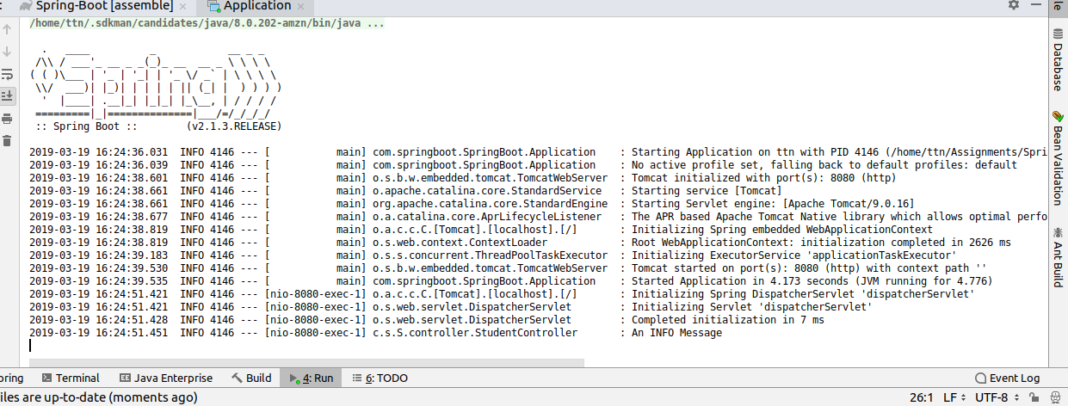

Q7. Bootstrap Data for Student Domain

Student

package com.springboot.SpringBoot.entity;
import javax.persistence.Entity;
import javax.persistence.Id;
@Entity
public class Student {
@Id
private int id;
private String name;
public Student(int id, String name) {
this.id = id;
this.name = name;
}
public int getId() {
return id;
}
public void setId(int id) {
this.id = id;
}
public String getName() {
return name;
}
public void setName(String name) {
this.name = name;
}
}
Bootstrap

package com.springboot.SpringBoot.event;
import org.springframework.boot.context.event.ApplicationStartedEvent;
import org.springframework.context.event.EventListener;
import org.springframework.stereotype.Component;
@Component
public class Bootstrap {
@EventListener(ApplicationStartedEvent.class)
public void init(){
System.out.println("Your Application is up and running");
}
}
application.properties

spring.datasource.url=jdbc:mysql://localhost/SpringDemo
spring.datasource.username=root
spring.datasource.password=K96sanjeev@
spring.datasource.driver-class-name=com.mysql.jdbc.Driver
spring.jpa.hibernate.ddl-auto=create

BookRepository

package com.springboot.SpringBoot.repository;
import com.springboot.SpringBoot.entity.Student;
import org.springframework.data.repository.CrudRepository;
public interface BookRepository extends CrudRepository<Student, Integer> {
}

