Exercise 1:

- Create a class Database with 2 instance variables port and name. Configure Database class bean in spring container through Spring XML. Initialize instance variables using setter method.

- Get the bean of the class from spring container and print the values of the instance variable.

package com.coreSpring;
import org.springframework.context.ApplicationContext;
import org.springframework.context.support.ClassPathXmlApplicationContext;

public class Question1And2 {
public static void main(String[] args) {
ApplicationContext app = new ClassPathXmlApplicationContext("spring-config.xml");
System.out.println(app.getBean("database"));
((ClassPathXmlApplicationContext) app).close();
}
}

class Database {
private int port;
private String name;
public int getPort() {
return port;
}
public void setPort(int port) {
this.port = port;
}
public String getName() {
return name;
}
public void setName(String name) {
this.name = name;
}
@Override
public String toString() {
return "Database{" +
"port=" + port +
", name='" + name + '\'' +
'}';
}
}
spring-config.xml

<bean id="database" class="com.coreSpring.Database">
<property name="port" value="8080"/>
<property name="name" value="oracle"/>
</bean>
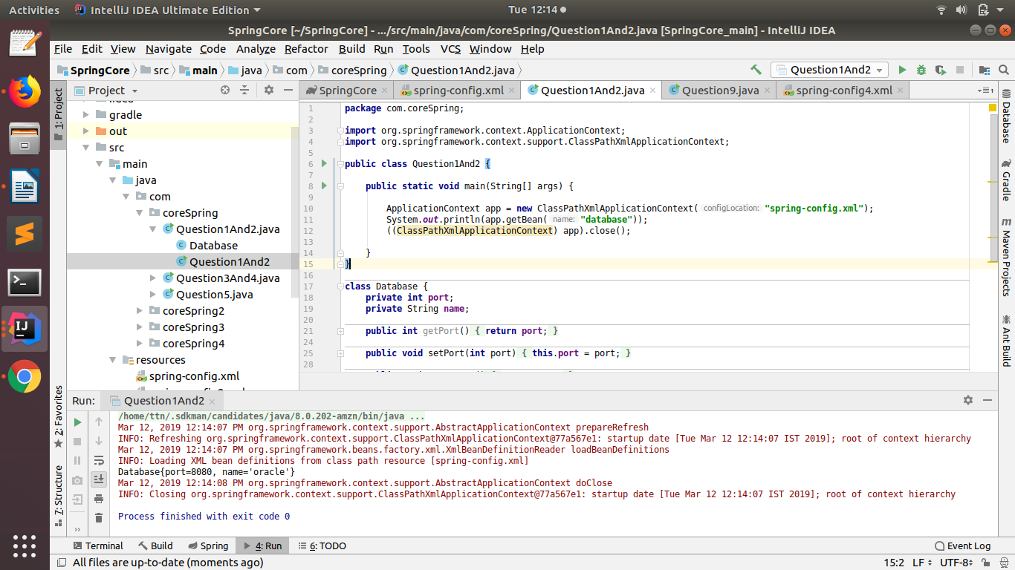

Exercise 2:

- Create a class Restaurant. Create an interface HotDrink with an abstract method prepareHotDrink. Create two classes Tea and ExpressTea which implements HotDrink Class. Create an instance variable of type HotDrink in Restaurant class. Configure Tea and ExpressTea classes beans in Spring XML. create a bean with the name teaRestaurant of type Restaurant which inject Tea object as dependency using setter method.

- Get both the beans and invoke prepareHotDrink method via hotDrink
instance variables. Try inner bean with expressTeaRestaurant.

package com.coreSpring;
import org.springframework.context.ApplicationContext;
import org.springframework.context.support.ClassPathXmlApplicationContext;
interface HotDrink {
String prepareHotDrink();
}
class Restaurant {
private HotDrink hotDrink;
public HotDrink getHotDrink() {
return hotDrink;
}
public void setHotDrink(HotDrink hotDrink) {
this.hotDrink = hotDrink;
}
@Override
public String toString() {
return "Restaurant{" +
"hotDrink=" + hotDrink.prepareHotDrink() +
'}';
}
}
class Tea implements HotDrink {
@Override
public String prepareHotDrink() {
return "Preparing Tea..";
}
}
class ExpressTea implements HotDrink {
@Override
public String prepareHotDrink() {
return "Preparing ExpressTea..";
}
}
public class Question3And4 {
public static void main(String[] args) {
ApplicationContext app = new ClassPathXmlApplicationContext("spring-config.xml");
System.out.println(app.getBean("teaRestaurant"));
System.out.println(app.getBean("teaExpressRestaurant"));
((ClassPathXmlApplicationContext) app).close();
}
}
spring-config.xml

<bean id="teaRestaurant" class="com.coreSpring.Restaurant">
<property name="hotDrink" ref="tea"/>
</bean>
<bean id="tea" class="com.coreSpring.Tea"/>
<bean id="expressTea" class="com.coreSpring.ExpressTea"/>

<bean id="teaExpressRestaurant" class="com.coreSpring.Restaurant">
<property name="hotDrink">
<bean class="com.coreSpring.ExpressTea"/>
</property>
</bean>

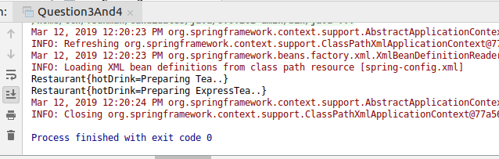

Exercise 3:

Create Class Complex as follows: class complex {List list;
Set set;
Map map;
}
Initialize all the instance variables of the complex class using Spring XML. Give bean name as
complexBean. Get the bean and display the properties.

package com.coreSpring;
import org.springframework.context.ApplicationContext;
import org.springframework.context.support.ClassPathXmlApplicationContext;
import java.util.List;
import java.util.Map;
import java.util.Set;
public class Question5 {
public static void main(String[] args) {
ApplicationContext app = new ClassPathXmlApplicationContext("spring-config.xml");
System.out.println(app.getBean("complex"));
((ClassPathXmlApplicationContext) app).close();
}
}
class Complex{
List list;
Set set;
Map map;
public List getList() {
return list;
}
public void setList(List list) {
this.list = list;
}
public Set getSet() {
return set;
}
public void setSet(Set set) {
this.set = set;
}
public Map getMap() {
return map;
}
public void setMap(Map map) {
this.map = map;
}
@Override
public String toString() {
return "Complex{" +
"list=" + list +
", set=" + set +
", map=" + map +
'}';
}
}

spring-config.xml

<bean class="com.coreSpring.Complex" id="complex" name="complexBean">
<property name="list">
<list>
<value>21</value>
<value>24</value>
<value>28</value>
</list>
</property>
<property name="set">
<set>
<value>10</value>
<value>11</value>
<value>12</value>
</set>
</property>
<property name="map">
<map>
<entry key="A" value="1"/>
<entry key="B" value="2"/>
<entry key="C" value="3"/>
</map>
</property>
</bean>
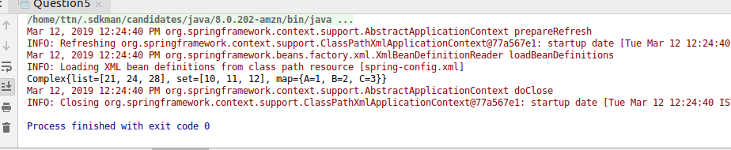

Exercise 4:

Autowire hotDrink in Restaurant with tea bean byName, byType and constructor.

package com.coreSpring2;
import org.springframework.context.ApplicationContext;
import org.springframework.context.support.ClassPathXmlApplicationContext;
interface HotDrink {
String prepareHotDrink();
}
class Restaurant {
private HotDrink hotDrink;
public Restaurant(HotDrink hotDrink) {
this.hotDrink = hotDrink;
}
public Restaurant() {
}
public HotDrink getHotDrink() {
return hotDrink;
}
public void setHotDrink(HotDrink hotDrink) {
this.hotDrink = hotDrink;
}
@Override
public String toString() {
return "Restaurant{" +
"hotDrink=" + hotDrink.prepareHotDrink() +
'}';
}
}
class Tea implements HotDrink {
@Override
public String prepareHotDrink() {
return "Preparing Tea..";
}
}
class ExpressTea implements HotDrink {
@Override
public String prepareHotDrink() {
return "Preparing ExpressTea..";
}
}
public class Question6 {
public static void main(String[] args) {
ApplicationContext app = new ClassPathXmlApplicationContext("spring-config.xml");
System.out.println("Autowire byName");
System.out.println(app.getBean("teaRestaurantByName"));
System.out.println("Autowire byType");
System.out.println(app.getBean("teaRestaurantByType"));
System.out.println("Autowire Constructor");
System.out.println(app.getBean("teaRestaurantConstructor"));
((ClassPathXmlApplicationContext) app).close();
}
}

spring-config.xml

<bean id="teaRestaurantByName" class="com.coreSpring2.Restaurant" autowire="byName">
<!-- <property name="hotDrink" ref="hotDrink"/>-->
</bean>
<bean id="teaRestaurantByType" class="com.coreSpring2.Restaurant" autowire="byType">
<!-- <property name="hotDrink" ref="hotDrink"/>-->
</bean>
<bean id="teaRestaurantConstructor" class="com.coreSpring2.Restaurant" autowire="constructor">
<!-- <constructor-arg name="hotDrink" ref="hotDrink"/>-->
</bean>
<bean id="hotDrink" class="com.coreSpring2.Tea"/>
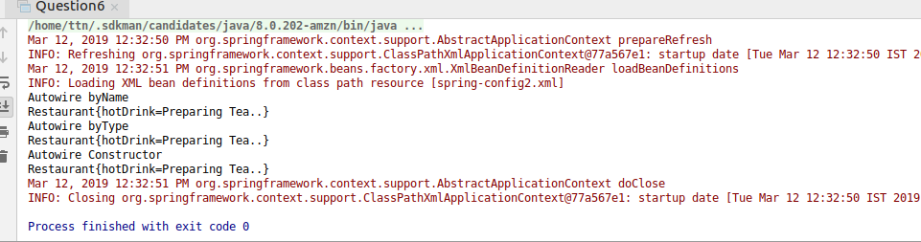

Exercise 5:

Set the scope of the teaRestaurant bean as proptotype and check the scope type after accessing the bean.

package com.coreSpring2;
import org.springframework.context.support.ClassPathXmlApplicationContext;
public class Question7 {
public static void main(String[] args) {
ClassPathXmlApplicationContext app = new ClassPathXmlApplicationContext("spring-config.xml");
Restaurant restaurant1 = (Restaurant) app.getBean("teaRestaurant1");
Restaurant restaurant2 = (Restaurant) app.getBean("teaRestaurant1");
System.out.println(restaurant1);
System.out.println(restaurant2);
app.close();
}
}
spring-config.xml

<bean id="tea" class="com.coreSpring2.Tea"/>

<bean id="teaRestaurant1" class="com.coreSpring2.Restaurant" scope="prototype">
<property name="hotDrink" ref="tea"/>
</bean>

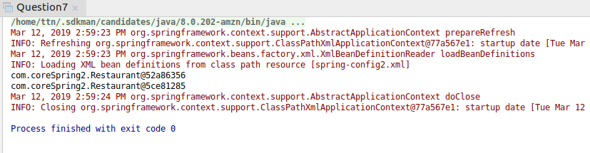

Exercise 6:

Use @Required annotation for hotDrink setter method in Restaurant class.

package com.coreSpring3;
import org.springframework.beans.factory.annotation.Required;
import org.springframework.context.ApplicationContext;
import org.springframework.context.support.ClassPathXmlApplicationContext;
interface HotDrink {
String prepareHotDrink();
}
class Restaurant {
private HotDrink hotDrink;
public HotDrink getHotDrink() {
return hotDrink;
}
@Required
public void setHotDrink(HotDrink hotDrink) {
this.hotDrink = hotDrink;
}
@Override
public String toString() {
return "Restaurant{" +
"hotDrink=" + hotDrink.prepareHotDrink() +
'}';
}
}
class Tea implements HotDrink {
@Override
public String prepareHotDrink() {
return "Preparing Tea..";
}
}
class ExpressTea implements HotDrink {
@Override
public String prepareHotDrink() {
return "Preparing ExpressTea..";
}
}
public class Question8 {
public static void main(String[] args) {
ApplicationContext app = new ClassPathXmlApplicationContext("spring-config.xml");
System.out.println(app.getBean("teaRestaurant"));
((ClassPathXmlApplicationContext) app).close();
}
}
spring-config.xml

<bean id="teaRestaurant" class="com.coreSpring3.Restaurant">
<property name="hotDrink" ref="tea"/>
</bean>
<bean id="tea" class="com.coreSpring3.Tea"/>
<bean class="org.springframework.beans.factory.annotation.RequiredAnnotationBeanPostProcessor" />
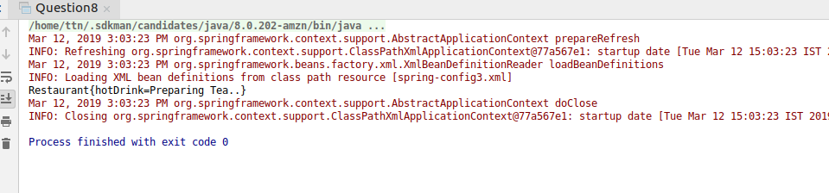

Exercise 7:

Use @Autowired annotation to wire Tea with Restaurant class Using setter method, field and constructor.

package com.coreSpring4;
import org.springframework.beans.factory.annotation.Autowired;
import org.springframework.beans.factory.annotation.Required;
import org.springframework.context.ApplicationContext;
import org.springframework.context.support.ClassPathXmlApplicationContext;
interface HotDrink {
String prepareHotDrink();
}
class Restaurant {
@Autowired
private HotDrink hotDrink;
@Autowired
public Restaurant(HotDrink hotDrink) {
this.hotDrink = hotDrink;
}
public HotDrink getHotDrink() {
return hotDrink;
}
@Autowired
public void setHotDrink(HotDrink hotDrink) {
this.hotDrink = hotDrink;
}
@Override
public String toString() {
return "Restaurant{" +
"hotDrink=" + hotDrink.prepareHotDrink() +
'}';
}
}
class Tea implements HotDrink {
@Override
public String prepareHotDrink() {
return "Preparing Tea..";
}
}
class ExpressTea implements HotDrink {
@Override
public String prepareHotDrink() {
return "Preparing ExpressTea..";
}
}
public class Question9 {
public static void main(String[] args) {
ApplicationContext app = new ClassPathXmlApplicationContext("spring-config.xml");
System.out.println(app.getBean("teaRestaurant"));
((ClassPathXmlApplicationContext) app).close();
}
}
spring-config.xml

<bean id="teaRestaurant" class="com.coreSpring4.Restaurant">
<!-- <property name="hotDrink" ref="tea"/>-->
</bean>
<bean id="tea" class="com.coreSpring4.Tea"/>
<bean class="org.springframework.beans.factory.annotation.AutowiredAnnotationBeanPostProcessor"/>
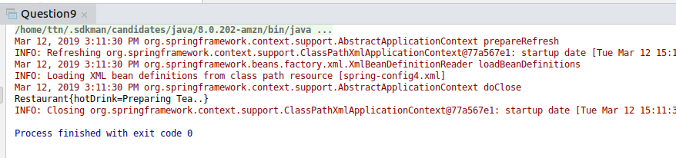

Exercise 8:

Use @Component, @Controller, @Repository etc annotation to configure Tea and Restaurant in Spring Container.

package com.coreSpring5;
import org.springframework.beans.factory.annotation.Autowired;
import org.springframework.beans.factory.annotation.Qualifier;
import org.springframework.context.ApplicationContext;
import org.springframework.context.support.ClassPathXmlApplicationContext;
import org.springframework.stereotype.Component;
interface HotDrink {
String prepareHotDrink();
}
@Component()
class Restaurant {
@Autowired
@Qualifier("tea")
private HotDrink hotDrink;
Restaurant() {
}
public Restaurant(HotDrink hotDrink) {
this.hotDrink = hotDrink;
}
public HotDrink getHotDrink() {
return hotDrink;
}
public void setHotDrink(HotDrink hotDrink) {
this.hotDrink = hotDrink;
}
@Override
public String toString() {
return "Restaurant{" +
"hotDrink=" + hotDrink.prepareHotDrink() +
'}';
}
}
@Component()
class Tea implements HotDrink {
@Override
public String prepareHotDrink() {
return "Preparing Tea..";
}
}
@Component
class ExpressTea implements HotDrink {
@Override
public String prepareHotDrink() {
return "Preparing ExpressTea..";
}
}
public class Question10 {
public static void main(String[] args) {
ApplicationContext app = new ClassPathXmlApplicationContext("spring-config5.xml");
System.out.println(app.getBean("restaurant"));
((ClassPathXmlApplicationContext) app).close();
}
}

spring-config.xml

<context:component-scan base-package="com.coreSpring5"/>
