PersistenceContext(Configuration Class)

package com.spring.config;
import org.springframework.context.annotation.Bean;
import org.springframework.context.annotation.Configuration;
import org.springframework.data.jpa.repository.config.EnableJpaRepositories;
import org.springframework.jdbc.datasource.DriverManagerDataSource;
import org.springframework.orm.jpa.JpaTransactionManager;
import org.springframework.orm.jpa.LocalContainerEntityManagerFactoryBean;
import org.springframework.orm.jpa.vendor.HibernateJpaVendorAdapter;
import javax.persistence.EntityManagerFactory;
import javax.sql.DataSource;
import java.util.Properties;

@Configuration
@EnableJpaRepositories("com.spring.repository")
public class PersistenceContext {
@Bean
DataSource dataSource(){
DriverManagerDataSource driverManagerDataSource = new DriverManagerDataSource();
driverManagerDataSource.setDriverClassName("com.mysql.jdbc.Driver");
driverManagerDataSource.setUrl("jdbc:mysql://localhost:3306/springJpa");
driverManagerDataSource.setUsername("root");
driverManagerDataSource.setPassword("K96sanjeev@");
return driverManagerDataSource;
}
@Bean
LocalContainerEntityManagerFactoryBean entityManagerFactory(DataSource dataSource){
LocalContainerEntityManagerFactoryBean entityManagerFactoryBean =
new LocalContainerEntityManagerFactoryBean();
entityManagerFactoryBean.setDataSource(dataSource);
entityManagerFactoryBean.setJpaVendorAdapter(new HibernateJpaVendorAdapter());
entityManagerFactoryBean.setPackagesToScan("com/spring/entity");
Properties jpaProperties= new Properties();
jpaProperties.setProperty("hibernate.dialect","org.hibernate.dialect.MySQLDialect");
jpaProperties.setProperty("hibernate.show_sql","true");
jpaProperties.setProperty("hibernate.hbm2ddl.auto","update");
entityManagerFactoryBean.setJpaProperties(jpaProperties);
return entityManagerFactoryBean;
}
@Bean
JpaTransactionManager transactionManager(EntityManagerFactory entityManagerFactory) {
JpaTransactionManager transactionManager = new JpaTransactionManager();
transactionManager.setEntityManagerFactory(entityManagerFactory);
return transactionManager;
}
}

Q1. Create a Person entity with instance variables Firstname, Lastname, salary, age and Id.
Person
package com.spring.entity;
import javax.persistence.Entity;
import javax.persistence.GeneratedValue;
import javax.persistence.GenerationType;
import javax.persistence.Id;

@Entity
public class Person {
@Id
@GeneratedValue(strategy = GenerationType.AUTO)
private int id;
private String firstName;
private String lastName;
private int age;
private double salary;
public Person(){
}
public Person(String firstName, String lastName, int age, double salary) {
this.firstName = firstName;
this.lastName = lastName;
this.age = age;
this.salary = salary;
}
public int getId() {
return id;
}
public void setId(int id) {
this.id = id;
}
public String getFirstName() {
return firstName;
}
public void setFirstName(String firstName) {
this.firstName = firstName;
}
public String getLastName() {
return lastName;
}
public void setLastName(String lastName) {
this.lastName = lastName;
}
public int getAge() {
return age;
}
public void setAge(int age) {
this.age = age;
}
public double getSalary() {
return salary;
}
public void setSalary(double salary) {
this.salary = salary;
}
@Override
public String toString() {
return "Person{" +
"id=" + id +
", firstName='" + firstName + '\'' +
", lastName='" + lastName + '\'' +
", age=" + age +
", salary=" + salary +
'}';
}
}

Q2. Implement CrudRepository for it.
PersonRepository

package com.spring.repository;
import com.spring.entity.Person;
import org.springframework.data.repository.CrudRepository;

public interface PersonRepository extends CrudRepository<Person, Integer> {

}

Q3. Perform all the methods inside CrudRepository for Person Class.
PersonService

package com.spring.service;
import com.spring.entity.Person;
import com.spring.repository.PersonRepository;
import org.springframework.beans.factory.annotation.Autowired;
import org.springframework.stereotype.Service;
import javax.jws.soap.SOAPBinding;
import java.util.Iterator;

@Service
public class PersonService {
@Autowired
PersonRepository personRepository;
public void insert(Person person){
personRepository.save(person);
System.out.println("Record inserted..");
}
public void read(){
Iterable<Person> iterable=personRepository.findAll();
Iterator<Person> iterator=iterable.iterator();
System.out.println("Fetching records..");
while (iterator.hasNext()){
System.out.println(iterator.next());
}
System.out.println("------------------------------------------");
}
public void isExist(Integer id){
System.out.println("\nRecord exist of id "+id+": "+personRepository.exists(id));
}
public void delete(int id){
System.out.println("\nRecord deleted of id: "+id);
personRepository.delete(id);
}
public void count(){
System.out.println("\nNumber of total records are: "+personRepository.count());
}
public void findOne(Integer id){
System.out.println("\nExecuting findOne for id "+id+": ");
System.out.println(personRepository.findOne(id));
}
}

Main
package com.spring;
import com.spring.entity.Person;
import com.spring.service.PersonService;
import org.springframework.context.ApplicationContext;
import org.springframework.context.annotation.AnnotationConfigApplicationContext;

public class Main {
public static void main(String[] args) {
ApplicationContext ctx = new AnnotationConfigApplicationContext("com.spring");
PersonService personService = ctx.getBean(PersonService.class);

Person vishal = new Person("Vishal","Aggarwal", 22, 15000);
Person rehan = new Person("Rehan","Khan",25,20000);
Person anoop = new Person("Anoop","Kumar",32,35000);
Person aman = new Person("Aman","Choudhary",25,30000);
personService.insert(vishal);
personService.insert(rehan);
personService.insert(anoop);
personService.insert(aman);
personService.read();
personService.count();
personService.findOne(2);
personService.isExist(1);
personService.delete(1);

}
}

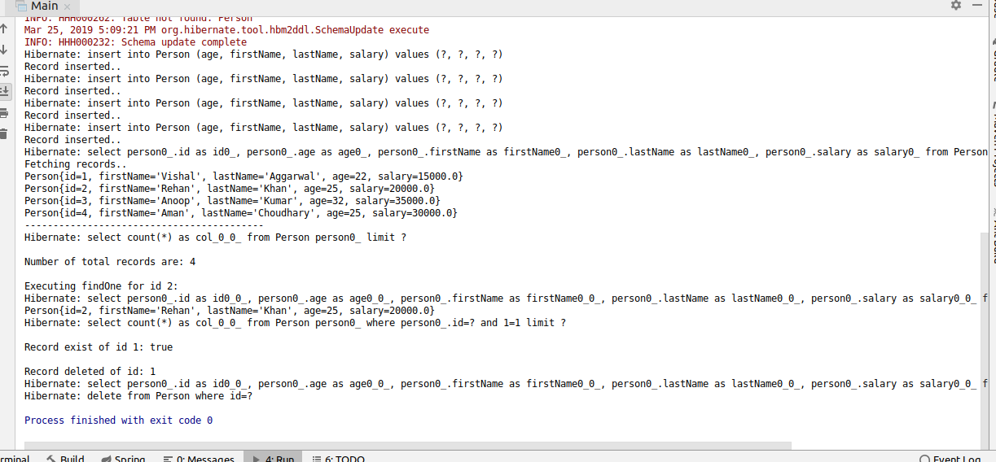

Q4. For class Person find person declare methods in repository to find person by firstname, lastname and Id.
PersonRepository

package com.spring.repository;
import com.spring.entity.Person;
import org.springframework.data.repository.CrudRepository;
import java.util.List;

public interface PersonRepository extends CrudRepository<Person, Integer> {
List<Person> findByFirstName(String name);
List<Person> findByLastName(String name);
List<Person> findById(int id);
}

Q5. Use the methods declared above to fetch the person.
PersonService

package com.spring.service;
import com.spring.repository.PersonRepository;
import org.springframework.beans.factory.annotation.Autowired;
import org.springframework.stereotype.Service;
import java.util.List;

@Service
public class PersonService {
@Autowired
PersonRepository personRepository;

public List getByFirstName(String name) {
return personRepository.findByFirstName(name);
}
public List getByLastName(String name) {
return personRepository.findByLastName(name);
}
public List getById(int id) {
return personRepository.findById(id);
}
}
Main
package com.spring;
import com.spring.entity.Person;
import com.spring.service.PersonService;
import org.springframework.context.ApplicationContext;
import org.springframework.context.annotation.AnnotationConfigApplicationContext;
public class Main {
public static void main(String[] args) {
ApplicationContext ctx = new AnnotationConfigApplicationContext("com.spring");
PersonService personService = ctx.getBean(PersonService.class);

System.out.println(personService.getByFirstName("Rehan"));
System.out.println(personService.getByLastName("Khan"));
System.out.println(personService.getById(2));
}
}

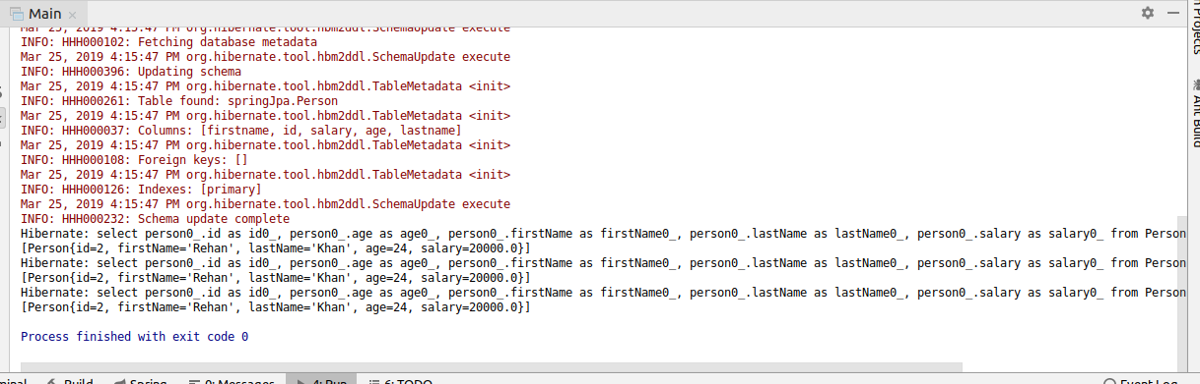

Q6. Use @Query to fetch firstname of the Person whose age is 25.
PersonRepository

package com.spring.repository;
import com.spring.entity.Person;
import org.springframework.data.jpa.repository.Query;
import org.springframework.data.repository.CrudRepository;
import org.springframework.data.repository.query.Param;
import java.util.List;

public interface PersonRepository extends CrudRepository<Person, Integer> {

@Query("SELECT firstName from Person where age=:age")
List<String> findByAge(@Param("age") Integer age);

}
PersonService
package com.spring.service;
import com.spring.entity.Person;
import com.spring.repository.PersonRepository;
import org.springframework.beans.factory.annotation.Autowired;
import org.springframework.stereotype.Service;
import java.util.Iterator;
import java.util.List;

@Service
public class PersonService {
@Autowired
PersonRepository personRepository;

public List<String> firstNameByAge(int age){
return personRepository.findByAge(age);
}
}
Main
package com.spring;
import com.spring.entity.Person;
import com.spring.service.PersonService;
import org.springframework.context.ApplicationContext;
import org.springframework.context.annotation.AnnotationConfigApplicationContext;

public class Main {
public static void main(String[] args) {
ApplicationContext ctx = new AnnotationConfigApplicationContext("com.spring");
PersonService personService = ctx.getBean(PersonService.class);
System.out.println(personService.firstNameByAge(25));
}
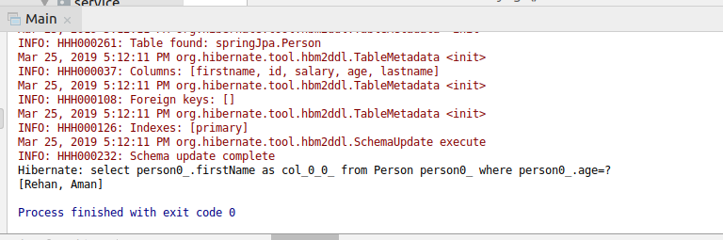
}

Q7. Use @Query to fetch firstname and lastname of the Person whose age is 25.
PersonRepository

package com.spring.repository;
import com.spring.entity.Person;
import org.springframework.data.jpa.repository.Query;
import org.springframework.data.repository.CrudRepository;
import org.springframework.data.repository.query.Param;
import java.util.List;

public interface PersonRepository extends CrudRepository<Person, Integer> {

@Query("select firstName, lastName from Person where age=:age")
List<Object[]> findFullNameByAge(@Param("age") Integer age);
}

PersonService
package com.spring.service;
import com.spring.entity.Person;
import com.spring.repository.PersonRepository;
import org.springframework.beans.factory.annotation.Autowired;
import org.springframework.stereotype.Service;
import java.util.Iterator;
import java.util.List;

@Service
public class PersonService {
@Autowired
PersonRepository personRepository;

public void getFnameAndLnameByAge(int age){
List<Object[]> list=personRepository.findFullNameByAge(25);
Iterator<Object[]> iterator=list.iterator();
while (iterator.hasNext()){
Object[] objects=iterator.next();
System.out.println(objects[0] +" "+objects[1]);
}
}
}

Main
package com.spring;
import com.spring.entity.Person;
import com.spring.service.PersonService;
import org.springframework.context.ApplicationContext;
import org.springframework.context.annotation.AnnotationConfigApplicationContext;

public class Main {
public static void main(String[] args) {
ApplicationContext ctx = new AnnotationConfigApplicationContext("com.spring");
PersonService personService = ctx.getBean(PersonService.class);

personService.getFnameAndLnameByAge(25);
}
}

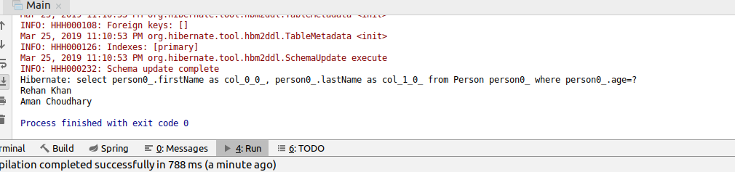

Q8. Get complete information of the Employee whose age is 25 using @Query.
PersonRepository

package com.spring.repository;
import com.spring.entity.Person;
import org.springframework.data.jpa.repository.Query;
import org.springframework.data.repository.CrudRepository;
import org.springframework.data.repository.query.Param;
import java.util.List;

public interface PersonRepository extends CrudRepository<Person, Integer> {
@Query("select p from Person p where p.age=:age")
List<Person> getInfoByAge(@Param("age") Integer age);
}

PersonService
package com.spring.service;
import com.spring.entity.Person;
import com.spring.repository.PersonRepository;
import org.springframework.beans.factory.annotation.Autowired;
import org.springframework.stereotype.Service;
import java.util.Iterator;
import java.util.List;

@Service
public class PersonService {
@Autowired
PersonRepository personRepository;

public void getPersonInfo(int age){
List<Person> personList = personRepository.getInfoByAge(age);
System.out.println(personList);
}
}

Main
package com.spring;
import com.spring.entity.Person;
import com.spring.service.PersonService;
import org.springframework.context.ApplicationContext;
import org.springframework.context.annotation.AnnotationConfigApplicationContext;

public class Main {
public static void main(String[] args) {
ApplicationContext ctx = new AnnotationConfigApplicationContext("com.spring");
PersonService personService = ctx.getBean(PersonService.class);

personService.getPersonInfo(25);
}
}
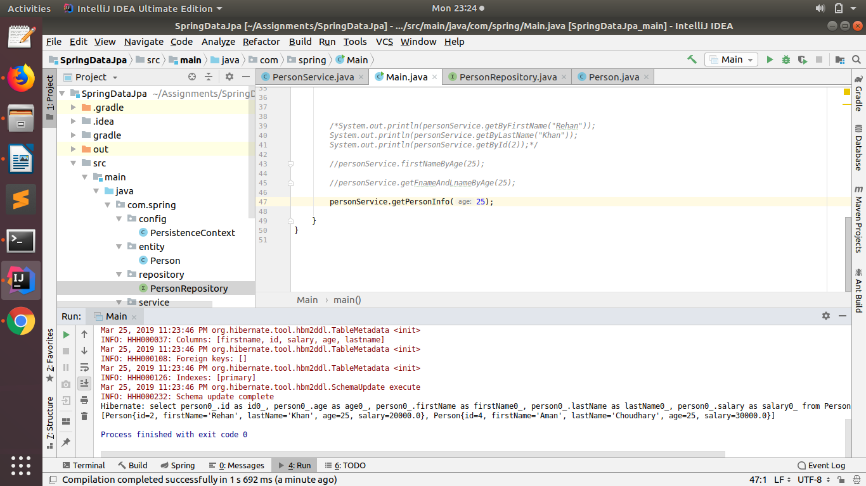

Q9. Count Person where name is "Peter" using @Query.
PersonRepository
package com.spring.repository;
import com.spring.entity.Person;
import org.springframework.data.jpa.repository.Query;
import org.springframework.data.repository.CrudRepository;
import org.springframework.data.repository.query.Param;
import java.util.List;

public interface PersonRepository extends CrudRepository<Person, Integer> {

@Query("select count(p) from Person p where p.firstName=:name")
Integer countByFirstName(@Param("name") String name);
}
PersonService
package com.spring.service;
import com.spring.entity.Person;
import com.spring.repository.PersonRepository;
import org.springframework.beans.factory.annotation.Autowired;
import org.springframework.stereotype.Service;
import java.util.Iterator;
import java.util.List;

@Service
public class PersonService {
@Autowired
PersonRepository personRepository;

public void countPersonByName(String name){
System.out.println(personRepository.countByFirstName(name));
}
}
main
package com.spring;
import com.spring.entity.Person;
import com.spring.service.PersonService;
import org.springframework.context.ApplicationContext;
import org.springframework.context.annotation.AnnotationConfigApplicationContext;

public class Main {

public static void main(String[] args) {
ApplicationContext ctx = new AnnotationConfigApplicationContext("com.spring");
PersonService personService = ctx.getBean(PersonService.class);

personService.countPersonByName("Peter");
}
}

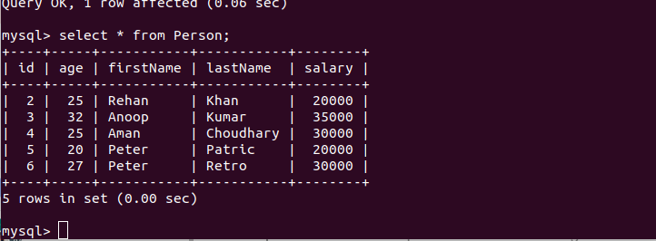

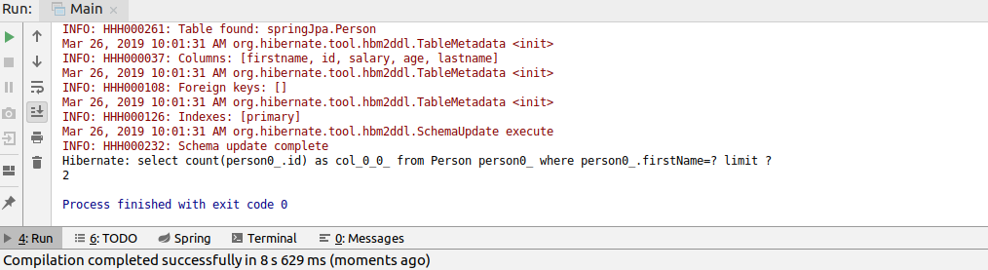
Q10. Implement following methods for Person repository:
- count
- distinct
- or
- and
- between
- LessThan
- GreaterThan
- Like
- Not
- In
- IgnoreCase
PersonRepository

package com.spring.repository;
import com.spring.entity.Person;
import org.springframework.data.jpa.repository.Query;
import org.springframework.data.repository.CrudRepository;
import org.springframework.data.repository.query.Param;
import java.util.List;

public interface PersonRepository extends CrudRepository<Person, Integer> {

Integer countByFirstName(String name);
List<Person> findDistinctByFirstName(String name);
List<Person> findByAgeOrFirstName(Integer age, String name);
List<Person> findByAgeAndFirstName(Integer age, String name);
List<Person> findByAgeBetween(int min, int max);
List<Person> findByAgeLessThan(int age);
List<Person> findByAgeGreaterThan(int age);
List<Person> findByFirstNameLike(String name);
List<Person> findByFirstNameNot(String name);
List<Person> findByAgeIn(List<Integer> ageList);
List<Person> findByFirstNameIgnoreCase(String name);
}
PersonService

package com.spring.service;
import com.spring.entity.Person;
import com.spring.repository.PersonRepository;
import org.springframework.beans.factory.annotation.Autowired;
import org.springframework.stereotype.Service;
import java.util.Iterator;
import java.util.List;

@Service
public class PersonService {
@Autowired
PersonRepository personRepository;

public void countPersonByFirstName(String name){
System.out.println("\nTotal number of person of name "+name+": "+personRepository.countByFirstName(name));
}
public void getDistinctPersonByFirstName(String name){
System.out.println("\nDistinct by FirstName: "+personRepository.findDistinctByFirstName(name));
}
public void getPersonByOrOperation(Integer age, String name){
List<Person> personList = personRepository.findByAgeOrFirstName(age,name);
Iterator<Person> iterator = personList.iterator();
System.out.println("\nDetail using Or: ");
while (iterator.hasNext()){
System.out.println(iterator.next());
}
}
public void getPersonByAndOperation(Integer age, String name){
List<Person> personList = personRepository.findByAgeAndFirstName(age,name);
Iterator<Person> iterator = personList.iterator();
System.out.println("\nDetail using And: ");
while (iterator.hasNext()){
System.out.println(iterator.next());
}
}
public void getPersonByAgeBetween(int min, int max){
List<Person> personList = personRepository.findByAgeBetween(min,max);
Iterator<Person> iterator = personList.iterator();
System.out.println("\nRecords between age "+min+" and "+max+" are: ");
while (iterator.hasNext()){
System.out.println(iterator.next());
}
}
public void getPersonByAgeLessThan(int age){
List<Person> personList = personRepository.findByAgeLessThan(age);
Iterator<Person> iterator = personList.iterator();
System.out.println("\nRecords Less than age "+age+" are: ");
while (iterator.hasNext()){
System.out.println(iterator.next());
}
}
public void getPersonByAgeGreaterThan(int age){
List<Person> personList = personRepository.findByAgeGreaterThan(age);
Iterator<Person> iterator = personList.iterator();
System.out.println("\nRecords Greater than age "+age+" are: ");
while (iterator.hasNext()){
System.out.println(iterator.next());
}
}
public void getPersonByNameLike(String name){
List<Person> personList = personRepository.findByFirstNameLike(name);
Iterator<Person> iterator = personList.iterator();
System.out.println("\nRecords of name like "+name+" are: ");
while (iterator.hasNext()){
System.out.println(iterator.next());
}
}
public void getPersonByNameNot(String name){
List<Person> personList = personRepository.findByFirstNameNot(name);
Iterator<Person> iterator = personList.iterator();
System.out.println("\nRecords of name except "+name+" are: ");
while (iterator.hasNext()){
System.out.println(iterator.next());
}
}
public void getPersonByAgeIn(List<Integer> ageList){
List<Person> personList = personRepository.findByAgeIn(ageList);
Iterator<Person> iterator = personList.iterator();
System.out.println("\nRecords in ageList "+ageList+" are: ");
while (iterator.hasNext()){
System.out.println(iterator.next());
}
}
public void getPersonByIgnoringCase(String name){
List<Person> personList = personRepository.findByFirstNameIgnoreCase(name);
Iterator<Person> iterator = personList.iterator();
System.out.println("\nRecords of name "+name+" by ignoring case are: ");
while (iterator.hasNext()){
System.out.println(iterator.next());
}
}
}

Main
package com.spring;
import com.spring.entity.Person;
import com.spring.service.PersonService;
import org.springframework.context.ApplicationContext;
import org.springframework.context.annotation.AnnotationConfigApplicationContext;

import java.util.Arrays;

public class Main {
public static void main(String[] args) {

ApplicationContext ctx = new AnnotationConfigApplicationContext("com.spring");
PersonService personService = ctx.getBean(PersonService.class);

personService.countPersonByFirstName("Peter");
personService.getDistinctPersonByFirstName("Peter");
personService.getPersonByOrOperation(90,"Peter");
personService.getPersonByAndOperation(20,"Peter");
personService.getPersonByAgeBetween(20,28);
personService.getPersonByAgeLessThan(27);
personService.getPersonByAgeGreaterThan(25);
personService.getPersonByNameLike("A%");
personService.getPersonByNameNot("Peter");
personService.getPersonByAgeIn(Arrays.asList(20,27,25));
personService.getPersonByIgnoringCase("peTer");
}
}

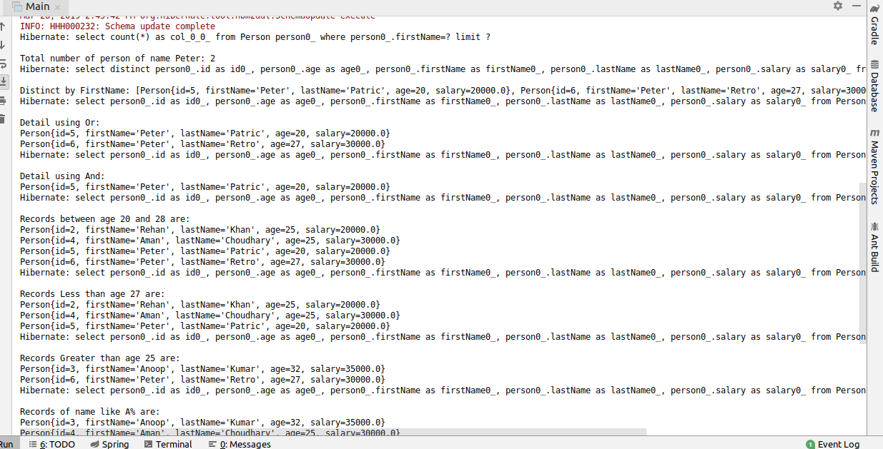

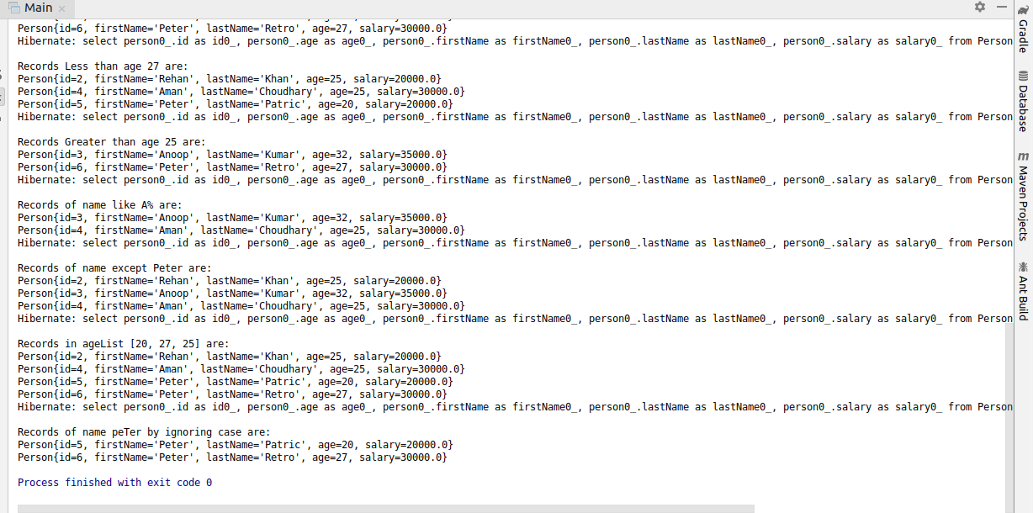

Q11. Get the persons greater than age 25 and sort them in descending order according to id by method query.
PersonRepository
package com.spring.repository;
import com.spring.entity.Person;
import org.springframework.data.jpa.repository.Query;
import org.springframework.data.repository.CrudRepository;
import org.springframework.data.repository.query.Param;
import java.util.List;

public interface PersonRepository extends CrudRepository<Person, Integer> {
List<Person> findByAgeGreaterThanOrderByIdDesc(int age);
}
PersonService

package com.spring.service;
import com.spring.entity.Person;
import com.spring.repository.PersonRepository;
import org.springframework.beans.factory.annotation.Autowired;
import org.springframework.stereotype.Service;
import java.util.Iterator;
import java.util.List;

@Service
public class PersonService {
@Autowired
PersonRepository personRepository;

public void getPersonBySorting(int age){
List<Person> personList = personRepository.findByAgeGreaterThanOrderByIdDesc(age);
Iterator<Person> iterator = personList.iterator();
System.out.println("\nRecords of greater than age "+age+" and sorting by id are: ");
while (iterator.hasNext()){
System.out.println(iterator.next());
}
}
}

Main
package com.spring;
import com.spring.entity.Person;
import com.spring.service.PersonService;
import org.springframework.context.ApplicationContext;
import org.springframework.context.annotation.AnnotationConfigApplicationContext;
import java.util.Arrays;

public class Main {
public static void main(String[] args) {

ApplicationContext ctx = new AnnotationConfigApplicationContext("com.spring");
PersonService personService = ctx.getBean(PersonService.class);
personService.getPersonBySorting(25);
}
}
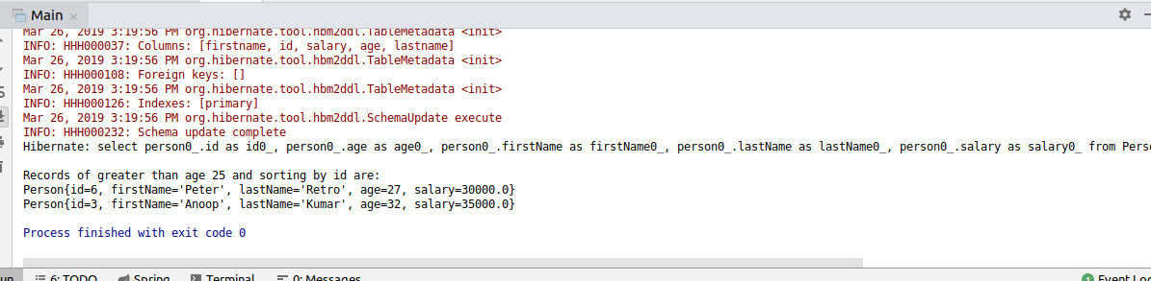
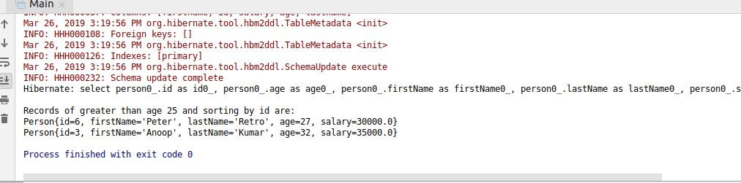

Q12. Do the question above using the Sort class.
PersonRepository

package com.spring.repository;
import com.spring.entity.Person;
import org.springframework.data.domain.Sort;
import org.springframework.data.jpa.repository.Query;
import org.springframework.data.repository.CrudRepository;
import org.springframework.data.repository.query.Param;
import java.util.List;

public interface PersonRepository extends CrudRepository<Person, Integer> {

@Query("select p from Person p where p.age>:age")
List<Person> findAll(@Param("age") Integer age, Sort sor);
}
PersonService
package com.spring.service;
import com.spring.entity.Person;
import com.spring.repository.PersonRepository;
import org.springframework.beans.factory.annotation.Autowired;
import org.springframework.data.domain.Sort;
import org.springframework.stereotype.Service;
import java.util.Iterator;
import java.util.List;

@Service
public class PersonService {
@Autowired
PersonRepository personRepository;

public void getPersonBySortClass(int age, Sort sort){
List<Person> personList = personRepository.findAll(age, sort);
Iterator<Person> iterator = personList.iterator();
System.out.println("\nRecords of greater than age "+age+" and sorting by id using sort class : ");
while (iterator.hasNext()){
System.out.println(iterator.next());
}
}
}

Main
package com.spring;
import com.spring.entity.Person;
import com.spring.service.PersonService;
import org.springframework.context.ApplicationContext;
import org.springframework.context.annotation.AnnotationConfigApplicationContext;
import java.util.Arrays;

public class Main {
public static void main(String[] args) {

ApplicationContext ctx = new AnnotationConfigApplicationContext("com.spring");
PersonService personService = ctx.getBean(PersonService.class);
personService.getPersonBySortClass(25, new Sort(Sort.Direction.DESC,"id"));

}
}

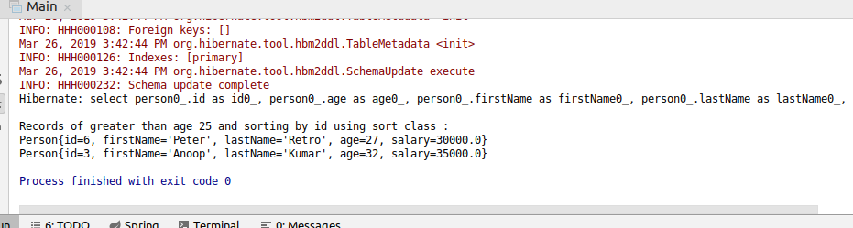

Q13. Apply Pagination on Person entities.
PersonRepository

package com.spring.repository;
import com.spring.entity.Person;
import org.springframework.data.domain.Page;
import org.springframework.data.domain.Pageable;
import org.springframework.data.domain.Sort;
import org.springframework.data.jpa.repository.Query;
import org.springframework.data.repository.CrudRepository;
import org.springframework.data.repository.query.Param;
import java.util.List;

public interface PersonRepository extends CrudRepository<Person, Integer> {

Page<Person> findAll(Pageable pageable);
}

PersonService
package com.spring.service;
import com.spring.entity.Person;
import com.spring.repository.PersonRepository;
import org.springframework.beans.factory.annotation.Autowired;
import org.springframework.data.domain.Page;
import org.springframework.data.domain.Pageable;
import org.springframework.data.domain.Sort;
import org.springframework.stereotype.Service;
import java.util.Iterator;
import java.util.List;

@Service
public class PersonService {
@Autowired
PersonRepository personRepository;

public void getPageContent(Pageable pageable){
Page<Person> page = personRepository.findAll(pageable);
List<Person> personList = page.getContent();
Iterator<Person> iterator = personList.iterator();
System.out.println("Page of size 3:");
while (iterator.hasNext()){
System.out.println(iterator.next());
}
}
}
Main
package com.spring;
import com.spring.entity.Person;
import com.spring.service.PersonService;
import org.springframework.context.ApplicationContext;
import org.springframework.context.annotation.AnnotationConfigApplicationContext;
import java.util.Arrays;

public class Main {
public static void main(String[] args) {

ApplicationContext ctx = new AnnotationConfigApplicationContext("com.spring");
PersonService personService = ctx.getBean(PersonService.class);
personService.getPageContent(new PageRequest(0,3));

}
}

