Q1. Create a Rest API for Student using noun plurals for endpoint and http verbs for different operations.

Student

package com.rest.SpringRest.entities;
import javax.persistence.Entity;
import javax.persistence.GeneratedValue;
import javax.persistence.Id;

@Entity
public class Student {
@Id
@GeneratedValue
private Integer id;
private String name;
private Integer age;
public Integer getId() {
return id;
}
public void setId(Integer id) {
this.id = id;
}
public String getName() {
return name;
}
public void setName(String name) {
this.name = name;
}
public Integer getAge() {
return age;
}
public void setAge(Integer age) {
this.age = age;
}
}
HomeController

package com.rest.SpringRest.controller;
import com.rest.SpringRest.entities.Student;
import com.rest.SpringRest.services.StudentService;
import org.springframework.beans.factory.annotation.Autowired;
import org.springframework.web.bind.annotation.*;
import java.util.List;

@RestController
public class HomeController {
@Autowired
StudentService studentService;
//Question 1
@PostMapping("/students")
Student saveStudent(@RequestBody Student student) {
studentService.saveStudent(student);
return student;
}
@GetMapping("/students")
List<Student> getStudents() {
return studentService.getAllStudents();
}
@GetMapping("/students/{id}")
Student getStudentById(@PathVariable Integer id) {
return studentService.getStudentById(id);
}
@DeleteMapping("/student/{id}")
void deleteStudent(@PathVariable Integer id){
Student student = studentService.getStudentById(id);
if(student == null)
throw new StudentNotFoundException("Student not found..");
studentService.deleteStudentById(id);
}
}
StudentRepository

package com.rest.SpringRest.repositories;
import com.rest.SpringRest.entities.Student;
import org.springframework.data.repository.CrudRepository;
public interface StudentRepository extends CrudRepository<Student, Integer> {

}
StudentService

package com.rest.SpringRest.services;
import com.rest.SpringRest.entities.Student;
import com.rest.SpringRest.repositories.StudentRepository;
import org.springframework.beans.factory.annotation.Autowired;
import org.springframework.stereotype.Service;
import java.util.List;
import java.util.Optional;

@Service
public class StudentService {
@Autowired
StudentRepository studentRepository;
// Question 1
public void saveStudent(Student student){
studentRepository.save(student);
}
public List<Student> getAllStudents(){
return (List<Student>)studentRepository.findAll();
}
public Student getStudentById(Integer id){
Optional<Student> optional = studentRepository.findById(id);
return optional.isPresent() ? optional.get(): null;
}

public void deleteStudentById(Integer id){
studentRepository.deleteById(id);
}
}
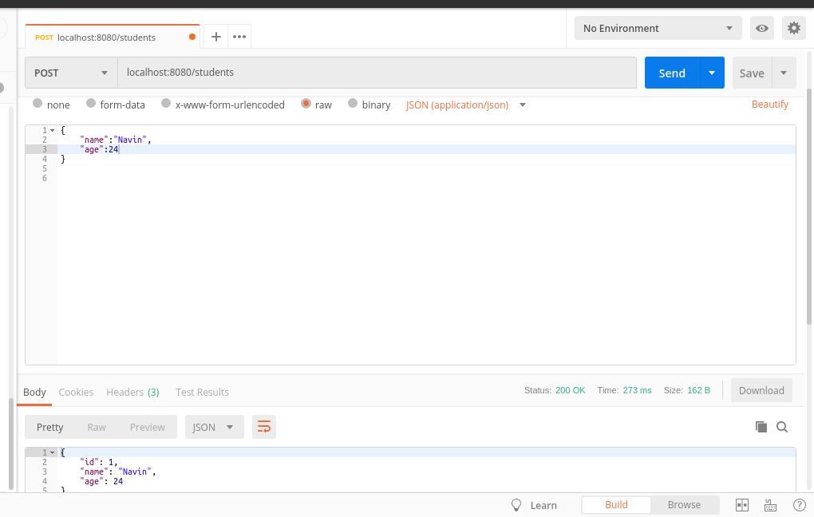

Q2. Create a Customise Exception Handler.

HomeController

package com.rest.SpringRest.controller;
import com.rest.SpringRest.entities.Student;
import com.rest.SpringRest.exceptions.StudentNotFoundException;
import com.rest.SpringRest.services.StudentService;
import org.springframework.beans.factory.annotation.Autowired;
import org.springframework.web.bind.annotation.*;
import java.util.List;
@RestController
public class HomeController {
@Autowired
StudentService studentService;

@PostMapping("/students")
List<Student> saveStudent(@RequestBody List<Student> student) {
studentService.saveStudent(student);
return student;
}
@GetMapping("/students")
List<Student> getStudents() {
return studentService.getAllStudents();
}
@GetMapping("/students/{id}")
Student getStudentById(@PathVariable Integer id) {
Student student = studentService.getStudentById(id);
if(student == null)
throw new StudentNotFoundException("Student not found..");
return student;
}
}
StudentNotFoundException

package com.rest.SpringRest.exceptions;
import org.springframework.http.HttpStatus;
import org.springframework.web.bind.annotation.ResponseStatus;

@ResponseStatus(HttpStatus.NOT_FOUND)
public class StudentNotFoundException extends RuntimeException {
public StudentNotFoundException(String message) {
super(message);
}
}

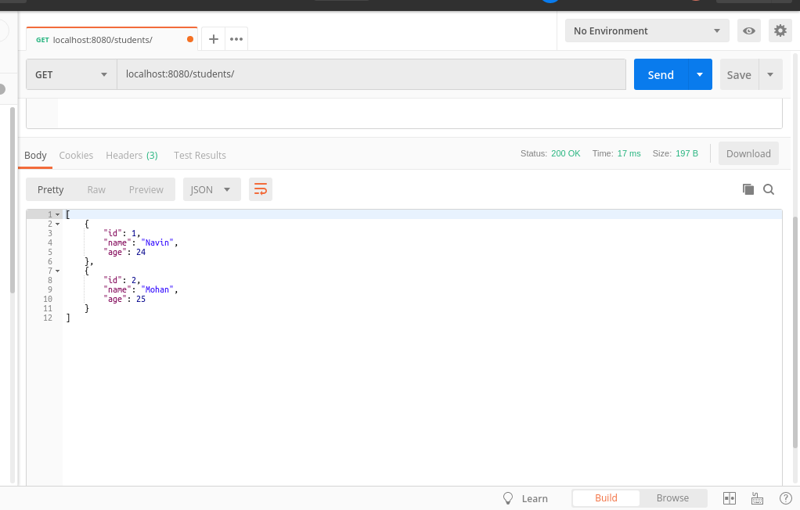
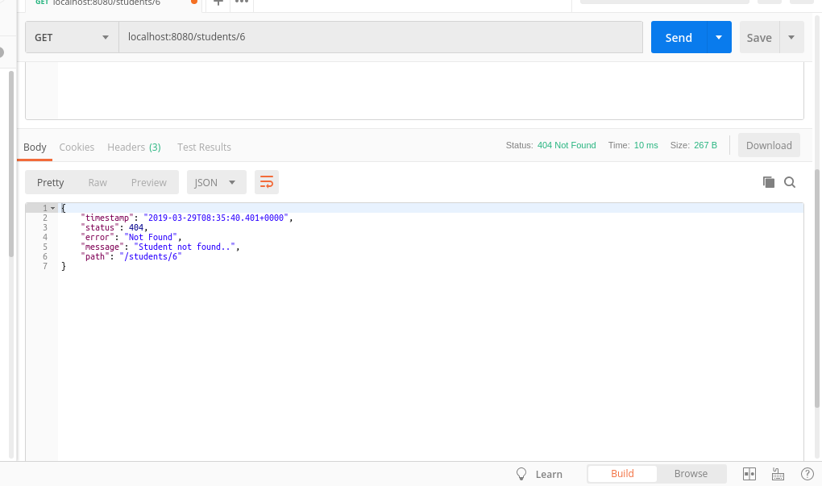

Q3. Print the Validation Messages of student Entity in response.

Student

package com.rest.SpringRest.entities;
import javax.persistence.Entity;
import javax.persistence.GeneratedValue;
import javax.persistence.Id;
import javax.validation.constraints.Size;

@Entity
public class Student {

@Id
@GeneratedValue
private Integer id;
@Size(min = 2,message = "Name should have at least 2 characters")
private String name;
private Integer age;
public Integer getId() {
return id;
}
public void setId(Integer id) {
this.id = id;
}
public String getName() {
return name;
}
public void setName(String name) {
this.name = name;
}
public Integer getAge() {
return age;
}
public void setAge(Integer age) {
this.age = age;
}
@Override
public String toString() {
return "Student{" +
"id=" + id +
", name='" + name + '\'' +
", age=" + age +
'}';
}
}
HomeController

package com.rest.SpringRest.controller;
import com.rest.SpringRest.entities.Student;
import com.rest.SpringRest.exceptions.StudentNotFoundException;
import com.rest.SpringRest.services.StudentService;
import org.springframework.beans.factory.annotation.Autowired;
import org.springframework.http.ResponseEntity;
import org.springframework.web.bind.annotation.*;
import org.springframework.web.servlet.support.ServletUriComponentsBuilder;
import javax.validation.Valid;
import java.net.URI;
import java.util.List;

@RestController
public class HomeController {

@Autowired
StudentService studentService;
@PostMapping("/students")
ResponseEntity<Student> saveStudent(@Valid @RequestBody Student student) {
studentService.saveStudent(student);

URI uri= ServletUriComponentsBuilder
.fromCurrentRequest()
.path("{id}").buildAndExpand(student.getId()).toUri();
return ResponseEntity.created(uri).build();
}
}
StudentService

public void saveStudent(Student student){
studentRepository.save(student);
}
ExceptionResponse

package com.rest.SpringRest.exceptions;
import java.util.Date;
public class ExceptionResponse {
private Date timestamp;
private String message;
private String details;
public ExceptionResponse(Date timestamp, String message, String details) {
this.timestamp = timestamp;
this.message = message;
this.details = details;
}
public Date getTimestamp() {
return timestamp;
}
public void setTimestamp(Date timestamp) {
this.timestamp = timestamp;
}
public String getMessage() {
return message;
}
public void setMessage(String message) {
this.message = message;
}
public String getDetails() {
return details;
}
public void setDetails(String details) {
this.details = details;
}
}

CustomResponseEntityExceptionHandler

package com.rest.SpringRest.exceptions;
import org.springframework.beans.factory.annotation.Autowired;
import org.springframework.context.MessageSource;
import org.springframework.http.HttpHeaders;
import org.springframework.http.HttpStatus;
import org.springframework.http.ResponseEntity;
import org.springframework.validation.FieldError;
import org.springframework.web.bind.MethodArgumentNotValidException;
import org.springframework.web.bind.annotation.ControllerAdvice;
import org.springframework.web.bind.annotation.ExceptionHandler;
import org.springframework.web.bind.annotation.RestController;
import org.springframework.web.context.request.WebRequest;
import org.springframework.web.servlet.mvc.method.annotation.ResponseEntityExceptionHandler;
import java.util.Date;
import java.util.List;
import java.util.stream.Collectors;

@ControllerAdvice
@RestController
public class CustomResponseEntityExceptionHandler extends ResponseEntityExceptionHandler {
@Autowired
MessageSource messageSource;
@ExceptionHandler(Exception.class)
public final ResponseEntity<Object> handleAllException(Exception ex, WebRequest request) {
ExceptionResponse exceptionResponse = new ExceptionResponse(new Date(),ex.getMessage(),request.getDescription(false));
return new ResponseEntity(exceptionResponse, HttpStatus.INTERNAL_SERVER_ERROR);
}
@ExceptionHandler(StudentNotFoundException.class)
public final ResponseEntity<Object> handleUserNotFoundException(StudentNotFoundException ex, WebRequest request) {
ExceptionResponse exceptionResponse = new ExceptionResponse(new Date(),ex.getMessage(),request.getDescription(false));
return new ResponseEntity(exceptionResponse, HttpStatus.NOT_FOUND);
}
@Override
protected ResponseEntity<Object> handleMethodArgumentNotValid(
MethodArgumentNotValidException ex, HttpHeaders headers, HttpStatus status, WebRequest request) {
List<String> errorMessageList=ex.getBindingResult().getAllErrors().stream().filter(e->e instanceof FieldError).map((e)->{
FieldError fieldError = (FieldError) e;
return messageSource.getMessage(fieldError, null);
}).collect(Collectors.toList());
ExceptionResponse exceptionResponse = new ExceptionResponse(new Date(),errorMessageList.toString(),request.getDescription(false));
return new ResponseEntity(exceptionResponse, HttpStatus.BAD_REQUEST);
}
}

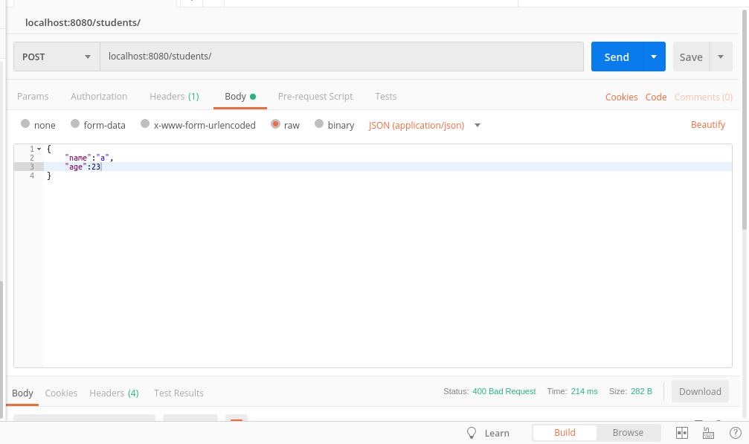

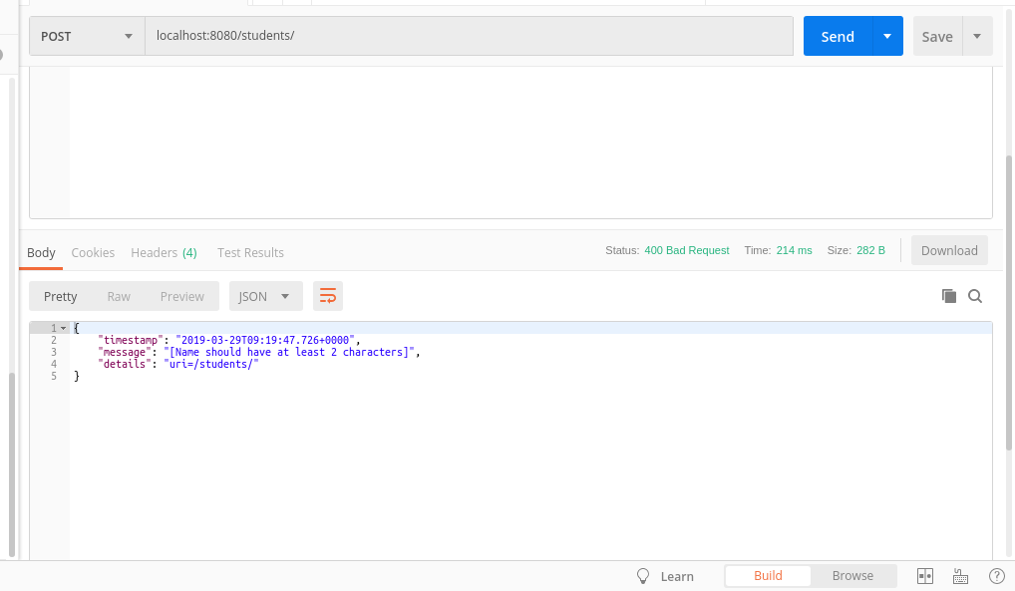

Q4. Perform Internationalization for a greeting message in your app.

HomeController

@GetMapping("/")
String helloWorld(@RequestHeader(name = "Accept-Language",required = false) Locale locale){
System.out.println("hello world");
System.out.println(locale.getLanguage());
return messageSource.getMessage("good.morning.message",null,locale);
}
messages.properties
good.morning.message=Good Morning
messages_fr.properties
good.morning.message=Bonjour

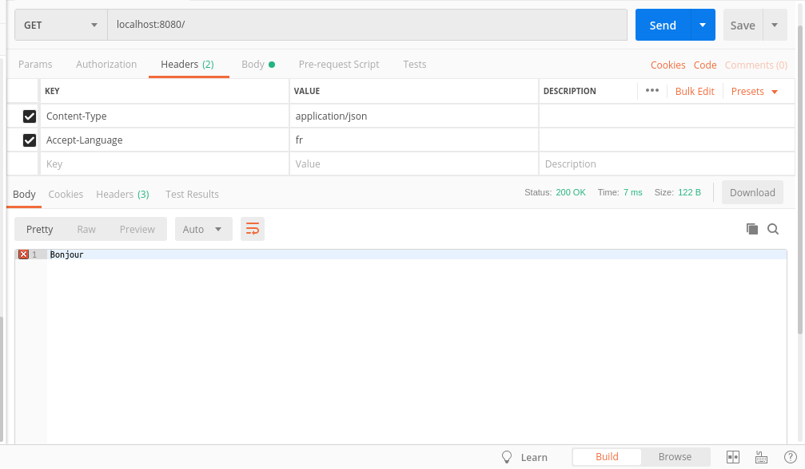

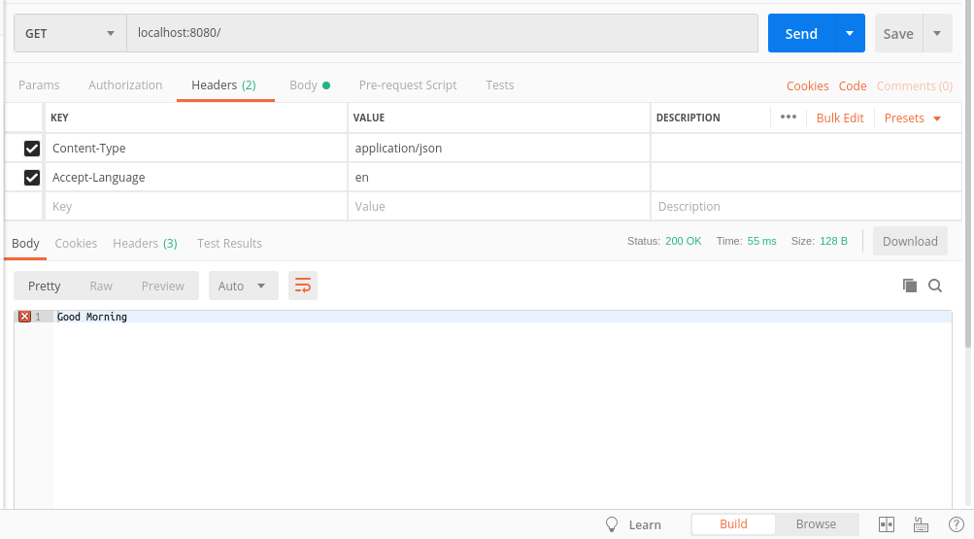

Q5. Return XML Response when new Student is created.

Build.gradle

dependencies {
implementation 'org.springframework.boot:spring-boot-starter-data-jpa'
implementation 'org.springframework.boot:spring-boot-starter-web'
runtimeOnly 'mysql:mysql-connector-java'
testImplementation 'org.springframework.boot:spring-boot-starter-test'
//for xml response
compile ('com.fasterxml.jackson.dataformat:jackson-dataformat-xml')
}

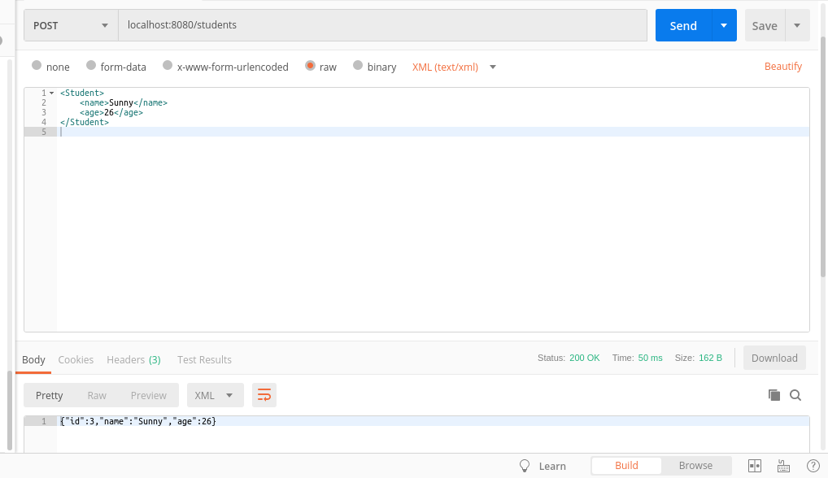

Q6. Ignore ID field in the Response.

Student

package com.rest.SpringRest.entities;
import com.fasterxml.jackson.annotation.JsonIgnore;
import javax.persistence.Entity;
import javax.persistence.GeneratedValue;
import javax.persistence.Id;
import javax.validation.constraints.Size;

@Entity
public class Student {
@Id
@GeneratedValue
@JsonIgnore
private Integer id;
@Size(min = 2,message = "Name should have at least 2 characters")
private String name;
private Integer age;
public Integer getId() {
return id;
}
public void setId(Integer id) {
this.id = id;
}
public String getName() {
return name;
}
public void setName(String name) {
this.name = name;
}
public Integer getAge() {
return age;
}
public void setAge(Integer age) {
this.age = age;
}
@Override
public String toString() {
return "Student{" +
"id=" + id +
", name='" + name + '\'' +
", age=" + age +
'}';
}
}

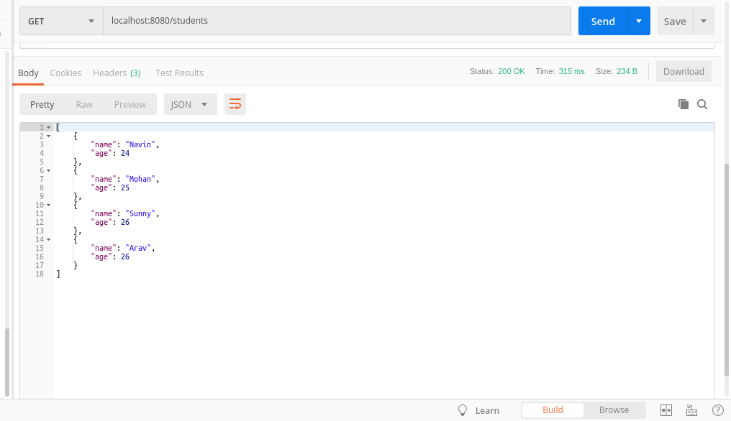

Q7. Create 2 versions of your API one take reprsent name of the Student as single string and other showing firstname and lastname seperately. (Create the Versions of the API using URI, parameter and header versioning)

StudentV1

package com.rest.SpringRest.entities;

public class StudentV1 {
private String name;
public StudentV1(String name) {
this.name = name;
}
public String getName() {
return name;
}
public void setName(String name) {
this.name = name;
}
}
StudentV2

package com.rest.SpringRest.entities;

public class StudentV2 {
private Name name;
public StudentV2(Name name) {
this.name = name;
}
public Name getName() {
return name;
}
public void setName(Name name) {
this.name = name;
}
}

Name

package com.rest.SpringRest.entities;

public class Name {
private String firstName;
private String lastName;
public Name(String firstName, String lastName) {
this.firstName = firstName;
this.lastName = lastName;
}
public String getFirstName() {
return firstName;
}
public void setFirstName(String firstName) {
this.firstName = firstName;
}
public String getLastName() {
return lastName;
}
public void setLastName(String lastName) {
this.lastName = lastName;
}
@Override
public String toString() {
return "Name{" +
"firstName='" + firstName + '\'' +
", lastName='" + lastName + '\'' +
'}';
}
}

HomeController

//URI Versioning
@GetMapping("/student/V1")
StudentV1 getStudentV1(){
return new StudentV1("Peter Parker");
}
@GetMapping("/student/V2")
StudentV2 getStudentV2(){
return new StudentV2(new Name("Peter", "Parker"));
}
//Parameter Versioning
@GetMapping(value = "/student/param",params = "version=1")
StudentV1 getStudentParam1() {
return new StudentV1("Peter Parker");
}
@GetMapping(value = "/student/param",params = "version=2")
StudentV2 getStudentParam2() {
return new StudentV2(new Name("Peter", "Parker"));
}
//Header Versioning
@GetMapping(value = "/student/header",headers = "API-VERSION=1")
StudentV1 getStudentHeader1() {
return new StudentV1("Peter Parker");
}
@GetMapping(value = "/student/header",headers = "API-VERSION=2")
StudentV2 getStudentHeader2() {
return new StudentV2(new Name("Peter", "Parker"));
}
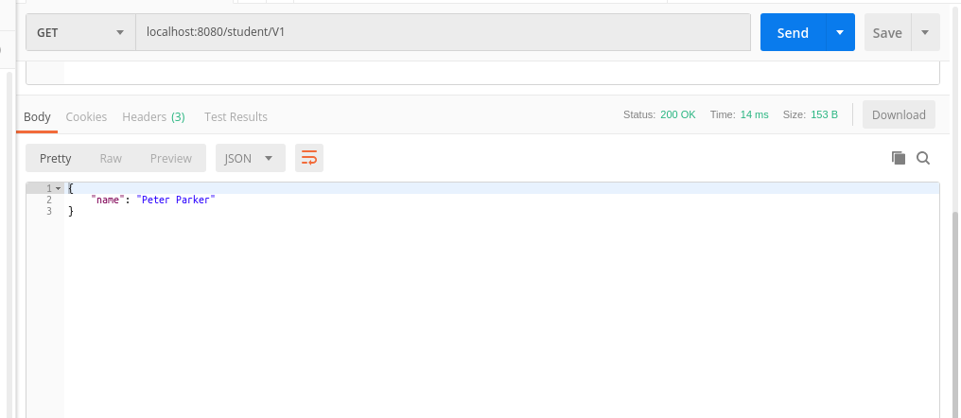

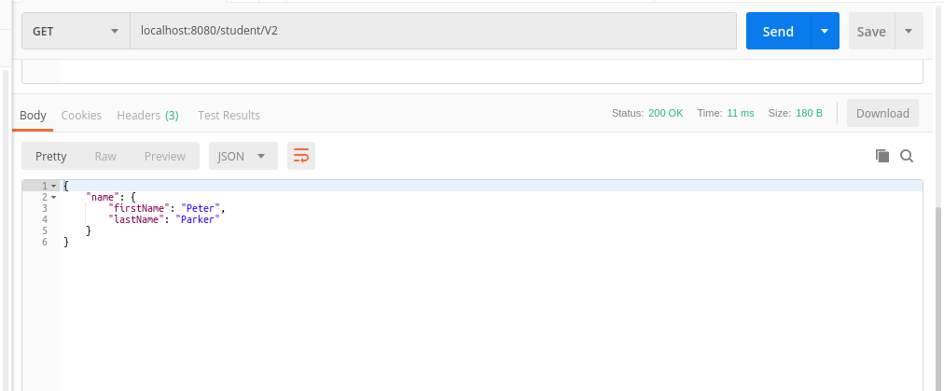

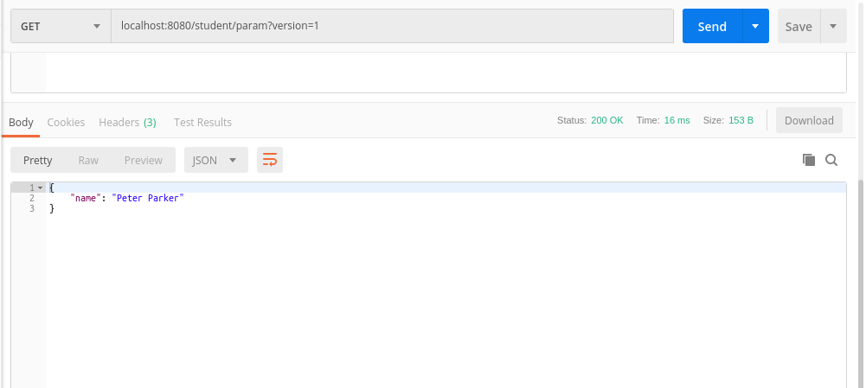
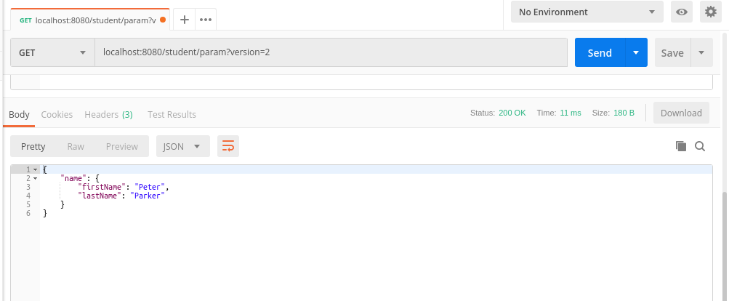

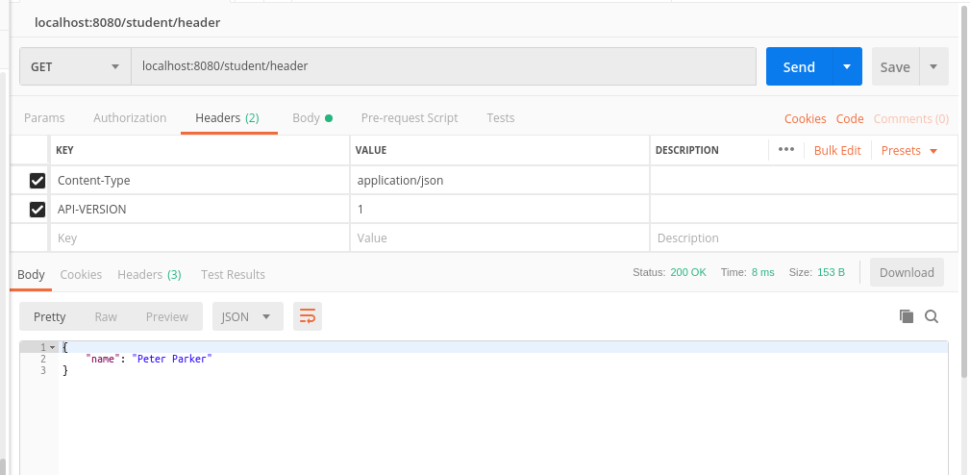

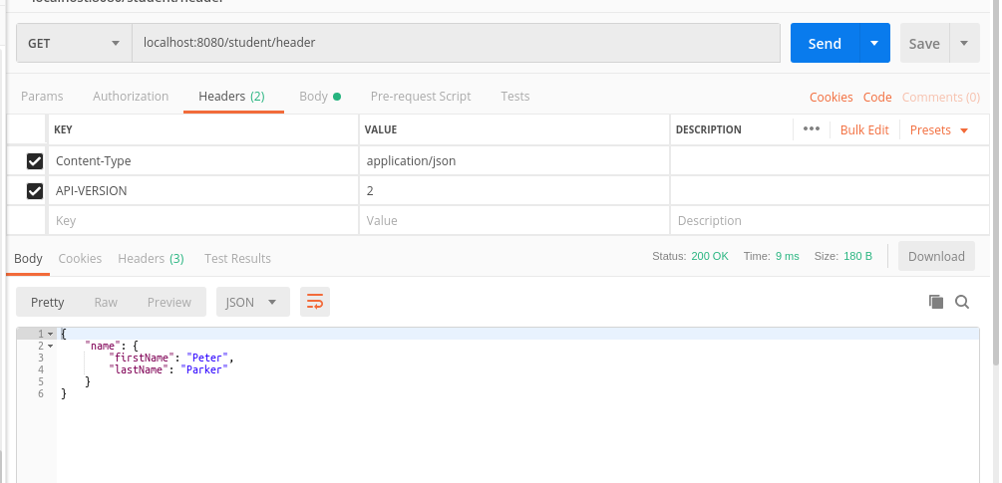

Q8. Perform CRUD operations on the resource below using RestTemplate https://jsonplaceholder.

Post

package com.rest.SpringRest.entities;

public class Post {
private Long userId;
private Long id;
private String title;
private String body;
public Post() {
}
public Post(Long userId, Long id, String title, String body) {
this.userId = userId;
this.id = id;
this.title = title;
this.body = body;
}
public Long getUserId() {
return userId;
}
public void setUserId(Long userId) {
this.userId = userId;
}
public Long getId() {
return id;
}
public void setId(Long id) {
this.id = id;
}
public String getTitle() {
return title;
}
public void setTitle(String title) {
this.title = title;
}
public String getBody() {
return body;
}
public void setBody(String body) {
this.body = body;
}
}

HomeController

@GetMapping("/postObject")
public Post getPostObject(){
RestTemplate restTemplate = new RestTemplate();
String url="https://jsonplaceholder.typicode.com/posts/1";
ResponseEntity<Post> response = restTemplate.getForEntity(url,Post.class);
System.out.println(response.getStatusCode().toString());
System.out.println(response.getHeaders().toString());
return response.getBody();
}

@PostMapping("/createPost")
public ResponseEntity<Post> createPost(){
String url="https://jsonplaceholder.typicode.com/posts";
RestTemplate restTemplate= new RestTemplate();
HttpHeaders httpHeaders= new HttpHeaders();
httpHeaders.add("Content-type","application/json; charset=UTF-8");
HttpEntity<Post> request=new HttpEntity<>(new Post(10000L,10000L,"title1","description1"),httpHeaders);
Post post=restTemplate.postForObject(url,request,Post.class);
System.out.println(post);
return new ResponseEntity<Post>(post, HttpStatus.CREATED);
}

@PutMapping("/updatePost")
public ResponseEntity<Post> updatePost(){
String url="https://jsonplaceholder.typicode.com/posts/1";
RestTemplate restTemplate= new RestTemplate();
HttpHeaders httpHeaders= new HttpHeaders();
httpHeaders.add("Content-type","application/json; charset=UTF-8");
HttpEntity<Post> request=new HttpEntity<>(new Post(1L,100L,"title1","description1"),httpHeaders);
return restTemplate.exchange(url, HttpMethod.PUT,request,Post.class);
}

@DeleteMapping("/deletePost")
public void deletePost(){
String url="https://jsonplaceholder.typicode.com/posts/1";
RestTemplate restTemplate= new RestTemplate();
HttpHeaders httpHeaders= new HttpHeaders();
httpHeaders.add("Content-type","application/json; charset=UTF-8");
HttpEntity<Post> request=new HttpEntity<>(httpHeaders);
restTemplate.exchange(url,HttpMethod.DELETE,request,Post.class);
}

