Q1. Create an external JS file and use it to show an alert on click of a button.

Index.html

<!DOCTYPE html>
<html lang="en" xmlns:th="http://www.thymeleaf.org">
<head>
<meta charset="UTF-8">
<title>Index</title>
<script th:src="@{'/JS/alert.js'}"></script>
</head>
<body>
<input type="button" value="Click Me" onclick="alertBox()">
</body>
</html>

MyController

package com.spring.ThymeleafDemo.controller;
import org.springframework.stereotype.Controller;
import org.springframework.web.bind.annotation.GetMapping;
@Controller
public class MyController {
@GetMapping("/")
public String firstPage(){
return "index";
}
}
alert.js

function alertBox() {
alert("Clicked..")
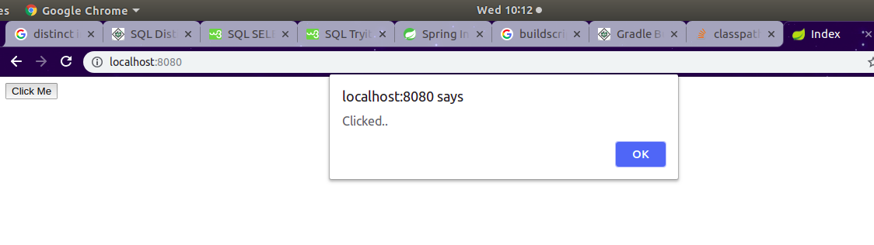
}

Q2. Create an external CSS file and use it to modify hello world page background color to grey.

HelloWorld.html

<!DOCTYPE html>
<html lang="en" xmlns:th="http://www.thymeleaf.org">
<head>
<meta charset="UTF-8">
<title>Hello World</title>
<link th:href="@{'/CSS/style.css'}" rel="stylesheet"/>
</head>
<body>
<h1>Hello World</h1>
</body>
</html>
style.css

body{
background-color: gray;
}
MyController

package com.spring.ThymeleafDemo.controller;
import org.springframework.stereotype.Controller;
import org.springframework.web.bind.annotation.GetMapping;
@Controller
public class MyController {

@GetMapping("/hello-world")
public String helloWorldPage(){
return "helloWorld";
}
}
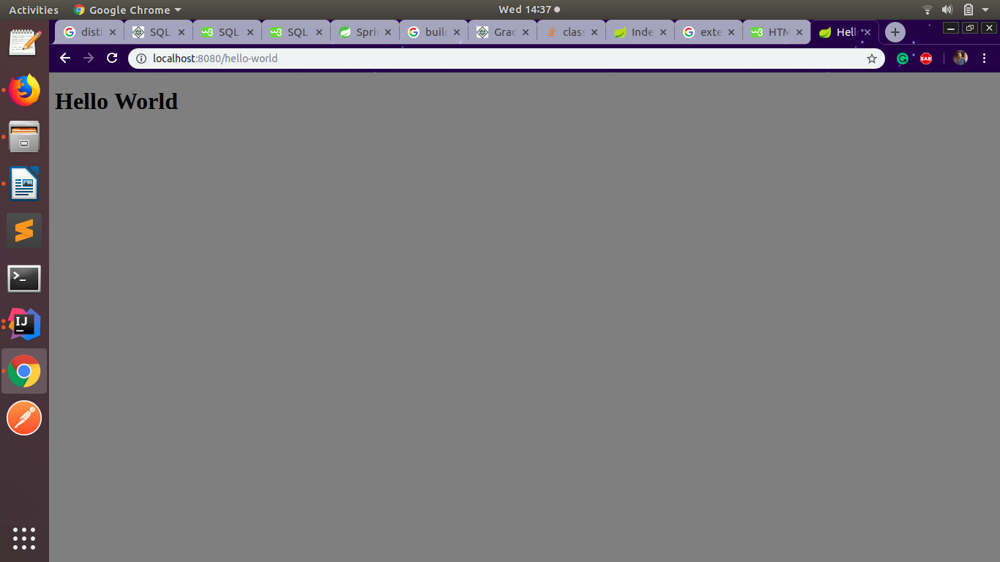
Q3. Create an Employee registration form and bind it's requested values on the controller.
Employee.html
<!DOCTYPE html>
<html lang="en" xmlns:th="http://www.thymeleaf.org">
<head>
<meta charset="UTF-8">
<title>Employee Registration</title>
<style>
label{
width: 100px;
display: inline-block;
}
</style>
</head>
<body>
<h1>Employee Registration Form</h1>
<hr/>
<form name="form1" method="post">
<label>Name: </label>
<input type="text" name="name"><br><br>
<label>Id: </label>
<input type="number" name="id"><br><br>
<label>Email id:</label>
<input type="email" name="email"><br><br>
<label>Competency</label>
<input type="text" name="competency"><br><br>
<input type="submit">
</form>
</body>
</html>
MyController
package com.spring.ThymeleafDemo.controller;
import org.springframework.http.HttpRequest;
import org.springframework.stereotype.Controller;
import org.springframework.ui.Model;
import org.springframework.web.bind.annotation.GetMapping;
import org.springframework.web.bind.annotation.PostMapping;
import javax.servlet.http.HttpServletRequest;

@Controller
public class MyController {

@GetMapping("/employeeForm")
public String employeeForm(){
return "employee";
}
@PostMapping("/employeeForm")
public String getEmployeeDetail(HttpServletRequest request, Model model){
model.addAttribute("name", request.getParameter("name"));
model.addAttribute("id", request.getParameter("id"));
model.addAttribute("email", request.getParameter("email"));
model.addAttribute("competency", request.getParameter("competency"));
return "employeeDetail";
}
}

employeeDetail.html
<!DOCTYPE html>
<html lang="en" xmlns:th="http://www.thymleaf.org">
<head>
<meta charset="UTF-8">
<title>Employee Detail</title>
<style>
label{
display: inline-block;
width: 100px;
}
</style>
</head>
<body>
<center>
<label>Name:</label> <h4 th:text="${name}"></h4>
<label>Id:</label> <h4 th:text="${id}"></h4>
<label>Email Id:</label> <h4 th:text="${email}"></h4>
<label>competency:</label> <h4 th:text="${competency}"></h4>
</center>
</body>
</html>

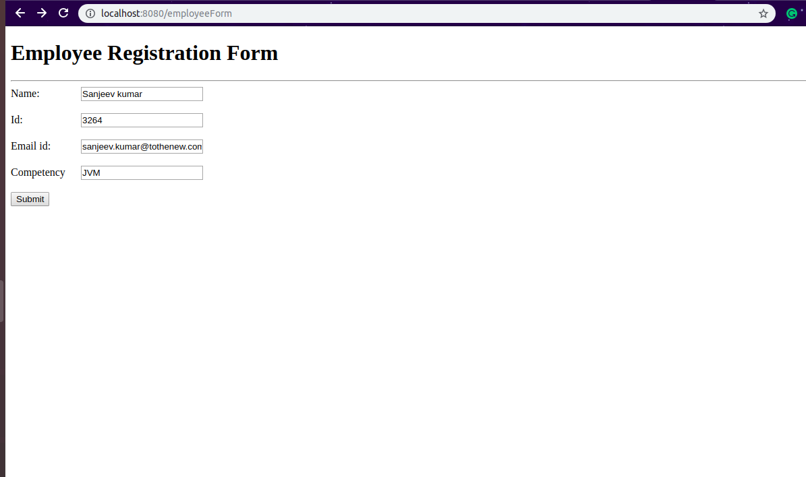

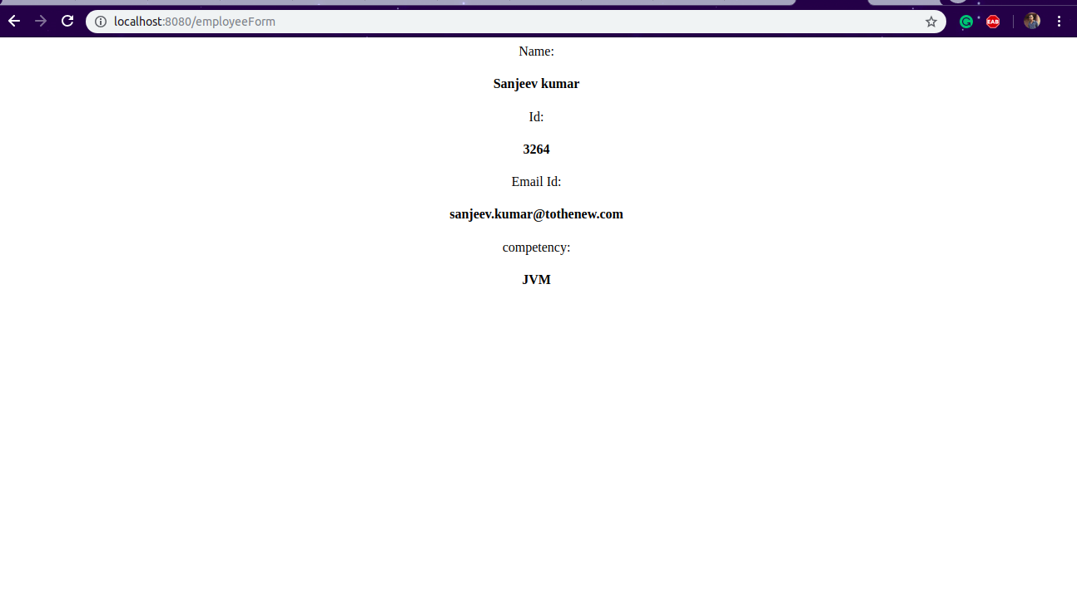

Q4. Create a dynamic HTML page and render an Employee table with emp object return from the controller
MyController
package com.spring.ThymeleafDemo.controller;
import com.spring.ThymeleafDemo.Employee;
import org.springframework.http.HttpRequest;
import org.springframework.stereotype.Controller;
import org.springframework.ui.Model;
import org.springframework.web.bind.annotation.GetMapping;
import org.springframework.web.bind.annotation.PostMapping;
import javax.servlet.http.HttpServletRequest;
import java.util.Arrays;
import java.util.List;

@Controller
public class MyController {

@GetMapping("/employees")
public String getEmployee(Model model){
List<Employee> employeeList = Arrays.asList(new Employee("Toshik", 2211, "toshik@gmail.com", 34000),
new Employee("Abhinav", 3321, "abhinav@gmail.com",25000),
new Employee("Ajitabh", 1211, "ajitabh@gmail.com", 33000));
model.addAttribute("employees",employeeList);
return "employeeTable";
}
}
employeeTable.html
<!DOCTYPE html>
<html lang="en" xmlns:th="http://www.w3.org/1999/xhtml">
<head>
<meta charset="UTF-8">
<title>Employee Table</title>
<style>
table {
border-collapse: collapse;
}
table, td {
border: 1px solid darkolivegreen;
padding: 5px;
text-align: center;
}
</style>
</head>
<body>
<center>
<table>
<tr>
<td>Name</td>
<td>Id</td>
<td>Email</td>
<td>Salary</td>
</tr>
<tr th:each="employee : ${employees}">
<td th:text="${employee.name}"></td>
<td th:text="${employee.id}"></td>
<td th:text="${employee.email}"></td>
<td th:text="${employee.salary}"></td>
</tr>
</table>
</center>
</body>
</html>

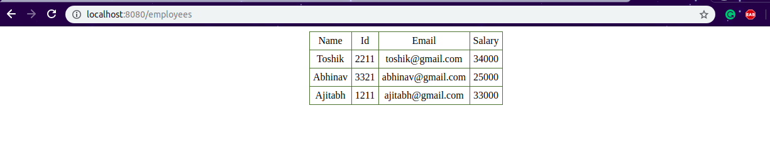

Q5. Show different custom greeting message based on the type of user. For example, if the user is of type admin=true then show "Hello Admin" message on Page else show "Hello User" basis on isAdmin attribute value passed in model data.
User.html
<!DOCTYPE html>
<html lang="en" xmlns:th="http://www.thymeleaf.org">
<head>
<meta charset="UTF-8">
<title></title>
</head>
<body>
<form name="form1" method="post">
<input type="radio" name="user" value="admin"> Admin<br>
<input type="radio" name="user" value="user"> User<br>
<input type="submit" value="Go">
</form>
</body>
</html>

MyController
package com.spring.ThymeleafDemo.controller;
import com.spring.ThymeleafDemo.Employee;
import org.springframework.http.HttpRequest;
import org.springframework.stereotype.Controller;
import org.springframework.ui.Model;
import org.springframework.web.bind.annotation.GetMapping;
import org.springframework.web.bind.annotation.PostMapping;
import javax.servlet.http.HttpServletRequest;
import java.util.Arrays;
import java.util.List;

@Controller
public class MyController {

@GetMapping("user")
public String userForm(){
return "user";
}
@PostMapping("user")
public String checkUser(HttpServletRequest request, Model model){
model.addAttribute("userType",request.getParameter("user"));
return "userTypePage";
}
}

userTypePage.html
<!DOCTYPE html>
<html lang="en" xmlns:th="http://www.w3.org/1999/xhtml">
<head>
<meta charset="UTF-8">
<title>Title</title>
</head>
<body th:with="isAdmin=${userType=='admin'}?'true':'false'">
<span th:if="${isAdmin}">Welcome Admin..!</span>
<span th:unless="${isAdmin}">Welcome User..!</span>
</body>
</html>
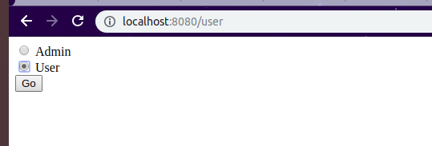

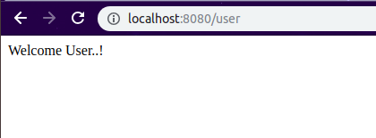

Q6. Create and split common header and footer in the above-created listing page.
User.html
<!DOCTYPE html>
<html lang="en" xmlns:th="http://www.thymeleaf.org">
<head>
<meta charset="UTF-8">
<title></title>
</head>
<body>
<form name="form1" method="post">
<input type="radio" name="user" value="admin"> Admin<br>
<input type="radio" name="user" value="user"> User<br>
<input type="submit" value="Go">
</form>
</body>
</html>

MyController
package com.spring.ThymeleafDemo.controller;
import com.spring.ThymeleafDemo.Employee;
import org.springframework.http.HttpRequest;
import org.springframework.stereotype.Controller;
import org.springframework.ui.Model;
import org.springframework.web.bind.annotation.GetMapping;
import org.springframework.web.bind.annotation.PostMapping;
import javax.servlet.http.HttpServletRequest;
import java.util.Arrays;
import java.util.List;

@Controller
public class MyController {

@GetMapping("user")
public String userForm(){
return "user";
}
@PostMapping("user")
public String checkUser(HttpServletRequest request, Model model){
model.addAttribute("userType",request.getParameter("user"));
return "userTypePage";
}
}

userTypePage.html
<!DOCTYPE html>
<html lang="en" xmlns:th="http://www.w3.org/1999/xhtml">
<head>
<meta charset="UTF-8">
<title>Title</title>
</head>
<body th:with="isAdmin=${userType=='admin'}?'true':'false'">
<div th:if="${isAdmin}">
<header th:insert="fragments/admin-header.html :: header"></header>
<p>Welcome Admin..!</p>
</div>
<div th:unless="${isAdmin}">
<header th:insert="fragments/user-header.html :: header"></header>
<p>Welcome User..!</p>
</div>
<footer th:insert="fragments/footer.html :: footer"></footer>
</body>
</html>

user-header.html
<!DOCTYPE html>
<html lang="en" xmlns:th="http://www.thymeleaf.org">
<head>
<meta charset="UTF-8">
<title>Title</title>
</head>
<body>
<div style="background-color: cadetblue; padding: 2px; text-align: center " th:fragment="header">
<h1>This is user header</h1>
</div>
</body>
</html>
admin-header.html
<!DOCTYPE html>
<html lang="en" xmlns:th="http://www.thymeleaf.org">
<head>
<meta charset="UTF-8">
<title>Title</title>
</head>
<body>
<div style="background-color: darkolivegreen; padding: 2px; text-align: center" th:fragment="header">
<h1>This is admin header</h1>
</div>
</body>
</html>

footer.html
<!DOCTYPE html>
<html lang="en" xmlns:th="http://www.thymeleaf.org">
<head>
<meta charset="UTF-8">
<title></title>
</head>
<body>
<div style="background-color: greenyellow; padding: 5px; text-align: center" th:fragment="footer">
2016 Footer
</div>
</body>
</html>

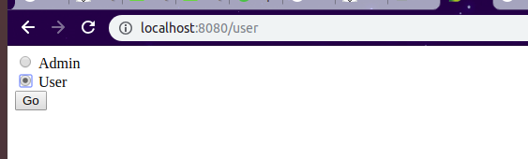
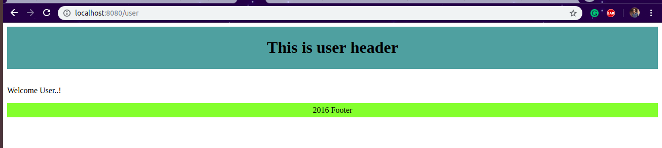

Q7.Make a web page to show server time using ajax call.
MyController
@GetMapping("/showTime")
public String getServerTime(){
return "showTime";
}
@RequestMapping("/getTime")
@ResponseBody
public String getTime(){
LocalTime time = LocalTime.now();
String formatedTime = time.getHour()+":"+time.getMinute()+":"+time.getSecond();
return formatedTime;
}
showTime.html
<!DOCTYPE html>
<html lang="en" xmlns:th="http://www.w3.org/1999/xhtml">
<head>
<meta charset="UTF-8">
<title></title>
<script src="https://ajax.googleapis.com/ajax/libs/jquery/3.3.1/jquery.min.js"></script>
<script th:src="@{'/JS/showTime.js'}"></script>
</head>
<body>
<p id="time">Time: </p>
</body>
</html>
showTime.js
$(document).ready(function(){
var time=$.ajax({
url :'/getTime',
type :'GET'
});
time.done(function (data) {
$("#time").append(data)
});
time.fail(function(){
console.log("Error in fetching time");
});
})

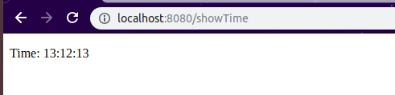

Q8. Create a user listing table show alternate row color using a conditional tag.
MyController
@GetMapping("/userConditional")
public String userConditionalTag(Model model){
List<User> userList = Arrays.asList(new User(11,"Adhiraj","Ranchi"), new User(12,"Abhinav","Delhi"),
new User(13,"Neeraj","Jaipur"), new User(14,"Vivek","Noida"));
model.addAttribute("users",userList);
return "userTable";
}
userTable.html
<!DOCTYPE html>
<html lang="en" xmlns:th="http://www.w3.org/1999/xhtml">
<head>
<meta charset="UTF-8">
<title></title>
<style>
table {
border-collapse: collapse;
}
table, td {
border: 1px solid darkolivegreen;
padding: 5px;
text-align: center;
}
</style>
</head>
<body>
<table>
<tr>
<td>Id</td>
<td>Name</td>
<td>City</td>
</tr>
<tr th:each="user, iStat : ${users}"
th:style="${iStat.odd}? 'background-color: aquamarine;'">
<td th:text="${user.id}"></td>
<td th:text="${user.name}"></td>
<td th:text="${user.city}"></td>
</tr>
</table>
</body>
</html>
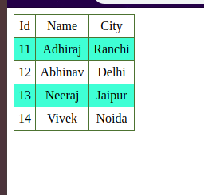

Q9. Create an ENUM with values USER, ADMIN, SUPER_ADMIN and iterate it to show a custom message to users basis on the ENUM value.
MyController
@GetMapping("/enumUser")
public String getEnumUser(){
return "enum-userType";
}
enum-userType.html
<!DOCTYPE html>
<html lang="en" xmlns:th="http://www.w3.org/1999/xhtml">
<head>
<meta charset="UTF-8">
<title></title>
</head>
<script th:src="@{/JS/showSelectedValue.js}"></script>
<body>
<form name="form1">
<label>Select user..</label>
<select name="mySelectedValue" id="mySelectedValue" onchange="selectedValue()">
<option th:value="None">Select One</option>
<option th:each="user : ${T(com.spring.ThymeleafDemo.EnumUser).values()}"
th:value="${user.getValue()}" th:text="${user.getValue()}"></option>
</select>
</form>
<p id="value" name="value"></p>
</body>
</html>
showSelectedValue.js
function selectedValue(){
var val = document.getElementById("mySelectedValue").value;
document.getElementById("value").innerHTML="Welcome "+val;
}

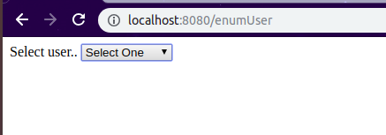

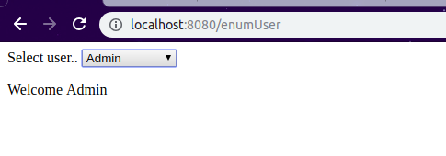

Q10. Add loader in registration form submission which renders load till server return success form submission response.
MyController
@GetMapping("/showLoader")
public String showLoader(){
return "registration";
}

@PostMapping("/registrationSubmit")
@ResponseBody
public String registerEmployee(@ModelAttribute Employee employee)
{
try {
Thread.sleep(1000);
} catch (InterruptedException e) {
e.printStackTrace();
}
return "Registered: "+employee.getName()+"\n";
}
registration.html
<!DOCTYPE html>
<html lang="en" xmlns:th="http://www.w3.org/1999/xhtml">
<head>
<meta charset="UTF-8">
<title></title>
<script
src="https://code.jquery.com/jquery-3.3.1.min.js"
integrity="sha256-FgpCb/KJQlLNfOu91ta32o/NMZxltwRo8QtmkMRdAu8="
crossorigin="anonymous"></script>
<title>Employee Registration Form</title>
<script th:src="@{/JS/showLoader.js}"></script>
<script type="text/javascript">
$(function(){
$("#LoadingImage").hide();
$("#employeeRegitsrationForm").on('submit',function(){
var data=$("#employeeRegitsrationForm").serialize();
showImage(data);
return false;
})
$(document).ajaxStart(function () {
$("#LoadingImage").show();
})
})
</script>
<style>
label{
display: inline-block;
width: 100px;
}
</style>
</head>
<body>
<form id="employeeRegitsrationForm" method="post">
<label>Id:</label> <input type="number" name="id" id="id"><br><br>
<label>Name :</label><input type="text" id="name" name="name"><br><br>
<label>Email :</label> <input type="email" name="email" id="email"><br><br>
<label>Salary :</label><input type="number" id="salary" name="salary"><br><br>
<input type="submit" value="Submit">
</form>
<p id="response"></p>
<div id="LoadingImage">
<img src="images/loader.gif"/>
</div>
</body>
</html>
showLoader.js
function showImage(formData)
{
var res= $.ajax({
method: "POST",
url: "/registrationSubmit",
data: formData,
success: function (data) {
console.log(data)
$("#LoadingImage").hide();
$("#response").append("Response "+data);
console.log("Successful Registration");
},
error: function (xhr, status) {
$("#LoadingImage").hide();
alert('Unknown error ' + status);
}
});
}

