1. OrderTest.groovy

package demo.domain
import spock.lang.Shared
import spock.lang.Specification
import spock.lang.Unroll

class OrderTest extends Specification {

def "constructor"(){
setup:
Order order;
when:
order = new Order(2,"laptop",55000)
then:
order.getQuantity()==2
order.getItemName()=="laptop"
order.getPrice()==55000
}

@Unroll
def "set Item Name"(){
setup:
Order order = new Order();
when:
order.setItemName(set)
then:
order.getItemName()==get
where:
set|get
"laptop"|"laptop"
"mobile"|"mobile"
}

@Unroll
def "set Price"(){
setup:
Order order = new Order();
when:
order.setPrice(set)
then:
order.getPrice()==get
where:
set|get
5000.68|5000.68
0|0
}

@Unroll
def "set Price With Tax"() {
setup:
Order order = new Order();
when:
order.setPriceWithTex(set)
then:
order.getPriceWithTex()==get
where:
set|get
5000.68|5000.68
0|0
}

@Unroll
def "set Quantity"(){
setup:
Order order = new Order();
when:
order.setQuantity(set)
then:
order.getQuantity()==get
where:
set|get
50|50
10|10
}
}

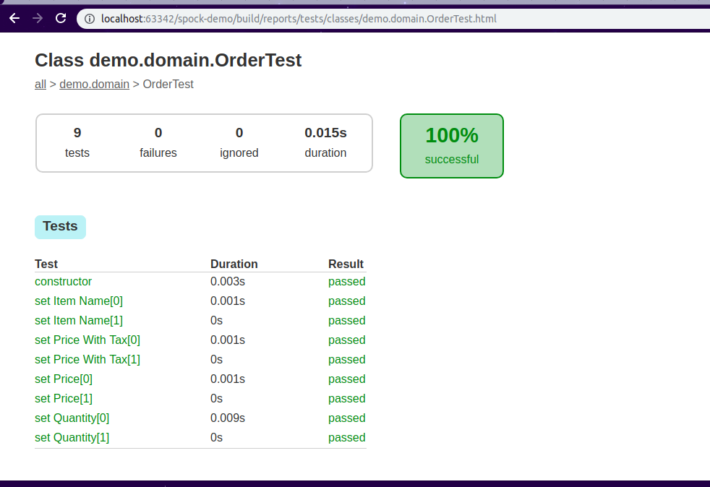

2. EmailServiceTest.groovy

package demo.service
import demo.domain.Order
import spock.lang.Specification

class EmailServiceTest extends Specification {

def "Send Email"() {
setup:
EmailService emailService = EmailService.getInstance();
when:
Order order = Mock(Order)
emailService.sendEmail(order);
then:
thrown(RuntimeException)
}

def "Send Email using a string"() {
setup:
EmailService emailService = EmailService.getInstance();
when:
Order order = Mock(Order)
Boolean result = emailService.sendEmail(order, "abc");
then:
result
}

def "send email with a string for cancel order"() {
setup:
EmailService emailService = EmailService.getInstance();
when:
Order order = Mock(Order)
boolean result = emailService.sendEmail(order, string)
then:
result == inputstatus
where:
string | inputstatus
"cancel" | true
" " | true
}
}
