
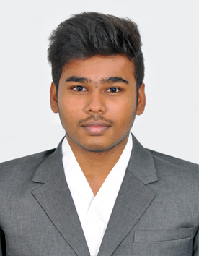
SANJEEV M
Computer Science Engineering
8870414266
sanjeevm4788@gmail.com
124-B/8,Thirumagal Nagar
,Rabindarnath Tagore Road
,Manikarampalayam,Ganapathy
,Coimbatore-641006
Seeking the position to utilize my skills and abilities in the field of Information Technology industry that offers professional as well as personal growth. I would like to utilize my skills and experience to the fullest potential while demonstrating my ability and eagerness on taking responsibility to develop a harmonious relationship between co-workers in reaching an organizational growth.

ACADEMIC BACKGROUND
Course | Institution | Board /  University | Year of Completion | Percentage/ CGPA
BE (CSE) | Sri Shakthi Institute of Engineering and Technology | Anna University | 2017-2021
H.S.C | Venkatalakshmi Matric Higher Secondary School | State Board | 2017 | 91.8%
S.S.L.C | Srinivasa Vidyalaya Mariculation Higher secondary School | State Board | 2015 | 85.75’%
AREAS OF INTEREST
- Full StackDevelopment
- ArtificialIntelligence
- IOTprojects
IT SKILLS
- Languages: Python, C, C++, Java, HTML, CSS, JavaScript.
- Software: Adobe Photoshop, Android Studio, Visual Studio.
PROJECTS

APP DEVELOPMENT
Company : Abhile tech
Duration : 4Week
Description : Developed an app.

MINI PROJECT
Institution : Sri Shakthi Institute of Engineering and Technology, CBE. Duration : 1 Month
Project Title : Cricket League Managegment Systems
Description : Devloped a Software to maintain a cricket league.

MINI PROJECT
Institution : Sri Shakthi Institute of Engineering and Technology, CBE. Duration : 1Semester
Project Title : Online Course Management Systems
Description : Created a Software Register Online Courses
IMPLANT TRAINING / INDUSTRIAL VISITS

INTERNSHIPS
1. Company Name : Abhile tech
Duration : 28Days.
Purpose : Training on AppDevelopment.
INDUSTRIAL VISITS
1.Company Name :Vipro
Duration :1day
KEY STRENGTHS
- FastLearner.
- Hard worker.
- Self-motivated.
- Multi-tasker.
- Pressure handler.
- Leadership
ACADEMIC / EXTRA-CURRICULAR ACTIVITIES
- Attended various intra college competitions
- Developed an application on my own
DECLARATION
I hereby declare the above information is true to the best of my knowledge.

DATE:
PLACE:
SANJEEV M

