Game of Life - Solution

Business Problem – Game of Life 1
Problem 1
Assumptions 2
Known issues 2
Solution 4
Class Diagram 4
Sequence Diagram 5

Business Problem – Game of Life
The universe of the Game of Life is an infinite two-dimensional orthogonal grid of square cells, each of which is in one of two possible states, live or dead. Every cell interacts with its eight neighbors, which are the cells that are directly horizontally, vertically, or diagonally adjacent. At each step in time, the following transitions occur:
- Any live cell with fewer than two live neighbors dies, as if by loneliness.
- Any live cell with more than three live neighbors dies, as if by overcrowding.
- Any live cell with two or three live neighbors lives, unchanged, to the next generation.
- Any dead cell with exactly three live neighbors comes to life.
The initial pattern constitutes the 'seed' of the system. The first generation is created by applying the above rules simultaneously to every cell in the seed — births and deaths happen simultaneously, and the discrete moment at which this happens is sometimes called a tick. (In other words, each generation is a pure function of the one before.) The rules continue to be applied repeatedly to create further generations.

Problem
The inputs below represent the cells in the universe as X or - . X is a alive cell. - is a dead cell or no cell. The below inputs provide the provide pattern or initial cells in the universe. The output is the state of the system in the next tick (one run of the application of all the rules), represented in the same format.

Input A:  (Block pattern)  X X  X X  Output A:  X X  X X | Input B  (Boat pattern)  X X -  X - X  - X -  Output B  X X -  X - X  - X -
Input C  (Blinker pattern)  - X -  - X -  - X -  Output C  - - -  X X X  - - - | Input D  (Toad pattern)  - X X X  X X X -  Output D  - - X -  X - - X  X - - X  - X - -

Assumptions
- The input for creating the Universe of life shall be a 2 dimensional character array. It is possible to extend the functionally to allow other input types also. However, current system supports only two dimensional character array.
- Each array in the two dimensional array shall have same number of elements so that it makes a perfect “R X C” matrix if displayed.
- Out of curiosity, I have created the solution that can keep generating next version of the universe until one of the following three scenario occur
  - Universe is dead. There are no live cells in universe.
  - Universe pattern is identical to one of the previous generations that were generated. So the Universe pattern has started repeating itself.
  - For hardware and memory constraints on my laptop I have limited the number of generation to create and store for a pattern to 10. However I have tested it for large numbers as well.
- Output displays all generations that are stored and not just the next one.
- Output for the provided input patterns can be seen by running the test cases that are provided with the code in class: GameOfLifeTest.Java.
- I have compiled and tested the code with JDK1.6, JDK1.7 and Junt4.4, Junit4.10 on two different workbenches.
Known issues
- There are SOPs inside the test cases to generate the output on console.
- To keep it simple the Service locator class is a very basic one and does not do service pooling and other advanced stuff.
- The singleton class: GameOfLifePlayer.java is not a strict singleton.
- There may be some scope of improving the algorithm for generating next generation. However I have tried to keep it as efficient as possible in the limited time that I had.
- I have skipped some details in the sequence diagram to keep it simple and readable. However you will still have to zoom out this document to 200% to read it properly.
- Couple of classes have been deprecated but still kept in the code for my reference and in case they can be used in later version.
- All the classes are packaged under same default package to keep it simple to browse through and transfer over email.
- Test class is also packaged with the core classes for the same reason as above.

Continued on next page….

Solution
Solution consists of
- Class diagram: It can be found in this document below. It provides a snapshot of all the classes in the code. Deprecated classes have been removed from this view. Also, for the sake of simplicity lower level details like method arguments, return types have been omitted from the diagram.
- Sequence diagram: It can be found in this document below Provides the runtime behavior and interaction of the system. Please zoom to 200% for a better view.
- Source Code: The compressed (zip) src folder with all .java classes including the test class.
Class Diagram
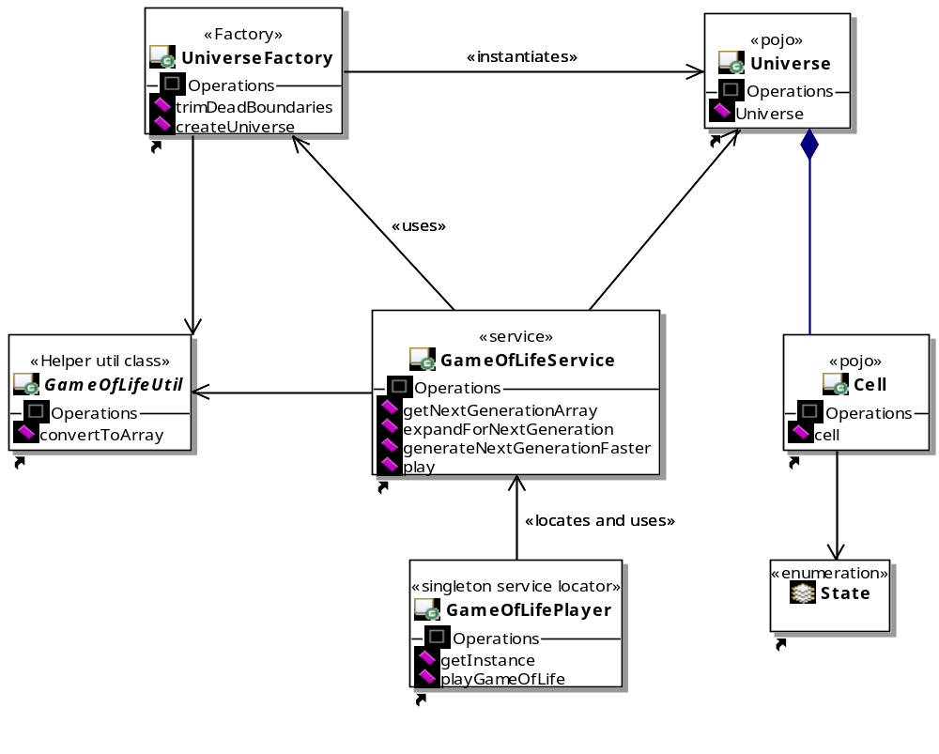
Continued on next page….
Sequence Diagram
Please zoom to 200% for a better view
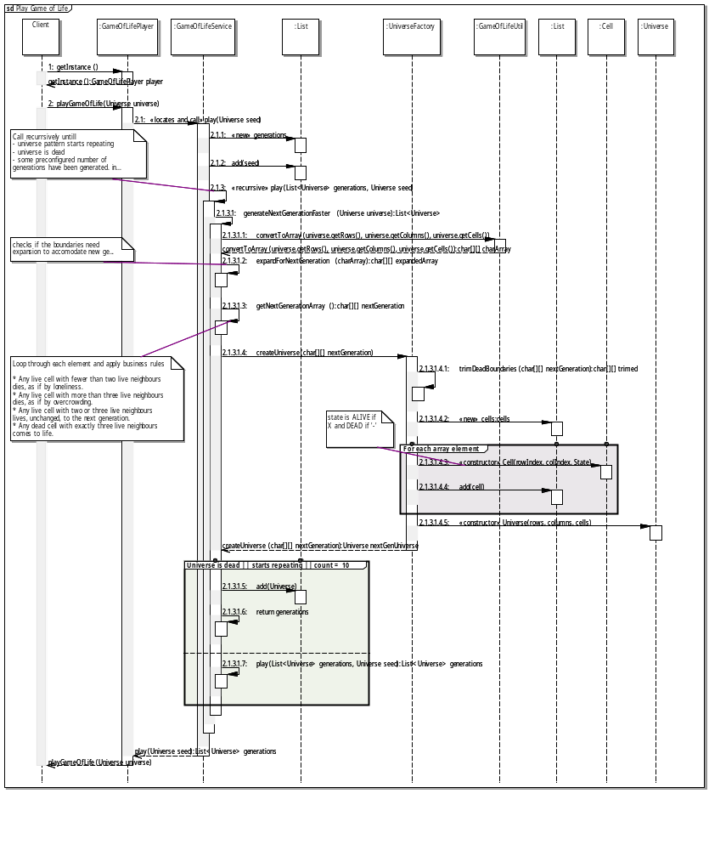
Actual Output from Test Cases
- Dead universe state is displayed as “–“.
- Output Generation # 1 below is the seed or input for the universe.

Block Pattern
Output Generation # 1
X X
X X

Output Generation # 2
X X
X X

Boat Pattern
Output Generation # 1
X X -
X - X
- X -

Output Generation # 2
X X -
X - X
- X -

Blinker Pattern
Output Generation # 1
X
X
X

Output Generation # 2
X X X

Output Generation # 3
X
X
X

Toad Pattern
Output Generation # 1
- X X X
X X X -

Output Generation # 2
- - X -
X - - X
X - - X
- X - -

Output Generation # 3
- X X X
X X X -

Random Pattern
Output Generation # 1
X X X X
X X X X
X X X X
X X X X

Output Generation # 2
- - X X - -
- X - - X -
X - - - - X
X - - - - X
- X - - X -
- - X X - -

Output Generation # 3
- - X X - -
- X X X X -
X X - - X X
X X - - X X
- X X X X -
- - X X - -

Output Generation # 4
- X - - X -
X - - - - X
- - - - - -
- - - - - -
X - - - - X
- X - - X -

Output Generation # 5
-

Circle Pattern
Output Generation # 1
- - X X - - - - - - X X - -
- - - - - - - - - - - - - -
X - - - - - - - - - - - - X
X - - - - - - - - - - - - X
- - - - - - - - - - - - - -
- - - - - - X X - - - - - -
- - - - - X - - X - - - - -
- - - - - X - - X - - - - -
- - - - - - X X - - - - - -
- - - - - - - - - - - - - -
X - - - - - - - - - - - - X
X - - - - - - - - - - - - X
- - - - - - - - - - - - - -
- - X X - - - - - - X X - -

Output Generation # 2
- X X -
X - - X
X - - X
- X X -

Output Generation # 3
- X X -
X - - X
X - - X
- X X -

Universe with more than 10 generations
Output Generation # 1
X X X X X X X X X X
X X X X X X X X X X
X X X X X X X X X X
X X X X X X X X X X
X X X X X X X X X X
X X X X X X X X X X
X X X X X X X X X X
X X X X X X X X X X
X X X X X X X X X X
X X X X X X X X X X

Output Generation # 2
- - X X X X X X X X - -
- X - - - - - - - - X -
X - - - - - - - - - - X
X - - - - - - - - - - X
X - - - - - - - - - - X
X - - - - - - - - - - X
X - - - - - - - - - - X
X - - - - - - - - - - X
X - - - - - - - - - - X
X - - - - - - - - - - X
- X - - - - - - - - X -
- - X X X X X X X X - -

Output Generation # 3
- - - - X X X X X X - - - -
- - - X X X X X X X X - - -
- - X X X X X X X X X X - -
- X X - - - - - - - - X X -
X X X - - - - - - - - X X X
X X X - - - - - - - - X X X
X X X - - - - - - - - X X X
X X X - - - - - - - - X X X
X X X - - - - - - - - X X X
X X X - - - - - - - - X X X
- X X - - - - - - - - X X -
- - X X X X X X X X X X - -
- - - X X X X X X X X - - -
- - - - X X X X X X - - - -

Output Generation # 4
- - - - - - X X X X - - - - - -
- - - - X - - - - - - X - - - -
- - - X - - - - - - - - X - - -
- - X - - - - - - - - - - X - -
- X - - - X X X X X X - - - X -
- - - - X - - - - - - X - - - -
X - - - X - - - - - - X - - - X
X - - - X - - - - - - X - - - X
X - - - X - - - - - - X - - - X
X - - - X - - - - - - X - - - X
- - - - X - - - - - - X - - - -
- X - - - X X X X X X - - - X -
- - X - - - - - - - - - - X - -
- - - X - - - - - - - - X - - -
- - - - X - - - - - - X - - - -
- - - - - - X X X X - - - - - -

Output Generation # 5
- - - - - - - - X X - - - - - - - -
- - - - - - - - X X - - - - - - - -
- - - - - - - - X X - - - - - - - -
- - - - X - - - - - - - - X - - - -
- - - X - - - X X X X - - - X - - -
- - - - - - X X X X X X - - - - - -
- - - - - X - X X X X - X - - - - -
- - - - X X X - - - - X X X - - - -
X X X - X X X - - - - X X X - X X X
X X X - X X X - - - - X X X - X X X
- - - - X X X - - - - X X X - - - -
- - - - - X - X X X X - X - - - - -
- - - - - - X X X X X X - - - - - -
- - - X - - - X X X X - - - X - - -
- - - - X - - - - - - - - X - - - -
- - - - - - - - X X - - - - - - - -
- - - - - - - - X X - - - - - - - -
- - - - - - - - X X - - - - - - - -

Output Generation # 6
- - - - - - - - X X - - - - - - - -
- - - - - - - X - - X - - - - - - -
- - - - - - - - X X - - - - - - - -
- - - - - - - X - - X - - - - - - -
- - - - - - X - - - - X - - - - - -
- - - - - - - - - - - - - - - - - -
- - - - X - - - - - - - - X - - - -
- X - X - - - - X X - - - - X - X -
X - X - - - - X - - X - - - - X - X
X - X - - - - X - - X - - - - X - X
- X - X - - - - X X - - - - X - X -
- - - - X - - - - - - - - X - - - -
- - - - - - - - - - - - - - - - - -
- - - - - - X - - - - X - - - - - -
- - - - - - - X - - X - - - - - - -
- - - - - - - - X X - - - - - - - -
- - - - - - - X - - X - - - - - - -
- - - - - - - - X X - - - - - - - -

Output Generation # 7
- - - - - - - - X X - - - - - - - -
- - - - - - - X - - X - - - - - - -
- - - - - - - X X X X - - - - - - -
- - - - - - - X X X X - - - - - - -
- - - - - - - - - - - - - - - - - -
- - - - - - - - - - - - - - - - - -
- - - - - - - - - - - - - - - - - -
- X X X - - - - X X - - - - X X X -
X - X X - - - X - - X - - - X X - X
X - X X - - - X - - X - - - X X - X
- X X X - - - - X X - - - - X X X -
- - - - - - - - - - - - - - - - - -
- - - - - - - - - - - - - - - - - -
- - - - - - - - - - - - - - - - - -
- - - - - - - X X X X - - - - - - -
- - - - - - - X X X X - - - - - - -
- - - - - - - X - - X - - - - - - -
- - - - - - - - X X - - - - - - - -

Output Generation # 8
- - - - - - - - X X - - - - - - - -
- - - - - - - X - - X - - - - - - -
- - - - - - X - - - - X - - - - - -
- - - - - - - X - - X - - - - - - -
- - - - - - - - X X - - - - - - - -
- - - - - - - - - - - - - - - - - -
- - X - - - - - - - - - - - - X - -
- X - X - - - - X X - - - - X - X -
X - - - X - - X - - X - - X - - - X
X - - - X - - X - - X - - X - - - X
- X - X - - - - X X - - - - X - X -
- - X - - - - - - - - - - - - X - -
- - - - - - - - - - - - - - - - - -
- - - - - - - - X X - - - - - - - -
- - - - - - - X - - X - - - - - - -
- - - - - - X - - - - X - - - - - -
- - - - - - - X - - X - - - - - - -
- - - - - - - - X X - - - - - - - -

Output Generation # 9
- - - - - - - - X X - - - - - - - -
- - - - - - - X X X X - - - - - - -
- - - - - - X X - - X X - - - - - -
- - - - - - - X X X X - - - - - - -
- - - - - - - - X X - - - - - - - -
- - - - - - - - - - - - - - - - - -
- - X - - - - - - - - - - - - X - -
- X X X - - - - X X - - - - X X X -
X X - X X - - X - - X - - X X - X X
X X - X X - - X - - X - - X X - X X
- X X X - - - - X X - - - - X X X -
- - X - - - - - - - - - - - - X - -
- - - - - - - - - - - - - - - - - -
- - - - - - - - X X - - - - - - - -
- - - - - - - X X X X - - - - - - -
- - - - - - X X - - X X - - - - - -
- - - - - - - X X X X - - - - - - -
- - - - - - - - X X - - - - - - - -

Output Generation # 10
- - - - - - - X - - X - - - - - - -
- - - - - - X - - - - X - - - - - -
- - - - - - X - - - - X - - - - - -
- - - - - - X - - - - X - - - - - -
- - - - - - - X - - X - - - - - - -
- - - - - - - - - - - - - - - - - -
- X X X - - - - - - - - - - X X X -
X - - - X - - - X X - - - X - - - X
- - - - - - - X - - X - - - - - - -
- - - - - - - X - - X - - - - - - -
X - - - X - - - X X - - - X - - - X
- X X X - - - - - - - - - - X X X -
- - - - - - - - - - - - - - - - - -
- - - - - - - X - - X - - - - - - -
- - - - - - X - - - - X - - - - - -
- - - - - - X - - - - X - - - - - -
- - - - - - X - - - - X - - - - - -
- - - - - - - X - - X - - - - - - -

**Intentionally stopped generating after 10 generations**

