External IP + Port: 35.202.188.5:8080

1. After entering the IP port, the following is seen:

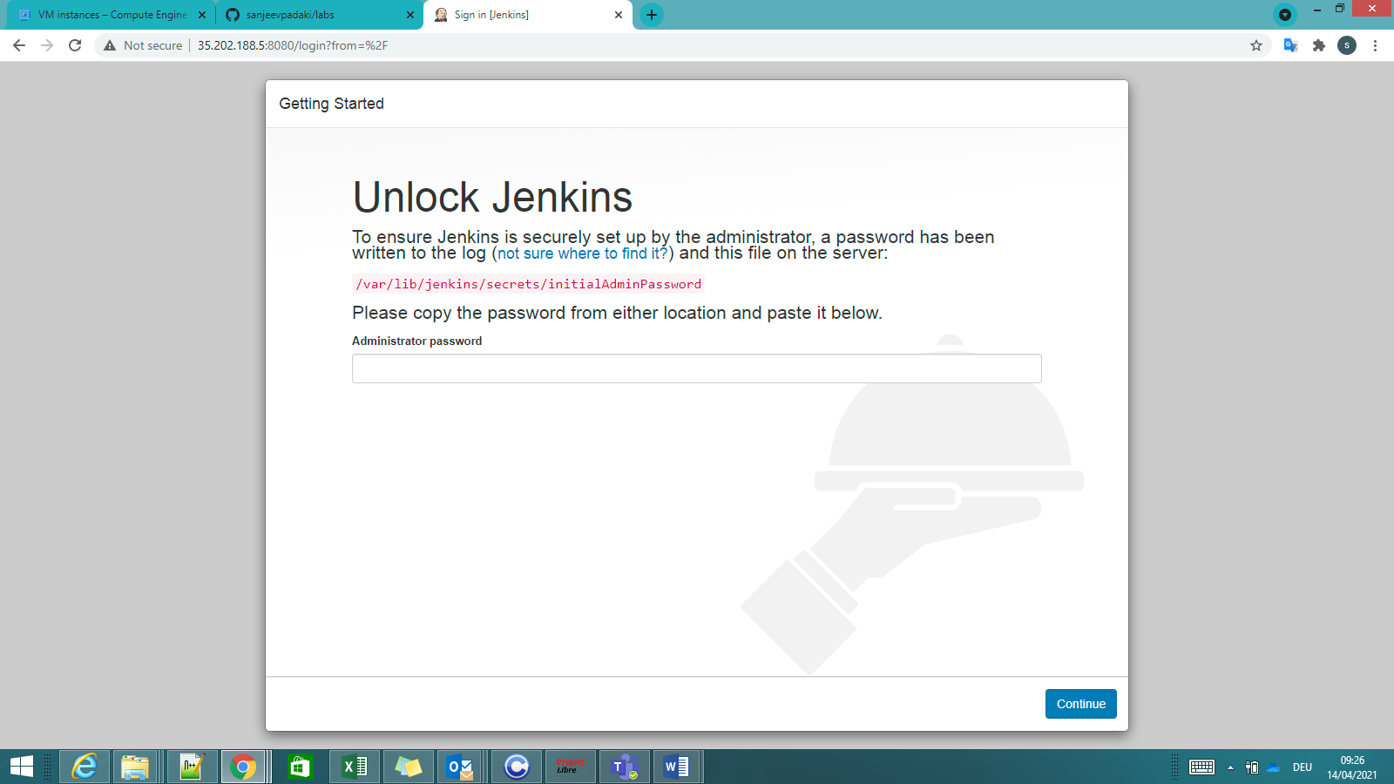

root@master:/tmp# cat /var/lib/jenkins/secrets/initialAdminPassword

**e6f0e44a08994e1e8225534f75421555**

root@master:/tmp#

1. After entering admin password:

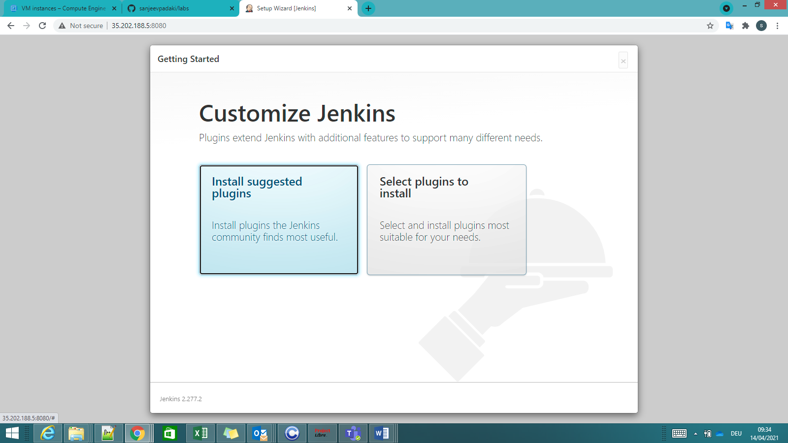

1. After selecting Install suggested plugins

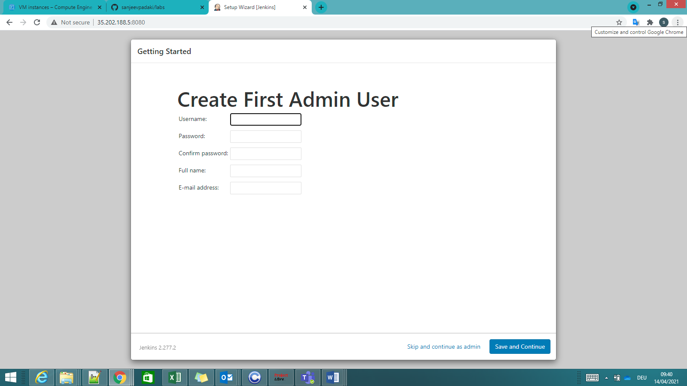

Username: admin

Password: admin

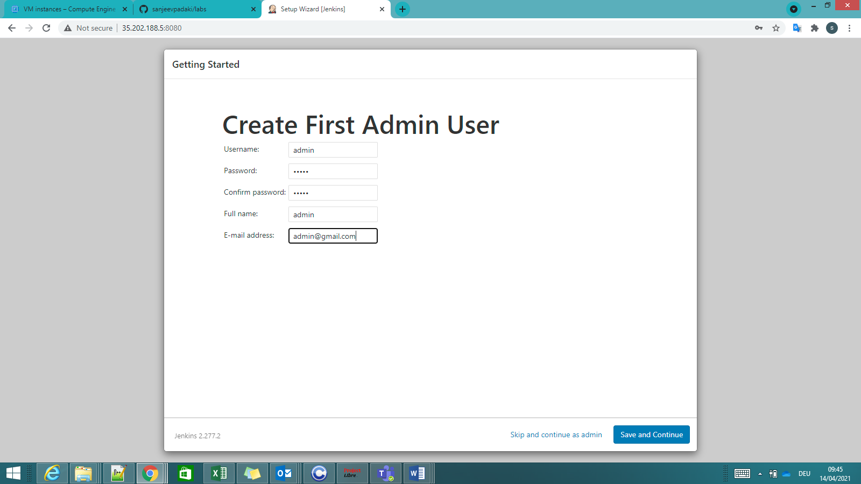

1. VM instances with internal and external ips during this activity:

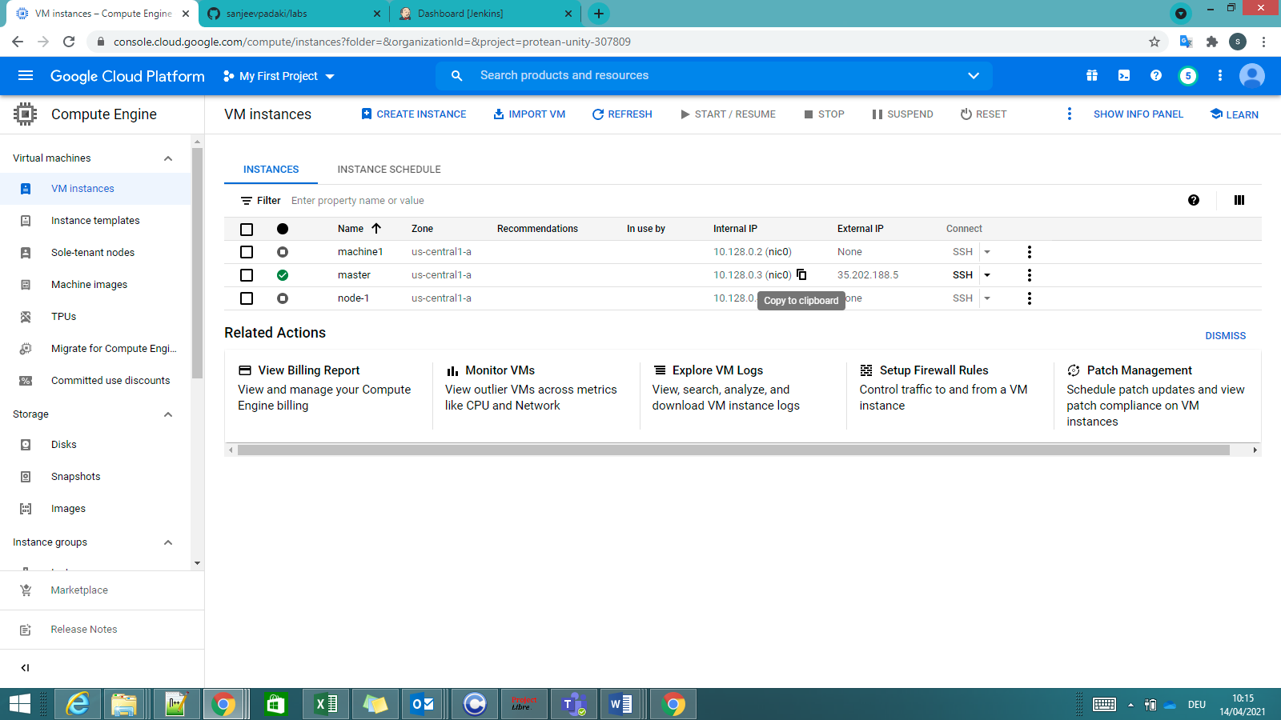

1. After save and continue, the following instance configuration page is seen:

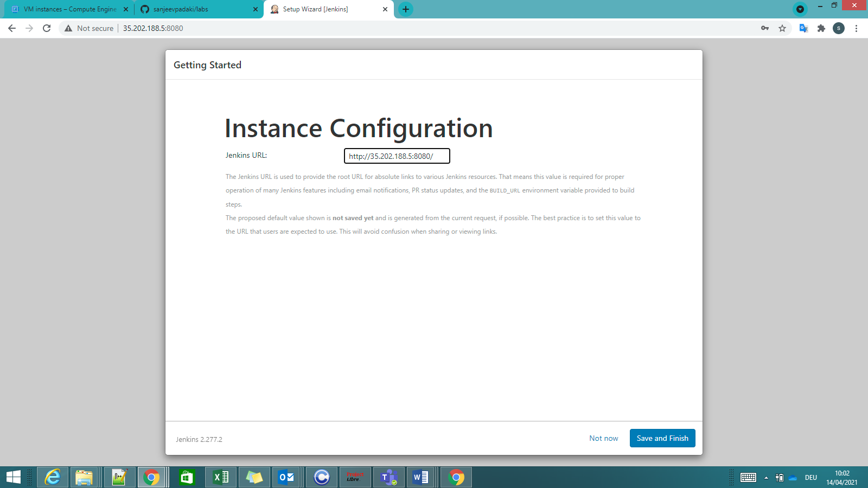

Replace external ip with the internal ip of the vm: 10.128.0.3 (Why?)

1. Default Jenkins page: Entire CI CD Dashboard will be seen here.

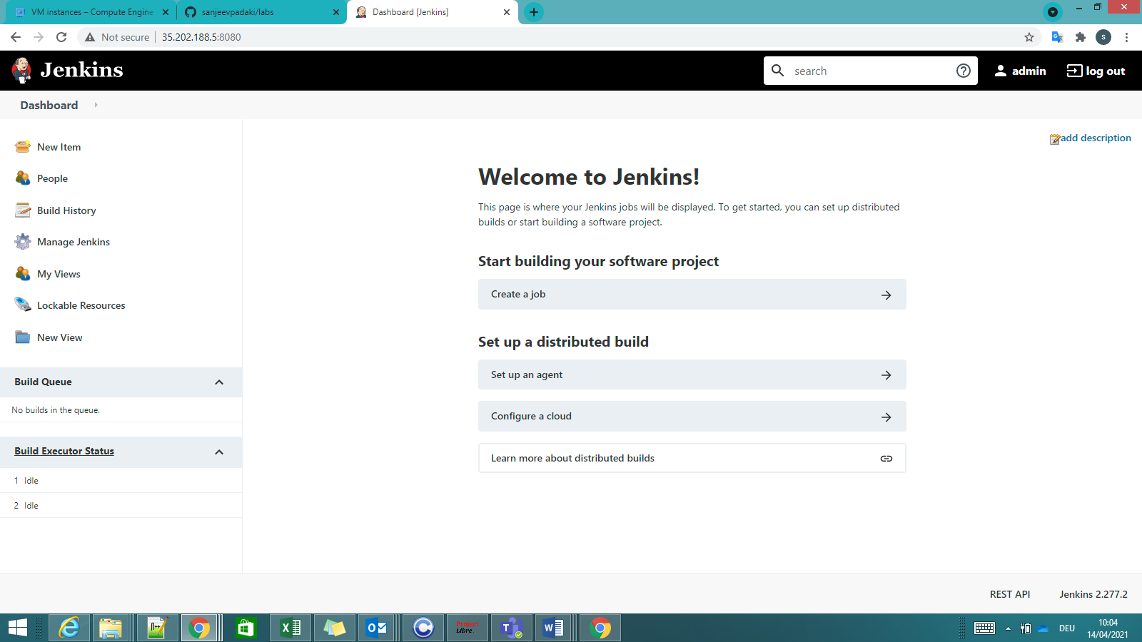

1. Jenkins -- Global tool configuration (Java path selection)

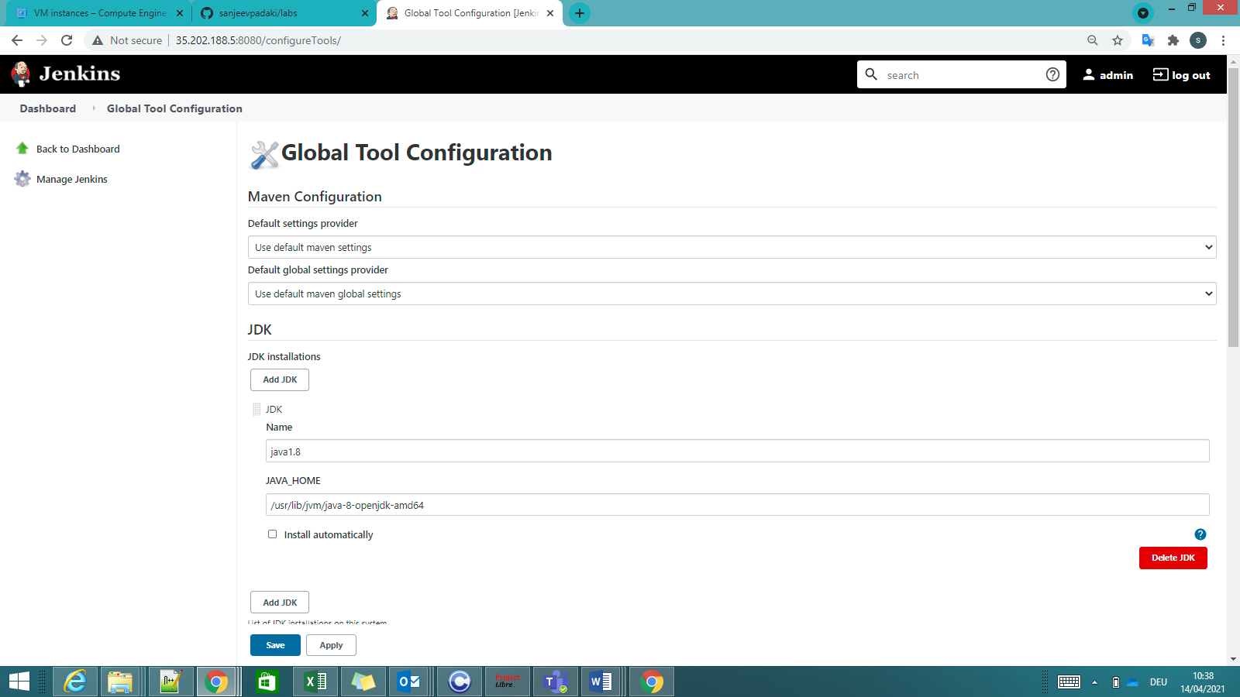

1. Jenkins – Git (default selected)

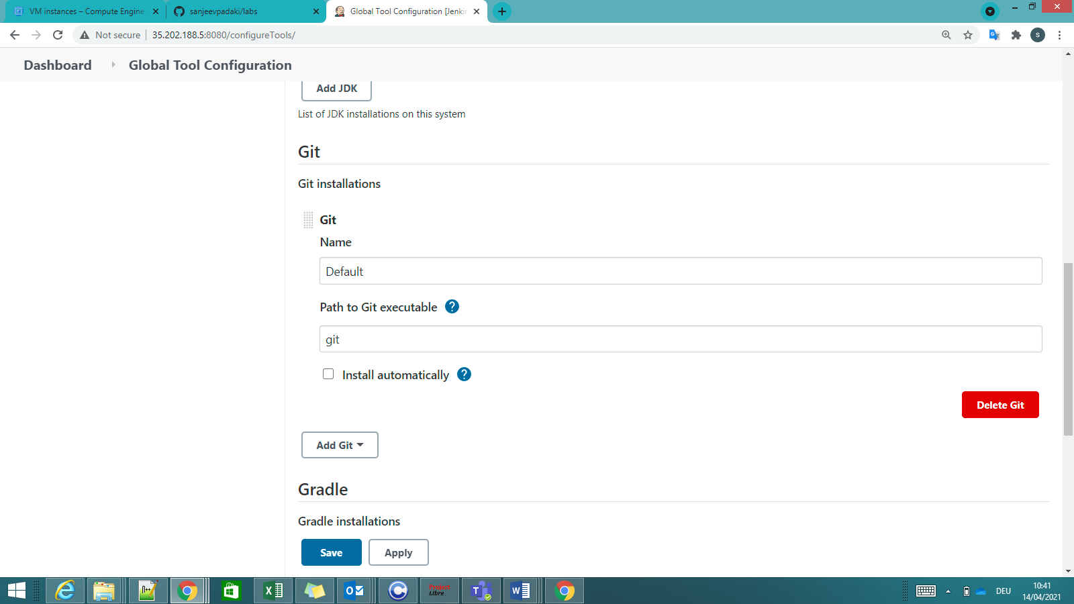

1. Jenkins – Maven

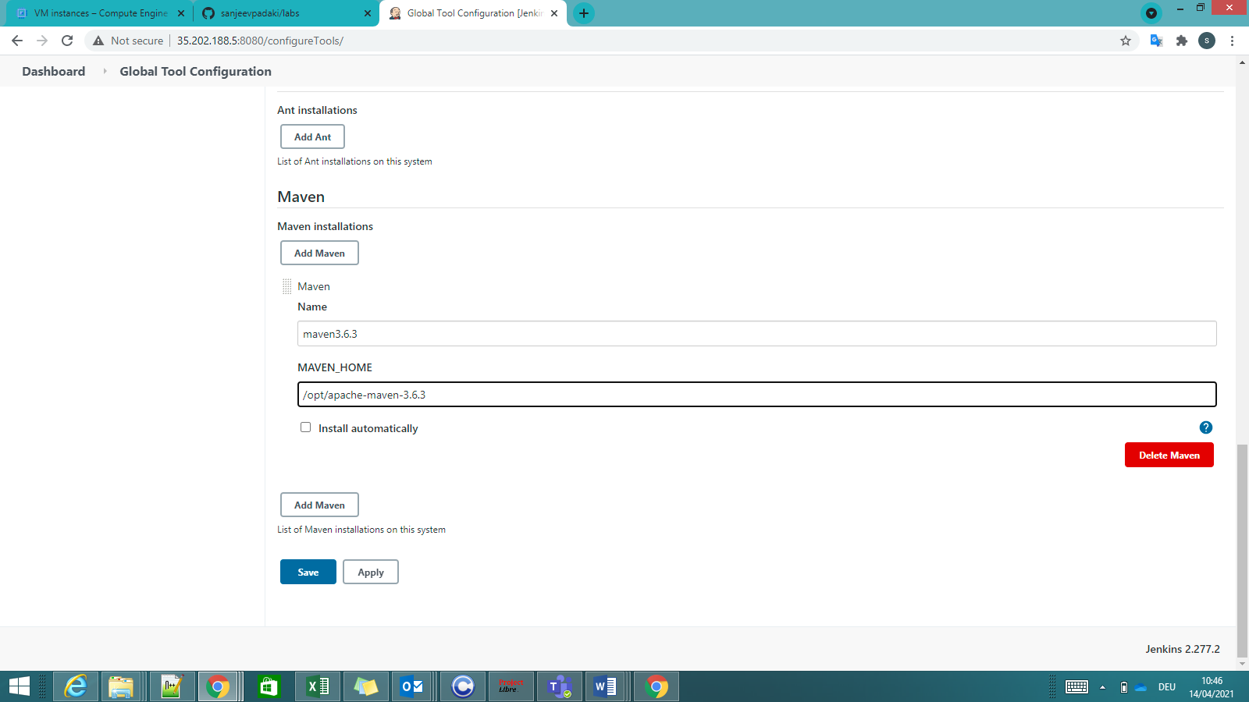

1. Start building your software project (to automate in Jenkins)

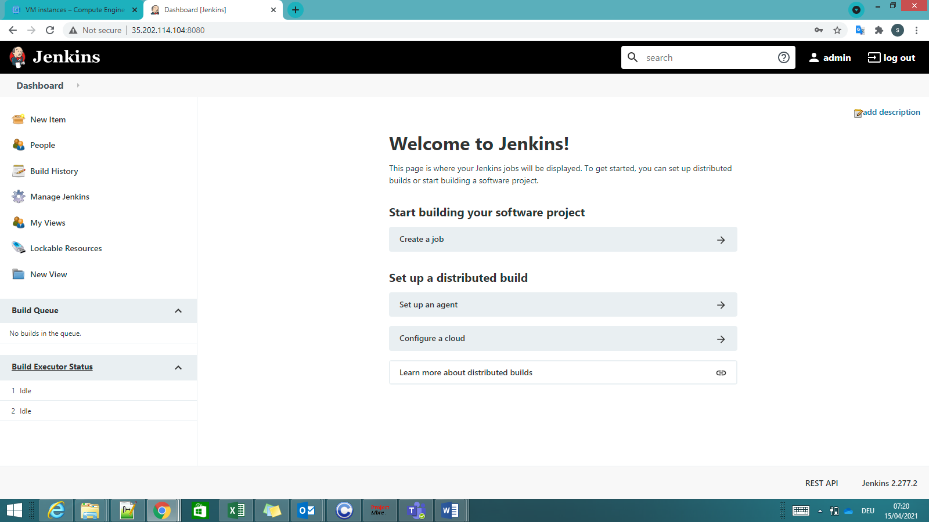

Create a job (a set of instructions that execute to give desired results): First time by clicking on “Create a job” & later on by selecting “New Item”

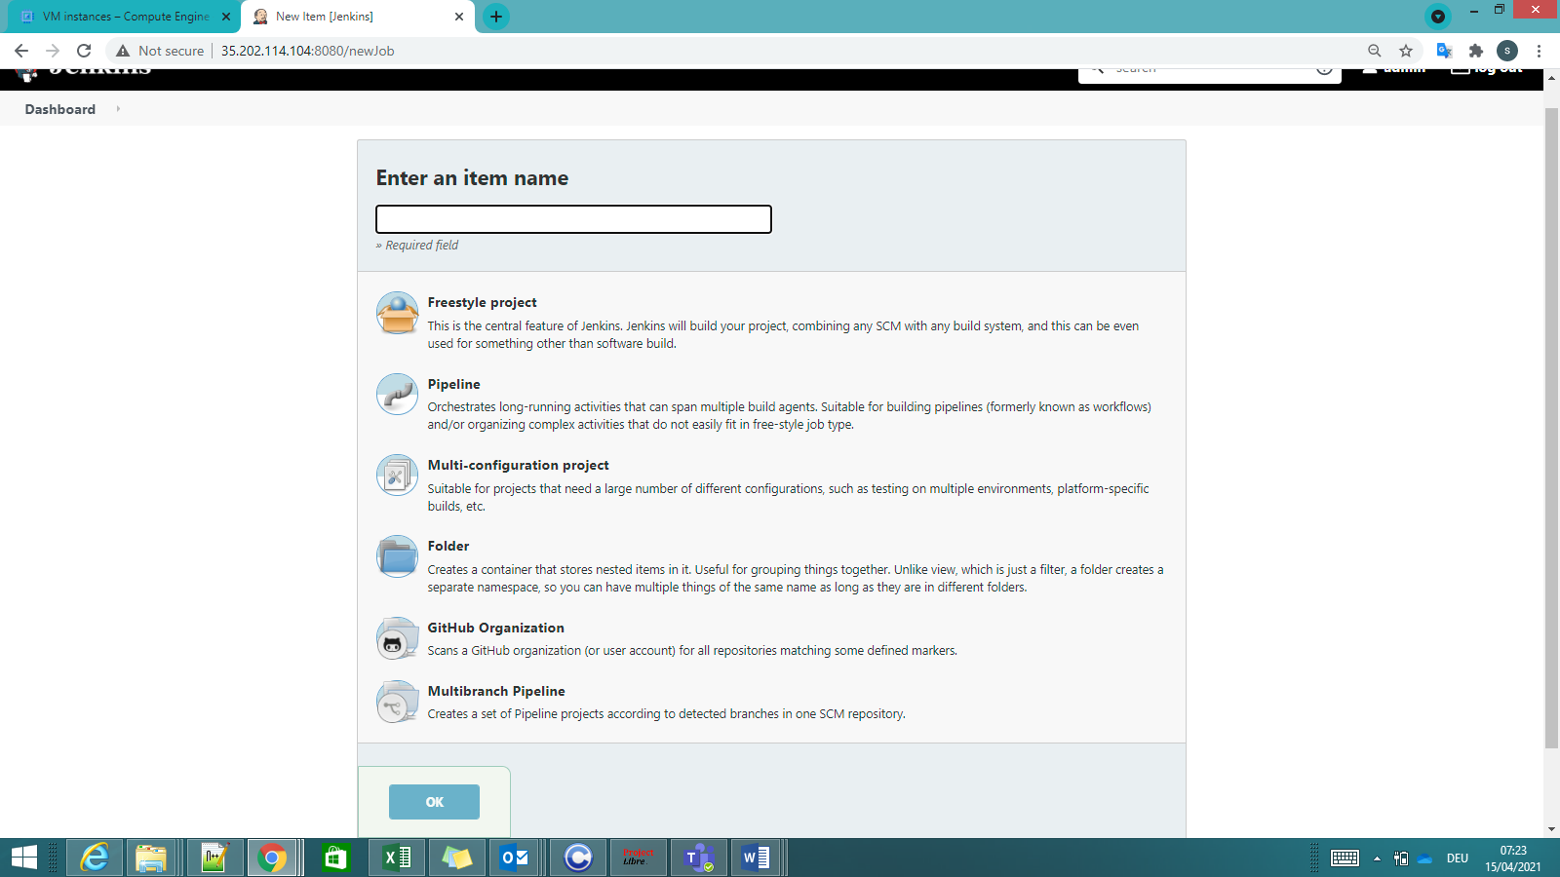

Select Freestyle project after entering item name

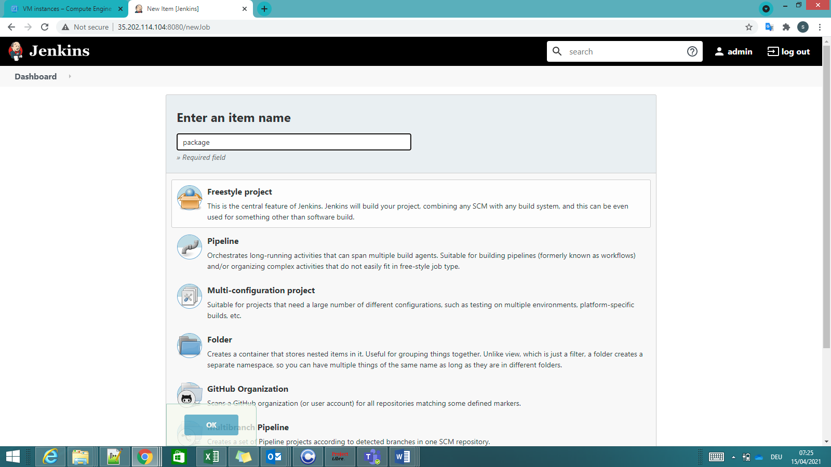

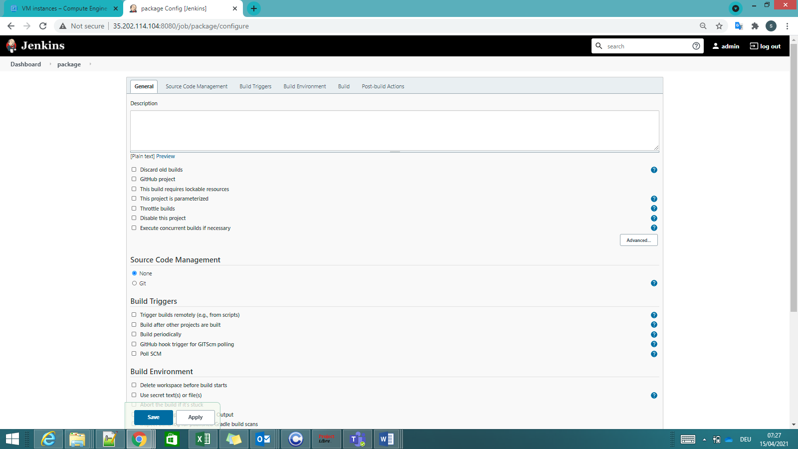

Source Code Management: Copy the Github link of your source code (as it is public repository, no credentials are needed), rest of the fields do not change: Cloning the repository from Github

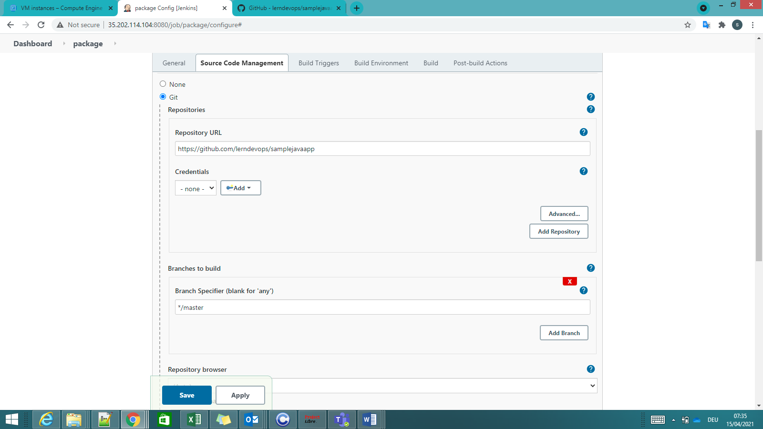

Build Triggers, Build Env are not modified as of now. Next is Build.

Main step in this job is to Build: to execute a maven build package in a shell

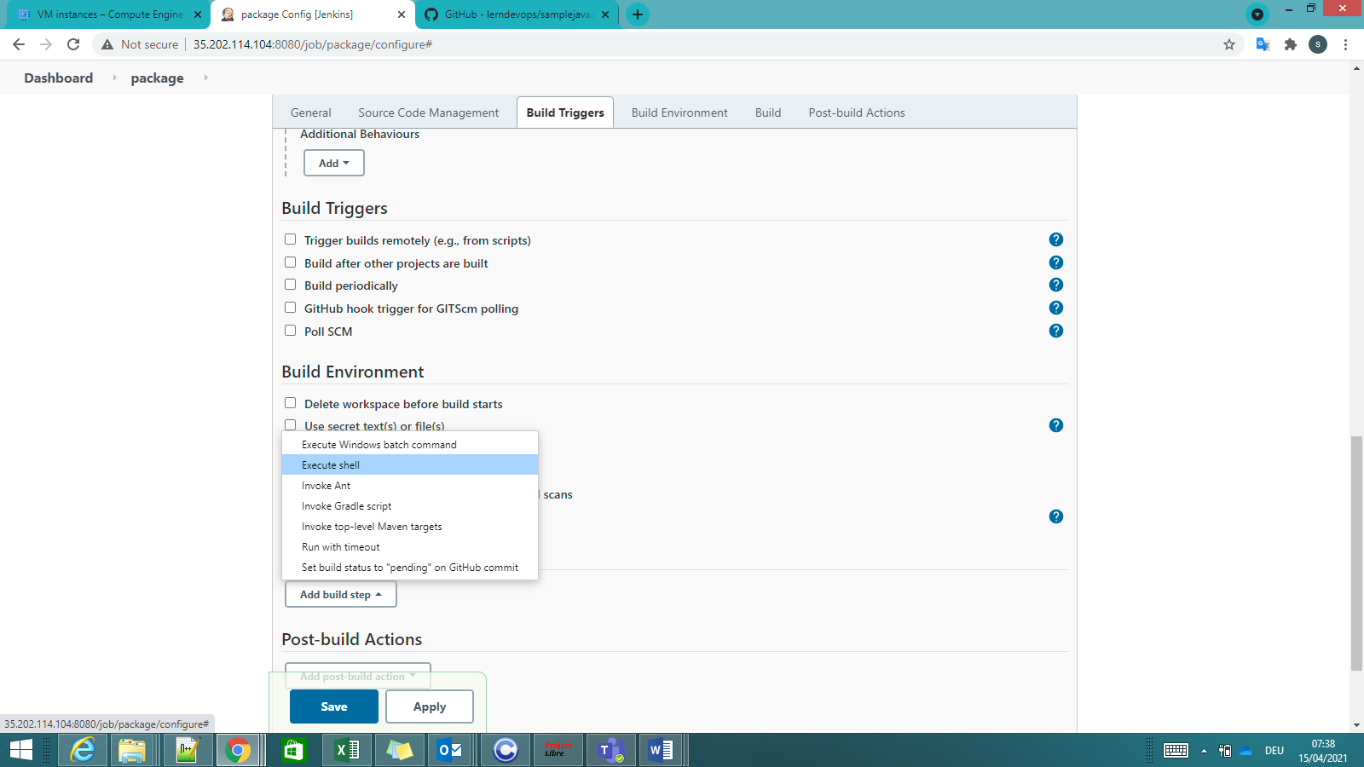

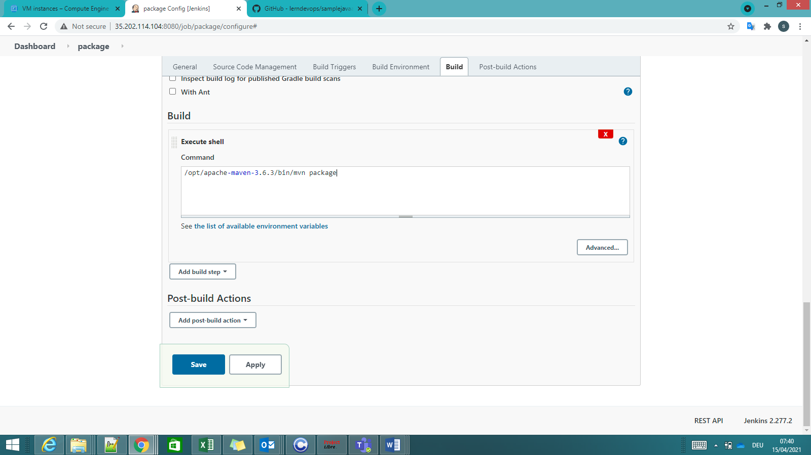

After this is saved you see the following:

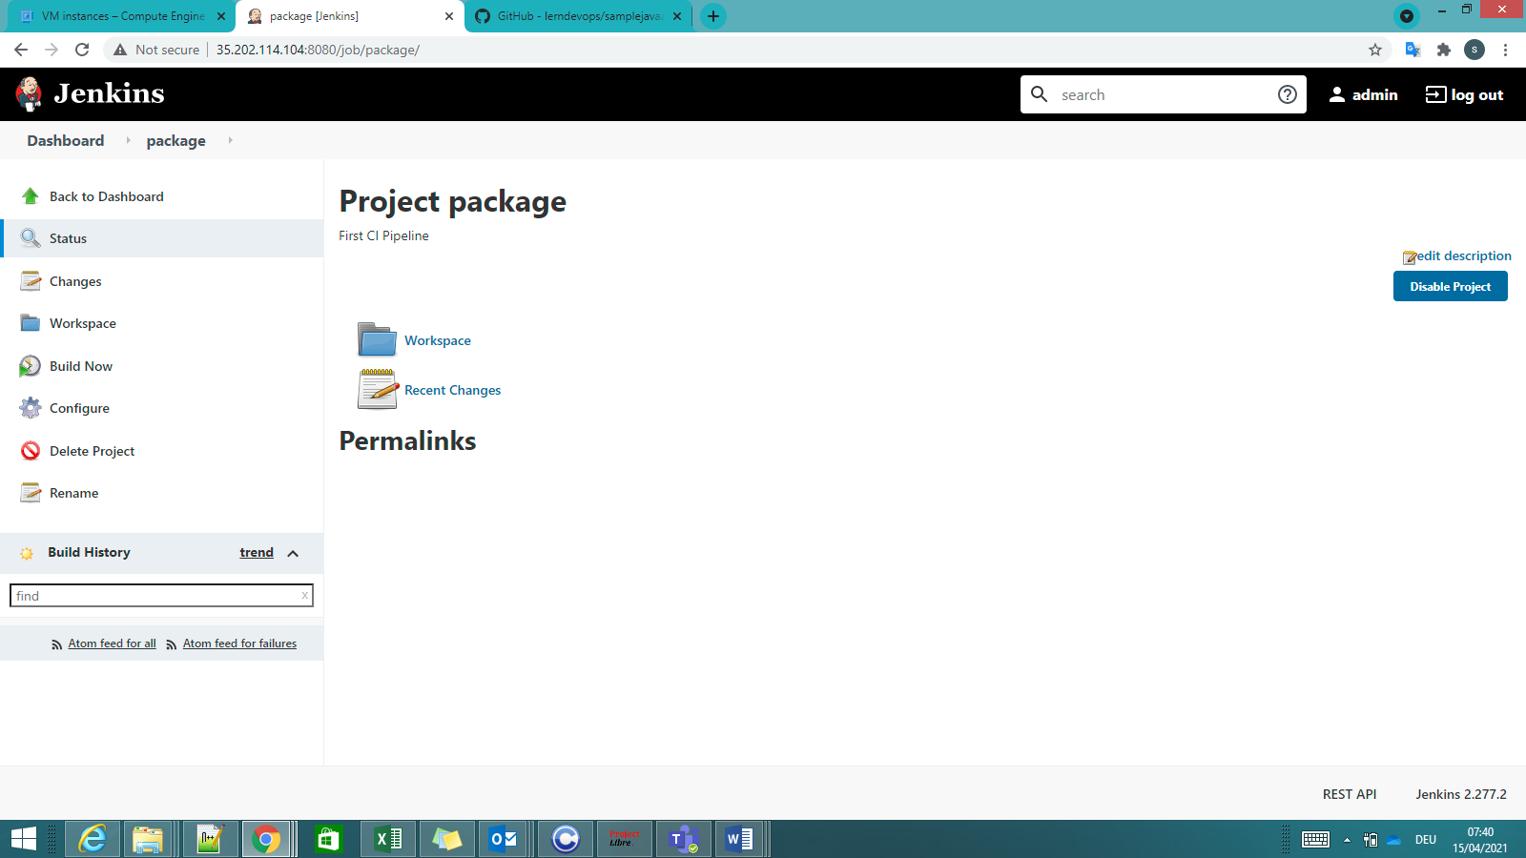

To see the package job that you configured, select Dashboard

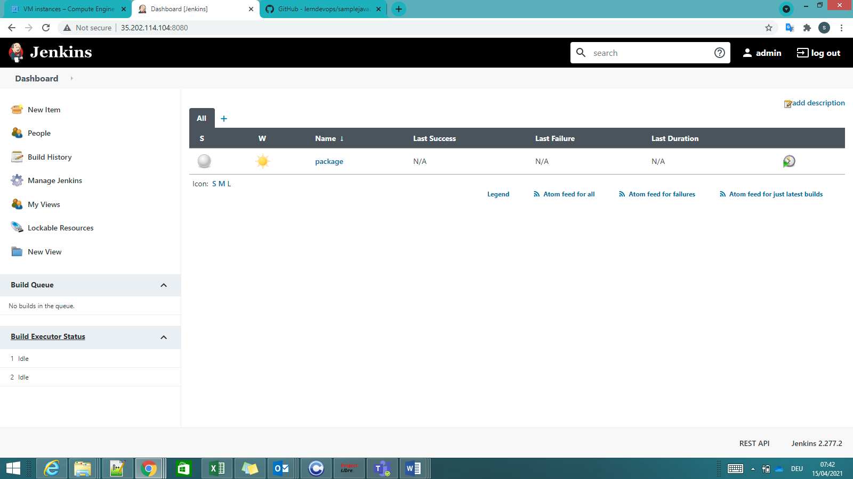

When you want to run this job i.e select Build now, you will see the ongoing build in Build History:

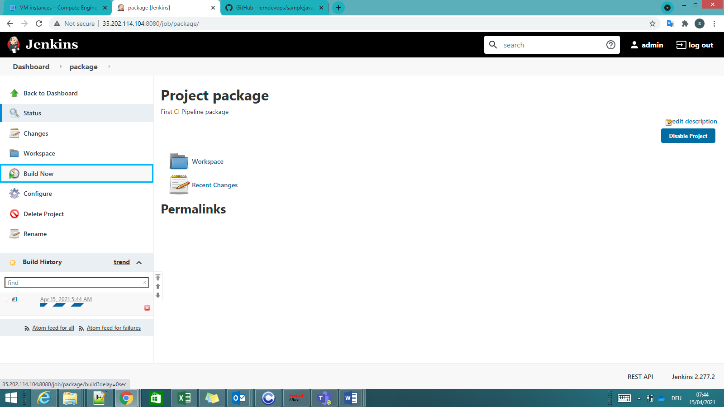

To check what happened in the build, select on the build number and Console output

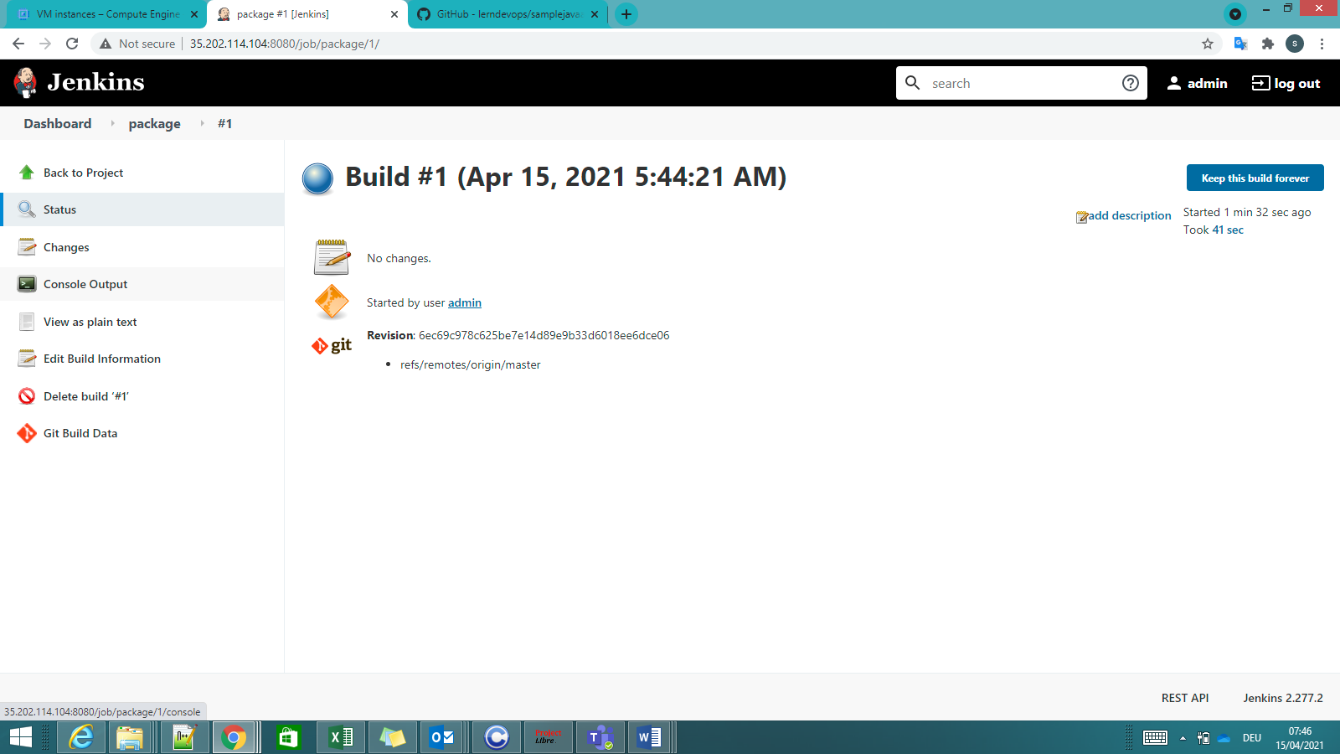

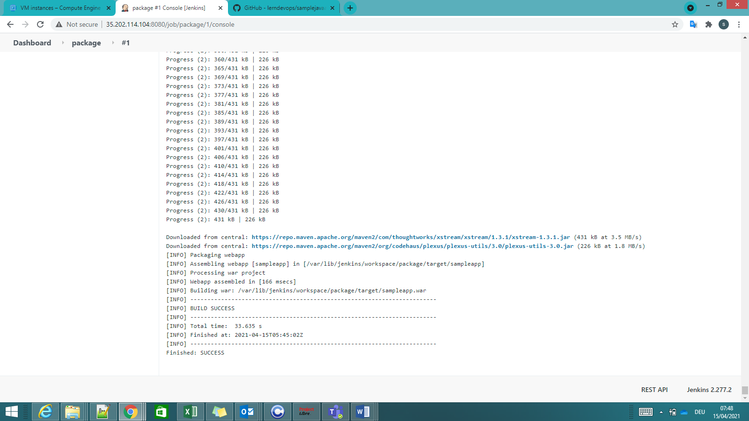

This Jenkin job has 2 steps:

1. Clone Github repository locally
2. Run Maven build command as provided in the shell

Jenkins cloned the repository in the following location: /var/lib/jenkins/workspace/package

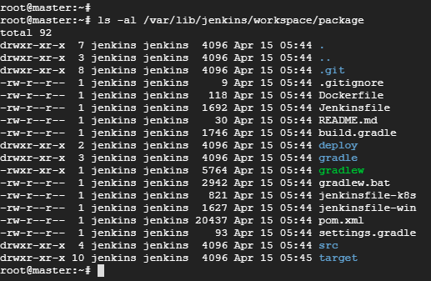

**pom.xml: Maven uses this file to build the package. This file will be provided by Developer.

Build output is as follows: sampleapp.war

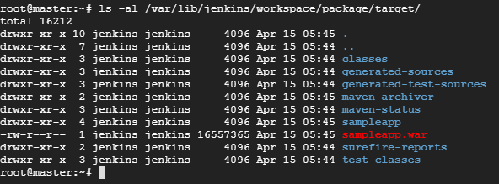

Continuous Integration pipeline: Code Review -> Code Coverage -> Unit testing -> Build Package

----------------------------------------------------------------------------------------------

Next Step: Creating Code Review Job in Jenkins

1. Creating Code Review Job in Jenkins:

Go back to Jenkins Dashboard -> New Item->Enter name: “codereview”->select Freestyle Project->Ok

Source Code Management->Git->Enter source code url: <https://github.com/lerndevops/samplejavaapp->> Build: Execute shell “/opt/apache-maven-3.6.3/bin/mvn –P metrics pmd:pmd”->Save