Docker:

1.>We can create docker image for each microservice.

2.>Docker image contains everything a microservice needs to run:

* Application runtime(JDK or python or NodeJS)
* Application Code
* Dependencies

3.>We can run docker containers the same way on any infrastructure

Like in our local machine, corporate data center, cloud

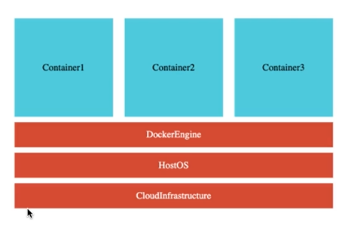

Installing Docker:

>>docker run in28min/todo-rest-api-h2:1.0.0.RELEASE

By using above command, image will get download from hub.docker.com

(Docker Registry: hub.docker.com)

Registry contains lot of repositories

(Registry: hub.docker.com)>Repository(in28min/todo-rest-api-h2)

Every repository contains tags. Different versions of application.

Image contains all the things which application needs to run. (like library, dependency)

Note: Image is static(a static template, set of bytes), when we run that (docker run in28min/todo-rest-api-h2:1.0.0.RELEASE). When image is running , it is called container.

Container: running version of image.

Docker Architecture:

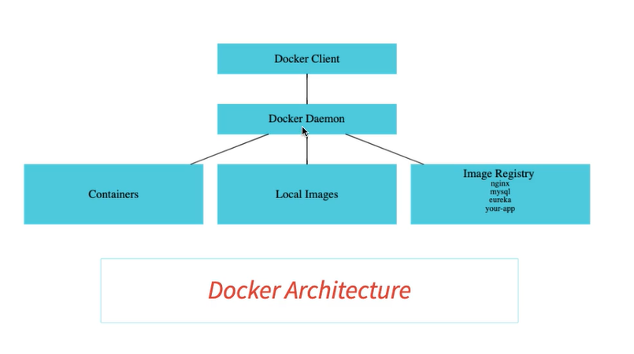

The place where we are running command is Docker Client. and those are send to Docker Daemon or engine. Local installation of Docker also uses client server architecture.

Docker Daemon is responsible of managing Containers, images, and for pulling and pushing images into registry.

Why Docker is popular: We can install docker on clouds as well.

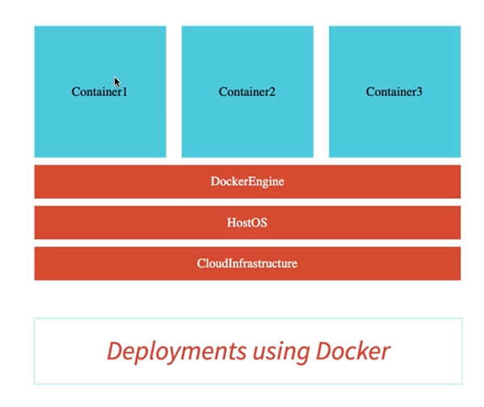

Playing with Docker Images:

We can create multiple tags for same images

**PS C:\Users\sanjeek9> docker images**

**REPOSITORY TAG IMAGE ID CREATED SIZE**

**in28min/todo-rest-api-h2 1.0.0.RELEASE f8049a029560 20 months ago 143MB**

**PS C:\Users\sanjeek9> docker tag in28min/todo-rest-api-h2:1.0.0.RELEASE in28min/todo-rest-api-h2:latest**

**PS C:\Users\sanjeek9> docker images**

**REPOSITORY TAG IMAGE ID CREATED SIZE**

**in28min/todo-rest-api-h2 1.0.0.RELEASE f8049a029560 20 months ago 143MB**

**in28min/todo-rest-api-h2 latest f8049a029560 20 months ago 143MB**

**PS C:\Users\sanjeek9>**

We can see that image id is same for both tag.

To check official image :

**PS C:\Users\sanjeek9> docker search mysql**

**NAME DESCRIPTION STARS OFFICIAL AUTOMATED**

**mysql MySQL is a widely used, open-source relation… 10545 [OK]**

**mariadb MariaDB is a community-developed fork of MyS… 3937 [OK]**

**mysql/mysql-server Optimized MySQL Server Docker images. Create… 773 [OK]**

**percona Percona Server is a fork of the MySQL relati… 527 [OK]**

**centos/mysql-57-centos7 MySQL 5.7 SQL database server 86**

**mysql/mysql-cluster Experimental MySQL Cluster Docker images. Cr… 79**

**centurylink/mysql Image containing mysql. Optimized to be link… 59 [OK]**

**bitnami/mysql Bitnami MySQL Docker Image 48 [OK]**

**deitch/mysql-backup REPLACED! Please use http://hub.docker.com/r… 41 [OK]**

**databack/mysql-backup Back up mysql databases to... anywhere! 38**

**prom/mysqld-exporter 37 [OK]**

**tutum/mysql Base docker image to run a MySQL database se… 35**

**schickling/mysql-backup-s3 Backup MySQL to S3 (supports periodic backup… 29 [OK]**

**linuxserver/mysql A Mysql container, brought to you by LinuxSe… 27**

**centos/mysql-56-centos7 MySQL 5.6 SQL database server 20**

**circleci/mysql MySQL is a widely used, open-source relation… 20**

**mysql/mysql-router MySQL Router provides transparent routing be… 18**

**arey/mysql-client Run a MySQL client from a docker container 17 [OK]**

**fradelg/mysql-cron-backup MySQL/MariaDB database backup using cron tas… 12 [OK]**

**openshift/mysql-55-centos7 DEPRECATED: A Centos7 based MySQL v5.5 image… 6**

**devilbox/mysql Retagged MySQL, MariaDB and PerconaDB offici… 3**

**ansibleplaybookbundle/mysql-apb An APB which deploys RHSCL MySQL 2 [OK]**

**widdpim/mysql-client Dockerized MySQL Client (5.7) including Curl… 1 [OK]**

**jelastic/mysql An image of the MySQL database server mainta… 1**

**monasca/mysql-init A minimal decoupled init container for mysql 0**

We can check history of image as well:

**PS C:\Users\sanjeek9> docker images**

**REPOSITORY TAG IMAGE ID CREATED SIZE**

**mysql latest 2933adc350f3 2 weeks ago 546MB**

**in28min/todo-rest-api-h2 1.0.0.RELEASE f8049a029560 20 months ago 143MB**

**in28min/todo-rest-api-h2 latest f8049a029560 20 months ago 143MB**

**PS C:\Users\sanjeek9> docker image history f8049a029560**

**IMAGE CREATED CREATED BY SIZE COMMENT**

**f8049a029560 20 months ago /bin/sh -c #(nop) ENTRYPOINT ["sh" "-c" "ja… 0B**

**<missing> 20 months ago /bin/sh -c #(nop) ENV JAVA_OPTS= 0B**

**<missing> 20 months ago /bin/sh -c #(nop) ADD file:b5f1bf3b3024aebbe… 38.1MB**

**<missing> 20 months ago /bin/sh -c #(nop) EXPOSE 5000 0B**

**<missing> 20 months ago /bin/sh -c #(nop) VOLUME [/tmp] 0B**

**<missing> 21 months ago /bin/sh -c set -x && apk add --no-cache o… 99.3MB**

**<missing> 21 months ago /bin/sh -c #(nop) ENV JAVA_ALPINE_VERSION=8… 0B**

**<missing> 21 months ago /bin/sh -c #(nop) ENV JAVA_VERSION=8u212 0B**

**<missing> 21 months ago /bin/sh -c #(nop) ENV PATH=/usr/local/sbin:… 0B**

**<missing> 21 months ago /bin/sh -c #(nop) ENV JAVA_HOME=/usr/lib/jv… 0B**

**<missing> 21 months ago /bin/sh -c { echo '#!/bin/sh'; echo 'set… 87B**

**<missing> 21 months ago /bin/sh -c #(nop) ENV LANG=C.UTF-8 0B**

**<missing> 21 months ago /bin/sh -c #(nop) CMD ["/bin/sh"] 0B**

**<missing> 21 months ago /bin/sh -c #(nop) ADD file:a86aea1f3a7d68f6a… 5.53MB**

playing with docker containers:

Creating Our Own Image:

We will create microservices using docker.

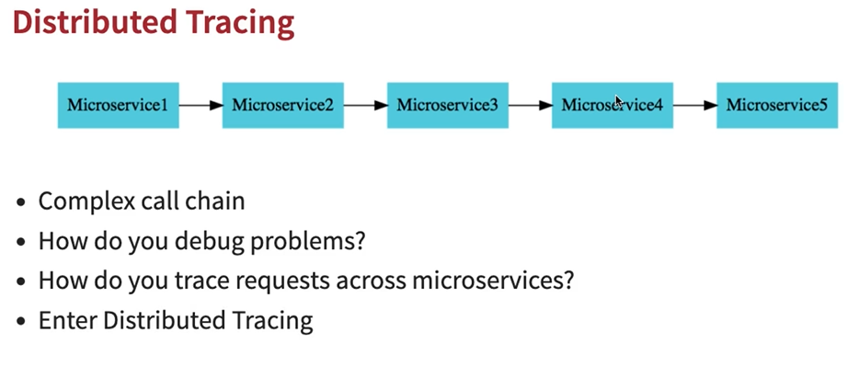

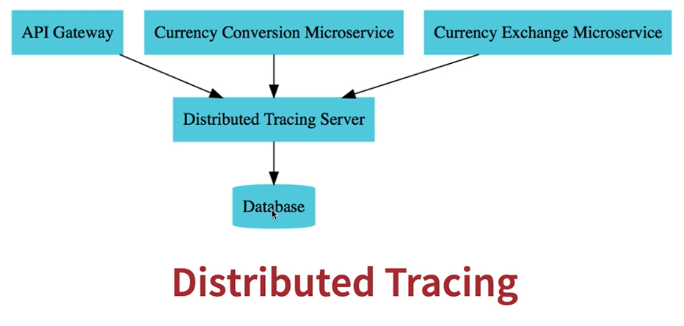

Distributed tracing server will store all info in data base.it can be in memory or real database.

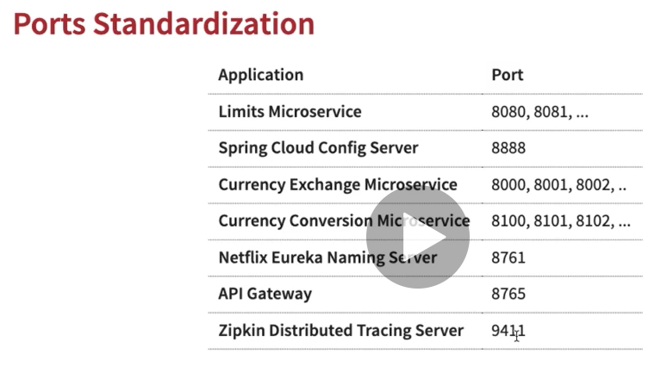

Launching Zipkin container using DOCKER:

We are running authoritative image of Zipkin, a distributed tracing system , which is available on docker

<https://hub.docker.com/r/openzipkin/zipkin>