Microsoft Project Management Tool - Setup Guide and System Design

Introduction and Overview
This document provides a high-level summary of Microsoft Project Management Tool, including goals, scope, and primary features such as task tracking, team collaboration, and reporting developed by Microsoft.

Prerequisites
- Project Manager credentials
- Approved project charter

Procedure: Creating a New Project
- Access the dashboard and select New Project.
- Complete the project details form.
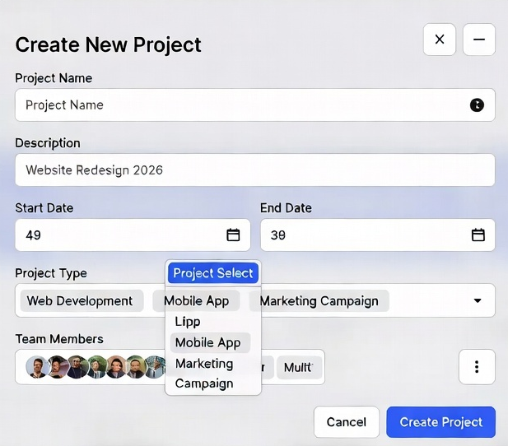
Figure 1: New Project Creation Interface

System Architecture (Microsoft)
The system follows a microservices-based architecture with the following major components:
- Frontend: React-based single-page application
- Backend: Node.js / Express services
- Database Layer: PostgreSQL + Redis cache
- Integration Services: REST APIs and Webhooks

Data Design in Microsoft Ecosystem
Data is managed using relational models with normalization for integrity.
Entity | Key Attributes
Project | id, name, status, dates
Task | id, project_id, assignee, priority

Interface Design as per Microsoft Standards
Internal communication uses RESTful APIs with JSON payloads. External integrations via OAuth and webhooks.

User Interface (UI) Mockups
The UI follows Microsoft Material Design principles with responsive layouts.
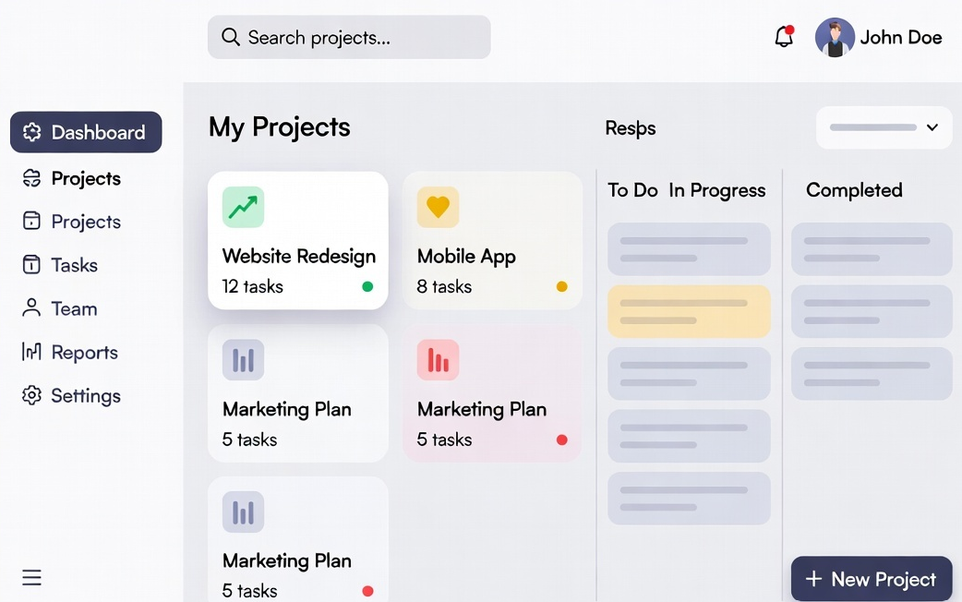
Figure 2: Microsoft Dashboard UI Mockup

This setup ensures scalability, maintainability, and excellent user experience (see attached image for wireframe)

Stakeholder List at Microsoft
Stakeholder | Role | Responsibilities
Microsoft Project Sponsor | Executive | Budget approval

Project Milestones at Microsoft
- Requirements Gathering - Week 2 (Microsoft standard)

