# Preface

The Package contains the complete library, Sample Project, Documentation, Tutorial Video to configure Analog Input in PLC and HMI.

# Compatibility

TIA Portal V19

TIA Unified HMI V19

# Import Control Module Library

## Import Library Package in TIA Portal Project

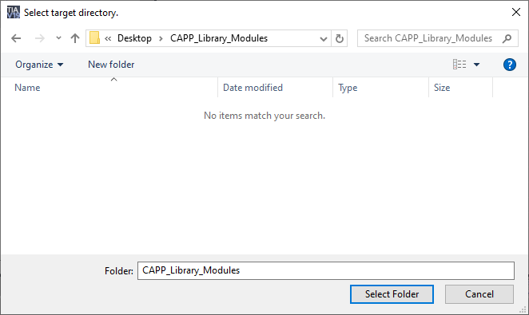

# Configure PLC Side

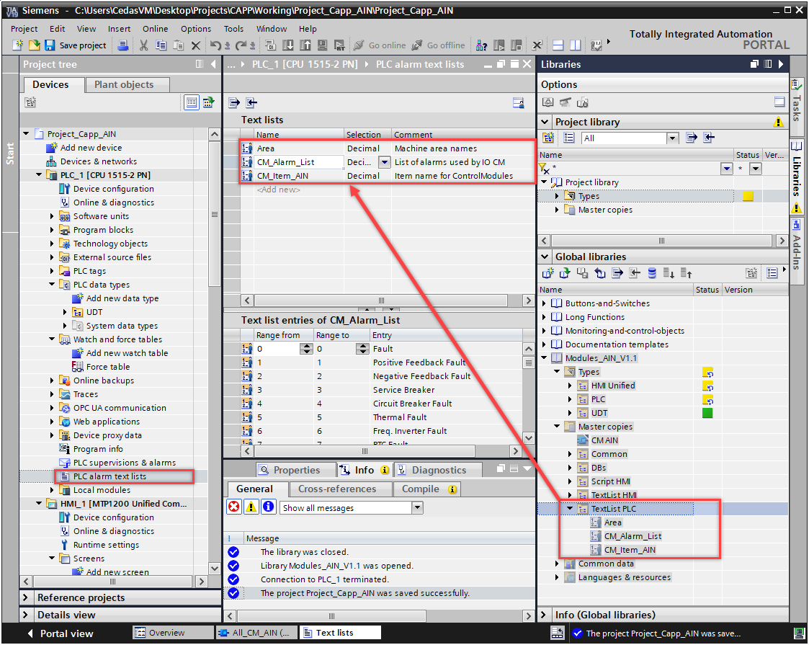

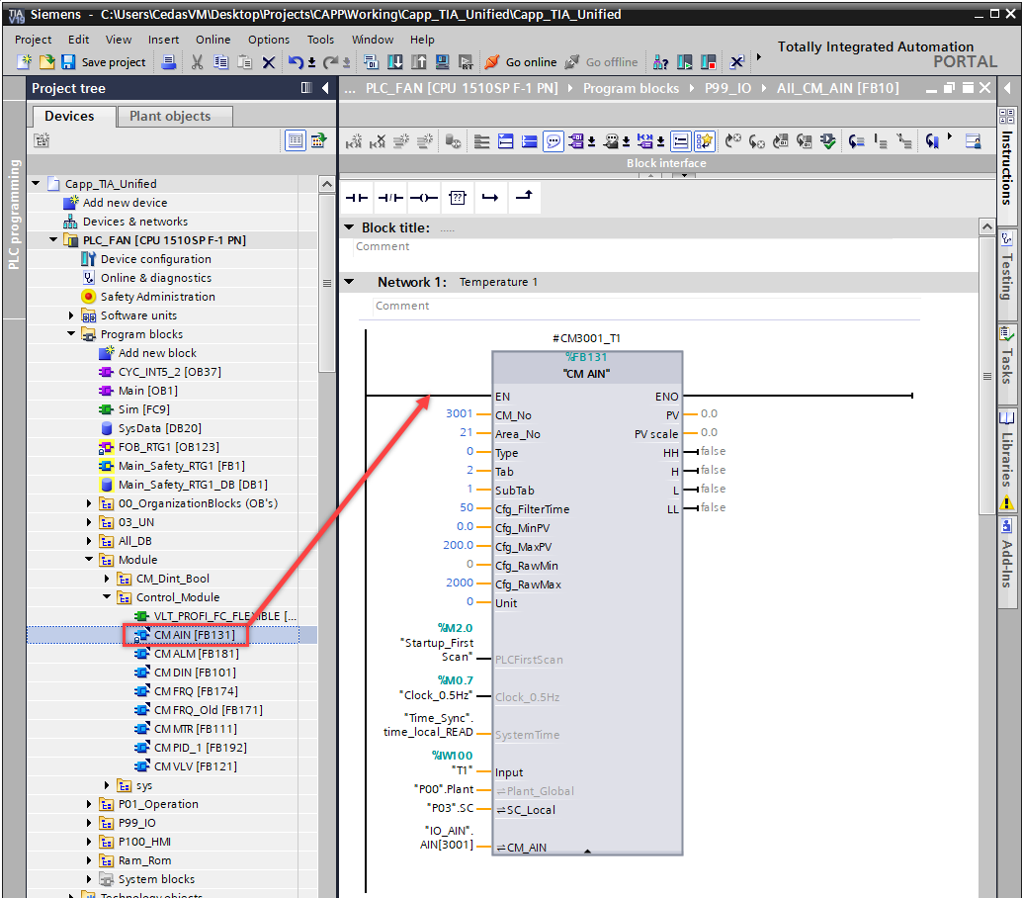

# Configure HMI Side

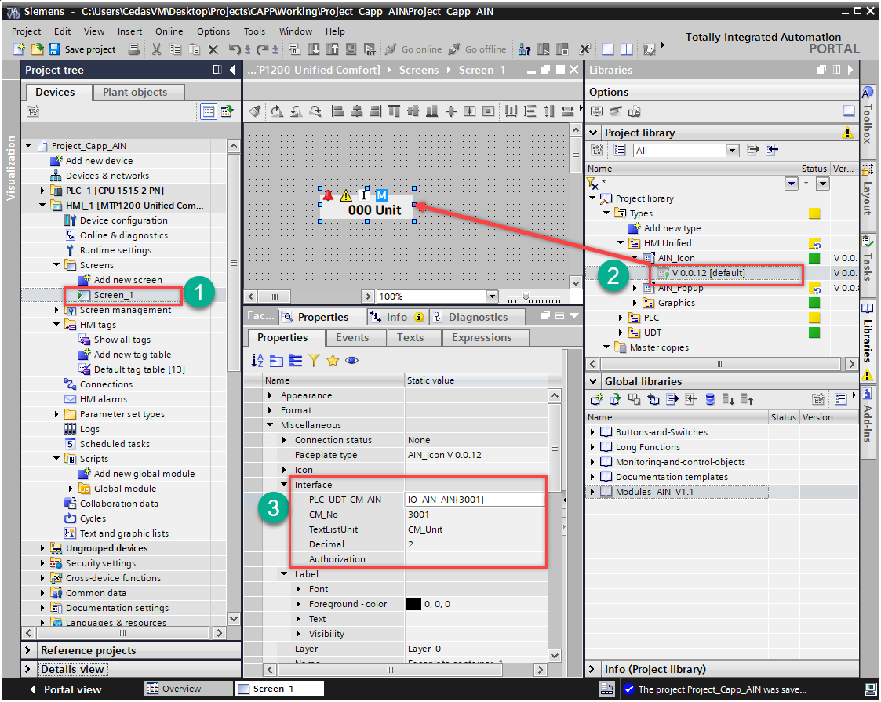

import * as module_global_module from "Global module";

try {

module_global_module.Popup_Parameters_AIN(CM_No, Top, Left, Decimal);

}

catch (err) {

HMIRuntime.Trace("Function call failed");

}

# Test HMI Runtime

Don’t change Text list name, it is configured in the HMI Scripts, if any change in Text list Name it must be changed in the Scripts.

# Alarms

# Control modules (CM)

Physical components of the plant, including valves, motors, transmitters, and sensors are referred to in this document as Control modules.

How the control modules are illustrated is shown below:

* MTR is a directly started motor.
* VLV is a valve, typically controlled by air pressure.
* AIN is an analog input signal to the PLC system.
* DIN is a digital input from a sensor, typically a switch, photo sensor, proximity sensor or a reed contact.
* FRQ is a speed-controlled motor, typically by a frequency inverter.
* ALM is digital input from a sensor or a software signal from PLC, which generates an alarm or warning

|  |  |  |
| --- | --- | --- |
| **MTR** | **VLV** | **AIN** |
|  |  |  |
|  |  |  |
|  |  |  |
|  |  |  |
| **DIN** | **FRQ** | **ALM-ES** |
|  |  |  |
|  |  |  |
|  |  |  |

All the items above are made as control modules. The control modules have different states that are indicated by colors, state text and icons. The control modules have different pop-up windows please refer to the description in Error! Reference source not found. chapter for further information. The pop-up control dialog is shown by clicking on the symbol.

# Control module pop-up.

All control modules have a pop-up with functionality according to the item type.

All pop-up windows are equipped with a set of tabs. The tabs are grouped according to the data displayed. Below is an example pop-up window for the welder arm lift.

1. **Home**
2. **Information**
3. **Settings**

## Analog input (AIN)

Analog inputs are used for all transmitters, for example loadcell transmitter, temperature transmitter, pressure transmitter, moisture sensors and band position sensors.

**AIN – Icon**



**Icon Information - symbols**

* Alarm 
* Warning
* I=Ignore
* M=Manual

### AIN – Face plate

Touch the AIN icon on the screen and it is possible to see this faceplate where advanced setup is accessible for the specific signal.

Note: If the Ignore button is activated – no Alarms will be displayed for this sensor.

Warning: Ignore must *never* be activated without a specific work order from maintenance!!

### Home tab

A bar graph shows the value from the sensor and a small trend shows the past few minutes of sensor values. This gives a fast overview of the sensor condition in a quick time perspective.

**Buttons**

* **Auto Reset:** Button to automatically reset alarms from this control module.
* **Reset:** Reset the alarm on the local control module (example feedback sensor alarm).
* **Ignore:** Button to tell the program to ignore faults from this control module.

**Status indication (*S)**

* **HH:** (Green Lamp indication) (Grey on the picture)

The “HH” Green lamp is an indication that the HH alarm limit is currently crossed and will trigger an “HH-Alarm” once an alarm delay has elapsed.

* **H:** (Green Lamp indication) (Same as HH-Green applies)
* **L:** (Green Lamp indication) (Same as HH-Green applies)
* **LL:** (Green Lamp indication) (Same as HH-Green applies)

**Alarm and Warning indication (*E)**

* **HH:** (Red Lamp indication) (Gray on the picture)

The “HH” Red lamp is an indication that the HH alarm limit is currently crossed and it has triggered an “HH-Alarm” because a delay time has (already) elapsed.

* **H:** (Yellow Lamp indication) (Same as HH-Red applies)
* **L:** (Yellow Lamp indication) (Same as HH-Red applies)
* **LL:** (Red Lamp indication) (Same as HH-Red applies)
* **Overflow** (Red Indication): Input from sensor has exceeded a value acceptable to the configured range. (Check for a short circuit)
* **Wire break** (Red Indication): Input from the sensor is below the configured range. (Check for loose or broken connection).

### Trend tab

* **Trend**: Shows an online trend for the control module.
* **Auto**: Reset the alarm on the local control module.
* **Manual**: Input value has exceeded the HH value + Dead band.

### Settings tab

**Settings**

* **HH:** If the sensor value is higher than the adjusted value, the HH-Green status will light on the Home tab and the “Alarm Delay will start timing, once the alarm delay has elapsed the “HH-Red” status indicator will light up and an High-High Alarm is triggered.
* **H:** The same behavior as HH
* **L:** The same behavior as HH (But lower)
* **LL:** The same behavior as HH (But lower)
* **Stop if Checked:** If the “Check-mark” is set – the machine will stop upon HH or LL Alarm respectively.

If the “Check-mark” is not set – the machine will not stop upon these Alarms, but the Alarm-Banner will show the alarm.

* **Deadband:** This value creates a hysteresis for the limits to activate and deactivate HH, H, L, LL status.
* **Warning Delay:** Time from error exceeds the limit until the warning is set.
* **Alarm Delay:** Time from the error exceeds the limit until the alarm is set.

**Status**

* **Input Raw:** Displays the raw sensor value from the analog input card.
* **Manual Fixed PV:** Displays the manual value (Engineering Unit) in case of Manual operation.

Intended for use with Manual mode selection and is available in case of a sensor is broken and it may therefore be possible to continue the operation while the sensor is replaced.

# User Access Level

User access is configured based on the category of the logged-in user. Each user is assigned different access levels, which are classified with codes A through K. Below is a table detailing these access levels.

|  |  |  |  |  |  |  |
| --- | --- | --- | --- | --- | --- | --- |
|  | login duration |  | 8hrs | 2hrs | 2hrs | 2hrs |
| **Code** | **Access** | **Default** | **Operators** | **Maintenance** | **Administrator** | **Engineer** |
| A | Start/Stop Machine, Jog Conveyor, Home Sequence | No | Yes | Yes | Yes | Yes |
| B | Acknowledge of alarms | No | Yes | Yes | Yes | Yes |
| C | Load recipe data | No | Yes | Yes | Yes | Yes |
| D | Change setpoints /recipe values/ Activation time/-delay + Activate Auto reset | No | No | Yes | Yes | Yes |
| E | Change between Auto- / Manual mode | No | No | Yes | Yes | Yes |
| F | Motor Jog activation | No | No | Yes | Yes | Yes |
| G | Reset counter | No | No | Yes | Yes | Yes |
| H | Activate Ignore button | No | No | Yes | Yes | Yes |
| I | Motor Acc- / Dec- time, Digital Sensor Act/DAct Delay | No | No | No | Yes | Yes |
| J | Edit System settings | No | No | No | Yes | Yes |
| K | Advanced machine builder and developer actions and settings | No | No | No | No | Yes |

User levels are divided into the five user groups below. Find passwords related to the listed users.

|  |  |  |  |  |  |  |
| --- | --- | --- | --- | --- | --- | --- |
|  | Siemens Predefined access |  | Operate | Remote access | User Management |  |
|  | User defined access |  |  |  | Administrator | Engineer |
|  | **Username** | **Password** |  |  |  |  |
| 1 | Operator | Operator123 | Yes | No | No | No |
| 2 | Maintenance | Maint123 | Yes | Yes | No | No |
| 3 | Admin | Admin123 | Yes | Yes | Yes | No |
| 4 | SuperAdmin | [Admin@123](mailto:Cedas@123) | Yes | Yes | Yes | Yes |

Each action on the HMI screens is configured with various access levels. The assigned codes are cross-referenced with the table above to determine the rights of the logged-in user.

### AIN - Faceplate

