KPMG Challenge –

Challenge #1

A 3-tier environment is a common setup. Use a tool of your choosing/familiarity create these

resources in a cloud environment (Azure/AWS/GCP).

Ans: - Web-Apps can be implemented in multiple ways, below is Sample implementation of a 3- tier architecture.

In this architecture, the Web and Apps deployed using simple IAAS services and for the Data layer used a PAAS implementation of Data base.

In this architecture we have use Load Balance, DataBase and backend VM and frontend VM we have deployed all the resources in Azure using Terraform.

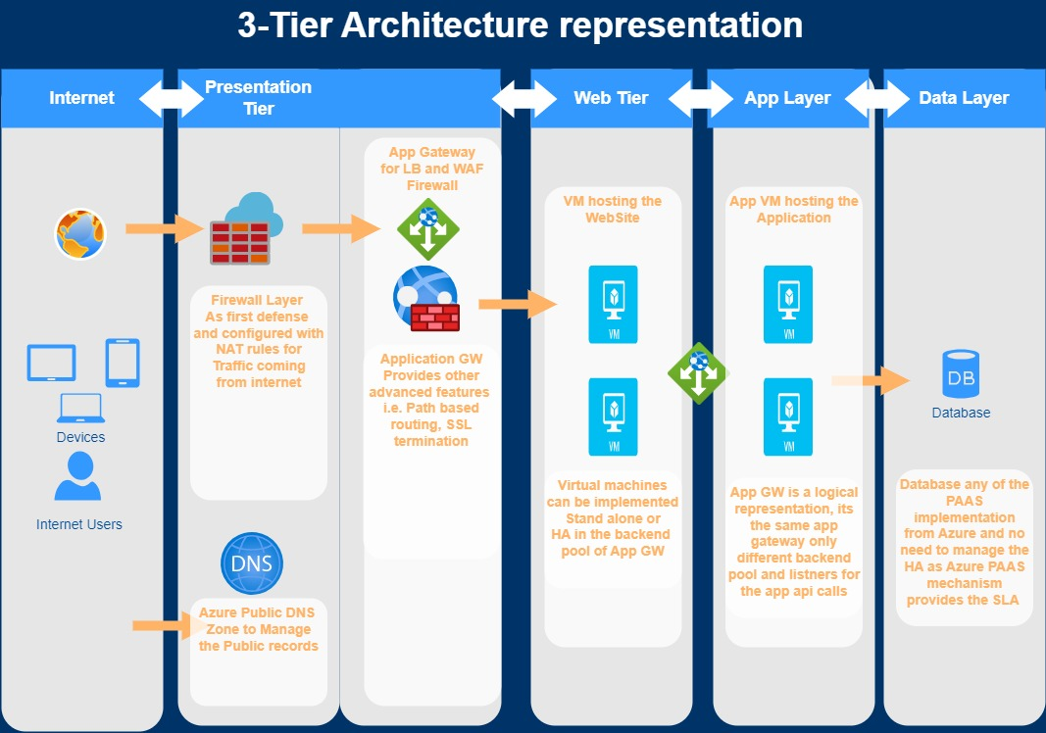

Challenge #2

We need to write code that will query the meta data of an instance within AWS or Azure or GCP

and provide a json formatted output.

Ans: - This PowerShell script sends a GET request to the specified URL with the given headers, retrieves the JSON response, converts it to a PowerShell object, and then formats it as JSON with an indentation of 4 spaces. Finally, it outputs the formatted JSON.

$headers = @{

'Metadata' = 'true'

}

$metadata_url = 'http://192.168.0.1/metadata/instance?api-version=2024-04-19'

$response = Invoke-RestMethod -Uri $metadata_url -Headers $headers

$formatted_output = $response | ConvertTo-Json -Depth 4

Write-Output $formatted_output

Challenge #3

We have a nested object. We would like a function where you pass in the object and a key and

get back the value.

* Example Inputs

object = {“a”:{“b”:{“c”:”d”}}}

key = a/b/c

Unable to understand