Mentoring exercise accomplished:
Java DONE program uses a REST API that allows creating and ordering Pizzas.
AngularJS DONE program uses an AngularJS (aka Angular 1) based front-end over this Pizza API.
Redevelop this front-end in Angular (aka Angular 2).

The source code of the front-end developed in Angular can be found at https://github.com/sanjeevsachdev/pizza-store-front-end. It could be readily set up by looking at its README.md.

Following pages show screenshots of the two front-ends:

Pizza bases – grid view
AngularJS

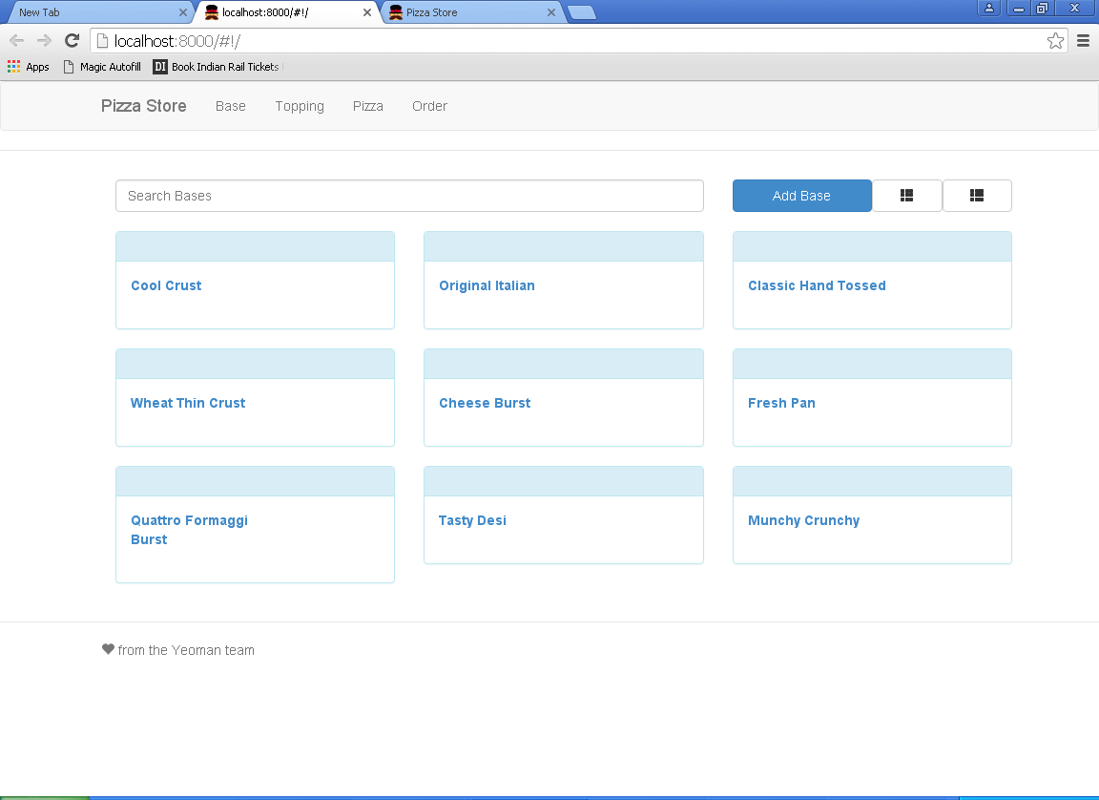

Angular

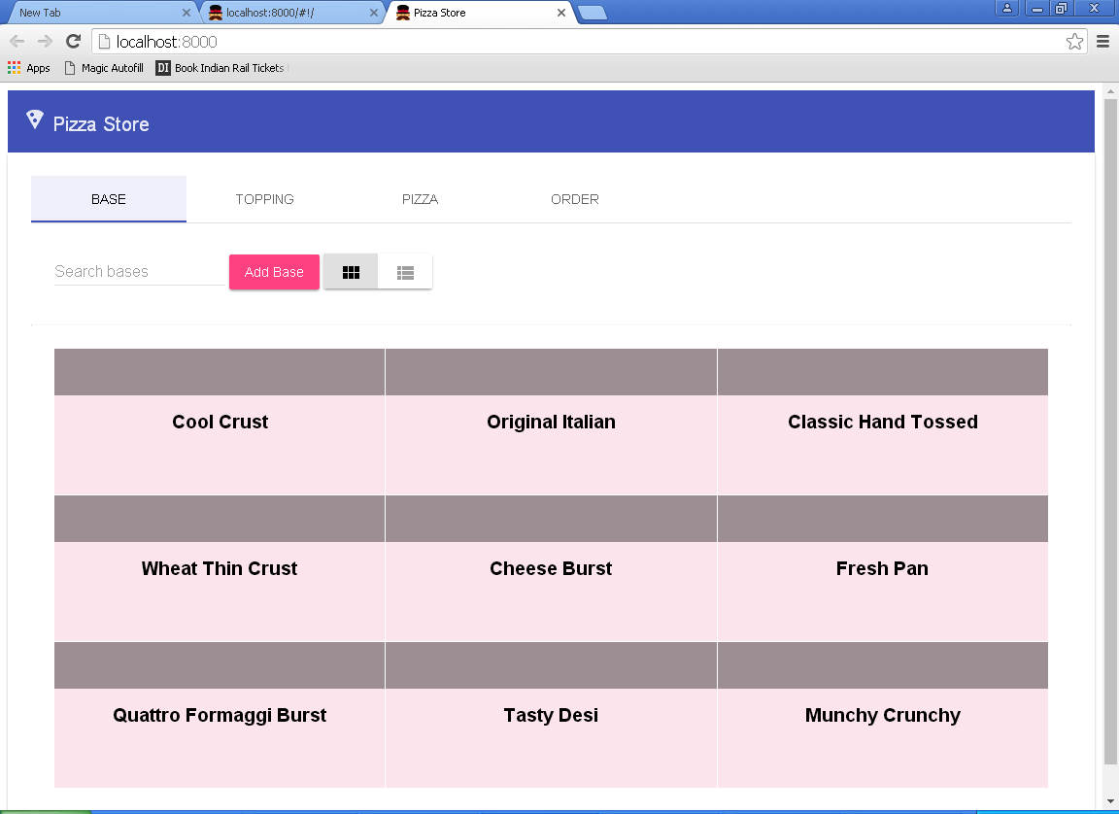
Pizza bases – list view
AngularJS

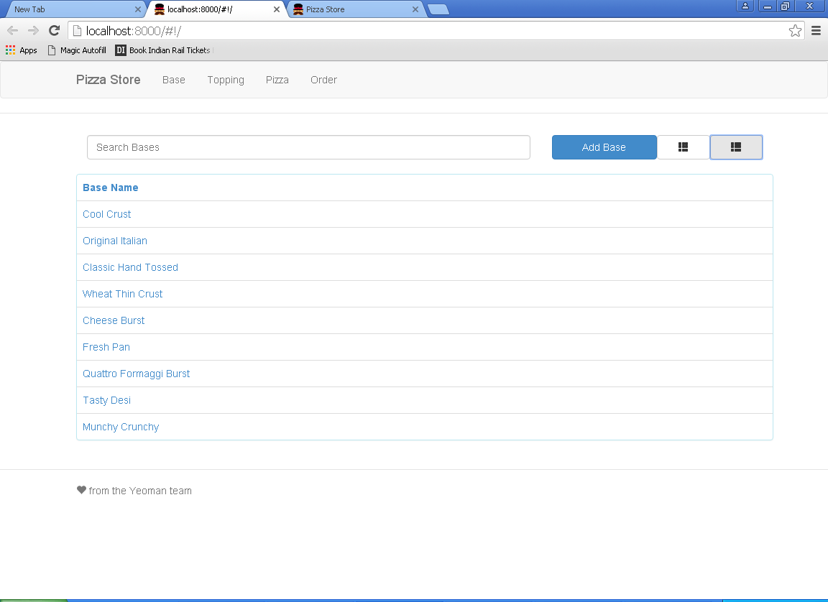

Angular

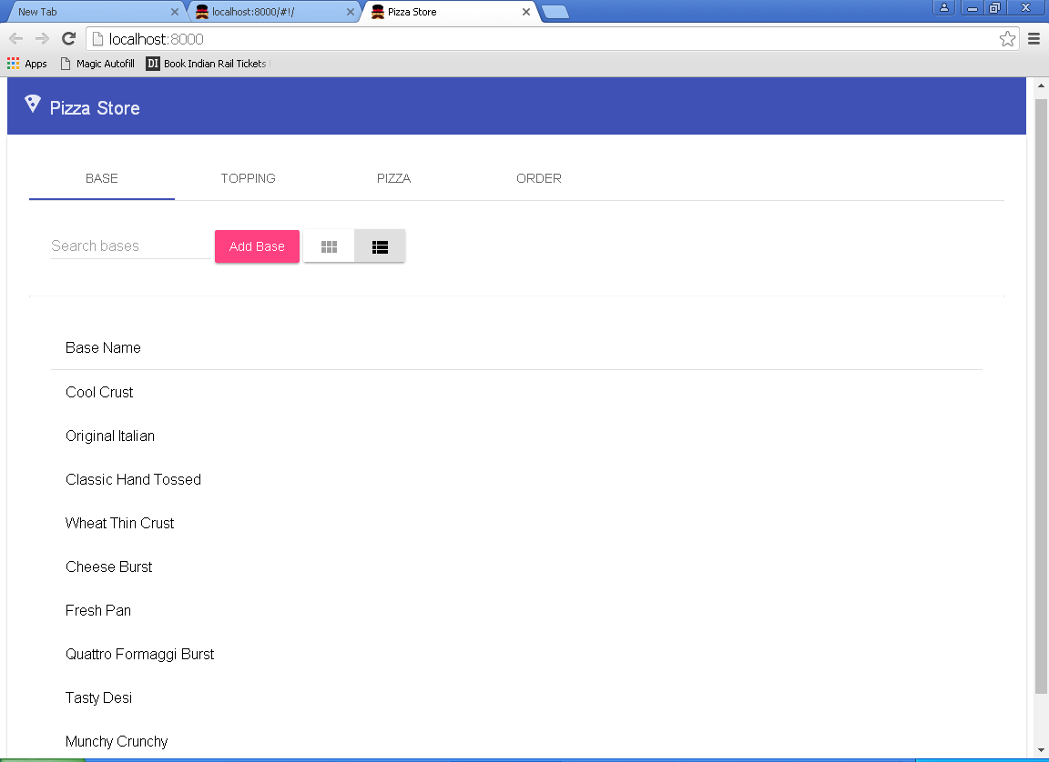
Pizza bases – add a new one
AngularJS

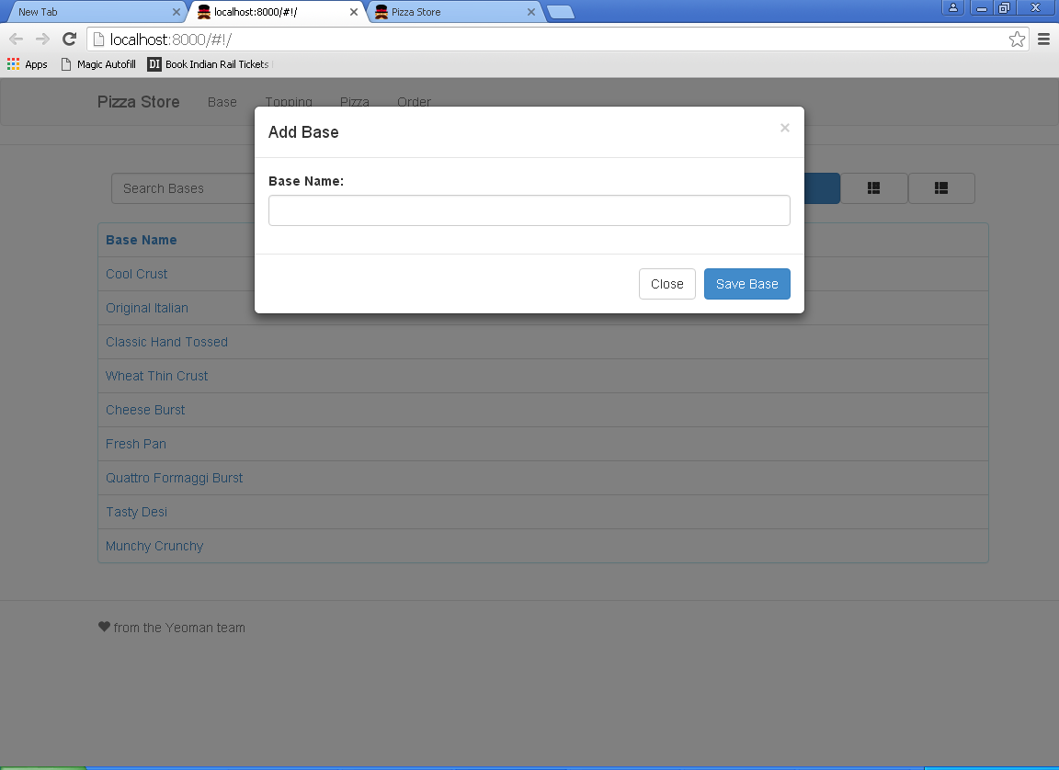

Angular

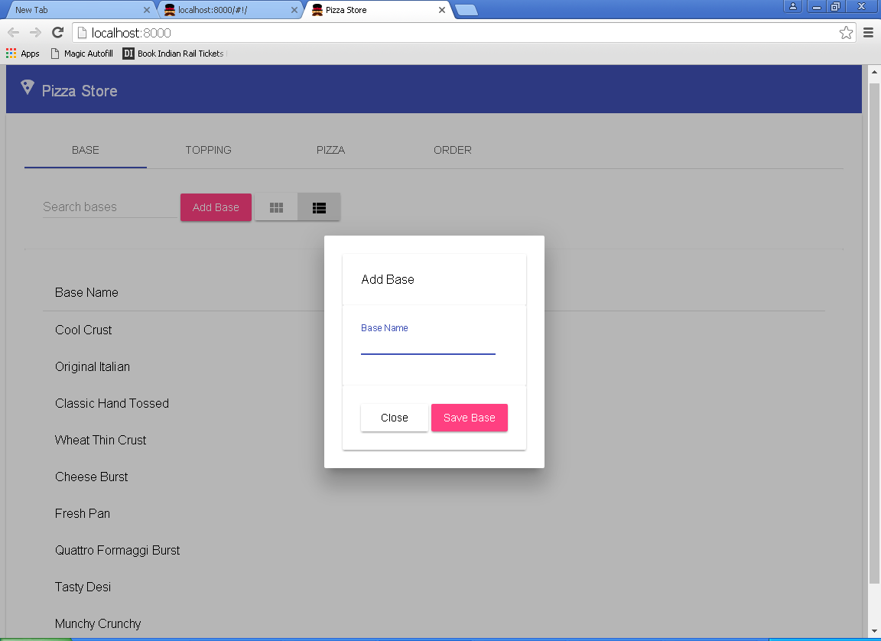

Pizza bases – filtering
AngularJS

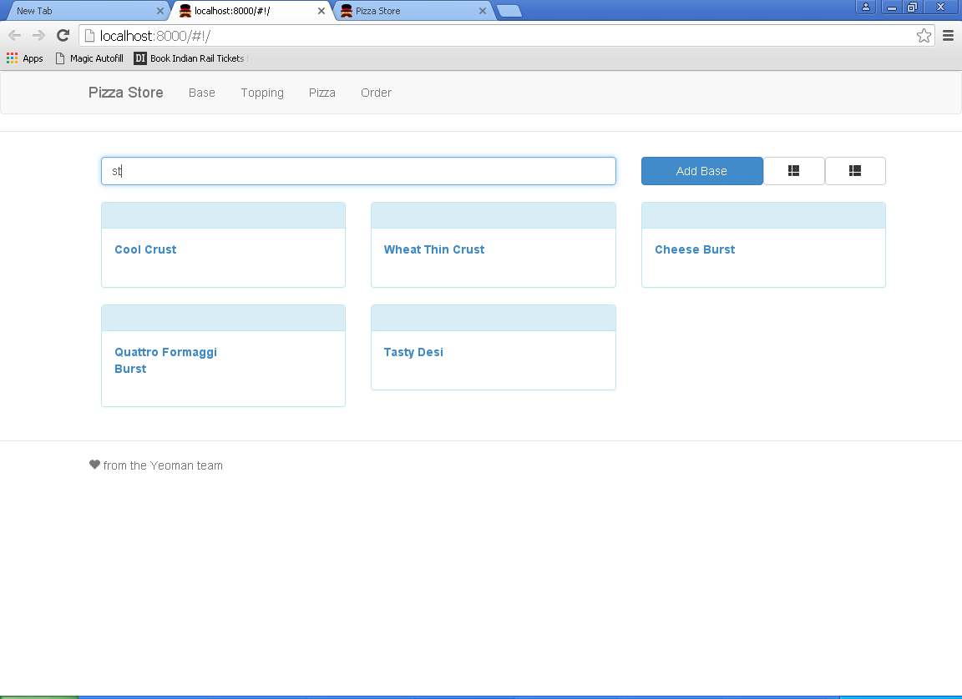

Angular

