**First React App**

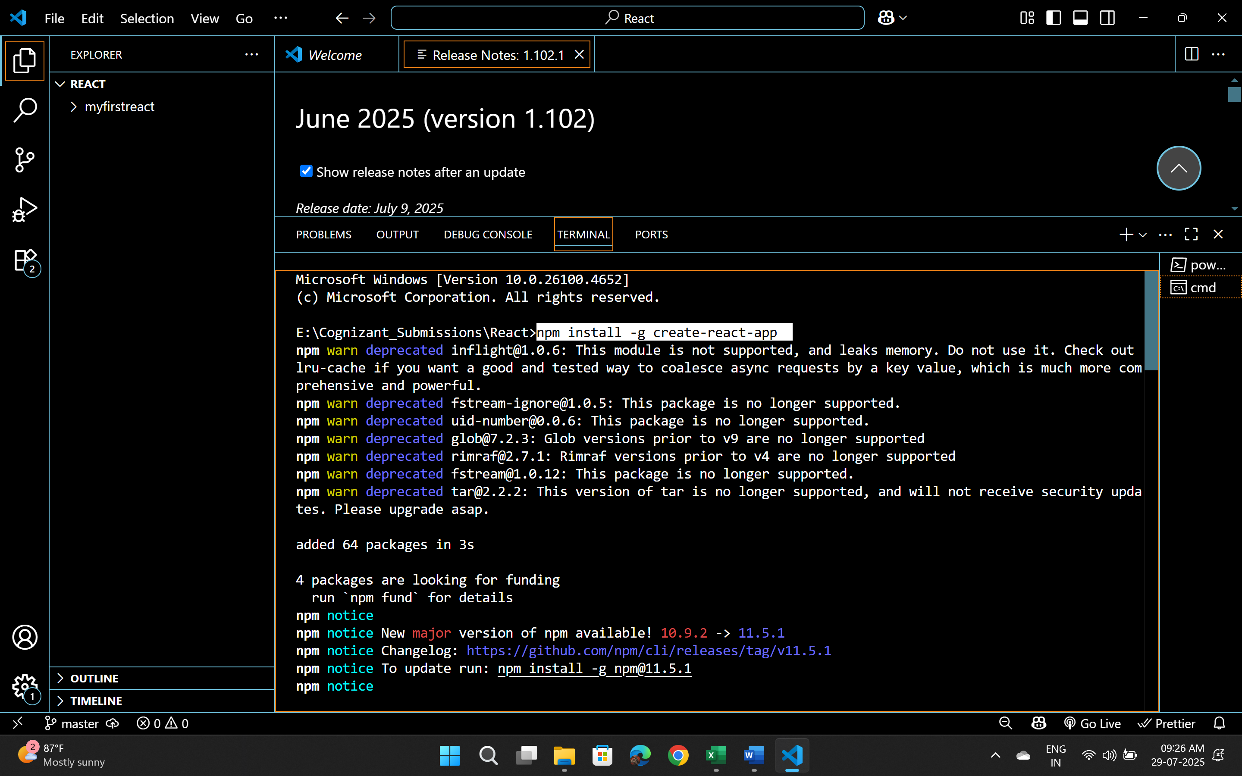

import './App.css';

function App() {

  return (

    <h1>Welcome to the first react appp </h1>

  );

}

export default App;

