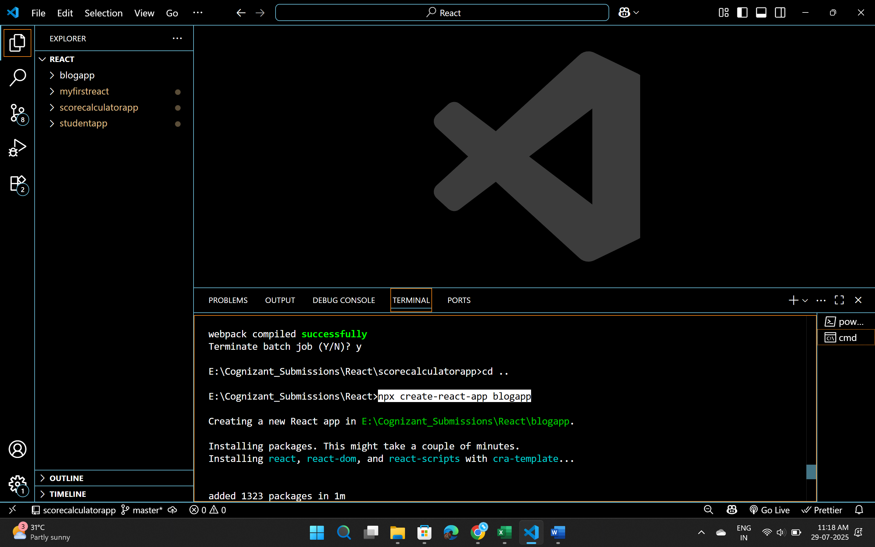

Post.js

// src/Post.js

class Post {

  constructor(userId, id, title, body) {

    this.userId = userId;

    this.id = id;

    this.title = title;

    this.body = body;

  }

}

export default Post;

Posts.js

import React, { Component } from 'react';

class Posts extends Component {

  constructor(props) {

    super(props);

    this.state = {

      posts: [],

      hasError: false

    };

  }

  componentDidMount() {

    this.loadPosts();

  }

  loadPosts = () => {

    fetch('https://jsonplaceholder.typicode.com/posts')

      .then(res => res.json())

      .then(data => {

        this.setState({ posts: data });

      })

      .catch(error => {

        console.error('Error loading posts:', error);

        this.setState({ hasError: true });

      });

  }

  componentDidCatch(error, info) {

    alert("An error occurred while rendering posts.");

    console.error("Error boundary caught:", error, info);

  }

  render() {

    if (this.state.hasError) {

      return <h2>Something went wrong.</h2>;

    }

    return (

      <div>

        <h1>Blog Posts</h1>

        {this.state.posts.slice(0, 10).map(post => (

          <div key={post.id} style={{ marginBottom: '20px' }}>

            <h3>{post.title}</h3>

            <p>{post.body}</p>

            <hr />

          </div>

        ))}

      </div>

    );

  }

}

export default Posts;

App.js

import React from 'react';

import './App.css';

import Posts from './Posts';

function App() {

  return (

    <div className="App">

      <Posts />

    </div>

  );

}

export default App;

