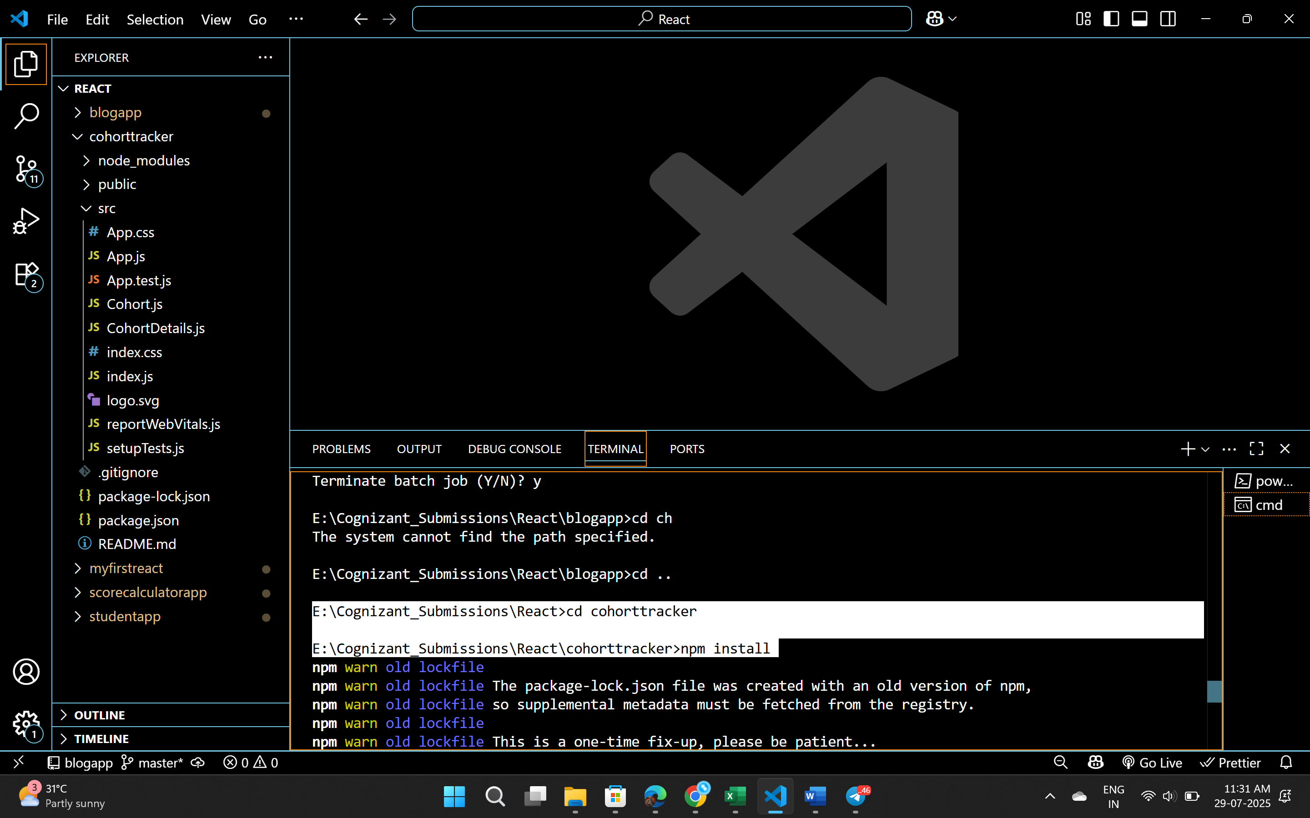

CohortDetails.module.css

.box {

  width: 300px;

  display: inline-block;

  margin: 10px;

  padding: 10px 20px;

  border: 1px solid black;

  border-radius: 10px;

}

dt {

  font-weight: 500;

}

CohortDetails.js

import React from 'react';

import styles from './CohortDetails.module.css';

function CohortDetails(props) {

  const { cohort } = props;

  // Cleaned and normalized status value

  const normalizedStatus = cohort.currentStatus.trim().toLowerCase();

  const headingStyle = {

    color: normalizedStatus === 'ongoing' ? 'green' : 'blue'

  };

  return (

    <div className={styles.box}>

      <h3 style={headingStyle}>

        {cohort.cohortCode} - <span>{cohort.technology}</span>

      </h3>

      <dl>

        <dt>Started On</dt>

        <dd>{cohort.startDate}</dd>

        <dt>Current Status</dt>

        <dd>{cohort.currentStatus}</dd>

        <dt>Coach</dt>

        <dd>{cohort.coachName}</dd>

        <dt>Trainer</dt>

        <dd>{cohort.trainerName}</dd>

      </dl>

    </div>

  );

}

export default CohortDetails;

