Implicit conversion

When we add the one int and the one float int convert in to float and as well as after adding that return the values as float also

Explicit conversion

When we want to concatenate a int to the string that time we need convert int to string usigng type casting ,type converting str(int)

* Implicit made by automatically with python and explicit we need to manually convert types

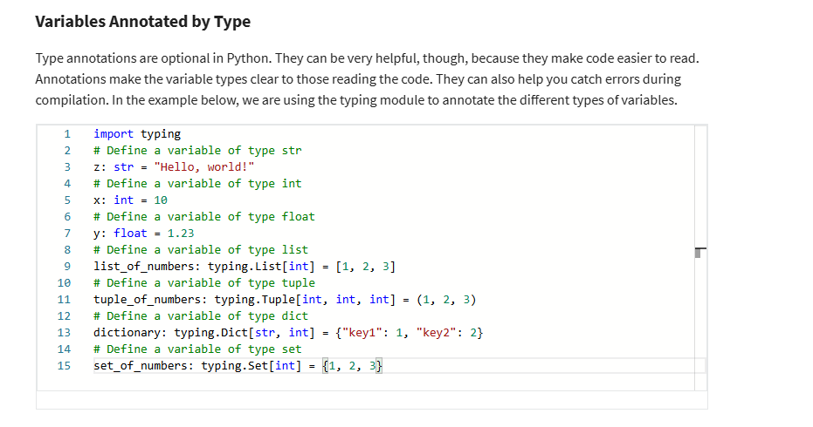

Function

Def function_name(para1,para2):

Para = para1+ para2

Return para,para2,para3

A,b,c = function_name(4,30

6//2.5 flow devition devide num and get only integer part

6%2.5 devide number and get reminder