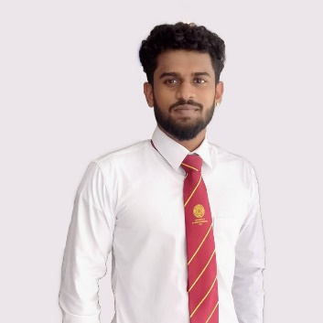 Sanjeev **Thanarasa**

SOFTWARE DEVELOPER · LEARNING ARTIFICIAL INTELLIGENCE

*NO:133B, Inner harbor Road, Orrs ’hill, Trincomalee, Sri Lanka -31000*

(+94) 779702687 | sanjeev.thanarasa@gmail.com |  sanji185 |   [sanjeev-thanarasa-5624a21aa](https://www.linkedin.com/in/ashutosh-hathidara-88710b138)

*“I want to be the best version of mine.”*

# Education

**Bachelor of Information and Communication Technology, Software Specialist** *USJP - Sri Lanka*

B.ICT. IN SOFTWARE FROM UNIVERSITY OF SRI JEYAWARDHANAPURA *January, 2017 – October, 2022*

* I secured 1st position in A/L examination of Sri Lanka 2016 batch in Trincomalee district.
* BICT_GPA: 3.5/4.0

# Technical Skills & Expertise

* **Languages:** C, C++, Java, Advanced Python, Advanced C, HTML, CSS, JavaScript, Dart
* **Database:** MySQL, MongoDB
* **Framework:** Flutter, React
* **Operating System:** Linux, Windows
* **Learned Tec:** Machine Learning, Deep Learning, Data Science, TensorFlow, Keras, Flask
* **Tools:** Google Cloud Platform, Amazon Web Services, Cognitive class labs, IBM Watson Studio, Microsoft Azure, Notebooks (Jupyter, Kaggle, Google Collab etc.), Android Studio

# Experience

**KaymuLanka (Private) Limited (daraz.lk).** *Colombo-Sri Lanka*

SOFTWARE ENGINEER INTERN *April 2021 – Oct 2021*

* **Duration:** 6 Month
* It was a good experience for me and I learned many things and technical ideas from this company. I went to this company for my university Internship program at NAITA. And completed 6 months of training in this company. I got a chance to work continuously in that company but I didn't because our 7th-semester course was an internship program then we had a final-semester course. So, after completing my internship I focused on my remaining studies.

**CyberWarders (Private) Limited.** *Work From Home*

SOFTWARE DEVELOPER INTERN *Jan. 2022 - PRESENT*

* **Duration:** 7 Month
* I have developed a Mobile Application Using Flutter for a Canadian Restaurant.
* I have implemented the task using database Firebase.
* They used an application deployed by me and few other interns.
* **Android App link on play store: https://play.google.com/store/apps/details?id=com.thunderboarsolution.foodom**

# Extracurricular Activities

* Member of Social Service Group.
* Motivational writer, and Reader.
* Chess Player, Football Player, Competitive Coder.