**BRS**

Bank Reconciliation is a process that gives the reasons for differences between the bank statement and Cash Book maintained by a business. Not only is the process used to find out the differences, but also to bring about changes in relevant accounting records to keep the records up to date. Bank reconciliations examples are carried out at regular intervals.

### Reasons for Difference Between Bank Statement and Company’s Accounting Record

When banks send companies a bank statement that contains the company’s beginning cash balance, transactions during the period, and ending cash balance, the bank’s ending cash balance and the company’s ending cash balance are almost always different. Some reasons for the difference are:

* Deposits in transit: Cash and checks that have been received and recorded by the company but have not yet been recorded on the bank statement.
* Outstanding checks: Checks that have been issued by the company to creditors but the payments have not yet been processed.
* Bank service fees: Banks deduct charges for services they provide to customers but these amounts are usually relatively small.
* Interest income: Banks pay interest on some bank accounts.
* Not sufficient funds (NSF) checks: When a customer deposits a check into an account but the account of the issuer of the check has an insufficient amount to pay the check, the bank deducts from the customer’s account the check that was previously credited. The check is then returned to the depositor as an NSF check.

Nowadays, many companies use specialized accounting software in bank reconciliation to reduce the amount of work and adjustments required and to enable real-time updates.

### Bank Reconciliation Procedure

1. On the bank statement, compare the company’s list of issued checks and deposits to the checks shown on the statement to identify uncleared checks and deposits in transit.
2. Using the cash balance shown on the bank statement, add back any deposits in transit.
3. Deduct any outstanding checks.
4. This will provide the adjusted bank cash balance.
5. Next, use the company’s ending cash balance, add any interest earned and notes receivable amount.
6. Deduct any bank service fees, penalties, and NSF checks. This will arrive at the adjusted company cash balance.
7. After reconciliation, the adjusted bank balance should match with the company’s ending adjusted cash balance.

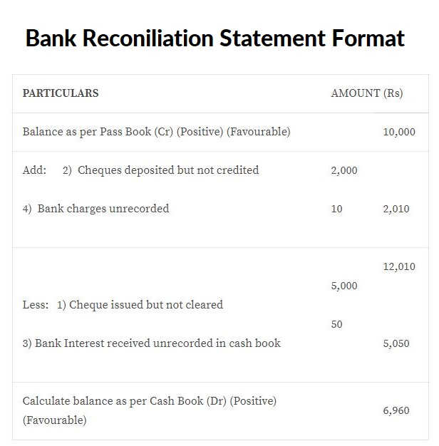

**Bank Reconciliation Example – 1**

Markson’s & Co. has a balance as per pass book of $1,000 as on 31st March 2019. It has a balance as per Cash Book as on 31st March 2019 of $1050. Further details are as follows:

1. A cheque of $300 was deposited, but not collected by the bank.
2. Bank charges of $50 were recorded in Passbook, but not in Cash Book.
3. Cheques worth $200 were issued, but not presented for payment.
4. Bank interest of $100 was recorded in Passbook, but not in Cash Book.

**Bank Reconciliation Statement of Wright Inc. as on 31st December 2019**

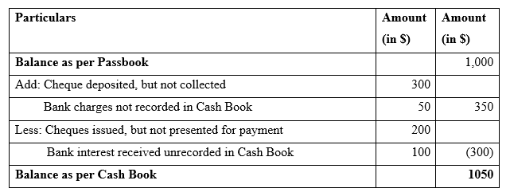

**Bank Reconciliation Example – 2**

Wright Inc. has a balance in a Passbook of $10,000 as on 31st December 2018. These are the other details:

1. Three cheques of $2,000, $1,500 and $2,500 were deposited in the bank on 30th December 2018 but were recorded in the bank statement in January 2019.
2. Cheque of $500 issued on 31st December 2018 was not presented for payment.
3. A dividend of $1,000 on stocks was credited in Bank Account, but not recorded in Cash Book.
4. A direct deposit of $400 was made in Bank Account by a customer, which was not recorded in Cash Book.
5. Bank charges of $100 were entered only in Bank Passbook
6. Balance as per Cash Book on 31st December 2018 was $14,200.

**Solution:**

**Bank Reconciliation Statement of Wright Inc. as on 31st December 2018**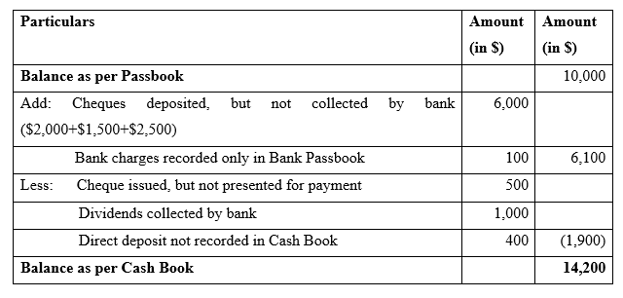

**Bank Reconciliation Example – 3**

Rutherford Inc. has a difference in the balance as per Cash Book and bank statement as on 31st March 2019. You are advised to prepare a Bank Reconciliation statement as on that date with the following information:

1. Balance as per Bank Statement as on 31st March 2019 is $4,000. Balance as per Cash Book is $1,400.
2. Cheque of $1,000 and $500 issued as on 30th March 2019, but not yet cleared
3. An insurance premium paid by bank $200. It is not yet recorded in Cash Book.
4. An outgoing cheque of $2,000 recorded twice in the Cash Book. It is properly recorded in the bank statement.
5. Payment received of a cheque of $400 recorded twice in Cash Book.
6. Dividends received $500 recorded only in the bank statements and not Cash Book.
7. Cheque of $700 deposited on 29th March 2019. But, it is not yet collected.
8. Bank charges of $100 debited only in Bank PassBook.

**Solution:**

**Bank Reconciliation Statement of Rutherford Inc. as on 31st March 2019**

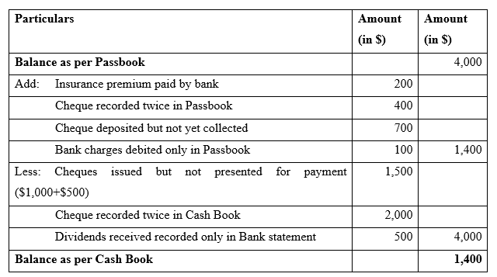

#### Bank Reconciliation Example – 4

You are an Accountant in Jeffries Inc. You have prepared a Cash Book for March 2019. There is a difference in the balance as on 31st March 2019 between the bank statement and Cash Book. You are required to prepare a Bank Reconciliation Statement as on 31st March 2019. Below is the extract for Cash Book and Bank statement for the month of March 2019.

**Cash Book (March 2019) for Jeffries Inc**

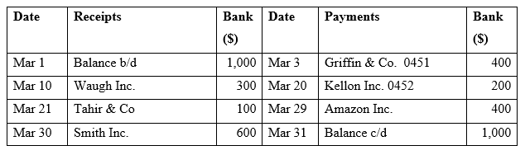

**Bank statement (March 2019) for Jeffries Inc**

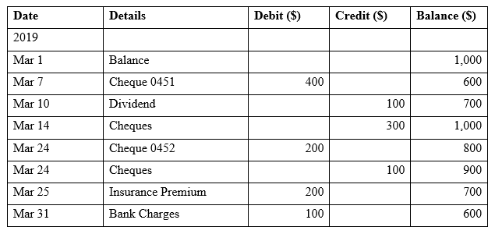

**Solution:**

We first find the common items in the Cash Book and the Bank statement. The common items are:

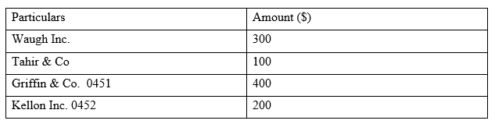

The balance items would appear in the Bank Reconciliation Statement

