Project :

MINOR PROJECT 1

Cybersecurity Risk Assessment Framework for Small Retail Businesses

Name: Sanjibani Paul
Course & Semester: B.Tech CSE , 3rd Semester
University Name: Chandigarh University
Submission Month & Year: November, 2025

INDEX

1 | Abstract
2 | Introduction
3 | Business Profile & Scope
4 | Threat Summary
5 | Framework Design
6 | Risk Assessment Method
7 | Risk Register Findings
8 | Treatment Plan & Implementation
9 | Conclusion and Future Enhancements

- ABSTRACT
This project focuses on developing a simple and effective Cybersecurity Risk Assessment Framework tailored for small retail and service businesses with 1–25 employees. Small businesses often lack the knowledge, budget, and resources to protect themselves from cyber threats. As a result, they are highly vulnerable to cyberattacks such as phishing, data breaches, Wi-Fi intrusion, and ransomware.
The objective of this project is to create a practical risk assessment model that small business owners can easily adopt without technical expertise. The framework includes five key stages: data gathering, threat identification, risk scoring, treatment planning, and implementation. The project also includes checklists, scoring techniques, a risk register, and a risk treatment plan to help small businesses evaluate and improve their cybersecurity posture.
To demonstrate the effectiveness of the framework, a simulated assessment was conducted for a sample small café business. The assessment identified critical risks such as shared staff accounts, lack of MFA, unsecure Wi-Fi, outdated POS software, and weak backup practices. Corrective actions were proposed to reduce cyber risks within 30 days.
This framework contributes as a beginner-friendly cybersecurity model for small businesses and can be further enhanced for real-world use.

- INTRODUCTION
In today’s digital age, cybersecurity has become essential for all types of businesses, including small retail and service businesses. Even though small businesses may not store large amounts of data like big companies, they are still major targets for cybercriminals because they usually have weaker security controls, limited budgets, and low awareness about cyber threats. Small retail and service businesses such as cafés, salons, bakeries, stationery shops, and small service centres rely on basic IT systems like Wi-Fi, Point of Sale (POS) systems, mobile phones, and laptops for daily operations. However, they often ignore cybersecurity practices such as strong passwords, secure Wi-Fi networks, data backups, and regular software updates. This makes them vulnerable to cyberattacks such as phishing, malware, identity theft, online payment fraud, and data loss.
To solve this problem, this project presents a simple and beginner-friendly Cybersecurity Risk Assessment Framework designed specially for small retail and service businesses with 1–25 employees. The framework helps business owners identify risks, understand threats, and apply basic cybersecurity measures to protect their business.
This project provides a step-by-step approach that includes data collection, threat assessment, risk scoring, risk register creation, treatment planning, and implementation with simple checklists and easy methods. A simulated case study was also conducted to demonstrate the use of the framework on a small business.
3. BUSINESS PROFILE AND SCOPE
3.1 Business Profile
For this project, a simulated case study was conducted for a small café business to demonstrate the use of the Cybersecurity Risk Assessment Framework. The selected business details are as follows:
- Business Name: Sweet Bean Café
- Location: Chandigarh – Sector 34
- Type of Business: Retail Food & Beverage Service
- Number of Employees: 6
- Operational Systems Used: 1 POS system, 1 laptop, 3 staff mobile phones, 2 CCTV cameras, and a Wi-Fi network
- IT Support: No full-time IT staff; occasional support from a local technician
The café depends on digital systems for daily operations such as billing, online orders, payments, and customer communication. Due to limited knowledge of cybersecurity, the business has several weaknesses that can lead to security risks. Therefore, a cybersecurity assessment was carried out using the proposed framework.

3.2 Scope of the Assessment
The scope of the cybersecurity assessment includes the evaluation of key digital assets and security practices used in the business. The assessment covers:
- Wi-Fi Network Security
- Device and System Security (POS, Laptop, Mobile Devices)
- User Access and Password Management
- Data Backup and Recovery Practices
- Awareness of Cyber Threats and Staff Training
The assessment does not include large-scale enterprise systems or advanced cybersecurity tools. The focus is only on basic security controls suitable for small businesses with limited technical expertise and budget.

3.3 Objectives of the Project
The main objectives of this project are:
- To develop a simple Cybersecurity Risk Assessment Framework for small retail and service businesses
- To identify and evaluate common cyber risks faced by small businesses
- To provide practical and low-cost solutions to reduce cyber risks
- To demonstrate the framework through a simulated real-world case study

4.THREAT SUMMARY
Small retail and service businesses face multiple cyber threats due to limited security awareness, lack of IT staff, and the use of common digital tools such as Wi-Fi, mobile phones, and POS systems. The table below summarises the most common cyber threats relevant to such businesses.
4.1 Common Cyber Threats for Small Businesses
Category | Threat | Description
Network Security | Wi-Fi Hacking | Attackers break into weak or unsecured Wi-Fi networks to access business systems.
Device Security | Malware & Ransomware | Malicious software that locks or damages systems and demands payment to restore access.
User Accounts | Phishing & Credential Theft | Fake emails or messages used to steal passwords or banking details.
Data Security | Data Loss | Loss of important business data due to system failure, accidental deletion, or cyberattack.
Access Control | Unauthorized Access | Shared or weak passwords can lead to misuse of systems or data theft by internal or external users.
Payment & POS | POS System Attack | Outdated POS systems can be exploited to steal payment or customer information.
Human Factor | Social Engineering | Staff are tricked into sharing passwords, clicking unsafe links, or installing harmful software.

4.2 Potential Impact on Small Businesses
Cyberattacks can have direct and long-term effects on small businesses. The major impacts include:
- Loss of customer data or payment information
- Financial losses due to fraud or ransomware
- Business downtime leading to revenue loss
- Damage to business reputation and customer trust
- Legal or compliance issues related to data privacy

4.3 Need for a Risk Assessment Framework
Due to limited security knowledge and low budget, small businesses often do not implement cybersecurity measures. A simple and structured framework is required to:
- Identify possible cyber threats
- Evaluate the level of risk
- Take corrective action to prevent attacks
The proposed framework in this project provides a beginner-friendly approach to help small businesses improve cybersecurity with minimal cost and effort.

5. FRAMEWORK DESIGN
The proposed Cybersecurity Risk Assessment Framework is designed to help small retail and service businesses evaluate their cybersecurity posture in a simple and structured manner. The framework consists of five key stages, starting from information gathering to implementation of security measures.
5.1 Framework Overview
The framework follows a step-by-step approach:
- Data Collection – Gather information about business assets, devices, user access, and existing security practices.
- Threat Identification – Identify the possible cyber threats and vulnerabilities related to the business.
- Risk Assessment & Scoring – Analyse the likelihood and impact of each risk using a simple scoring method.
- Risk Treatment Planning – Define actions to reduce or eliminate the identified risks.
- Implementation & Review – Apply the corrective actions and review improvements.
This framework is easy to use and does not require technical expertise, making it suitable for small business owners.

5.2 Framework Diagram

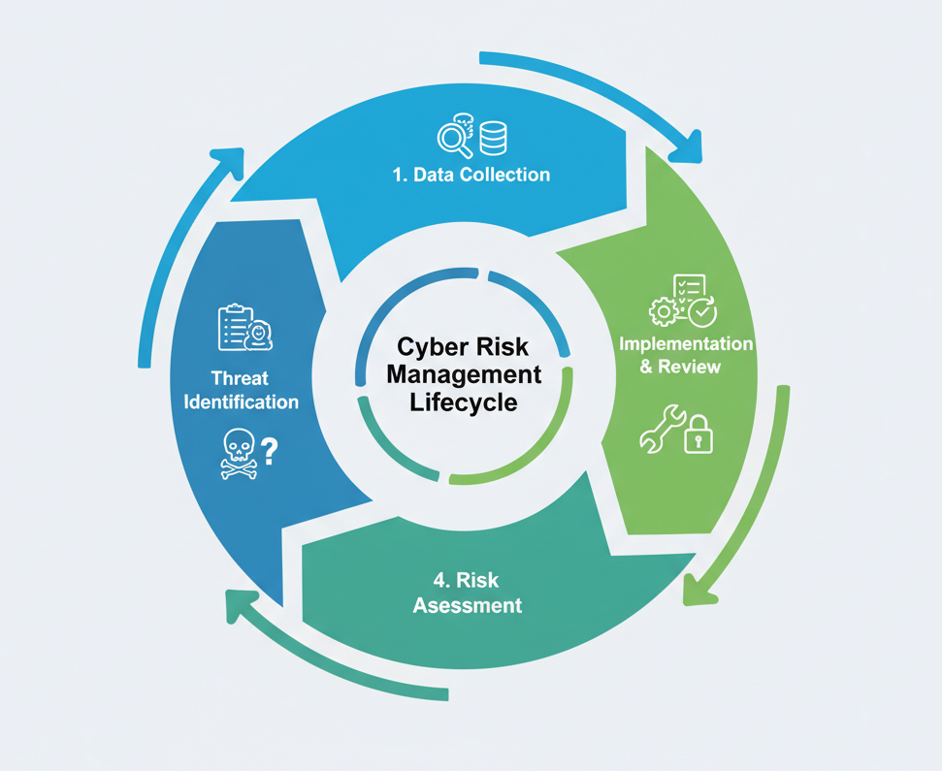

5.3 Tools and Documents Used in the Framework
The following tools and documents were used while applying the framework:
Stage | Document/Tool Used
Data Collection | Interview Checklist, Consent Form
Threat Identification | Threat Summary Table
Risk Scoring | Likelihood & Impact Scoring Sheet
Risk Assessment | Risk Register (Excel Sheet)
Risk Treatment | Risk Treatment Plan
Implementation | Evidence Screenshots & Follow-up Review

5.4 Benefits of the Framework
- Simple and beginner-friendly
- Cost-effective and suitable for small shops/businesses
- Helps identify risks early
- Provides step-by-step actions to improve security
- Can be adapted for any small business sector

6. RISK ASSESSMENT METHOD
The risk assessment process helps in identifying, analysing, and prioritising cyber risks that may affect the business. A simple scoring system was used to assess the likelihood and impact of each risk, making it easy for small business owners to understand.

6.1 Data Collection Approach
The first step was to gather information about the business, devices, network, and current security practices. This was done using:
- Interview Checklist to collect details about IT usage, access control, backup practices, and awareness levels
- Consent Form to seek permission for assessment
- Technical Checklist to inspect Wi-Fi security, POS, devices, and backup settings
This step helped in understanding the existing security posture of the business.

6.2 Risk Scoring Method
A simple Likelihood–Impact scoring model was used to evaluate each risk. Both Likelihood and Impact were rated on a scale of 1 to 4, as shown below:
Score | Likelihood Level | Description
1 | Rare | Very unlikely to occur
2 | Possible | Could occur occasionally
3 | Likely | Expected to occur
4 | Very Likely | High chance of occurrence

Score | Impact Level | Description
1 | Low | Minimal effect on operations
2 | Medium | Noticeable impact but manageable
3 | High | Significant disruption or financial loss
4 | Critical | Major damage, financial or reputational loss

6.3 Calculation of Risk Scores
The following formulas were used to calculate risk scores:
- Raw Risk = Likelihood × Impact
- Residual Risk = Raw Risk × (1 − Controls Effectiveness)
Where Controls Effectiveness is measured on a scale of 0 to 1 (example: 0.10 = 10% effective).
This helped in prioritising the risks based on the level of threat to the business.

6.4 Risk Register
A Risk Register was prepared to record all identified risks along with their likelihood, impact, existing controls, recommended actions, and priority level. The risk register helps in tracking risk treatment progress.
The risk register includes:
- Risk ID
- Asset
- Threat
- Vulnerability
- Likelihood & Impact score
- Raw and Residual Risk
- Priority Level
- Recommended Action

7. RISK REGISTER FINDINGS
Based on the assessment of the Sweet Bean Café, a total of ten (10) cybersecurity risks were identified. Each risk was analysed using the Likelihood–Impact model, and a risk score was calculated to determine the priority level. The table below summarizes the key risks identified during the assessment.

7.1 Summary of Key Risks Identified
Risk ID | Risk Description | Priority Level
1 | Shared staff user accounts | High
2 | Single Wi-Fi network for guests and staff | Critical
3 | No Multi-Factor Authentication (MFA) | Critical
4 | Outdated POS software | High
5 | Backups not tested for recovery | High
6 | Weak Wi-Fi password | Medium
7 | No cybersecurity awareness training for staff | High
8 | Free/low-level antivirus only | Medium
9 | Backup stored only on café premises | Low
10 | CCTV access not secured | Medium

7.2 Analysis of Results
From the risk register, it is clear that the business has several areas of high and critical risk that require immediate attention.
- Critical Risks such as lack of Wi-Fi separation and no MFA can lead to major data breaches and financial loss if exploited.
- High Risks like outdated POS software and weak backup methods can severely affect the business if a cyber incident occurs.
- Medium and Low Risks are less urgent but should be addressed as part of continuous improvement.

7.3 Risk Prioritization
The risks were prioritised based on residual risk score, after considering the effectiveness of existing controls. A summary of the prioritization approach:
- Critical Risks must be fixed within 7 days
- High Risks should be addressed within 15 days
- Medium Risks should be resolved within 25 days
- Low Risks can be treated within 30 days
This prioritization helps the business plan risk mitigation efforts effectively.

8. RISK TREATMENT PLAN AND IMPLEMENTATION
A Risk Treatment Plan was created to reduce or eliminate the identified cybersecurity risks. The plan includes recommended actions, responsible persons, and target dates for completion. This ensures that risks are addressed in a structured manner.

8.1 Risk Treatment Plan
The table below summarises the treatment actions planned for each risk:
Risk ID | Risk Description | Action to be Taken
1 | Shared staff user accounts | Create separate user accounts for all staff
2 | Single Wi-Fi for guests and staff | Create separate Guest and Staff Wi-Fi networks
3 | No MFA enabled | Enable MFA on email, banking, and POS accounts
4 | Outdated POS software | Update POS software and enable auto-updates
5 | Backups not tested | Schedule regular backups & test restoration monthly
6 | Weak Wi-Fi password | Set a strong password and change every 3 months
7 | No staff cybersecurity training | Conduct basic cybersecurity awareness training
8 | Free antivirus only | Upgrade to better antivirus or security plan
9 | Backup stored on-site only | Store backup on cloud or off-site location
10 | CCTV not secured | Change default ports & enable secure access
Each action was assigned a target timeline to ensure timely completion.
8.2 Implementation Evidence
To validate the application of the treatment plan, evidence was collected in the form of screenshots. These screenshots show the actions that were implemented as part of the cybersecurity improvement process.
The following implementation evidence was recorded:
- Wi-Fi network separation successfully completed
- POS system updated to the latest version
- Multi-Factor Authentication (MFA) enabled
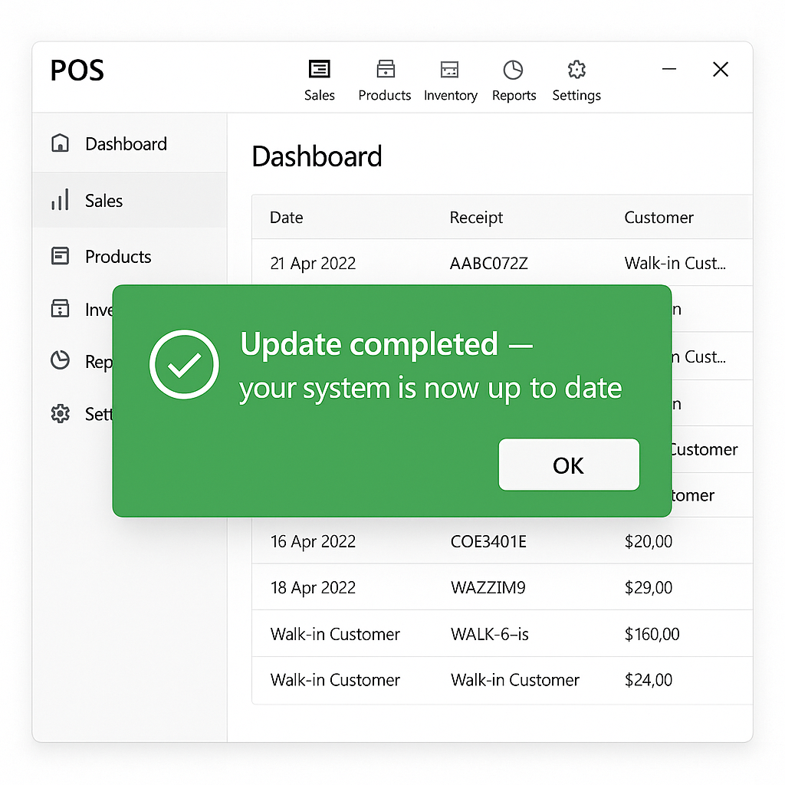
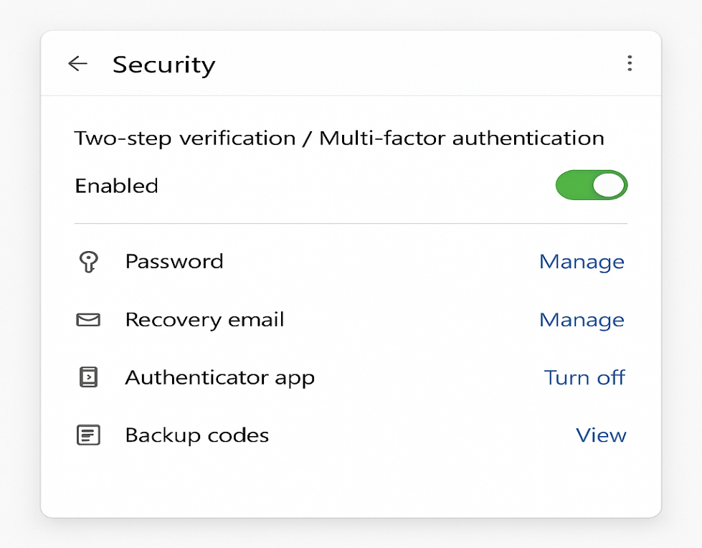
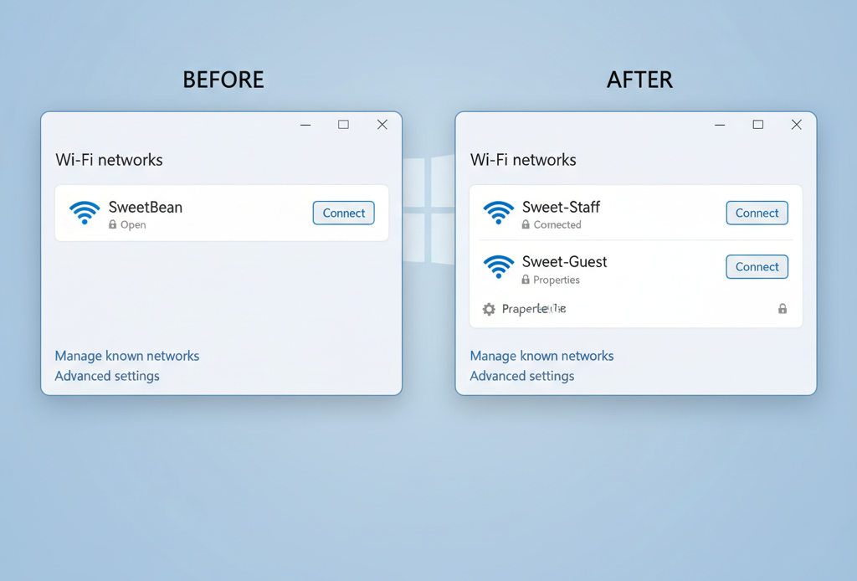
8.3 Summary of Improvements
After completing the initial phase of risk treatment:
- Critical risks such as Wi-Fi security and lack of MFA were addressed
- Security of key systems such as POS and user accounts improved
- Business awareness toward cybersecurity increased
9. CONCLUSION
This project presented a simple and practical Cybersecurity Risk Assessment Framework designed for small retail and service businesses with limited technical knowledge and budget. The framework helps business owners identify cyber risks, evaluate their severity, and take necessary actions to improve security using easy-to-follow steps.
Through a simulated case study of “Sweet Bean Café,” several cybersecurity gaps were identified, including weak Wi-Fi security, lack of Multi-Factor Authentication (MFA), shared user accounts, outdated software, and poor backup practices. A structured Risk Register and Risk Treatment Plan were developed to address these issues based on priority and impact. Initial implementation evidence shows that the business has started taking steps to improve its cybersecurity posture.
Overall, the framework successfully demonstrates that even small businesses can enhance their cybersecurity with simple, low-cost measures. It provides a starting point for adopting better security practices and building cyber awareness among staff members.

- FUTURE ENHANCEMENT
Although the framework is simple and effective for small businesses, it can be further enhanced in the future. Possible improvements include:
- Adding automated tools for risk assessment and reporting
- Expanding the framework for medium-sized businesses and other sectors
- Introducing more technical controls such as intrusion detection and monitoring
- Developing a mobile or web-based version of the framework for easy use
- Conducting real-world assessments on multiple small businesses to improve accuracy
These enhancements can make the framework more scalable, efficient, and suitable for a broader range of organizations.

