Practical Framework for Small Business Resilience
This document outlines a simple, five-part cybersecurity framework designed specifically for small retail and service businesses.
Existing frameworks from organizations like NIST and ISO are powerful but are often too complex and resource-intensive for a small business to implement effectively¹¹¹¹. This framework adapts the core logic of the NIST Cybersecurity Framework (CSF) into a set of practical, low-cost, and high-impact actions .
The goal is not to build a complex security fortress, but to make your business resilient. This means you can prevent the most common attacks, detect problems quickly, and recover with minimal downtime and financial loss.
This framework is built around five simple functions:
- Identify: Know what you need to protect.
- Protect: Defend your business with basic, essential controls.
- Detect: Spot problems as soon as they happen.
- Respond: Know what to do in an emergency.
- Recover: Get back to business safely.
Research shows that most small business cybersecurity efforts focus heavily on Identify and Protect, while dangerously neglecting Detect, Respond, and Recover . This framework provides simple, actionable steps for all five areas.
# The Five Functions
Here are the core activities for a small retail or service business for each function.
- ID. IDENTIFY
Goal: Understand what business systems, data, and devices you rely on.
You can't protect what you don't know you have. This step is about making a simple list.
Core Activities for Small Retail:
- Asset Inventory: Make a list of your key technology and data. This doesn't need to be complicated. Use a simple spreadsheet.
  - Hardware: Point-of-Sale (POS) terminal, employee laptops/PCs, main office computer, store Wi-Fi router, any card readers.
  - Software: Your POS software, cloud accounting (e.g., QuickBooks, Xero), email provider (e.g., GSuite, Microsoft 365), e-commerce platform (e.g., Shopify), and customer email list (e.g., Mailchimp).
  - Data: Customer payment information, the customer email list, financial records, and supplier bank details.
- Risk Assessment: Understand what threatens these assets.
  - This task was completed in the 02_threat_summary.pdf document. The key threats are Phishing, Ransomware, POS Compromise, and Supplier Fraud.

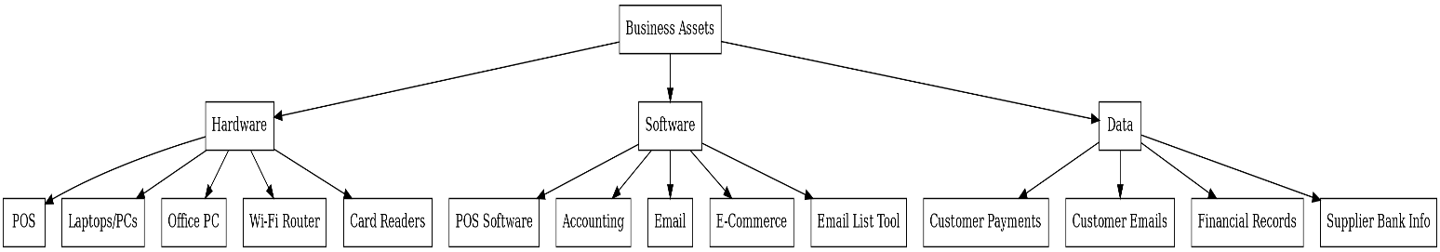
- PR. PROTECT
Goal: Implement simple defenses to stop an attack from succeeding.
This is about making it harder for attackers. Many of the most effective controls are low-cost and focus on employee behavior⁴⁴⁴⁴.
Core Activities for Small Retail:
- Access Control:
  - Use strong, unique passwords for all accounts (POS, email, banking, accounting).
  - Enable Multi-Factor Authentication (MFA) wherever possible. This is the single most effective way to stop credential theft⁵.
  - Do not share accounts. Give each employee who needs access their own login.
- Awareness & Training:
  - Since phishing is a primary threat⁶⁶⁶⁶, train staff to spot suspicious emails (e.g., fake supplier invoices, urgent password resets).
  - Train staff on correct procedures for handling payments and verifying any "change of bank details" requests to prevent supplier fraud.
- Data Security (Backups):
  - Regularly back up critical data (POS sales, financial records, customer lists).
  - Keep one copy of the backup offline (e.g., an external hard drive you unplug) so ransomware can't encrypt it.
- P rotective Technology (Basic):
  - Patch Management: Keep your POS software, Windows/macOS, and web browser updated. This fixes vulnerabilities attackers use.
  - Network Security: Secure your Wi-Fi. Change the router's default admin password and use a strong WPA2/WPA3 password. Create a separate "Guest" network for customers.
  - Antivirus: Ensure basic antivirus software is running on all computers.

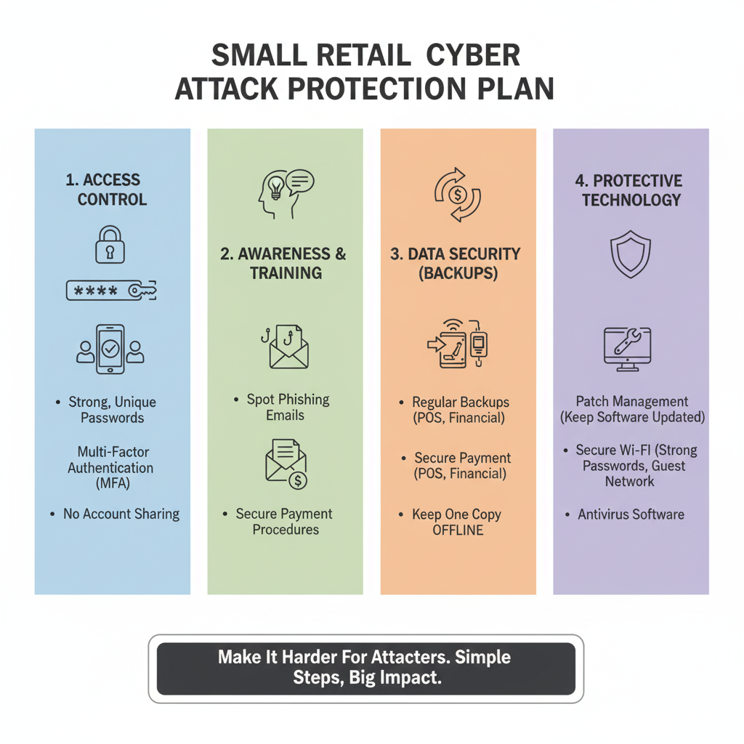
- DE. DETECT
Goal: Discover a security breach as it's happening, or as quickly as possible.
The faster you know, the less damage is done. For a small business, this means paying attention to simple, clear warning signs.
Core Activities for Small Retail:
- Monitor for Anomalies:
  - Pay attention to bank and credit card alerts for unusual transactions.
  - Investigate customer complaints about duplicate charges or fraudulent activity (a key sign of POS compromise).
  - Note unusual POS behavior, such as sudden slowness, freezes, or restarts.
- Review System Logs:
  - This sounds technical, but it can be simple. Enable login alerts on your key cloud accounts (email, accounting). If someone logs in from an unrecognized location, you'll get an email.
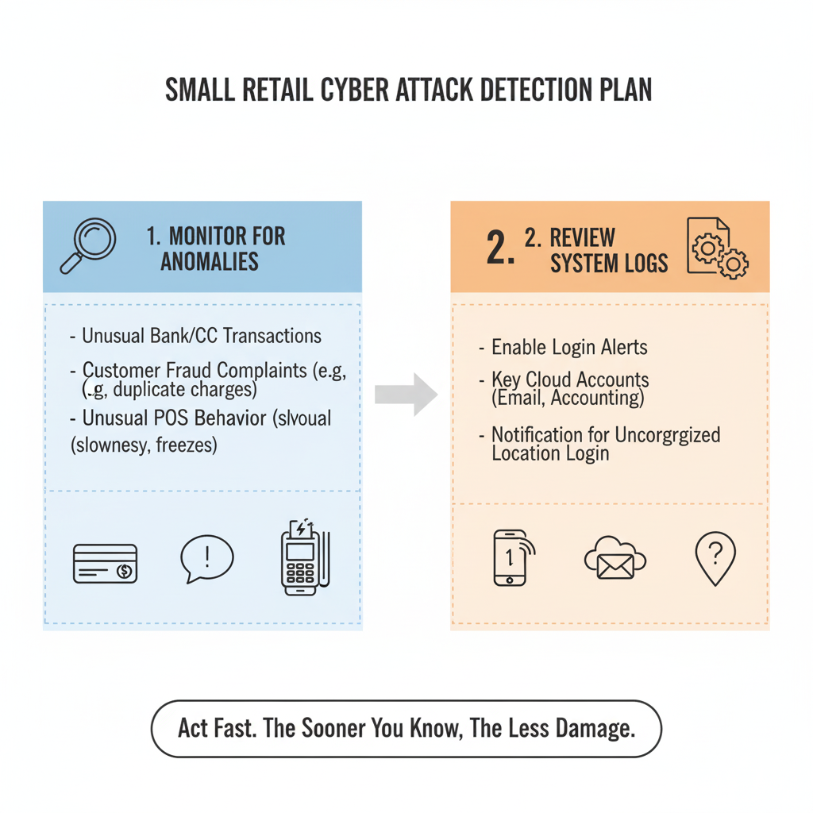
- RS. RESPOND
Goal: Have a simple plan for what to do during an attack to limit damage.
When an incident happens, panic is the enemy. A simple checklist is your best tool.
Core Activities for Small Retail:
- Create a Contact List: Have a printed list of who to call.
  - Your bank's fraud department.
  - Your payment/POS provider (e.g., Shopify, Square, Global Payments).
  - Any on-call IT support person.
- Create an Incident Checklist (Example for Ransomware):
  - Isolate: Immediately unplug the network cable and disconnect from Wi-Fi on the infected machine.
  - Do NOT Pay: Do not pay the ransom. It encourages attackers and there is no guarantee you will get your data back.
  - Report: Call your bank and POS provider to warn them of a potential breach.
  - Restore: Move to the Recover step (i.e., restoring from your offline backup).
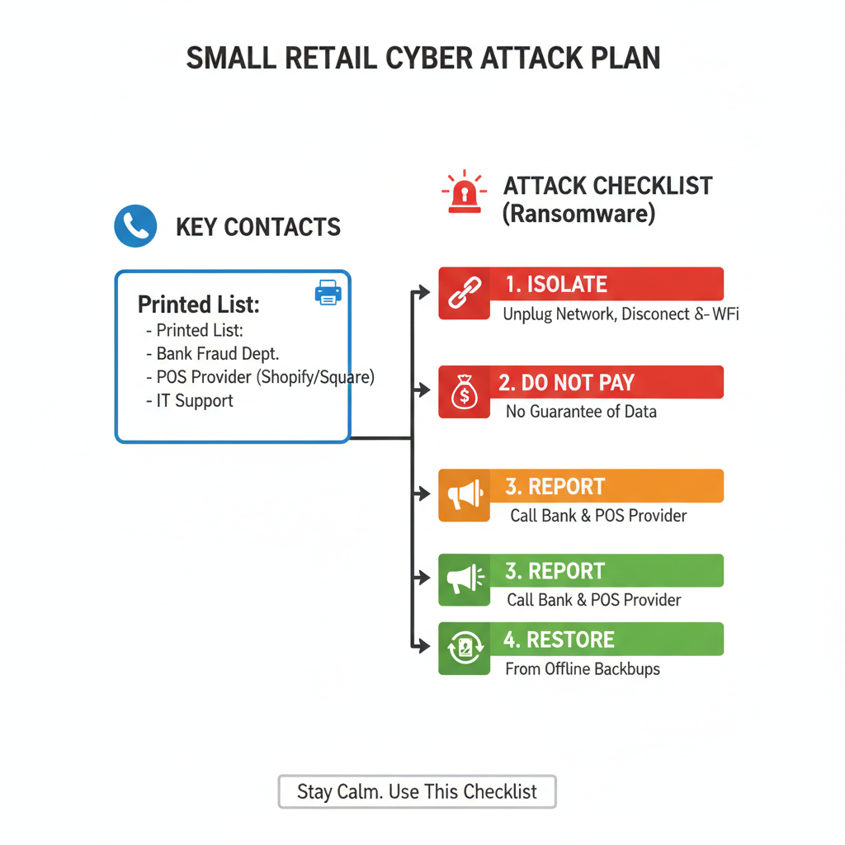
- RC. RECOVER
Goal: Get your business back up and running safely after an incident.
This is how you ensure your business survives. The plan is simple: restore and learn.
Core Activities for Small Retail:
- Restore from Backups:
  - This is your primary recovery method. After an attack (like ransomware), the plan is to wipe the infected machine and restore your data from your known-good, offline backup.
- Learn from the Incident:
  - After the immediate crisis is over, ask one question: "How did they get in?"
  - If it was a phishing email, your follow-up action is more training (Protect).
  - If it was an unpatched system, your follow-up is to improve your patching (Protect).
  - This feedback loop makes your business stronger.

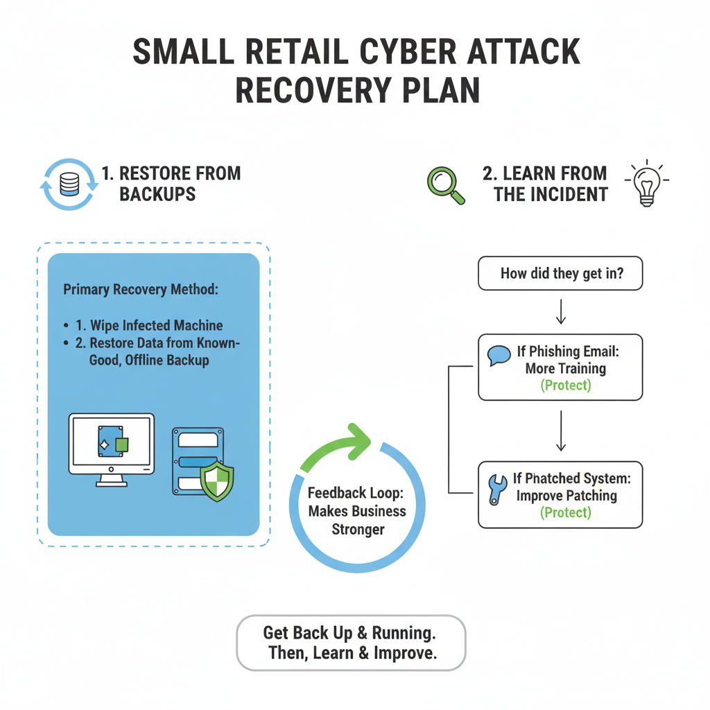
# Asset Mapping Table
This table connects your key assets (from Identify) to the framework functions that are most important for protecting them.
Asset | Key Data Involved | Most Important Functions to Apply
POS Terminal | Customer Card Data (PCI), Sales Data | Protect: Keep software patched, use strong access codes.  Detect: Monitor for slow transactions or customer fraud complaints.  Respond: Know how to shut it down and who to call (payment processor).
Back Office PC / Laptop | Financials, Supplier Info, Payroll, Email | Protect: Antivirus, software updates, regular backups, and strong employee phishing training.  Respond: Isolate from the network if infected.
Cloud Accounting  (e.g., QuickBooks, Xero) | All Financial Data, Supplier Bank Details | Identify: Know this is a "crown jewel" asset.  Protect: Multi-Factor Authentication (MFA) is mandatory. Use a strong, unique password.
Email Accounts  (e.g., GSuite, Microsoft 365) | Sensitive communications, password resets | Protect: Multi-Factor Authentication (MFA) is mandatory.  Detect: Review login alerts.  Respond: Be ready to change passwords if an account is compromised.
Wi-Fi Router | (Gateway to all network traffic) | Protect: Change the default admin password. Use a strong WPA2/WPA3 key. Create a separate "Guest" network for customers.
Customer Email List  (e.g., Mailchimp) | Customer Names, Email Addresses (PII) | Identify: Know this data is sensitive.  Protect: Use a strong, unique password and MFA. Limit who has access.

