**Bluetooth controlled car** is controlled by using Android mobile phone instead of any other method like buttons, gesture etc. Here only needs to touch button in android phone to control the car in forward, backward, left and right directions. So here android phone is used as transmitting device and Bluetooth module placed in car is used as receiver. Android phone will transmit command using its in-built Bluetooth to car so that it can move in the required direction like moving forward, reverse, turning left, turning right and stop.

**Components**

* Arduino UNO
* DC Motors
* Bluetooth module HC-05
* Motor Driver L293D
* Battery
* Connector
* Chassis

**Bluetooth Module**

HC Bluetooth module consists two things one is Bluetooth serial interface module and a Bluetooth adaptor. Bluetooth serial module is used for converting serial port to Bluetooth.

**How to operate Bluetooth module?**

You can directly use the Bluetooth module after purchasing from market, because there is no need to change any setting of Bluetooth module. Default baud rate of new Bluetooth module is 9600 bps. You just need to connect rx and tx to controller or serial converter and give 5 volt dc regulated power supply to module.

**Working Explanation**

In this project we have used a toy car for demonstration. Here we have selected a RF toy car with moving left right steering feature. After buying this car we have replaced its RF circuit with our **Arduino circuit**. This car have two dc motors at its front and rear side. Front side motor is used for giving direction to car means turning left or right side (like real car steering feature). And rear side motor is used for driving the car in forward and backward direction. A Bluetooth module is used to receive command from android phone and Arduino UNO is used for controlling the whole system.

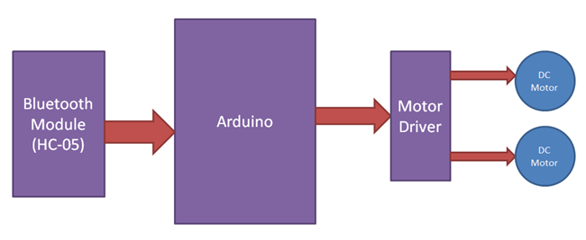

Bluetooth controlled car moves according to button touched in the android Bluetooth mobile app. To run this project first we need to download Bluetooth app form Google play store. We can use any Bluetooth app that supporting or can send data. Here are some apps' name that might work correctly.

- Bluetooth Spp pro

- Bluetooth controller

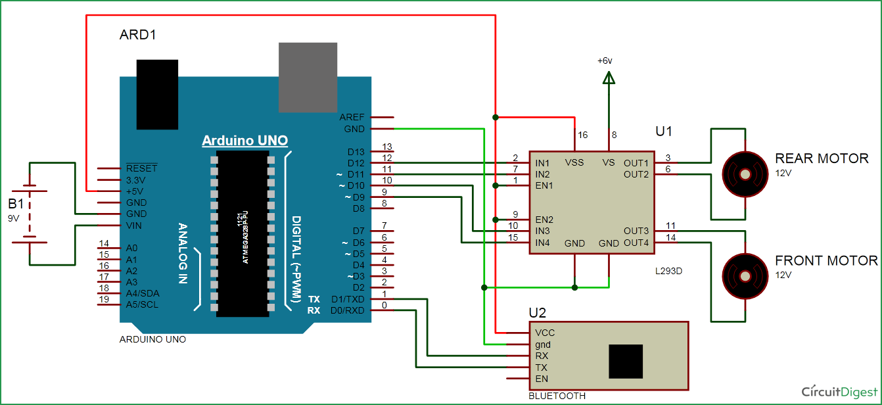

**Circuit diagram for bluetooth controlled car** is shown in above figure. A Motor driver is connected to arduino to run the car. Motor driver’s input pins 2, 7, 10 and 15 are connected to arduino's digital pin number 12, 11, 10 and 9 respectively. Here we have used two DC motors to driver car in which one motor is connected at output pin of motor driver 3 and 6 and another motor is connected at 11 and 14.  A 6 volt Battery is also used to power the motor driver for driving motors. Bluetooth module’s rx and tx pins are directly connected at tx and rx of Arduino. And vcc and ground pin of Bluetooth module is connected at +5 volt and gnd of Arduino. And a 9 volt battery is used for power the circuit at Arduino’s Vin pin.

**Program Explanation**

 In program first of all we have defined output pins for motors.

#define m11 11 // rear motor

#define m12 12

#define m21 10 // front motor

#define m22 9

And then in setup, we gave directions to pin.

void setup()

{

Serial.begin(9600);

pinMode(m11, OUTPUT);

pinMode(m12, OUTPUT);

pinMode(m21, OUTPUT);

pinMode(m22, OUTPUT);

}

After this we read input by using serial communication form Bluetooth module and perform the operation accordingly.

void loop()

{

while(Serial.available())

{

char ch=Serial.read();

str[i++]=ch;

if(str[i-1]=='1')

{

Serial.println("Forward");

forward();

i=0;

}

else if(str[i-1]=='2')

{

Serial.println("Left");

right();

i=0;

}

else if(str[i-1]=='3')

{

Serial.println("Right");

left();

i=0;

}