Linux Commands Assignment

1. Creating and Renaming Files/Directories
Command:
mkdir test_dir
cd test_dir
touch example.txt
mv example.txt renamed_example.txt
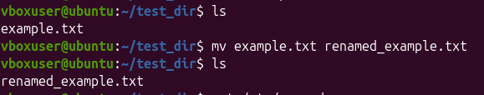
Explanation:
Creates a directory, navigates into it, creates a file, and renames it.

2. Viewing File Contents
Command:
cat /etc/passwd
head -n 5 /etc/passwd
tail -n 5 /etc/passwd

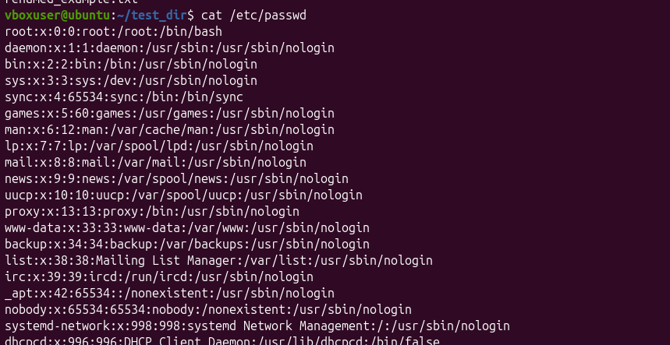
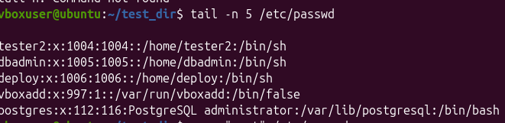

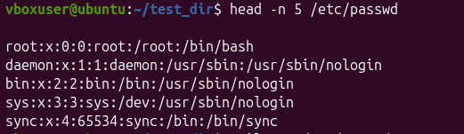

Explanation:
Displays full file content, first 5 lines, and last 5 lines.

3. Searching for Patterns
Command:
grep "root" /etc/passwd
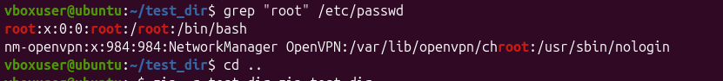
Explanation:
Searches for lines containing the word "root".

4. Zipping and Unzipping
Command:
zip -r test_dir.zip test_dir
unzip test_dir.zip -d unzipped_dir
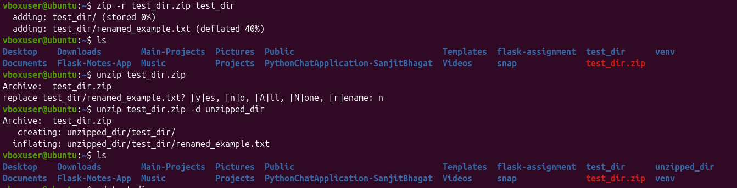
Explanation:
Compresses directory and extracts it to a new folder.

5. Downloading Files
Command:
wget https://www.w3schools.com/w3css/4/w3.css
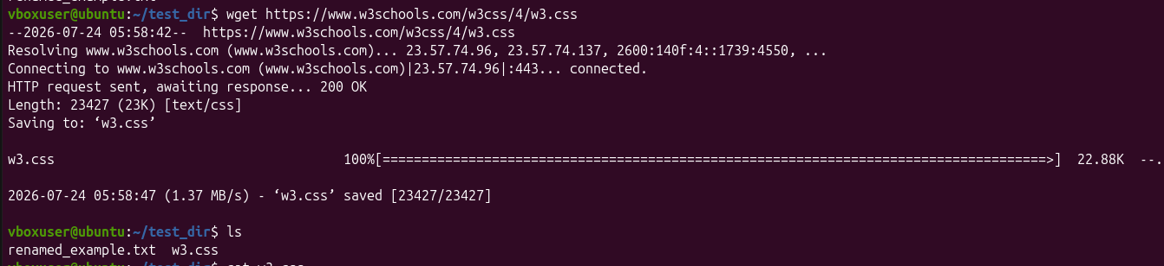
Explanation:
Downloads a file from the internet.

6. Changing Permissions
Command:
touch secure.txt
chmod 444 secure.txt

Explanation:
Creates a file and sets it to read-only for all users.

7. Environment Variables
Command:
export my_var="Hello, Linux!"
echo $my_var
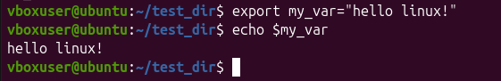
Explanation:
Creates and displays an environment variable.

