Big Data Analytics Project

End-to-End BigEarthNet Land Cover Classification using Hadoop and Apache Spark

  - A Distributed Machine Learning Pipeline

Technologies Used: Apache Hadoop (HDFS), Apache Spark (MLlib), Scala, Python, Pandas, Rasterio, Scikit-Learn, Docker

CHAPTER 1 — INTRODUCTION
Background: Land cover classification is a fundamental task in remote sensing. With the massive influx of satellite imagery (such as the Sentinel-2 missions), processing these large-scale datasets on a single machine is computationally prohibitive.
Problem: Satellite imagery archives like BigEarthNet are massive (80+ GB) and consist of hundreds of thousands of tiny individual files (TIFF patches). Traditional machine learning approaches struggle with loading, preprocessing, and training on such massive, heavily-distributed file architectures.
Proposed Solution: This project implements a distributed Big Data pipeline. We overcome the "Small File Problem" by extracting aggregated spectral features locally in parallel and packaging them into a columnar Parquet format. We then deploy a distributed Hadoop and Spark cluster using Docker to train a Random Forest classifier at scale using Spark MLlib.

CHAPTER 2 — PROBLEM STATEMENT
How can we efficiently process and classify massive volumes of distributed satellite imagery patches into land cover categories using distributed Big Data infrastructure?

CHAPTER 3 — OBJECTIVES

Primary Objectives:
- 1. Construct an automated feature extraction pipeline using Rasterio for Sentinel-2 multi-band imagery.
- 2. Deploy a distributed Hadoop Distributed File System (HDFS) and Apache Spark cluster using Docker.
- 3. Train a distributed Random Forest model using Spark MLlib to classify land cover categories.

Secondary Objectives:
- 1. Handle the HDFS "Small File Problem" via Parquet aggregation.
- 2. Conduct Hyperparameter Tuning across Spark worker nodes.
- 3. Generate visual evaluation dashboards.

CHAPTER 4 — LITERATURE / EXISTING APPROACHES
Existing approaches often rely on deep learning (CNNs) trained on single, massive GPU workstations. While effective, they are bottlenecked by vertical scaling. This project differs by focusing on horizontal scaling: relying on distributed computing (Hadoop/Spark) for Big Data processing of spectral features (NDVI, NDWI).

CHAPTER 5 — PROPOSED SYSTEM
1. Data Ingestion: Sentinel-2 patches are sampled (40,000 images).
2. Feature Extraction (Python/Rasterio): Calculate NDVI, NDWI, Mean, and Standard Deviation for Bands B02, B03, B04, and B08. Saved to a single massive Parquet file.
3. Distributed Storage: The Parquet file is uploaded to the HDFS NameNode.
4. Distributed ML Training (Scala/Spark): Spark Master coordinates with Spark Workers to ingest the Parquet data, construct vector assemblies, and train a Random Forest model using Cross-Validation.
5. Evaluation (Scikit-Learn/Seaborn): Extract Spark predictions from HDFS via getmerge and visualize using Python dashboards.

CHAPTER 6 — TECHNOLOGIES AND TOOLS
Technology / Tool | Purpose | Where Used
Python & Pandas | Data preprocessing and evaluation | Local Scripts
Rasterio | Read/Process .tif satellite bands | Feature Extraction
Docker Compose | Deploy distributed infrastructure | Cluster Setup
Hadoop HDFS | Distributed Storage | NameNode / DataNodes
Scala & SBT | Build and run Spark Jobs | Model Training
Apache Spark MLlib | Distributed Machine Learning | Model Training
Scikit-Learn & Seaborn | Metric evaluation & Visuals | Dashboard Generation

CHAPTER 7 — DATASET / INPUT DATA
Dataset: BigEarthNet Subset (Sentinel-2)
Size: 40,000 image patches (Sampled from the original ~590k patches)
Format: Multi-band .tif files -> Aggregated to .parquet
Features Extracted (10): ndvi, ndwi, b02_mean, b02_std, b03_mean, b03_std, b04_mean, b04_std, b08_mean, b08_std
Target: 19 Corine Land Cover categories (e.g., Arable land, Coniferous forest, Urban fabric)

CHAPTER 8 — METHODOLOGY & IMPLEMENTATION
Step 1: Subset Generation (0_create_subset_from_archive.py, 1_build_subset.py)
Extracts a random 40k sample of BigEarthNet to avoid running out of local disk space.
Step 2: Distributed Feature Extraction (2_extract_features.py)
Uses Python multiprocessing to compute Normalized Difference Vegetation Index (NDVI) and Normalized Difference Water Index (NDWI) from Near-Infrared (B08), Red (B04), and Green (B03) bands to generate highly-correlated vegetation/water markers. It produces features_40k.parquet.
Step 3: Spark MLlib Modeling (LandCoverClassifier.scala)
1. Ingests HDFS Parquet data.
2. Uses StringIndexer to convert labels to numeric categories.
3. Uses VectorAssembler to combine the 10 features into a feature vector.
4. Trains a RandomForestClassifier using CrossValidator (3 folds, ParamGrid: Trees=[50,100,150], Depth=[5,10,15]).
5. Saves predictions to HDFS.
Step 4: Evaluation Dashboard (3_evaluate_results.py, generate_dashboard.py)
Parses the Spark predictions output and uses sklearn.metrics to generate a classification report and confusion matrix. Uses seaborn to plot the dashboard.

CHAPTER 11 — EXPERIMENTAL SETUP
Hardware (Local Simulation): Windows Host, Multi-core CPU
Distributed Environment: Docker Engine
- Hadoop: 1 NameNode, 3 DataNodes (bde2020 images)
- Spark: 1 Spark Master, 1 Spark Worker (2 Cores, 4GB RAM)
Train/Test Split: 75% / 25% (30,000 train, 10,000 test) using Seed=42

CHAPTER 12 — RESULTS
The Spark Random Forest pipeline achieved an overall accuracy of 68% across all 19 classes using only 10 extracted spectral features.
Model Training Runtime: ~30 Minutes (distributed on Spark Worker)

Classification Metrics (Top Classes):
Class | Precision | Recall | F1-Score | Support
Marine waters | 0.94 | 0.97 | 0.96 | 1128
Arable land | 0.64 | 0.84 | 0.72 | 3484
Coniferous forest | 0.69 | 0.77 | 0.73 | 1981
Broad-leaved forest | 0.65 | 0.49 | 0.56 | 1523

13. RESULT IMAGES
Figure 1: Training Dashboard Output (Confusion Matrix and F1-Scores by Class)
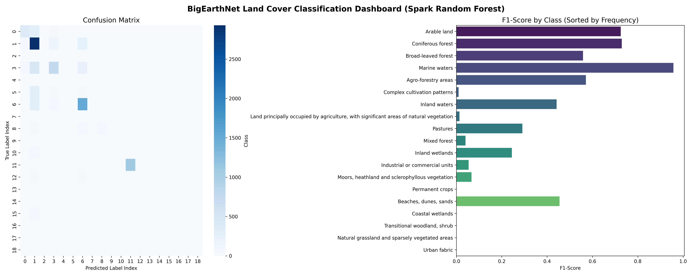
Figure 1. The confusion matrix (left) and F1-score chart (right) demonstrating the model performance on the hold-out test set.

CHAPTER 13 — RESULT ANALYSIS / DISCUSSION
The results indicate that the Random Forest model performs exceptionally well on distinct, heavily represented classes (e.g., Marine Waters F1=0.96, Arable Land F1=0.72). However, performance drops significantly for minority classes (e.g., Coastal wetlands, Urban fabric) where the Support size was less than 20 images. This demonstrates the extreme class imbalance of real-world remote sensing data.

CHAPTER 16 — LIMITATIONS
1. Class Imbalance: The model overfits to majority classes (Arable Land) and ignores rare classes (Urban Fabric) to maximize overall accuracy.
2. Feature Engineering: Hand-crafted features (NDVI, NDWI) capture spectral signatures well, but lose spatial and textural features that a Deep Learning CNN (like ResNet) would capture.
3. Compute Limitation: The Spark worker was limited to 2 cores, preventing training on the full 80GB dataset.

CHAPTER 17 — FUTURE WORK
- Scale to Full Dataset: Ingest the full 590k image dataset into a cloud cluster (AWS EMR/Databricks).
- Advanced Modeling: Use Spark MLlib to implement class weighting or SMOTE to handle class imbalance.

CHAPTER 18 — CONCLUSION
This project successfully demonstrated the implementation of a full-scale Big Data pipeline for Earth Observation data. By bridging the gap between raw Python feature extraction, Dockerized Hadoop distributed storage, and Scala Spark MLlib training, it provides a highly scalable blueprint for modern remote sensing analysis.

