EXP.NO: 7 | Write a Servlet program in Java to store preferences of the user for language using cookies. Retrieve and display the preferences on subsequent visits.
DATE:26/03/2025

AIM:
To create a Java Servlet that stores user preferences such as chosen language using cookies, and retrieves and displays those preferences when the user revisits the application.
ALGORITHM:
1. Input:
- The user selects a preferred language (e.g., English, Tamil, etc.).
- The form submits data to the servlet.

2. Steps to Create and Handle the Servlet:
1. Create an HTML Form:
- Design an HTML form with:
  - Dropdown list for selecting language
  - Submit button
- Set the form’s action to the servlet URL.

2. Create the Servlet to Handle Preference:
- Write a Java servlet class.
- Override:
  - doGet() method
  - doPost() method
- Retrieve the selected language using:
request.getParameter()

3. Store Preference Using Cookies (doPost method):
- Retrieve user input using request
- Create cookie:
Cookie cookie = new Cookie("language", value);
- Add cookie to response:
response.addCookie(cookie);

4. Retrieve Preference Using Cookies (doGet method):
- Fetch cookies from request:
Cookie[] cookies = request.getCookies();
- Loop through cookies to get stored value.

5. Display Preference:
- Generate HTML response showing:
  - Selected language
- If cookie exists → display preference
- Else → display message

6. Deploy and Test the Servlet:
- Compile servlet
- Deploy in server (e.g., Apache Tomcat)
- Open browser and access servlet URL

7. Observe Results:
- First visit → preferences not set
- Subsequent visits → preferences shown automatically

Code:
hmtl code:

<!DOCTYPE html>
<html>
<head>
<title>Courier Preferences</title>
<style>
body {
margin: 0;
font-family: 'Segoe UI';
background: linear-gradient(135deg,#4facfe,#00f2fe);
}
.card {
width: 350px;
margin: 80px auto;
background: white;
padding: 25px;
border-radius: 12px;
box-shadow: 0 8px 20px rgba(0,0,0,0.2);
text-align: center;
}
input, select {
width: 100%;
padding: 10px;
margin: 10px 0;
border-radius: 6px;
border: 1px solid #ccc;
}
button {
width: 100%;
padding: 10px;
margin-top: 10px;
border: none;
border-radius: 6px;
color: white;
cursor: pointer;
}
.save { background: #28a745; }
.view { background: #007bff; }
.clear { background: #dc3545; }
</style>
</head>

<body>

<div class="card">
<h2>📦 Courier Preferences</h2>

<form action="SetCookieServlet" method="post">
<input type="text" name="username" placeholder="Enter Name" required>

<select name="delivery" required>
<option value="">Select Delivery Type</option>
<option>Standard</option>
<option>Express</option>
<option>Same Day</option>
</select>

<input type="text" name="location" placeholder="Enter Location (Chennai, India)" required>

<button class="save" type="submit">Save</button>
</form>

<a href="GetCookieServlet"><button class="view">View Preferences</button></a>
<a href="ClearCookieServlet"><button class="clear">Clear</button></a>

</div>

</body>
</html>

SetCookieServlet.java::

import java.io.*;
import jakarta.servlet.*;
import jakarta.servlet.http.*;
import jakarta.servlet.annotation.WebServlet;
import java.net.URLEncoder;

@WebServlet("/SetCookieServlet")
public class SetCookieServlet extends HttpServlet {

protected void doPost(HttpServletRequest request, HttpServletResponse response)
throws ServletException, IOException {

response.setContentType("text/html");
PrintWriter out = response.getWriter();

String name = request.getParameter("username");
String delivery = request.getParameter("delivery");
String location = request.getParameter("location");

// Encode (fix error)
name = URLEncoder.encode(name, "UTF-8");
delivery = URLEncoder.encode(delivery, "UTF-8");
location = URLEncoder.encode(location, "UTF-8");

Cookie c1 = new Cookie("username", name);
Cookie c2 = new Cookie("delivery", delivery);
Cookie c3 = new Cookie("location", location);

c1.setMaxAge(86400);
c2.setMaxAge(86400);
c3.setMaxAge(86400);

response.addCookie(c1);
response.addCookie(c2);
response.addCookie(c3);

out.println("<html><head><style>");
out.println("body{font-family:Segoe UI;background:linear-gradient(135deg,#4facfe,#00f2fe);text-align:center;}");
out.println(".card{background:white;padding:30px;margin:100px auto;width:350px;border-radius:12px;box-shadow:0 8px 20px rgba(0,0,0,0.2);}");
out.println("button{padding:10px;margin:10px;border:none;border-radius:6px;color:white;cursor:pointer;}");
out.println(".view{background:#007bff;} .home{background:#28a745;}");
out.println("</style></head><body>");

out.println("<div class='card'>");
out.println("<h2>✅ Preferences Saved!</h2>");
out.println("<a href='GetCookieServlet'><button class='view'>View</button></a>");
out.println("<a href='index.html'><button class='home'>Home</button></a>");
out.println("</div></body></html>");
}
}

GetCookieServlet.java:

import java.io.*;
import jakarta.servlet.*;
import jakarta.servlet.http.*;
import jakarta.servlet.annotation.WebServlet;
import java.net.URLDecoder;

@WebServlet("/GetCookieServlet")
public class GetCookieServlet extends HttpServlet {

protected void doGet(HttpServletRequest request, HttpServletResponse response)
throws ServletException, IOException {

response.setContentType("text/html");
PrintWriter out = response.getWriter();

out.println("<html><head><style>");
out.println("body{font-family:Segoe UI;background:linear-gradient(135deg,#43e97b,#38f9d7);text-align:center;}");
out.println(".card{background:white;padding:30px;margin:80px auto;width:350px;border-radius:12px;box-shadow:0 8px 20px rgba(0,0,0,0.2);}");
out.println("p{font-size:18px;}");
out.println("button{padding:10px;margin:10px;border:none;border-radius:6px;color:white;cursor:pointer;}");
out.println(".home{background:#007bff;} .clear{background:#dc3545;}");
out.println("</style></head><body>");

out.println("<div class='card'>");
out.println("<h2>📋 Your Preferences</h2>");

Cookie[] cookies = request.getCookies();

if (cookies != null) {
for (Cookie c : cookies) {
String name = c.getName();

if(name.equals("username") || name.equals("delivery") || name.equals("location")) {
String value = URLDecoder.decode(c.getValue(), "UTF-8");
out.println("<p><b>" + name + ":</b> " + value + "</p>");
}
}
} else {
out.println("<p>No data found</p>");
}

out.println("<a href='index.html'><button class='home'>Home</button></a>");
out.println("<a href='ClearCookieServlet'><button class='clear'>Clear</button></a>");

out.println("</div></body></html>");
}
}

ClearCookieServlet.java::

import java.io.*;
import jakarta.servlet.*;
import jakarta.servlet.http.*;
import jakarta.servlet.annotation.WebServlet;

@WebServlet("/ClearCookieServlet")
public class ClearCookieServlet extends HttpServlet {

protected void doGet(HttpServletRequest request, HttpServletResponse response)
throws ServletException, IOException {

response.setContentType("text/html");
PrintWriter out = response.getWriter();

Cookie[] cookies = request.getCookies();

if (cookies != null) {
for (Cookie c : cookies) {
c.setMaxAge(0);
response.addCookie(c);
}
}

out.println("<html><body style='text-align:center;'>");
out.println("<h2>🗑 Cookies Cleared!</h2>");
out.println("<a href='index.html'>Go Back</a>");
out.println("</body></html>");
}
}

Output:
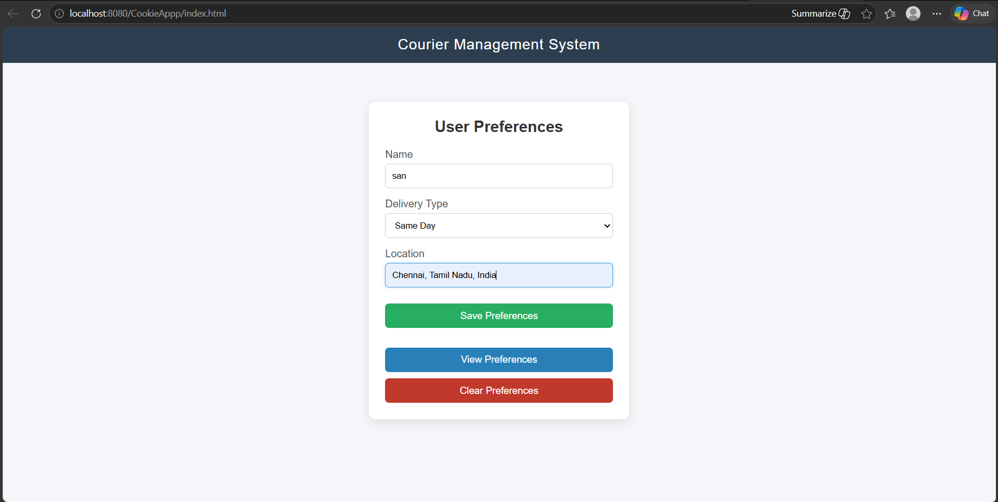

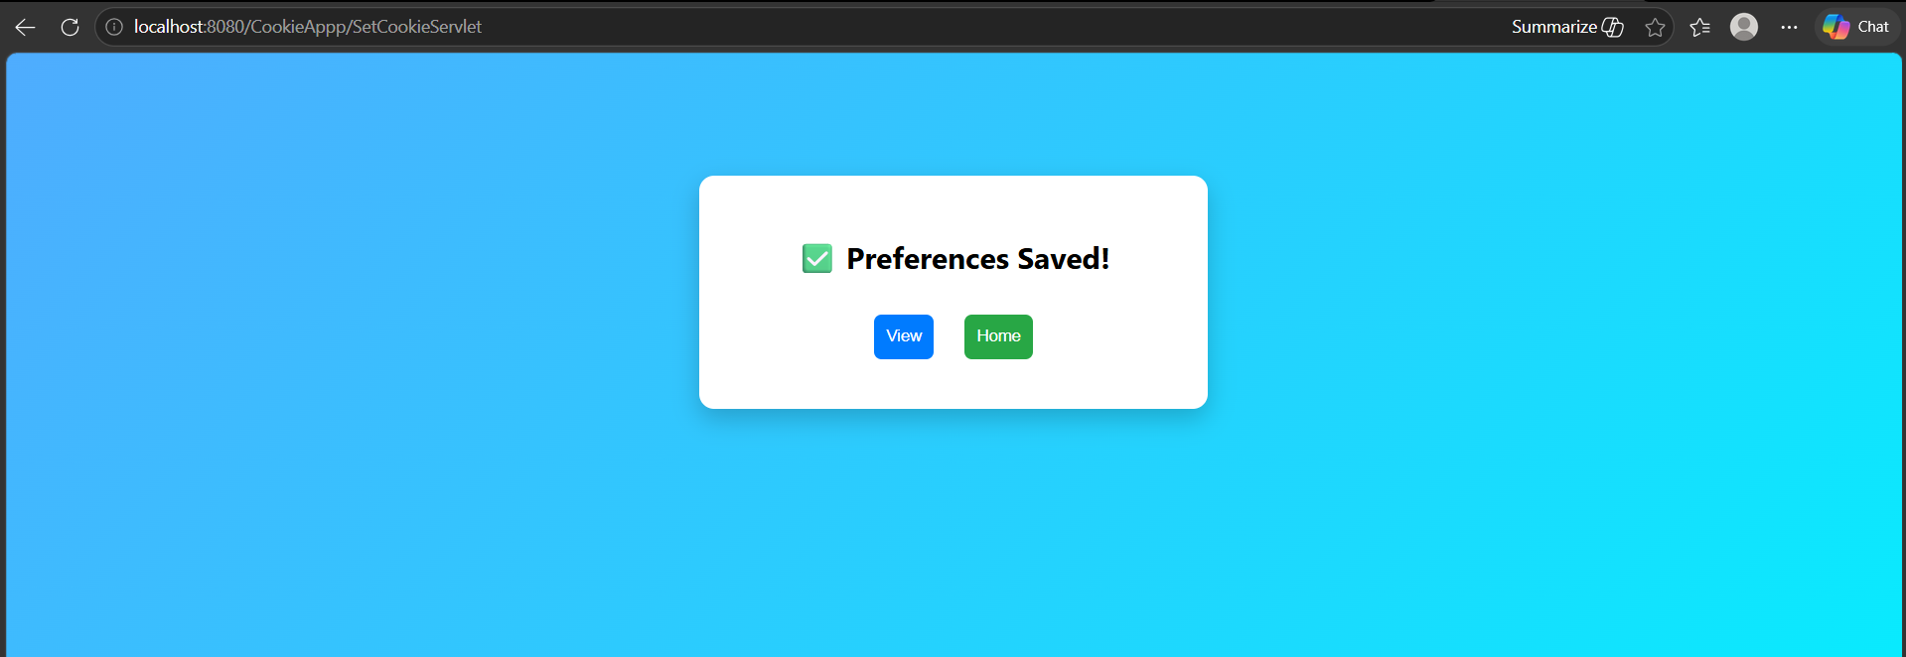

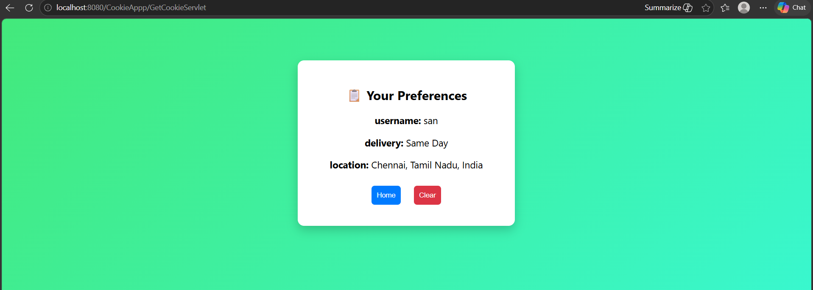

RESULT:
A Servlet program is successfully created to store user preferences using cookies and retrieve them on subsequent visits.

