EXPERIMENT 4b
Gym Membership Management — Subscription Form

1. Aim
To create a Subscription form in Zoho Creator and link a member with a selected membership plan, using the forms created in Experiment 4a.

2. Introduction
A Subscription record represents a member's enrolment in a gym plan. Lookup fields connect a Subscription form to existing records in the Member and Membership_Plan forms. This reduces repeated typing and keeps related records connected.

3. Procedure
- Open the existing Gym Membership application in Zoho Creator.
- Create a new blank form and name it Subscription.
- Add a lookup field named Member and configure it to select records from the existing Member form.
- Add a lookup field named Membership_Plan and configure it to select records from the existing Membership_Plan form.
- Add Start_Date and End_Date date fields if required by your Experiment 4b instructions.
- Save the form and open the live form.
- Select a sample member and a sample plan, enter test dates if required, and submit the record.
- Open the Subscription report and verify that the saved record appears.

4. Form Design
Field | Suggested field type | Purpose
Member | Lookup → Member | Select an existing gym member
Membership_Plan | Lookup → Membership_Plan | Select an available plan
Start_Date | Date (if required) | Record subscription start date
End_Date | Date (if required) | Record subscription end date
Note: Follow the exact field names and types in your lab manual. The date fields are suggestions if your 4b question requires them.

5. Screenshots and Observations
Replace each blank area with a screenshot captured from your own Zoho Creator application. Add a short caption or observation below each image.
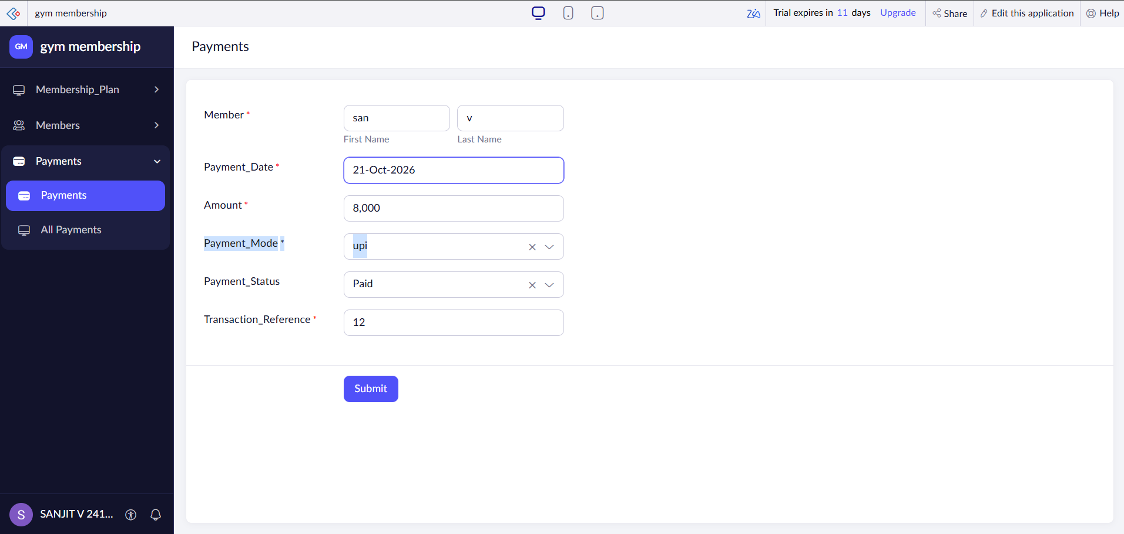

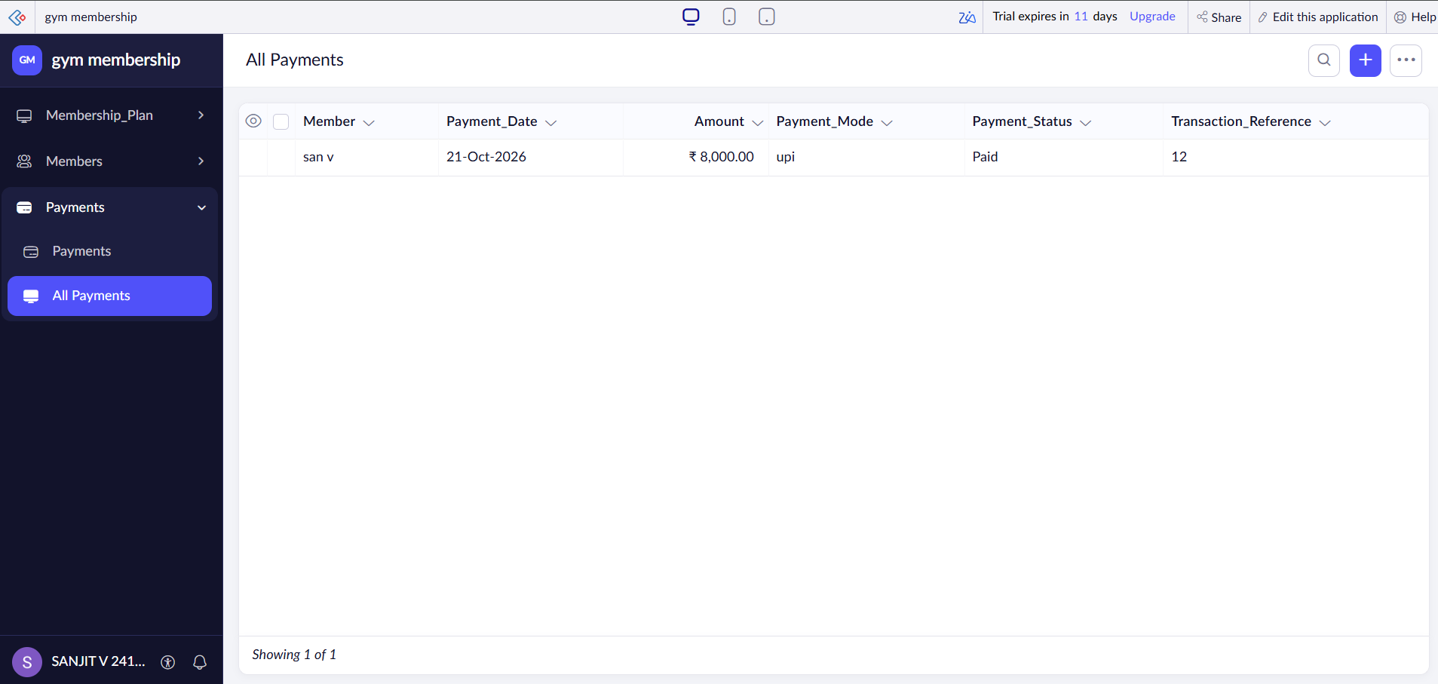

6. Discussion
Lookup fields allow the Subscription form to select existing records from the Member and Membership_Plan forms. This connects the forms and reduces repeated data entry. Verify the saved record in the Subscription report to check that the form and lookup configuration work as expected.

7. Result
The Subscription form was created to link a member with a membership plan. The form was tested and the saved record was verified in the report. Edit this result if any step is still incomplete.

8. References
- Zoho Creator: https://www.zoho.com/creator/
- Zoho Creator Help: https://www.zoho.com/creator/help/

