Contents

Day 1: Basics of NMOS (drain current Ids vs drain to source voltage Vds) 2

Why do we need SPICE simulation? 2

SPICE simulation of std cell. 3

Study of Nmos transistor: 4

Surface inversion and VT 5

Impact of Vsb on VT 6

# Day 1: Basics of NMOS (drain current Ids vs drain to source voltage Vds)

## Why do we need SPICE simulation?

Study of P mos and-n mos transistor characteristic

* Voltage to Idsat graph.
* How leakage peaks during switching

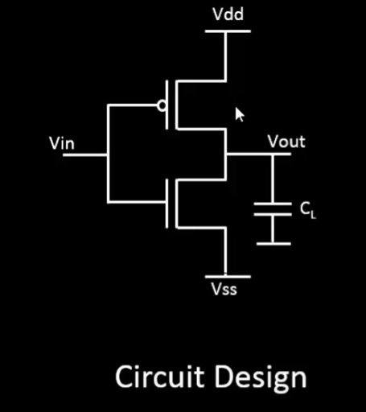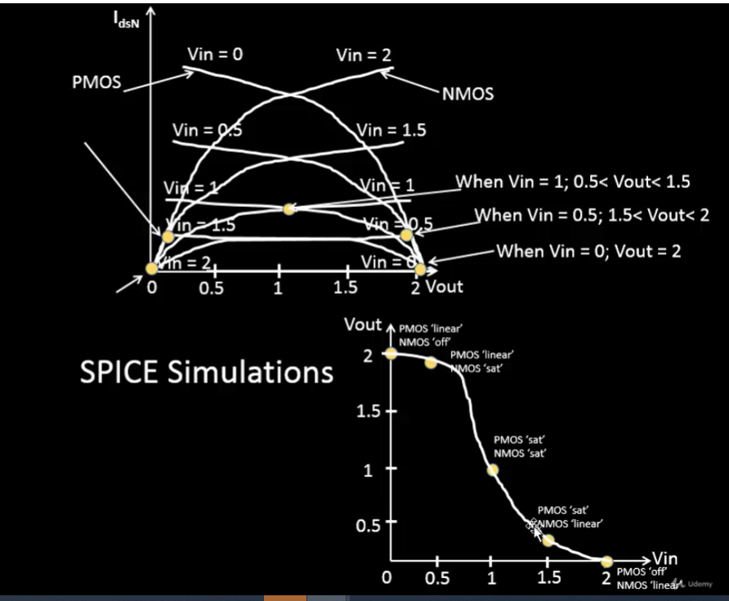

## SPICE simulation of std cell.

* Why do we need it?
* All STA is built on SPICE simulation of fundamental devices in the std cell circuit.
  + Simulation helps to come up with the delay table calculation
  + The table contains Slew (rate of input change) vs output load
  + Depending upon different situation of the cell placement, the delays can be ‘looked-up’ on the table
  + If the table element doesn’t exists, then the value is extrapolated.
  + The source of these tables comes from spice simulation.

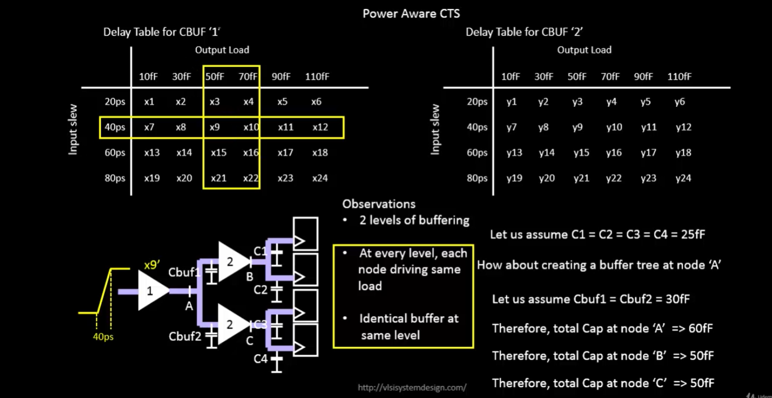

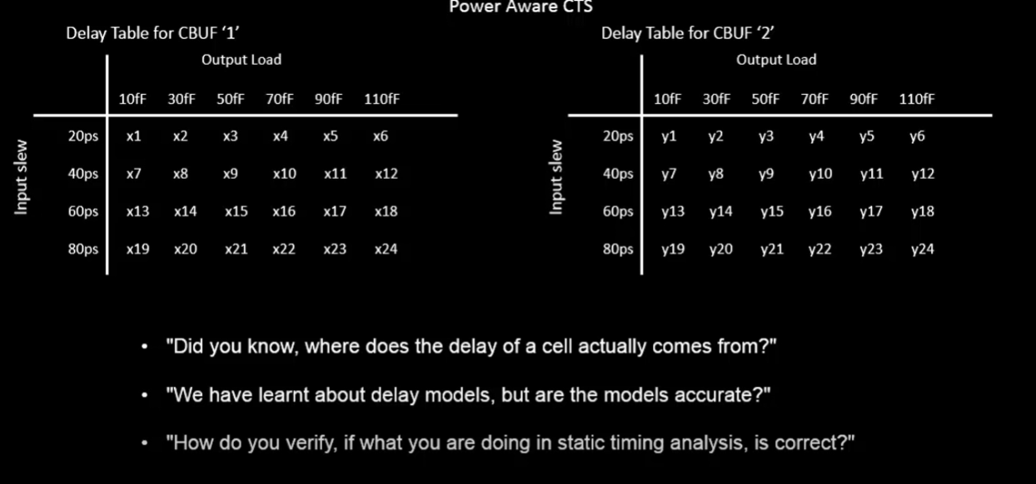

## Study of Nmos transistor:

* Nmos are isolated at the edge
* Bulk (psub) is tied to ground
* Gate is the most important control

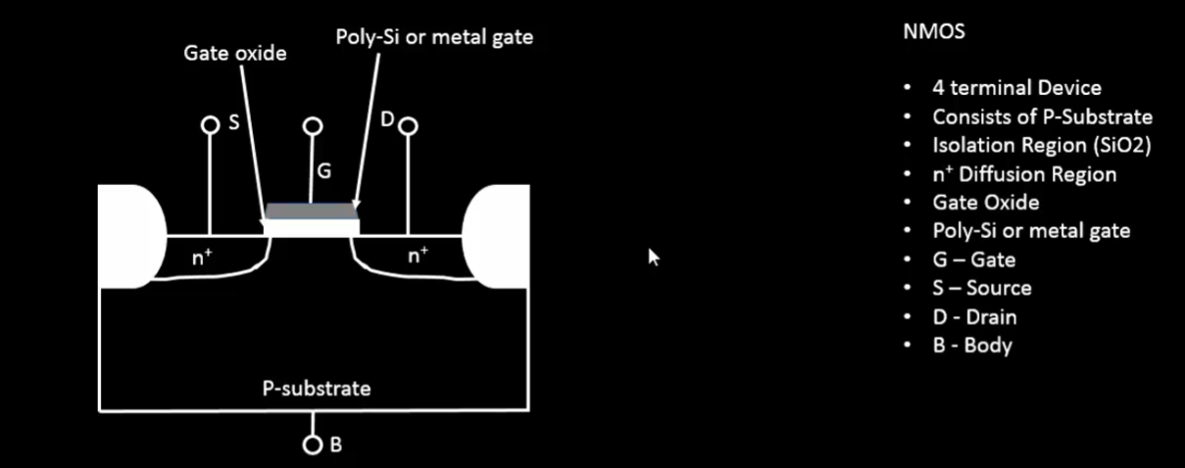

* Applying voltage to Gate (Vgs)
* It builds a positive charge over the oxide cap plate.
* Which builds negative charge in the channel region

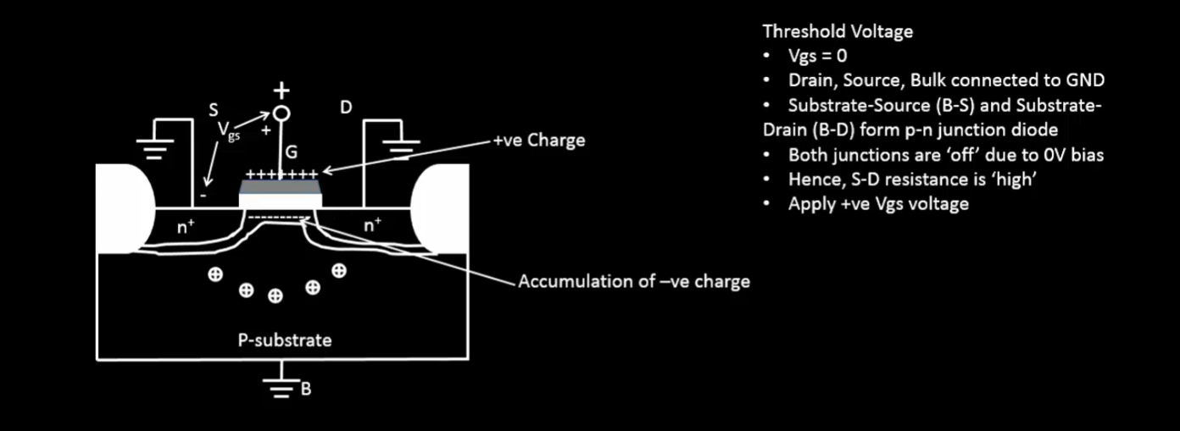

## Surface inversion and VT

* When the voltage applied is steadily increased, it leads to greater accumulation of negative dchange in the channel,
* In a P-substrate, there is a region created of negative change, and thus called inversion region.
* When inversion is at its highest, it’s called threshold voltage.

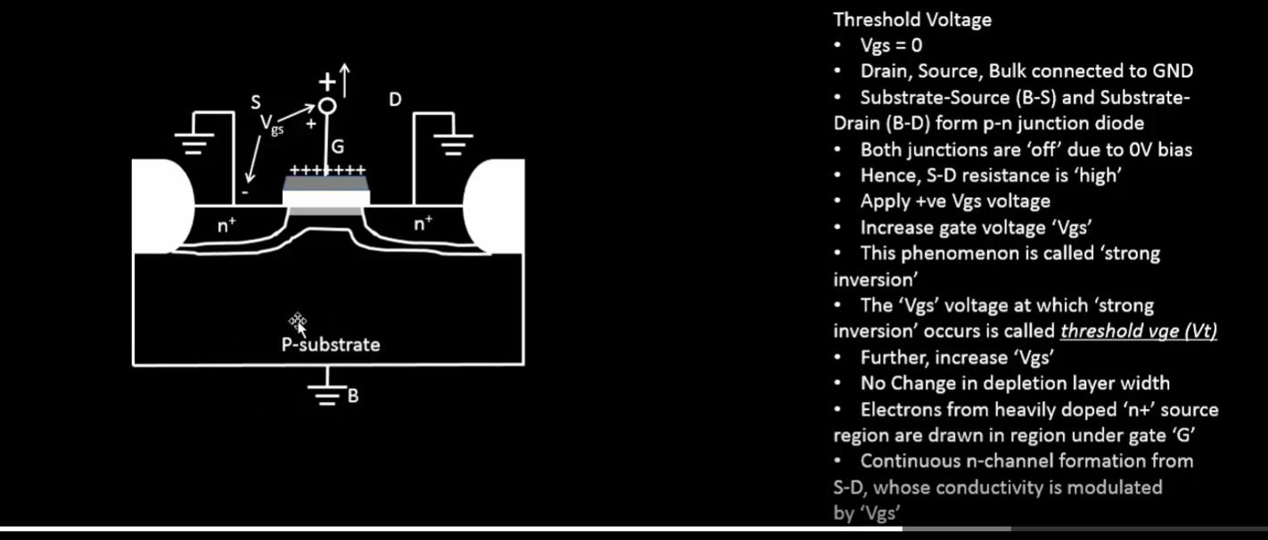

* Once the majority positive charge is repelled from the channel at VT, further negative charges are absorbed from the N+ region
* This forms the continus channel

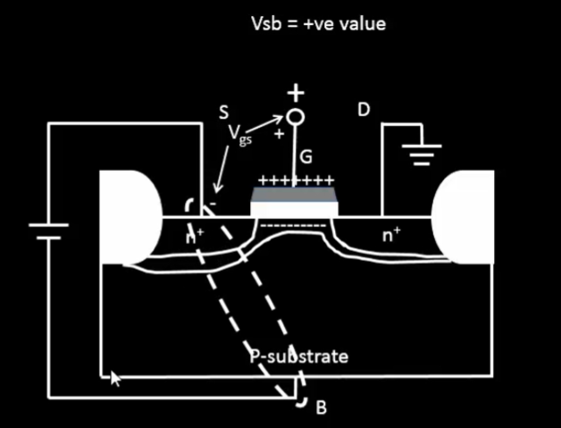

* Applying potential between Source and Substrate makes the diode more reverse biased
* This increases the channel width near source and substrate

## Impact of Vsb on VT

* In the presence of Vsb, additional voltage V1 is required to create the inversion region Vto+V1
* When Vds < Vgs -Vt device behave differently

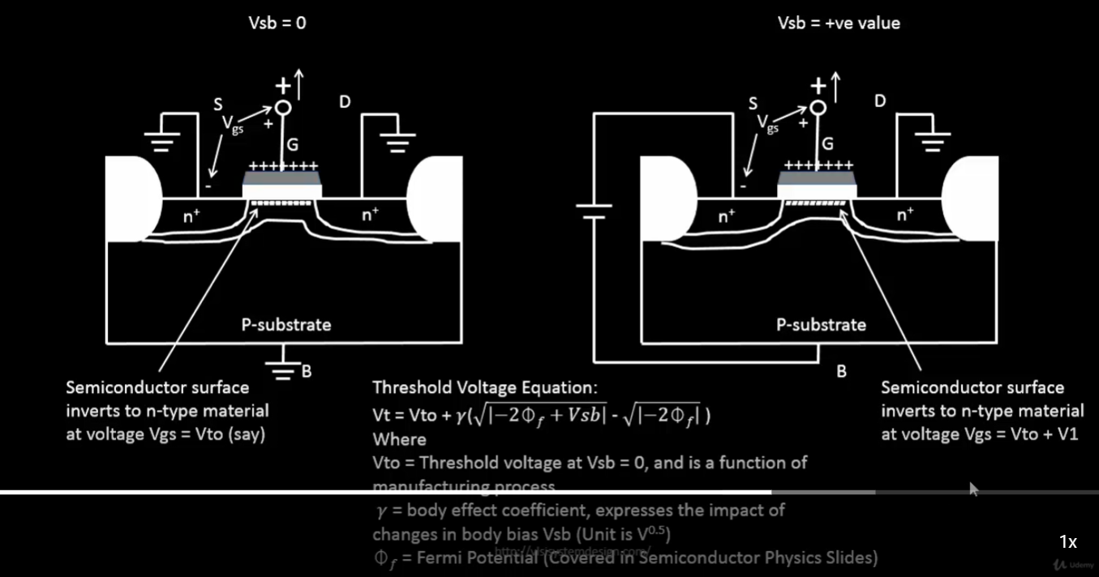

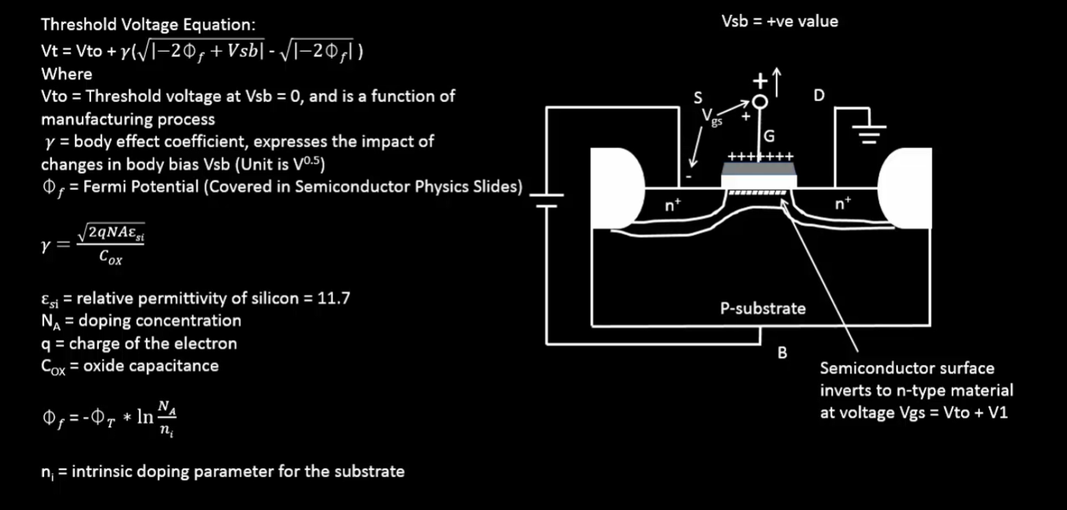

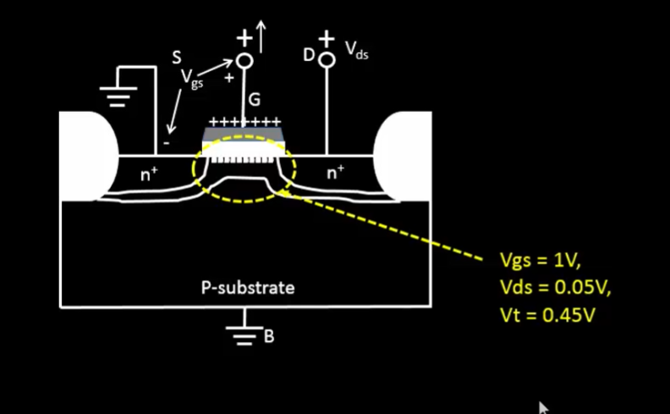

* Voltage is not constant across the channel. There is a gradient
* From 0 to Vds

