Name – Dhruv Oza Roll No - U19EC160

**PRACTICAL 2**

AIM – to study and observe the effect of multipath at different time instants.

* To observe transmitted signal and received signal after multipath in time domain and frequency domain.
* To obtain the transfer function and impulse response of the time varying channel for various time instants.

Theory –

MULTIPATH MODEL

Consider the signal ej*2π*fo*t transmitted from the transmitter and the corresponding received signal after subjected to multipath transmission is represented as follows:

Where,

* J is the total number of multipath,
* βj (t) is the attenuation in the jth path
* τj (t) is the time delay in the jth path

The transfer function of the multipath channel at f0,

Similary, it can be interpreted as the transfer function of the time varying channel for any value of f:

Thus, the impulse response of the time varying channel is obtained as follows:

Here, the response of time varying multipath channel to the input signal cos(2π*fo*t) is given by,

MATLAB CODE –

f=1;

nop=2; % initial value of nop = 2

rxsignal=[];

t=0:1/100:1; % choosing sampling freg=100Hz

txsignal=cos(2*pi*f*t); % transmitted signal

z=1;

for t=0:1/100:1

temp=0;

for p=1:1:nop

beta(p)=rand; % for every delayed singal there will be 10

delay(p)=rand*t; % delay of each multipth component generated

temp=temp+beta(p)*exp(1i*2*pi*f*(t-delay(p)));

end

BETACOL{z}=beta;

DELAYCOL{z}=delay;

beta=0;

delay=0;

rxsignal=[rxsignal temp];

z=z+1;

end

save CONSTANTS BETACOL DELAYCOL

figure(1)

subplot(4,1,1)

plot(txsignal)

title('trans signal U19EC160');

subplot(4,1,2)

plot(real(rxsignal))

title('rec signal after multipath U19EC160');

subplot(4,1,3)

plot(abs(fft(txsignal)))

title('spect of trans signal U19EC160');

subplot(4,1,4)

plot(abs(fft(real(rxsignal))))

title('spect of rec signal after multipath U19EC160');

hold

load CONSTANTS

fs=100;

u=1;

for f=0:fs/101:(50*fs)/101

rxsignal=[];

temp=0;

z=1;

for t=0:1/100:1

temp=0;

for p=1:1:nop

temp=temp+BETACOL{z}(p)*exp(1i*2*pi*f*(t-DELAYCOL{z}(p)));

end

rxsignal=[rxsignal temp];

z=z+1;

end

% The impulse response of the time-varying channel is computed as followed

t=0:1/100:1;

timevaryingTF_at_freq_f{u}=rxsignal.*exp(-1i*2*pi*f*t);

u=u+1;

end

TEMP=cell2mat(timevaryingTF_at_freq_f');

for i=1:1:101

u=TEMP(:,i);

u1=[u;transpose(u(length(u):-1:2)')];

timevaringIR_at_time_t{i} = ifft(u1);

end

TFMATRIX=abs(cell2mat(timevaryingTF_at_freq_f'));

IRMATRIX=cell2mat(timevaringIR_at_time_t);

s=[2:2:8];

for i=1:1:4

figure(2)

subplot (2,2,i)

plot(IRMATRIX(1:1:101,s(i)))

title(strcat('t=',num2str((s(i)-1)/100)))

figure(3)

subplot(2,2,i)

plot(TFMATRIX(:,s(i)))

title(strcat('t=',num2str((s(i)-1)/100)))

end

OUTPUT WAVEFORM –

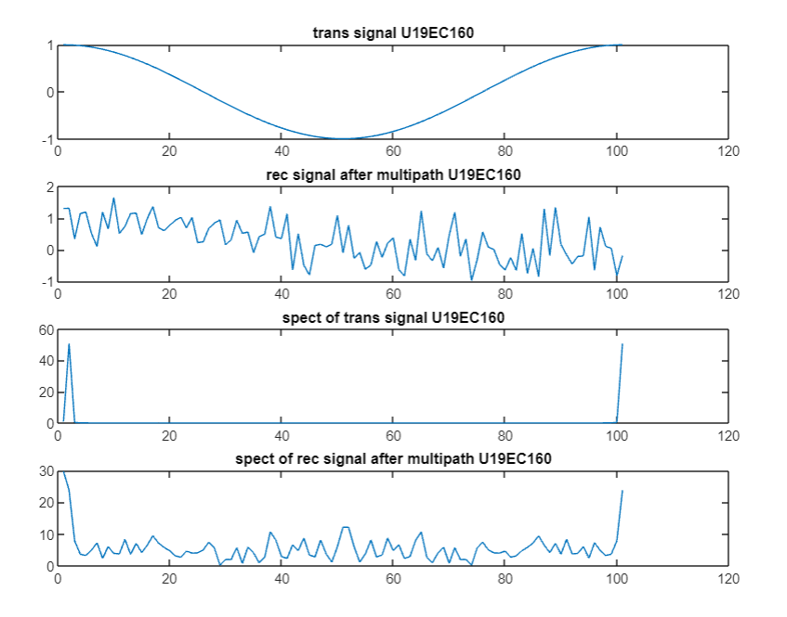

Impulse Response –

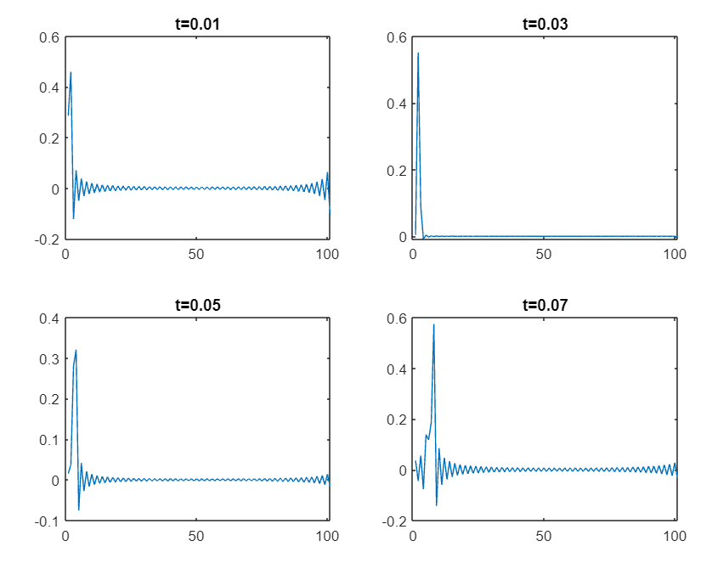

Transfer Function –

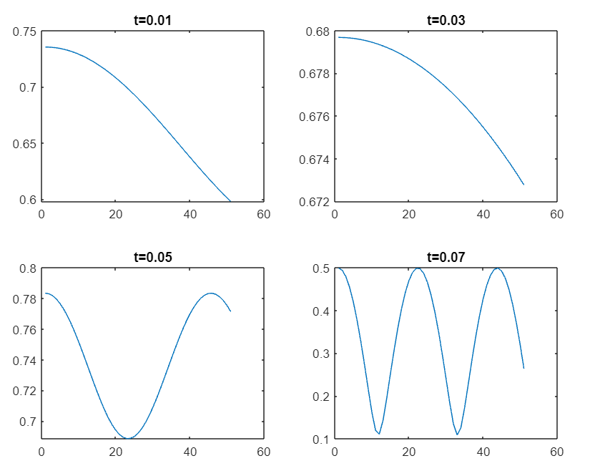

Conclusion –

In this experiment we observe the effect of multipath at different time instants and observe transmitted signal and received signal after multipath in time domain and frequency domain.

We also obtain the transfer function and impulse response of the time varying channel for various time instants.