**SANJIT ANAND U19EC008**

**24-01-2022 PRACTICAL ASSIGNMENT - 2**

**WIRELESS AND MOBILE COMMUNICATION**

**AIM:**

To study and observe the effect of multipath at different time instants.

* To observe transmitted signal and received signal after multipath in time domain and frequency domain.
* To obtain the transfer function and impulse response of the time varying channel for various time instants.

**APPARATUS:**

MATLAB Software

**THEORY:**

## Multipath Model

Consider the signal $e^{j*2π*f_{0}*t}$ transmitted from the transmitter and the corresponding received signal after subjected to multipath transmission is represented as follows:

Where,

* j is the total number of multipath,
* βj (t) is the attenuation in the jth path
* τj (t) is the time delay in the jth path

The transfer function of the multipath channel at f0,

Similarly, it can be interpreted as the transfer function of the time varying channel for any value of f:

Thus, the impulse response of the time varying channel is obtained as follows:

Here, the response of time varying multipath channel to the input signal cos(2π*fo*t) is given by,

**PROCEDURE:**

**Step1:** Initialize the values of transmitted signal and number of paths as per given in the aim.

**Step2:** Using two for loops, for every time instant between 0 and 1 with step size 0.01, introduce the phase change in transmitted signal using rand function and for delay multiply rand by time.

**Step3:** Plot the transmitted signal, received signal, spectrum of transmitted signal and spectrum of received signal.

**Step4:** Using the formulas given in the theory, compute the values of transfer function and impulse response of the channels at different time instants.

**Step5:** Plot the values of the above computed transfer function and impulse response for the channel at different time instances.

**MATLAB CODE:**

% LAB 02 U19EC008

clc;

clear all;

close all;

% Transmitted Signal Frequency

f = 1;

% Number of paths

nop = 2;

% Received Signal

rxsignal = [];

t = 0:0.01:1;

% Transmitted Signal

txsignal = cos(2*pi*f*t);

z = 1;

for t = 0:0.01:1

temp = 0;

for p = 1:1:nop

beta(p) = rand;

delay(p) = rand*t;

temp = temp + beta(p)*exp(1i*2*pi*f*(t-delay(p)));

end

BETA{z} = beta;

DELAY{z} = delay;

beta = 0;

delay = 0;

rxsignal = [rxsignal temp];

z = z+1;

end

save CONSTANTS BETA DELAY

% OUTPUTS

figure(1);

subplot(4, 1, 1);

plot(txsignal);

title('U19EC008 Transmitted Signal');

ylabel('Amplitude');

xlabel('Time');

subplot(4, 1, 2);

plot(real(rxsignal));

title('U19EC008 Received Signal After Multipath');

ylabel('Amplitude');

xlabel('Time');

subplot(4, 1, 3);

plot(abs(fft(txsignal)));

title('U19EC008 Spectrum of Transmitted Signal');

ylabel('Amplitude');

xlabel('Frequency');

subplot(4, 1, 4);

plot(abs(fft(real(rxsignal))));

title('U19EC008 Spectrum of Receieved Signal After Multipath');

ylabel('Amplitude');

xlabel('Frequency');

hold

% TRANSFER FUNCTION PART

load CONSTANTS

fs = 100;

u = 1;

for f=0:fs/101:(50*fs)/101

rxsignal=[];

temp = 0;

z = 1;

for t = 0:0.01:1

temp = 0;

for p=1:1:nop

temp = temp + BETA{z}(p)*exp(1i*2*pi*f*(t-DELAY{z}(p)));

end

rxsignal = [rxsignal temp];

z = z+1;

end

t = 0:0.01:1;

tv_TF_f{u} = rxsignal.*exp(-1i*2*pi*f*t);

u = u + 1;

end

TEMP = cell2mat(tv_TF_f');

for i=1:1:101

u = TEMP(:,i);

u1=[u;transpose(u(length(u):-1:2)')];

tv_TF_t{i} = ifft(u1);

end

TF_mat = abs(cell2mat(tv_TF_f'));

IR_mat = cell2mat(tv_TF_t);

s = [2:2:8];

for i=1:1:4

figure(2);

subplot (2,2,i);

plot(IR_mat(1:1:101,s(i)));

title(strcat('(U19EC008) t=',num2str((s(i)-1)/100)));

xlabel('Samples');

ylabel('Amplitude');

figure(3);

subplot(2,2,i);

plot(TF_mat(:,s(i)));

title(strcat('(U19EC008) t=',num2str((s(i)-1)/100)));

xlabel('Samples');

ylabel('Amplitude');

end

**OUTPUT:**

**Transmitted and Received Signals**

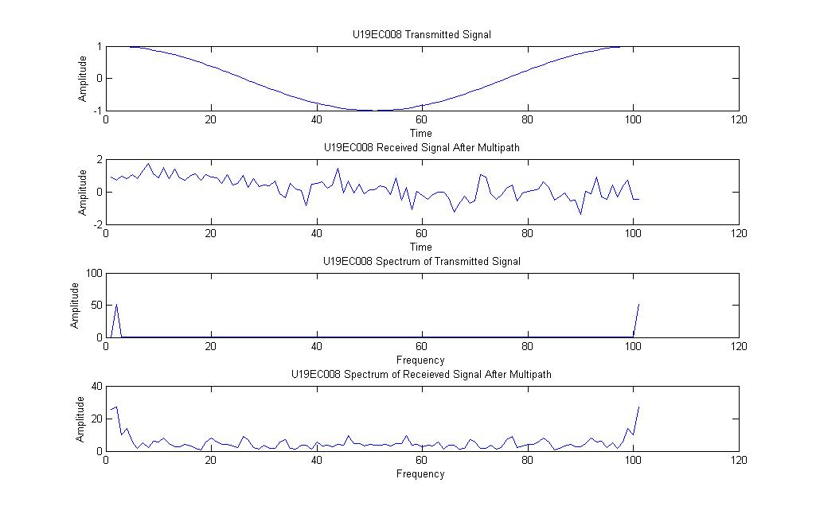

U19EC008

**Impulse Response of channel at different time instants**

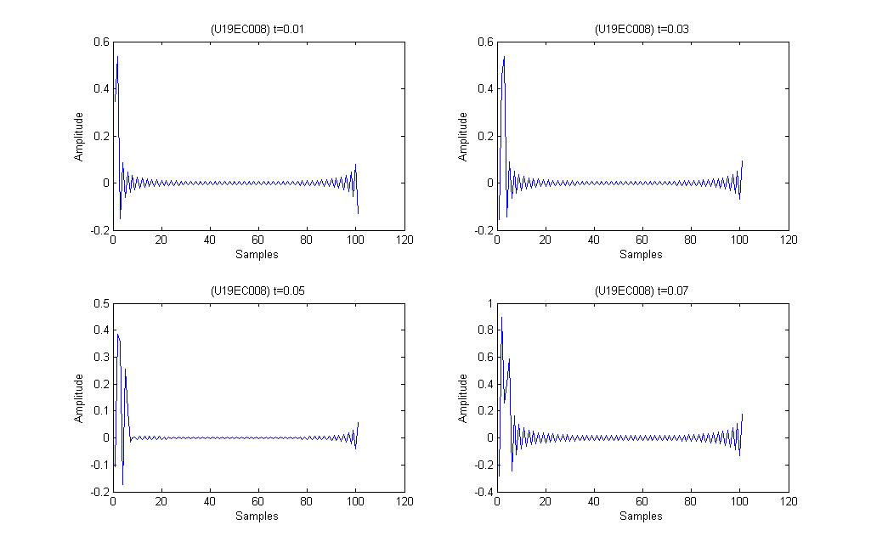

U19EC008

**Transfer Function of channel at different time instants**

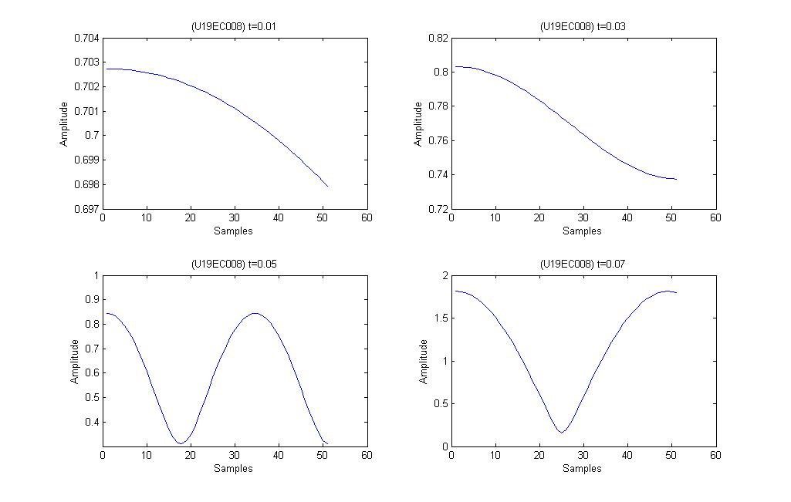

U19EC008

**CONCLUSION:**

In this practical, we have observed the effect of multipath at various time instants. We have observed the transmitted signal, received signal, spectrum of transmitted signal and spectrum of received signal. We have also obtained the transfer function, impulse response of the channel at different time instants.

We can conclude that as we increase the number of multipath, we get more fluctuations and thus we get more distorted output.