**SANJIT ANAND U19EC008**

**31-01-2022 PRACTICAL ASSIGNMENT - 3**

**WIRELESS AND MOBILE COMMUNICATION**

**AIM:**

To Simulate M PSK and M QAM Modulation Techniques using AWGN channel considering input as an Image with the help of MATLAB software Plot SNR v/s BER where M= 4 8 16 32 64 and constellation as well

**APPARATUS:**

MATLAB Software

**THEORY:**

## Additive White Gaussian Noise (AWGN)

* **AWGN -**  A basic noise model used to mimic the effect of many random processes that occur in nature
* Channel produces Additive White Gaussian Noise (AWGN).

**Additive**: The received signal equals the transmit signal plus some noise, where the noise is statistically independent of the signal.

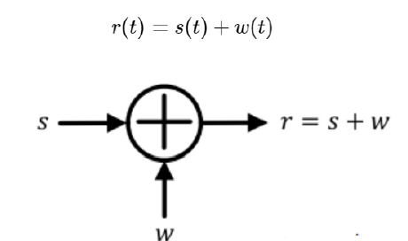

**White:** It refers that the noise has the same power distribution at every frequency OR it has uniform power across the frequency band for the information system.

It is an analogy to the colour white which has uniform emissions at all frequencies in the visible spectrum if I focused a beam of light for each colour on the visible spectrum onto a single spot that combination would result in a beam of white light.

As a consequence, the Power Spectral Density (of white noise is constant for all frequencies ranging from to as shown in figure below

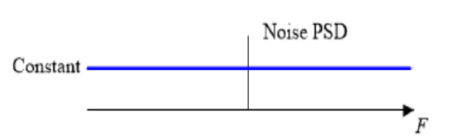

**Gaussian**: Gaussian distribution, or a normal distribution, has an average of zero in the time domain, and is represented as a bell shaped curve.

The probability distribution of the noise samples is Gaussian with a zero mean. The values close to zero have a higher chance of occurrence while the values far away from zero are less likely to appear.

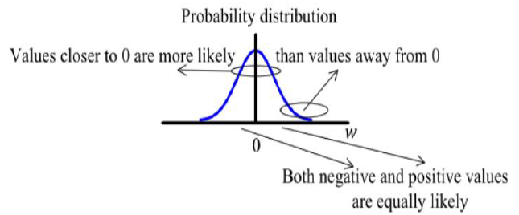

In reality, the ideal flat spectrum from to is true for frequencies of interest in wireless communications (a few kHz to hundreds of GHz) but not for higher frequencies.

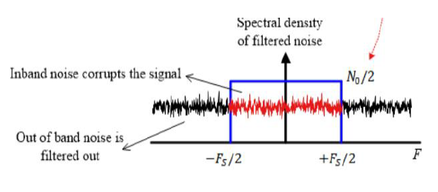

**Signal-to-Noise Ratio:** The SNR or S/N is a measure used in science and engineering that compares the level of a desired signal to the level of background noise.

It is defined as the ratio of signal power to the noise power, often expressed in decibels. A ratio higher than 1 1 (greater than 0 dB) indicates more signal than noise.

SNR, bandwidth, and channel capacity of a communication channel are connected by the Shannon Hartley theorem.

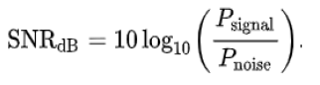

**Shannon-Hartley theorem:** It states the channel capacity bits per second OR information rate of data that can be communicated at low error rate using an average received signal power through communication channel subject to additive white Gaussian noise (AWGN) of power.

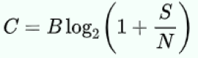

It is the related to signal to noise ratio (SNR) or the carrier to noise ratio (CNR) (expressed as a linear power ratio, not as logarithmic decibels)

* **5 dB - 10 dB:** is below the minimum level to establish a connection, due to the noise level being nearly indistinguishable from the desired signal (useful information**)**
* **25 dB - 40 dB:** is deemed to be good
* **41 dB or higher:** is considered to be excellent

**PROCEDURE:**

**Step1:** Input type of modulation and order of modulation technique

**Step2:** Converting colored image into grayscale image

**Step3:** Convert 2D pixel matrix into 1D Row vector

**Step4:** Convert 1D vector to binary and reshape to column vector

**Step5:** Padding 0 if required Modulate (M-ary PSK or QAM)

**Step6:** Add AWGN because of Channel Demodulation

**Step7:** Convert demodulated binary output to decimal and then to 2D matrix

**Step8:** Display reconstructed image and compare with original grayscale

**Step9:** Plot SNR Vs BER Graph END

**MATLAB CODE:**

% LAB 03 - U19EC008

clc;

clear all;

close all;

% Read Image

img=imread('cameraman.tif');

mxM = 6;

mxSNR = 40;

BERQAM = zeros(mxM,mxSNR/2);

BERPSK = zeros(mxM,mxSNR/2);

QAMstr = 'QAM (M = %d) U19EC008';

PSKstr = 'PSK (M = %d) U19EC008';

t = 1:2:mxSNR;

figure(1);

subplot(mxM/3,3,1);

imshow(img);

title('Original U19EC008');

figure(2);

subplot(mxM/3,3,1);

imshow(img);

title('Original U19EC008');

col = ['b','g','r','y','m','k']

for m = 2:mxM

Mod_Ord = 2^m;

SymSize = log2(Mod_Ord);

z = rem(length(img),SymSize);

if z ~= 0;

img = [img; zeros(SymSize - z, prod(size(img))/length (img))];

end

img_bin = de2bi(img);

img_rsp = reshape(img_bin, 8*length(img_bin)/SymSize, SymSize);

img_dec = bi2de(img_rsp);

yQAM = qammod(img_dec, Mod_Ord);

yPSK = pskmod(double(img_dec), Mod_Ord);

for s = 1:2:mxSNR

nQAM = awgn(yQAM,s);

nPSK = awgn(yPSK,s);

zQAM = qamdemod(nQAM, Mod_Ord);

zPSK = pskdemod(nPSK, Mod_Ord);

[a,b] = biterr(img_dec,zQAM);

BERQAM(m,(s+1)/2) = 100*b;

[c,d] = biterr(img_dec,zPSK);

BERPSK(m,(s+1)/2) = 100*d;

end

QAM_dec = de2bi(zQAM);

QAM_rsp = reshape(QAM_dec, size(img_bin));

QAMM = bi2de(QAM_rsp);

QAMM = uint8(reshape(QAMM,size(img)));

PSK_dec = uint8(de2bi(zPSK));

PSK_rsp = reshape(PSK_dec, size(img_bin));

PSKK = bi2de(PSK_rsp);

PSKK = uint8(reshape(PSKK,size(img)));

scatterplot(nQAM);

suptitle('U19EC008')

scatterplot(nPSK);

suptitle('U19EC008')

figure(1);

subplot(mxM/3,3,m);

imshow(QAMM);

title(sprintf(QAMstr,Mod_Ord));

figure(2);

subplot(mxM/3,3,m);

imshow(PSKK);

title(sprintf(PSKstr,Mod_Ord));

figure(mxM+1);

subplot(211);

plot(t,BERQAM(m,:),'linewidth',2,'DisplayName',sprintf(QAMstr,Mod_Ord), 'color', col(m-1));

title('BER vs SNR (QAM) U19EC008');

xlabel('Signal to Noise Ratio');

ylabel('Bit Error Rate(%)');

legend;

hold on;

subplot(212);

plot(t,BERPSK(m,:),'linewidth',2,'DisplayName',sprintf(PSKstr,Mod_Ord), 'color', col(m-1));

title('BER vs SNR (PSK) U19EC008');

xlabel('Signal to Noise Ratio');

ylabel('Bit Error Rate(%)');

legend;

hold on;

end

**OUTPUT:**

**(BER Performance of System)**

**Bit Error Rate vs Signal to Noise Ratio (QAM and PSK)**

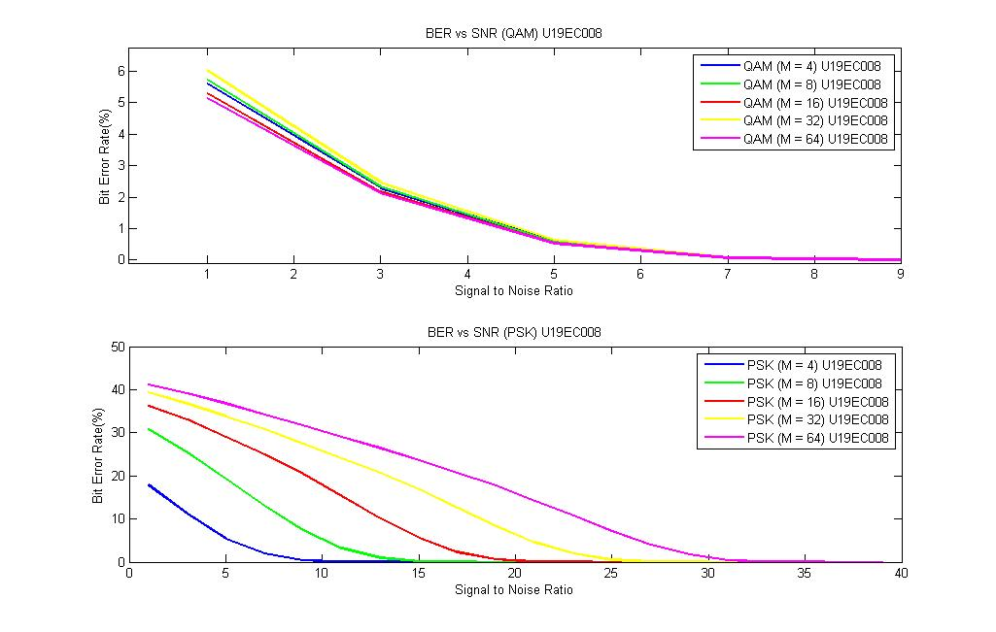

U19EC008

**Image Output using QAM [Original, M=4, 8, 16, 32, 64]**

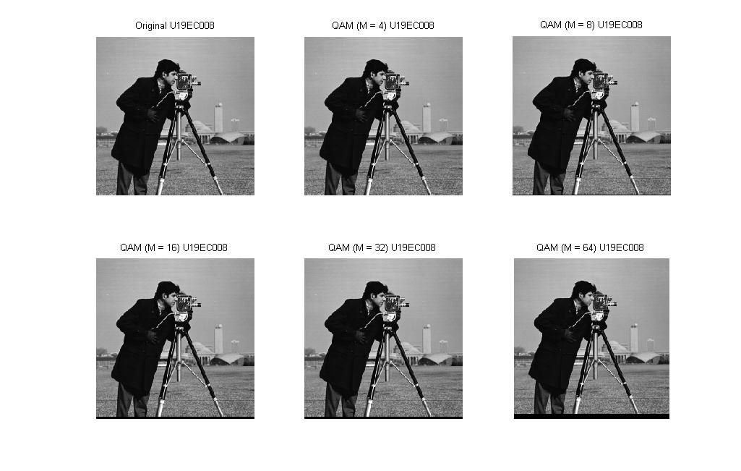

U19EC008

**Image Output using PSK [Original, M=4, 8, 16, 32, 64]**

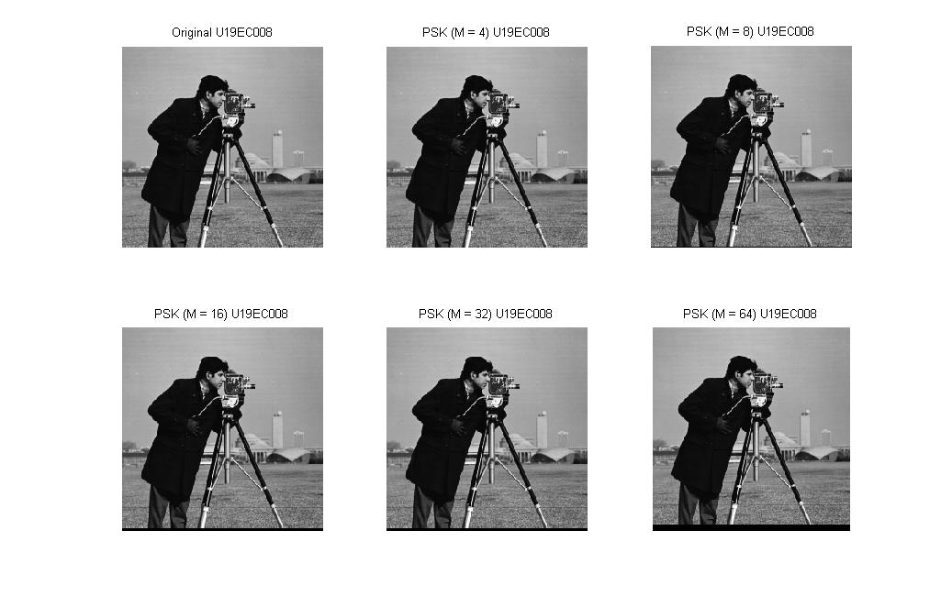

U19EC008

**Constellation Diagrams (Scatterplots):**

**QAM (M= 4) PSK (M=4)**

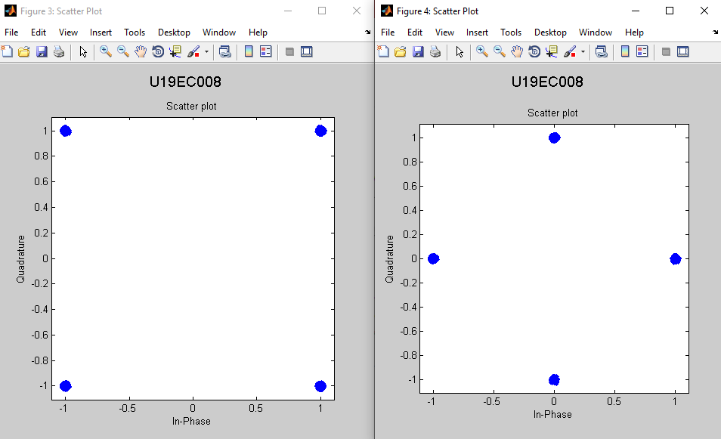

**QAM (M= 8) PSK (M=8)**

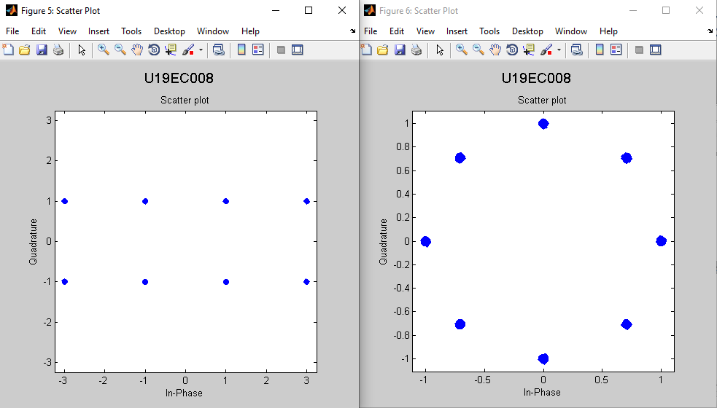

**QAM (M= 16) PSK (M=16)**

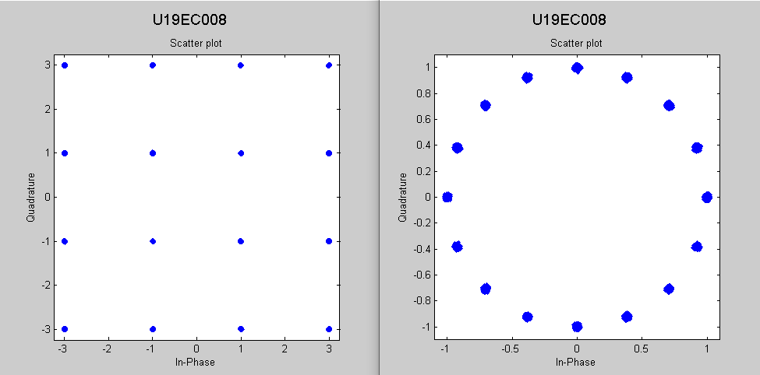

**QAM (M= 32) PSK (M=32)**

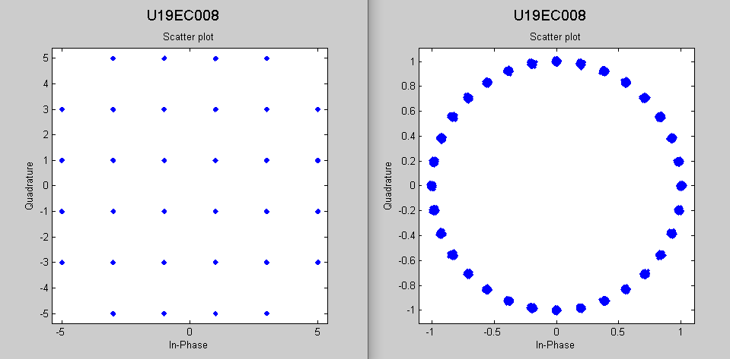

**QAM (M= 64) PSK (M=64)**

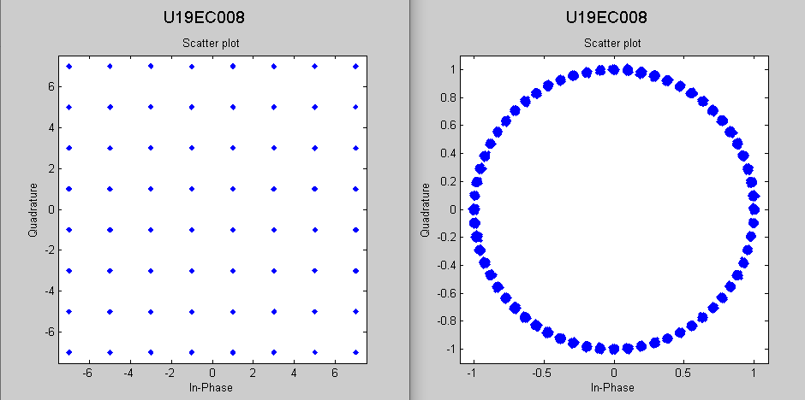

**CONCLUSION:**

In this practical, we have successfully transmitted the input source image using different orders of PSK modulation technique and calculated the Bit Error Rates for different SNR values for each of them. We can conclude that as the values of N increases, BER increases and the value of SNR increases BER decreases.