**Name**: Arnav Adhiya

**Roll** **No**: U19EC109

**Subject**: WMC

Experiment: 04

**Aim:**

To study and observe the effect of doppler spread and delay spread for fast fading and slow fading channel and calculate the coherent bandwidth in MATLAB.

**Theory:**

Delay Spread:

As we know that radio frequency signal takes different path to reach the destination due to multiple paths. These multiple paths cause reflection, refraction and scattering of radio signal. Hence when the signal is transmitted from one place to the other, multiple copies of the signal is received with different amplitudes and different delays (leads to different time of arrival) at the receiver​.

For example, if an impulse is transmitted then it will be no longer an impulse when it is received at the other end, but it will become a pulse with spreading effect. The effect which makes this spreading of signal is known as Delay spread.​  
​  
To measure performance of a wireless system different scenarios from low to medium to high delay spreads are considered for test purpose. Delay spread helps determine coherence bandwidth and coherence time of a wireless system. ​

Coherence time = (1/Doppler spread)​

In doppler spread, how fast the transfer function of the time-varying channel changes with time for a fixed frequency is to be studied. Doppler spread and the coherence time are used for the same.

In delay spread, how fast the transfer function of the time-varying channel changes with frequency at a particular time instant is to be studied.​

Doppler Spread:

Doppler shift is the random changes in a channel introduced as a result of a mobile user’s mobility.​

Doppler spread has the effect of shifting or spreading the frequency components of a signal​

Types of fading on the basis of doppler spread are fast fading and slow fading. ​  
• Fast fading: Channel impulse response changes rapidly within the symbol duration. ​  
• Slow fading: Channel impulse response changes at a rate much slower than the transmitted symbol bandwidth. ​  
• Doppler spread is expressed in the following formula. As mentioned, doppler spread is defined as maximum doppler shift (fm). ​

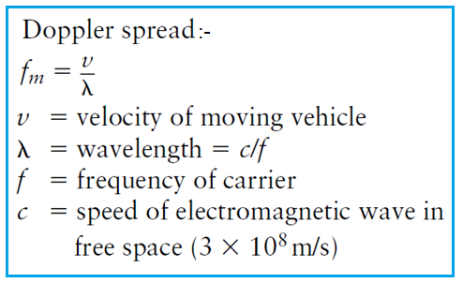

Coherence Time:

The coherence time is the time over which a propagating wave may be considered coherent. In other words, it is the time interval within which its phase is, on average, predictable.​

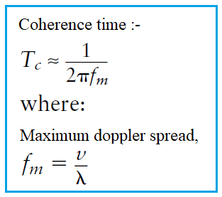

**Code:**

Delay Spread:

clc;

close all;

clear all;

tau0 = 0; %rate at which delay changes%

t0=1;

nop=4;

beta = rand(1, nop);

tauj = (rand(1, nop)*2 - 1);

comp_t0 = [];

z=1;

t1 = 1;

for f=0:0.001:1

temp =0;

temp1 =0;

for p=1:1:nop

temp1 = temp1+beta(p)*exp(-1j*2*pi*f*tau0)*exp(-1j*2*pi*f*tauj(p)*t0);

end

comp_t0 = [comp_t0 temp1];

end

figure

plot((0:(1/1000):1)*1000,abs(comp_t0));

title('time varying transfer function at timeInstant 1us');

Doppler Spread:

Clc;

clear all;

close all;

Tau0 =0;

f=1;

nop =4;

beta = rand(1,nop);

Tauj = [0.62 1.84 0.86 0.37];

BETA = [0.23 0.17 0.23 0.44];

rxsignal =[];

tvtf = [];

t = 0:(1/100):99.99;

txsignal = cos(2*pi*f*t);

z=1;

for t =0:(1/100):99.99

temp =0;

temp1 =0;

for p=1:1:nop

temp = temp+BETA(p)*exp(2*pi*f*t)*exp(-1i*2*pi*f*Tau0)*exp(-1i*2*pi*f*Tauj(p)*t);

temp1 = temp1+BETA(p)*exp(-1i*2*pi*f*Tau0)*exp(-1i*2*pi*f*Tauj(p)*t);

end

rxsignal = [rxsignal temp];

tvtf = [tvtf temp1];

end

figure(1)

subplot(2,2,1)

plot(txsignal)

axis([1 1000 -2 2]);

title('Transmitted signal');

subplot(2,2,2)

fre = (0:1:length(rxsignal)-1)/100;

plot(real(rxsignal),'r')

axis([1 1000 -2 2]);

title('Real part of received signal');

subplot(2,2,3)

plot(fre, abs(fft(txsignal)));

axis([0 2 0 1000]);

title('Spectrum of transfer signal');

subplot(2,2,4)

plot(fre, abs(fft(real(rxsignal))));

title('real part of corresponding spectrum of transmitted signal');

figure(2)

subplot(2,1,1)

plot(abs(tvtf));

axis([0 1000 0 2]);

title('Time varying transfer function value magnitude');

subplot(2,1,2)

plot(phase(tvtf));

axis([0 1000 -25 0]);

title('Time varying transfer function value phase');

**Output:**

Delay Spread:

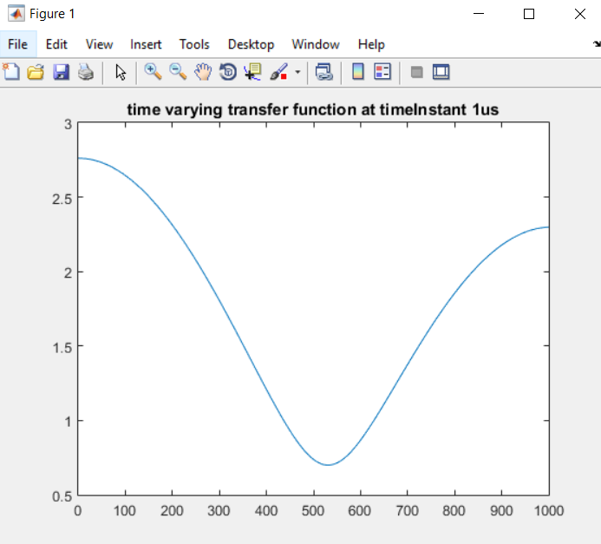

Doppler Spread:

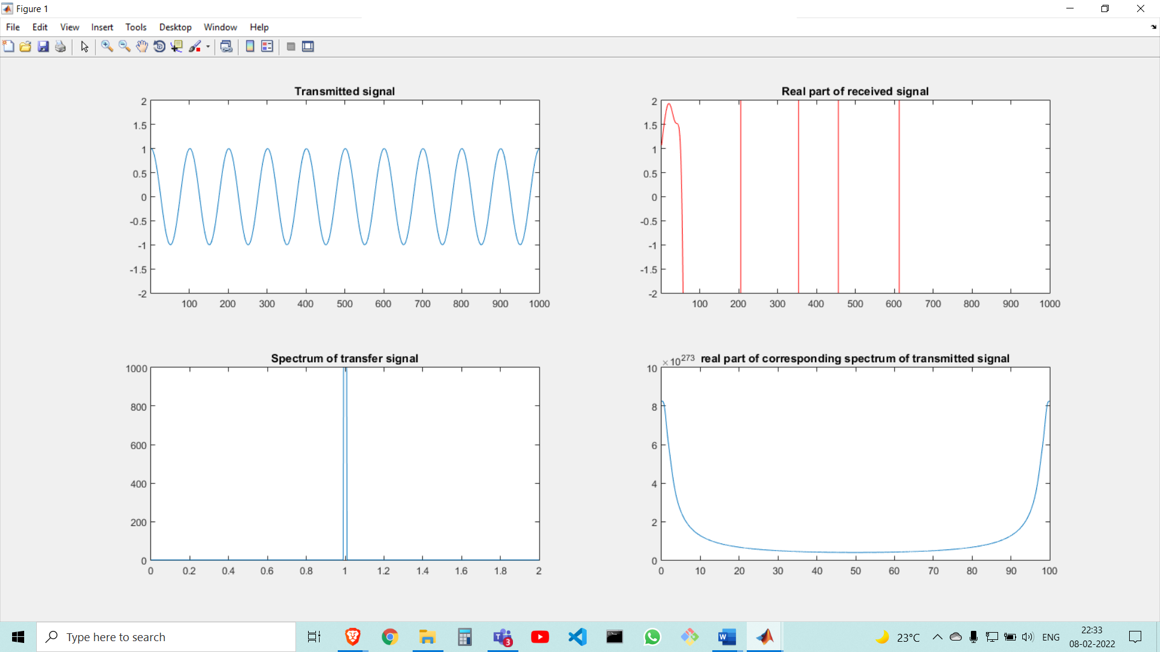

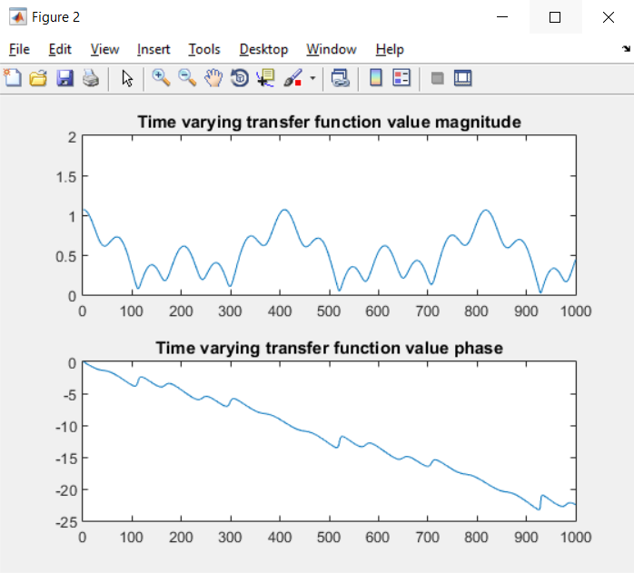

**Conclusion:**

In this experiment, we observed the effect of Delay spread and Doppler spread for fast fading and slow fading and verified the coherent bandwidth using MATLAB.