**SANJIT ANAND U19EC008**

**07-02-2022 PRACTICAL ASSIGNMENT - 4**

**WIRELESS AND MOBILE COMMUNICATION**

**AIM:**

To study and observe the effect of Doppler spread and delay spread for fast fading and slow fading channel and calculate the coherent bandwidth in MATLAB.

**APPARATUS:**

MATLAB Software

**THEORY:**

## Doppler Spread

• Doppler shift is the random changes in a channel introduced as a result of a mobile user’s mobility.

• Doppler spread has the effect of shifting or spreading the frequency components of a signal

• Types of fading on the basis of doppler spread are fast fading and slow fading.

• Fast fading: Channel impulse response changes rapidly within the symbol duration.

• Slow fading: Channel impulse response changes at a rate much slower than the transmitted symbol bandwidth.

• Doppler spread is expressed in the following formula. As mentioned, doppler spread is defined as maximum doppler shift (fm).

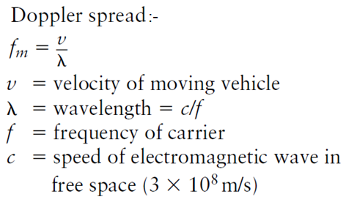

**Coherence Time:**

• The coherence time of the channel is the inverse of the Doppler spread.

• It is the measure of the speed at which channel characteristics change.

• The coherence time is the time over which a propagating wave may be considered coherent. In other words, it is the time interval within which its phase is, on average, predictable.

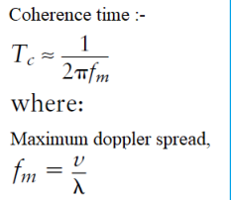

In Doppler spread, how fast the transfer function of the time-varying channel changes with time for a fixed frequency is to be studied. Doppler spread and the coherence time are used for the same. It is due to the different Doppler shift frequencies associated with the multiple propagation paths when there is relative motion between the transmitter and the receiver

## Delay Spread

Delay spread is a measure of the multipath profile of a mobile communications channel. It is generally defined as the difference between the time of arrival of the earliest component (e.g., the line-of-sight wave if there exists) and the time of arrival of the latest multipath component.

Coherence bandwidth Bc is a statistical measure of the range of frequencies over which the channel can be considered flat (i.e., it passes all spectral components with approximately equal gain and linear phase). All frequency components of the transmitted signal within the coherence bandwidth will fade simultaneously. The coherence bandwidth is inversely proportional to the delay spread, and we thus have the following:



In delay spread, how fast the transfer function of the time-varying channel changes with frequency at a particular time instant is to be studied. It happens because different propagation paths have different time delays.

**PROCEDURE:**

* **Step1:** For **Doppler Spread** **Fast fading**, consider the signal cos 2𝜋𝑓𝑜𝑡, where 𝑓𝑜 = 1 MHz. Also let the rate at which the delay (𝜏𝑗) is changing with time be randomly chosen as TAU_J = [0.62 1.84 0.86 0.37] for fast fading.
* **Step2**: Hence the corresponding Doppler shift for the frequency 𝑓𝑜 in the corresponding paths is obtained as DJ = −𝑓𝑜+TAUJ and the actual shift in the frequency is given as fshift = |DJ + 𝑓𝑜| = [0.38 0.84 0.14 0.63]
* **Step3**: Attenuation in individual paths, BETA($β$) = [0.23 0.17 0.23 0.44]
* **Step4**: Thus the received signal is represented as $\sum_{j=1}^{4}{β\left(j\right) cos⁡(2π\left(fshift(j)\right)t)}$
* **Step5**: Plot the received signal and the corresponding spectrum
* For **Doppler Spread Slow fading**, take Tauj as [0.0042 0.0098 0.0030 0.007] and Beta as [0.2691 0.4228 0.5479 0.9427];
* For **Delay spread**, take Tau as [0.9143 -0.0292 0.6006 -0.7162] and Beta as [0.9575 0.9649 0.1576 0.9706] and vary frequency at particular time instant.

**MATLAB CODE:**

**1. Doppler Spread (Fast Fading)**

% LAB04 U19EC008

% Doppler Spread Fast Spreading

clc;

clear all;

close all;

Tau0 =0;

% f is in MHz and sampling time is in microseconds

f=1;

% Number of Multipaths

nop = 4;

% Rate at which the delay is changing

Tauj = [0.62 1.84 0.86 0.37];

% Attenuation of Individual Paths

BETA = [0.23 0.17 0.23 0.44];

% Actual shift in the frequency

fshift=[];

for j=1:1:nop

fshift(j)=abs(-f+Tauj(j));

end

% Received Signal

rxsignal =[];

% time varying transfer function at f

tvtf = [];

t = 0:(0.01):100;

% Transmitted Signal

txsignal = cos(2*pi*f*t);

for t =0:(0.01):100

temp = 0;

tf = 0;

for p=1:1:nop

temp = temp+ BETA(p)*cos(2*pi*fshift(p)*t); %1.11

tf = tf+BETA(p)*exp(-1i*2*pi*f*Tau0)*exp(-1i*2*pi*f*Tauj(p)*t); % 1.9

end

rxsignal = [rxsignal temp];

tvtf = [tvtf tf];

end

% PLOTS

figure(1)

subplot(2,2,1)

plot(txsignal)

axis([1 1000 -2 2]);

title('U19EC008 Transmitted signal');

xlabel('time (microseconds)');

ylabel('Amplitude');

grid on;

subplot(2,2,2)

plot(real(rxsignal),'r')

axis([1 1000 -2 2]);

title('U19EC008 Received signal');

xlabel('time (microseconds)');

ylabel('Amplitude');

grid on;

subplot(2,2,3)

fre = (0:1:length(rxsignal)-1)/100;

plot(fre, abs(fft(txsignal)));

axis([0 2 0 6000]);

title('U19EC008 Spectrum of transmitted signal');

xlabel('Frequency (MHz)');

ylabel('Amplitude');

grid on;

subplot(2,2,4)

plot(fre, abs(fft(real(rxsignal))), 'r');

axis([0 2 0 2500]);

title('U19EC008 Corresponding Spectrum of Received signal');

xlabel('Frequency (MHz)');

ylabel('Amplitude');

grid on;

figure(2);

subplot(2,1,1)

plot(abs(tvtf));

axis([0 1000 0 2]);

title('U19EC008 Time varying transfer function (Magnitude)');

xlabel('time (microseconds)');

ylabel('Magnitude');

grid on;

subplot(2,1,2)

plot(phase(tvtf));

axis([0 1000 -25 0]);

title('U19EC008 Time varying transfer function (Phase)');

xlabel('time (microseconds)');

ylabel('Phase');

grid on;

**2. Doppler Spread (Slow Fading)**

% LAB04 U19EC008

% Doppler Spread Slow Spreading

clc;

clear all;

close all;

Tau0 =0;

% f is in MHz and sampling time is in microseconds

f=1;

% Number of Multipaths

nop = 4;

% Rate at which the delay is changing

Tauj = [0.0042 0.0098 0.0030 0.0070];

% Attenuation of Individual Paths

BETA = [0.2961 0.4228 0.5479 0.9427];

% Actual shift in the frequency

fshift=[];

for j=1:1:nop

fshift(j)=abs(f-Tauj(j));

end

% Received Signal

rxsignal =[];

% time varying transfer function at f

tvtf = [];

t = 0:(0.01):100;

% Transmitted Signal

txsignal = cos(2*pi*f*t);

for t =0:(0.01):100

temp = 0;

tf = 0;

for p=1:1:nop

temp = temp+ BETA(p)*cos(2*pi*fshift(p)*t); %1.11

tf = tf+BETA(p)*exp(-1i*2*pi*f*Tau0)*exp(-1i*2*pi*f*Tauj(p)*t); % 1.9

end

rxsignal = [rxsignal temp];

tvtf = [tvtf tf];

end

% PLOTS

figure(1)

subplot(2,2,1)

plot(txsignal)

xlim([0 10000])

title('U19EC008 Transmitted signal');

xlabel('time (microseconds)');

ylabel('Amplitude');

grid on;

subplot(2,2,2)

fre = (0:1:length(rxsignal)-1)/100;

plot(real(rxsignal),'r')

xlim([0 10000])

title('U19EC008 Received signal');

xlabel('time (microseconds)');

ylabel('Amplitude');

grid on;

subplot(2,2,3)

plot(fre, abs(fft(txsignal)));

xlim([0 2])

ylim([0 7000])

title('U19EC008 Spectrum of transmitted signal');

xlabel('Frequency (MHz)');

ylabel('Amplitude');

grid on;

subplot(2,2,4)

plot(fre, abs(fft(real(rxsignal))), 'r');

xlim([0 2])

ylim([0 7000])

title('U19EC008 Corresponding Spectrum of Received signal');

xlabel('Frequency (MHz)');

ylabel('Amplitude');

grid on;

figure(2);

subplot(2,1,1)

plot(abs(tvtf));

xlim([0 10000])

title('U19EC008 Time varying transfer function (Magnitude)');

xlabel('time (microseconds)');

ylabel('Magnitude');

grid on;

subplot(2,1,2)

plot(phase(tvtf));

xlim([0 10000])

title('U19EC008 Time varying transfer function (Phase)');

xlabel('time (microseconds)');

ylabel('Phase');

grid on;

**3. Delay Spread**

% LAB4 - U19EC008

% DELAY SPREAD

clc;

clear all;

close all;

TAU0=0;

% Time Instant

t0=1;

% Number of Multipaths

nop=4;

% Attenuation of Individual Paths

BETA=[0.9575 0.9649 0.1576 0.9706];

% Rate at which the delay is changing

TAUJ=[0.9143 -0.0292 0.6006 -0.7162];

% time varying transfer function at t0

tvtf_t0=[];

for f=0:(1/1000):1

temp1=0;

for p=1:1:nop

temp1=temp1+BETA(p)*exp(-1i*2*pi*f*TAU0)*exp(-1i*2*pi*f*TAUJ(p)*t0);

end

tvtf_t0=[tvtf_t0 temp1];

end

figure;

plot((0:(1/1000):1)*1000,abs(tvtf_t0));

title('U19EC008 Time Varying Transfer Function computed at the time instant t0=1us')

xlim([0 1000])

xlabel('Frequency (KHz)');

ylabel('Amplitude');

grid on;

**OUTPUT:**

**Doppler Spread (Fast Fading)**

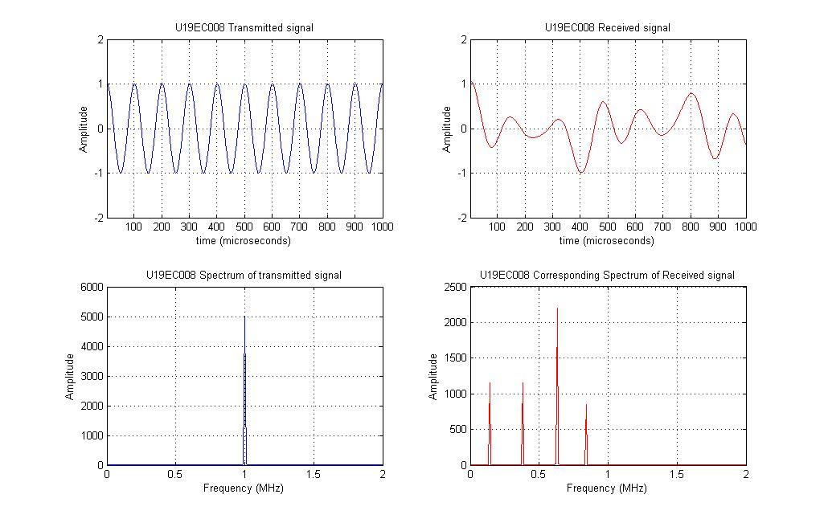

U19EC008

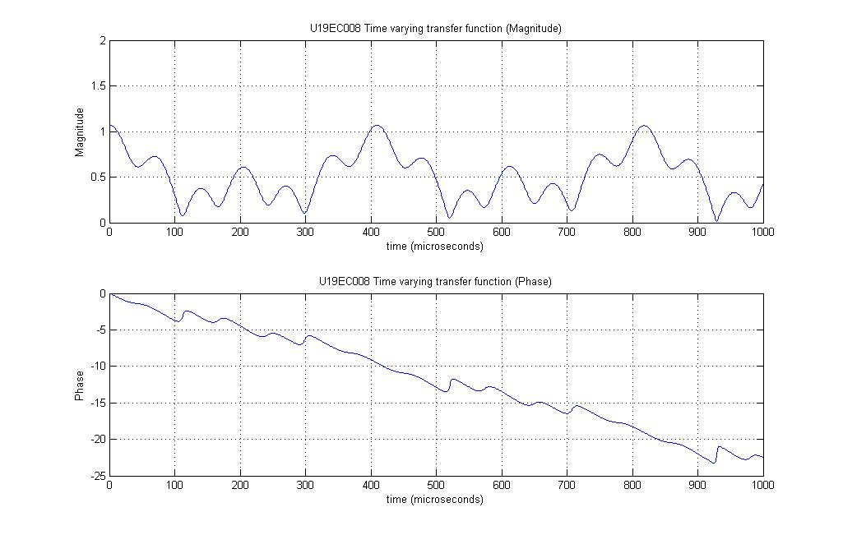

U19EC008

**Doppler Spread (Slow Fading)**

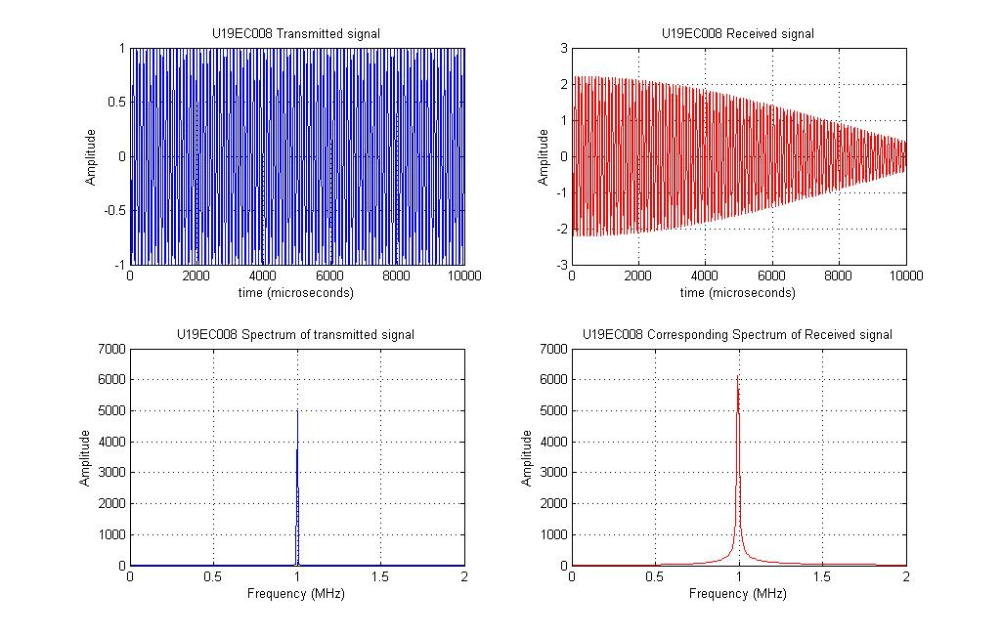

U19EC008

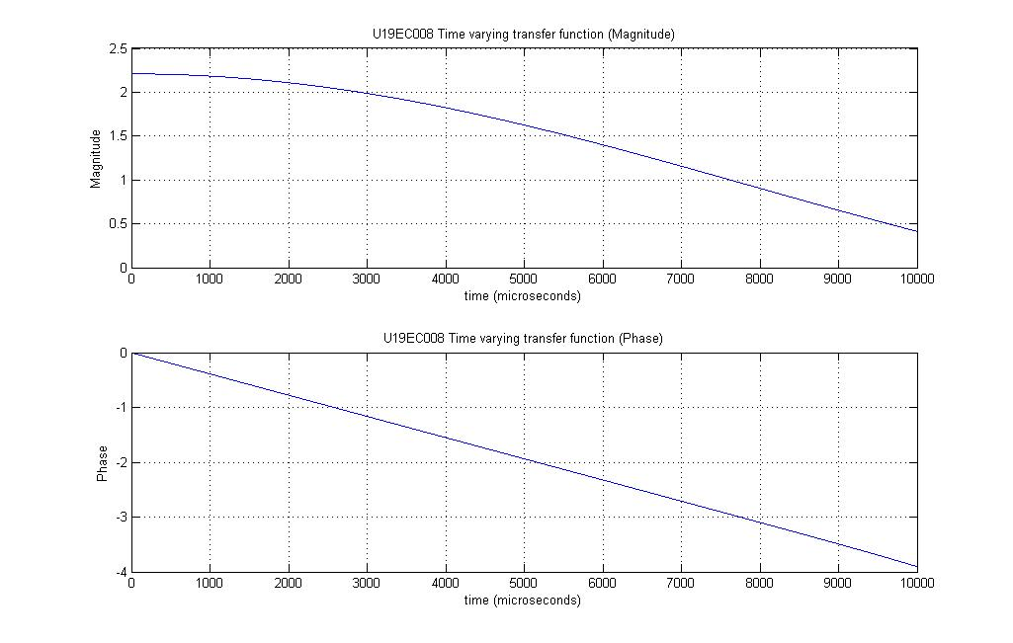

U19EC008

**Delay Spread**

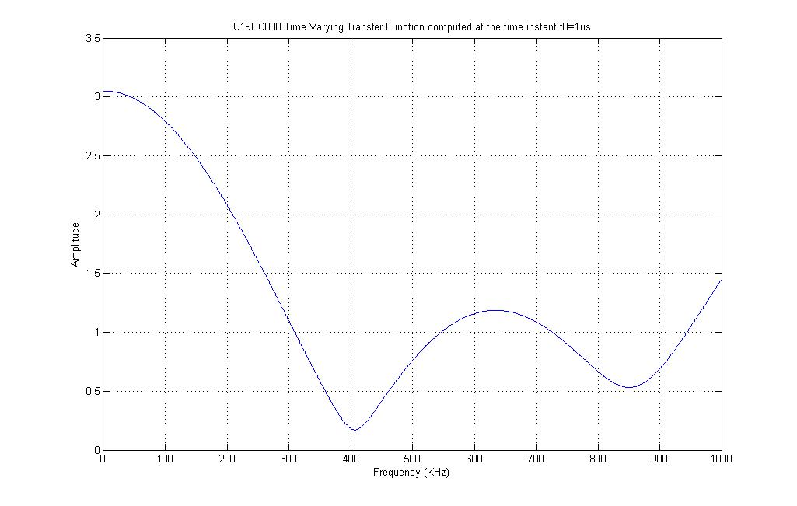

**CALCULATIONS:**

**Coherence Time** = 1/2D = **73us**

**Delay Spread L** = **1.6306**

**Coherence Frequency** = 1/2L= **306KHz**

**CONCLUSION:**

In this experiment, we observed the effect of Delay spread and Doppler spread for fast fading and slow fading and verified the coherent bandwidth using MATLAB. In doppler spread, how fast the transfer function of the time-varying channel changes with time for a fixed frequency is to be studied. Doppler spread and the coherence time are used for the same. In delay spread, how fast the transfer function of the time-varying channel changes with frequency at a particular time instant is to be studied.