**SANJIT ANAND U19EC008**

**21-03-2022 PRACTICAL ASSIGNMENT - 7**

**WIRELESS AND MOBILE COMMUNICATION**

**AIM:**

To calculate received signal strength as a function of distance separation between transmitter and receiver & understand path loss prediction formula.

Impact of parameters on received signal strength

• Transmitter Power

• Path Loss Exponent

• Carrier Frequency

• Receiver Antenna height

• Transmitter Antenna height

**APPARATUS:**

Virtual Labs (Based on Java 7)

**THEORY:**

* The design of a communication system involves selection of values of several parameters.
* Most important parameter is Transmit power.
* In terrestrial mobile communication system, electromagnetic waves propagation is affected by reflection, diffraction and scattering.
* These leads to dynamic variation of signal strength as a function of frequency, distance of separation, antenna height etc.

**Free Space Propagation Model**

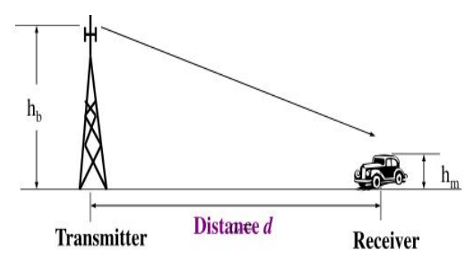

The Friis Free Space Propagation Loss for received power at a distance d is given by:

$$P_{r}\left(d\right)= \frac{P_{t}G_{t}G_{r}λ^{2}}{{(4π)}^{2}d^{2}L}$$

Where

*Pt = Transmitter Power.*

*Pr(d) = Received power at a distance 'd'.*

*Gt = Transmit antenna power gain.*

*Gr = Received antenna power gain.*

*λ = Wavelength.*

*L ≥ 1 System loss factor not related to propagation, Transmission line, Filter losses, Antenna loss etc.*

*D= Tx−Rx separation distance.*

Pr decrease as square of distance 20 dB/ decade

Received Power at a distance d is given by:

$$P_{r}\left(d\right)=P_{r}\left(d_{0}\right)+ 10*n_{p}*log \left(\frac{d_{0}}{d}\right) [Used in 1A and 1B]$$

$$P_{L}\left(d\right)=P_{L}\left(d_{0}\right)+ 10*n_{p}*log \left(\frac{d}{d_{0}}\right)$$

**Two Ray Propagation Model**

A free space propagation model is inaccurate. A useful propagation model (Two Ray Propagation Model) considers both direct path and ground reflected path between transmitter and receiver.

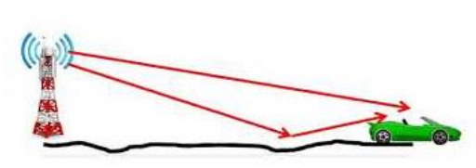

$$P_{L}\left(d\right)=10*n_{p}*log \left(d\right)+7.8-18 log\left(H_{TX}\right) -18 log\left(H_{RX}\right)+20 log(f(GHz)$$

**Used in 1C, 1D and 1E**

Where,

*D = Tx – Rx, i.e, Tx and Rx separation distance in metres.*

*HTX = the transmitter (base station) antenna height in metres.*

*HRX = the receiver (user terminal) antenna height in metres.*

*fc = Carrier frequency in GHz.*

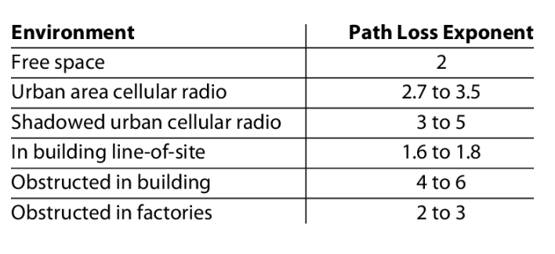

**PROCEDURE:**

1. Open the downloaded JNLP file.
2. Select the experiment from 1A to 1E.
3. Hover the mobile receiver to the desired location (d).
4. Click on take readings which will generate.
5. Calculate the desired value as per the equations.
6. Generate the report after submitting the predicted value to validate with the actual value.

**OBSERVATIONS:**

**For distance d = 100 m**

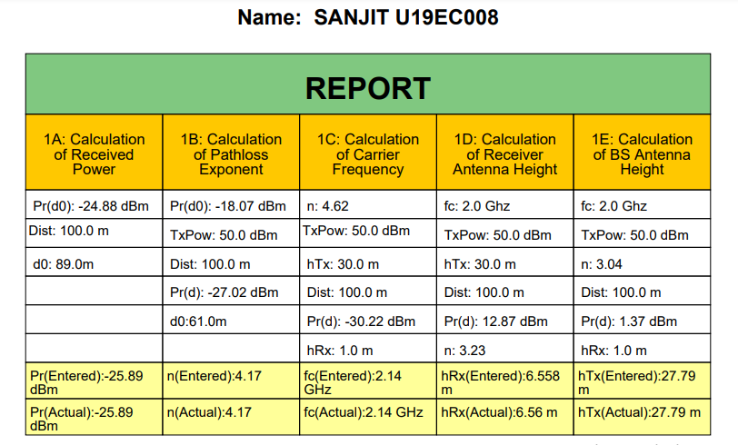

**For distance d = 500 m**

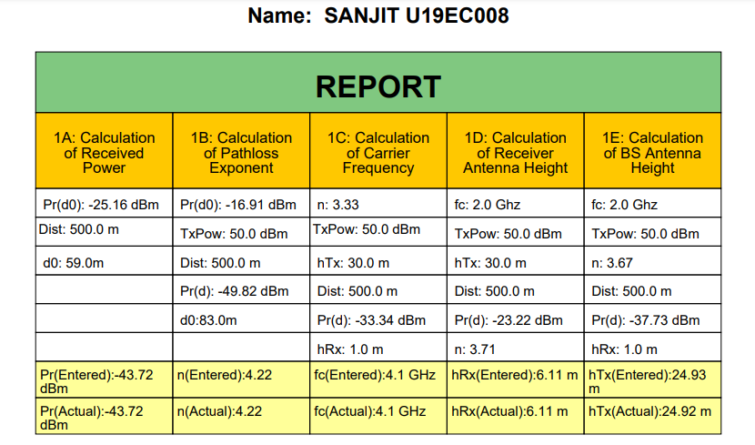

**For distance d = 800 m**

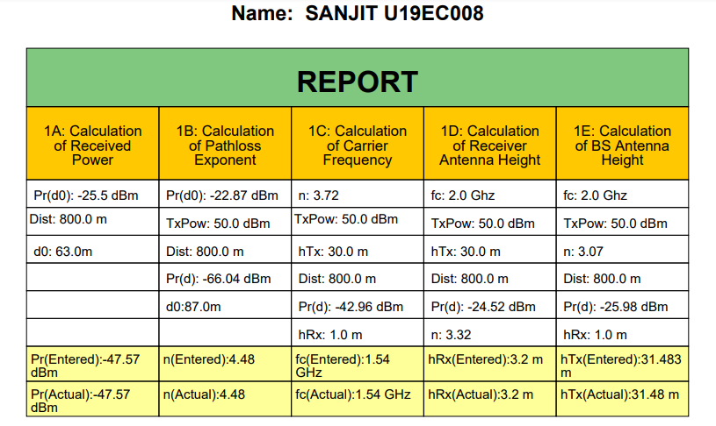

**For distance d = 1000 m**

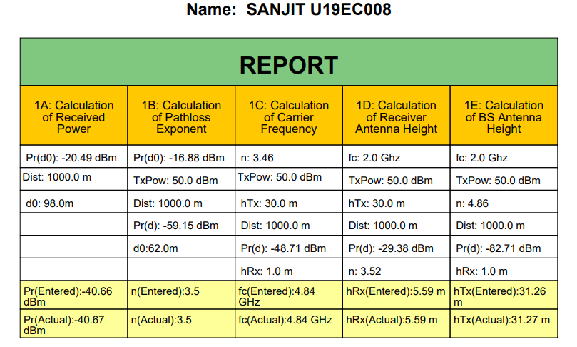

**For distance d = 1500 m**

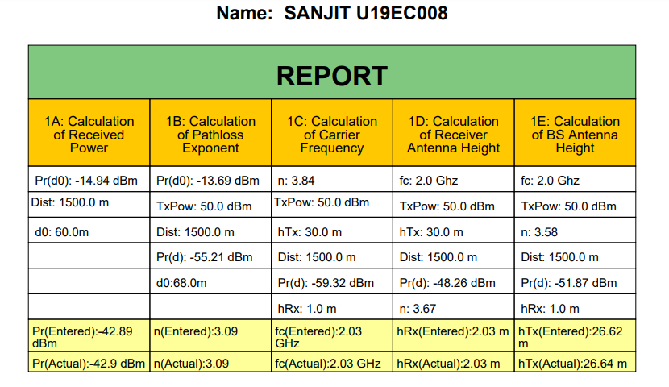

**RESULTS:**

**PART 1A**

|  |  |  |
| --- | --- | --- |
| Distance​  (m)​ | Pr (d)​ (dBm) | Avg. ​  Pr(d)​ (dBm) |
| ​  100 ​ | ​-25.89 | ​-20.344 |
| ​-15.04 |
| ​-15.13 |
| ​-26.82 |
| ​-18.84 |

**PART 1B**

|  |  |  |
| --- | --- | --- |
| Distance​  (m)​ | Pr (d)​ (dBm) | Path Loss Exponent (n)​ |
| ​  100 ​ | -27.02 | 4.17 |
| ​-24.19 | ​3.45 |
| ​-30.77 | ​4.74 |
| ​-23.61 | ​4.64 |
| ​-19.42 | ​4.27 |

**PART 1C**

|  |  |  |
| --- | --- | --- |
| Distance​  (m)​ | Pr (d)​ (dBm) | Carrier Frequency (Fc) (GHz)​ |
| ​  1000 ​ | ​-48.71 | ​4.84 |
| ​-59.4 | ​1.16 |
| ​-56.92 | ​1.74 |
| ​-90.83 | ​3.98 |
| ​-36.91 | ​4.42 |

**PART 1D**

|  |  |  |
| --- | --- | --- |
| Distance​  (m)​ | Pr (d)​ (dBm) | Receiver Antenna Height (hRx)(m)​ |
| ​  1000 ​ | ​-29.38 | ​5.59 |
| ​-62.65 | ​2.15 |
| ​-68.25 | ​5.26 |
| ​-21.75 | ​6.62 |
| ​-36.91 | ​4.42 |

**PART 1E**

|  |  |  |
| --- | --- | --- |
| Distance​  (m)​ | Pr (d)​ | Transmitter  Antenna Height (hTx)(m)​ |
| ​  1000 ​ | ​-82.71 | ​31.26 |
| ​-74.16 | ​22.56 |
| ​-60.47 | ​29.1 |
| ​-61.09 | ​29.03 |
| ​-73.02 | ​34.15 |

**CONCLUSION:**

In this experiment, we have simulated the path loss models and calculated path loss components using Visual Lab and verified the calculated and received values. We have calculated the path loss components for various cases in which we are required to find path loss exponent, carrier frequency, transmitter height, and receiver height. We have understood the concept of path loss by using the formulas and by practically finding and validating the values.