**SANJIT ANAND U19EC008**

**21-03-2022 PRACTICAL ASSIGNMENT - 8**

**WIRELESS AND MOBILE COMMUNICATION**

**AIM:**

To understand the cellular frequency reuse concept by:

1. Finding the co-channel cells for a particular cell.
2. Finding the cell clusters within certain geographic area.

**APPARATUS:**

Virtual Labs (Based on Java 7)

**THEORY:**

**Frequency Reuse**

* In mobile communication systems radio resource unit (Channel) is assigned to a user in order to support a call.
* In Mobile Communication System, we have limited spectrum. Thus the number of users who can be supported in a wireless system is highly limited.
* In order to support a large no. of users within a limited spectrum in a region the concept of frequency re-use is used.
* In term of cellular systems, the same frequency can used by two base stations which a sufficient spaced apart. In this way the same frequency gets reused by two or more different base station different users simultaneously.
* Now it is important to select the set of base stations which will use the same set of radio resources/ channel of frequencies or technically the co-channel cells.
* In this context the minimum adjacent set of cells which use different frequencies is called a **cluster**.

**Cell Cluster**

Considering a cellular system that has a total of S duplex radio channels. If each cell is allocated a group of k channels (k < S) and if the S channels are divided among N cells, then,

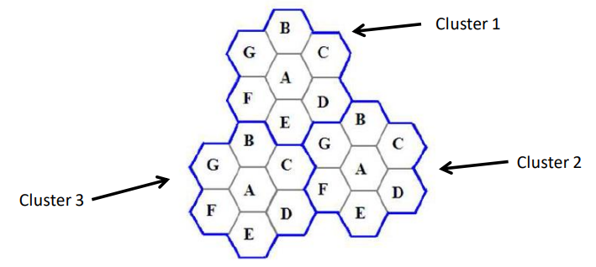

**Co-Channel Cells**

A larger cluster size causes the ratio between the cell radius and the distance between co-channel cells to decrease reducing co-channel interference. The value of N is a function of how much interference a mobile or base station can tolerate while maintaining a sufficient quality of communications. Since each hexagonal cell has six equidistant neighbours and the line joining the centres of any cell and each of its neighbours are separated by multiples of 60 degrees, only certain cluster sizes and cell layouts are possible. To connect without gaps between adjacent cells, the geometry of hexagons is such that the numbers of cells per cluster, N, can only have values that satisfy,

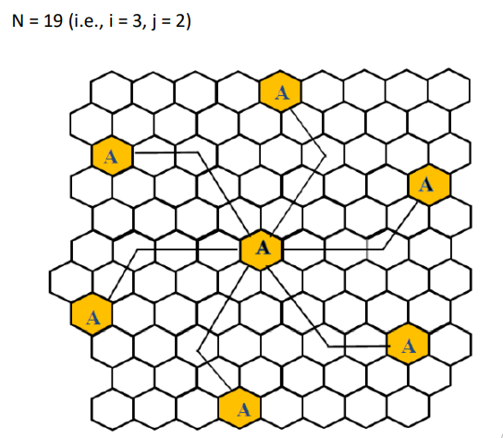

**PROCEDURE:**

**Part A: Finding co-channel cells for a particular cell**

1. Open the downloaded JNLP file of the experiment.
2. Select the values of cell radius, i and j.
3. Click on show cells
4. Mark the correct co-channel cells
5. Generate the report after submitting to validate with the actual cells.

**Part B: Finding the cell clusters within certain geographic area.**

1. Open the downloaded JNLP file of the experiment.

2. Select the values of cell radius and N(cluster size).

3. Click on show cells

4. Mark the correct cluster cells.

5. Generate the report after submitting to validate with the actual cells.

**OBSERVATIONS:**

**Part A: Finding co-channel cells for a particular cell**

**For i=1, j =1**

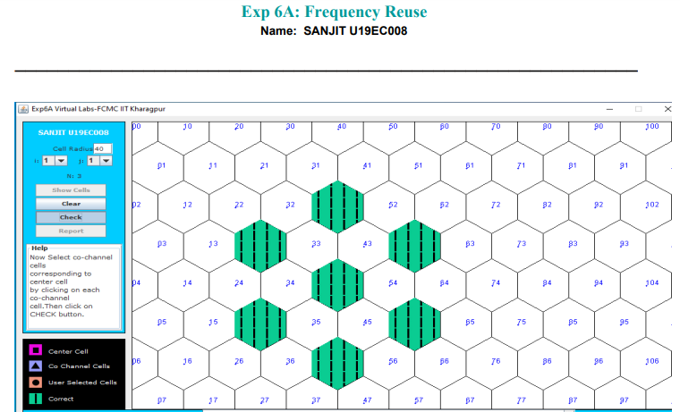

**For i=2, j =1**

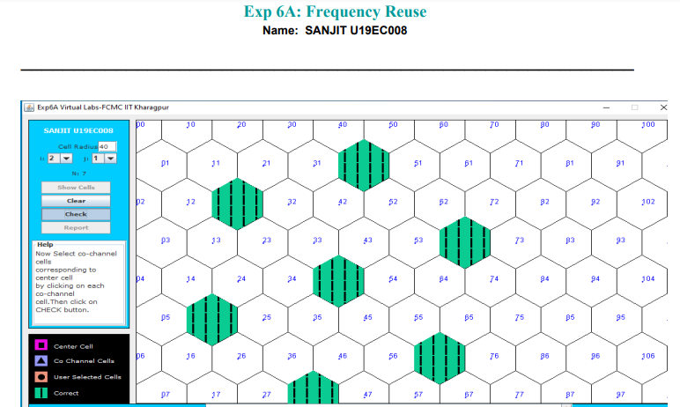

**For i=2, j =2**

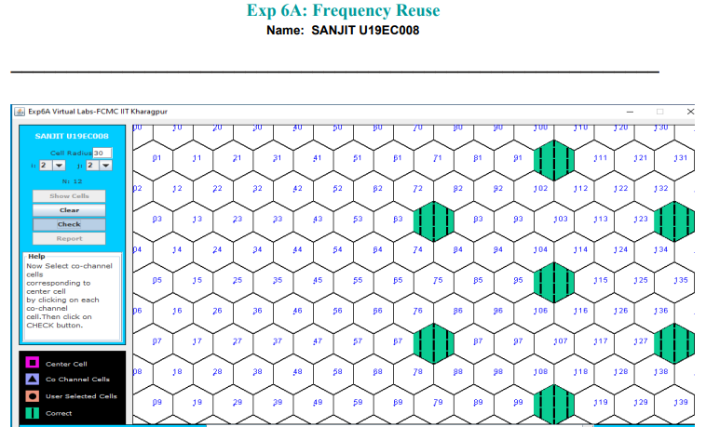

**For i=3, j =2**

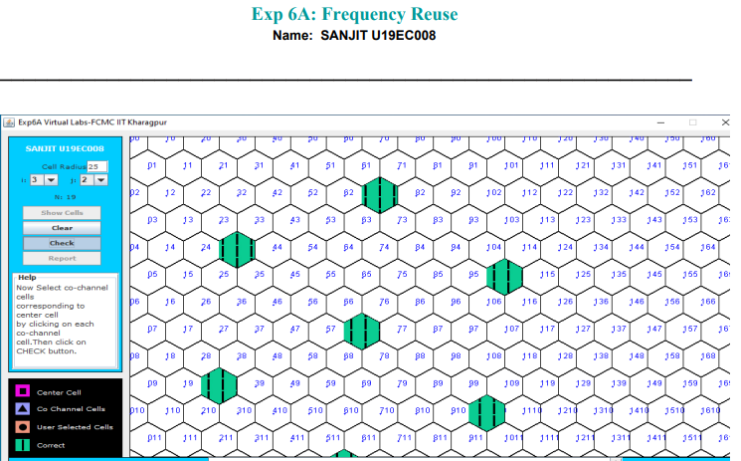

**For i=3, j =3**

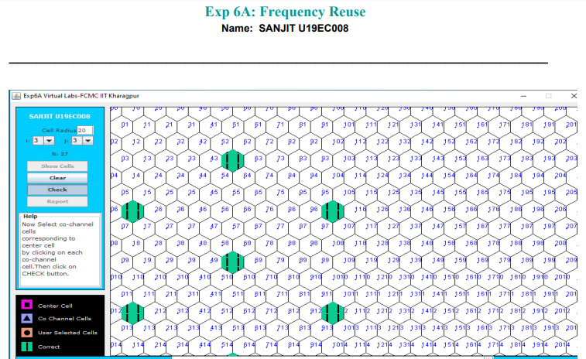

**Part B: Finding the cell clusters within certain geographic area.**

**For N = 4**

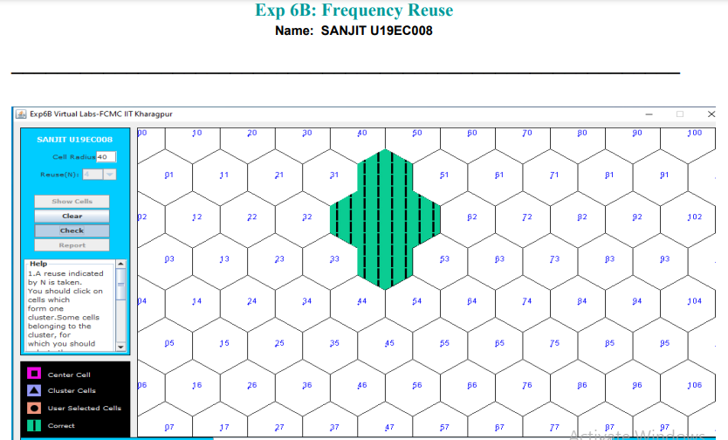

**For N = 7**

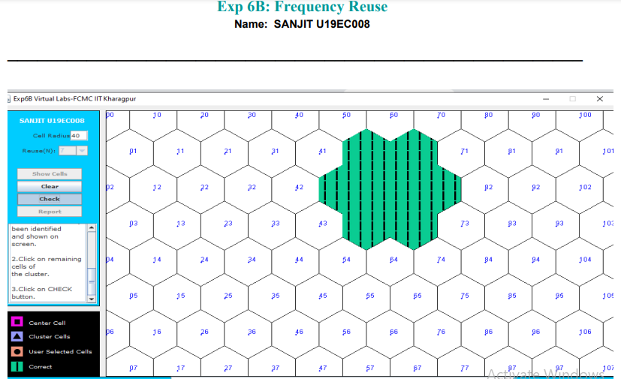

**For N = 9**

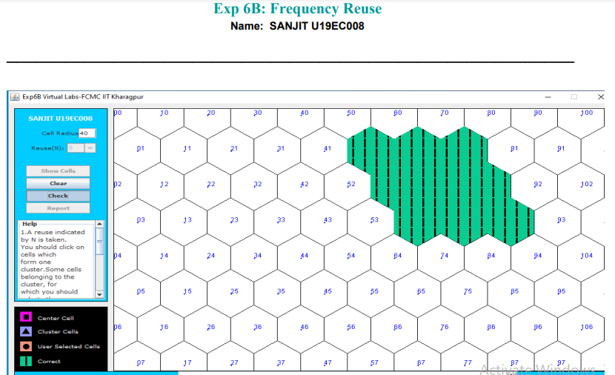

**For N = 12**

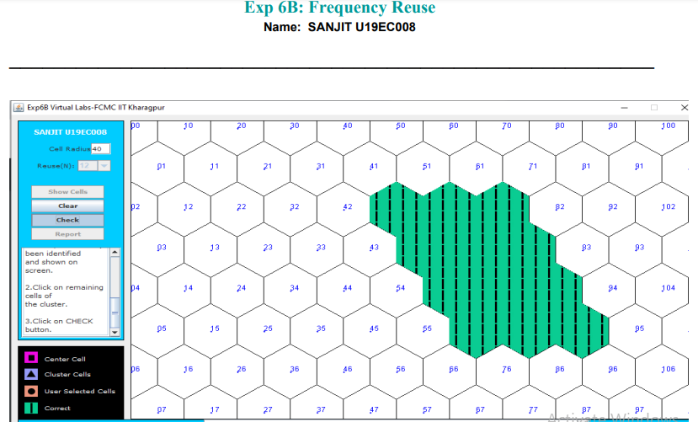

**CONCLUSION:**

In this experiment, we have implemented and simulated the co-channel and cell cluster in Visual Lab and obtained the outputs based on cells we have selected and validated with the correct output thus learning the concept of frequency reuse, co-channel cells and cell clusters.