**Exercise 1: Configuring a Basic Spring Application**

BookRepository.java  
  
package com.library.repository;

public class BookRepository {

public void displayBooks() {

System.out.println("Displaying books from the repository...");

}

}

BookService.java  
  
package com.library.service;

import com.library.repository.BookRepository;

public class BookService {

private BookRepository bookRepository;

public void showBooks() {

System.out.println("BookService: calling repository...");

bookRepository.displayBooks();

}

// Setter (needed for DI)

public void setBookRepository(BookRepository bookRepository) {

this.bookRepository = bookRepository;

}

}

LibraryManagementApplication.java  
  
package com.library;

import com.library.service.BookService;

import org.springframework.context.ApplicationContext;

import org.springframework.context.support.ClassPathXmlApplicationContext;

public class LibraryManagementApplication {

public static void main(String[] args) {

ApplicationContext context = new ClassPathXmlApplicationContext("applicationContext.xml");

BookService bookService = context.getBean("bookService", BookService.class);

bookService.showBooks(); // Should call repository (in Exercise 2)

}

}

OUTPUT:  
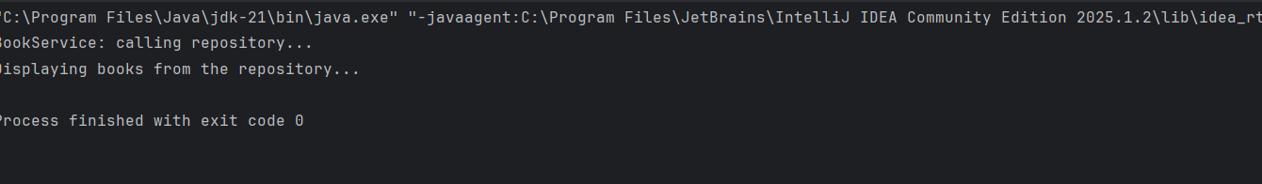  
  
  
  
  
  
  
  
  
  
  
**Exercise 2: Implementing Dependency Injection**

BookRepository.java  
  
package com.library.repository;

public class BookRepository {

public void displayBooks() {

System.out.println("Displaying books from the repository...");

}

}

BookService.java

package com.library.service;

import com.library.repository.BookRepository;

public class BookService {

private BookRepository bookRepository;

// Setter for Spring to inject dependency

public void setBookRepository(BookRepository bookRepository) {

this.bookRepository = bookRepository;

}

public void displayBooks() {

System.out.println("BookService: calling repository...");

bookRepository.displayBooks();

}

}

LibraryManagementApplication.java  
  
package com.library;

import com.library.service.BookService;

import org.springframework.context.ApplicationContext;

import org.springframework.context.support.ClassPathXmlApplicationContext;

public class LibraryManagementApplication {

public static void main(String[] args) {

ApplicationContext context = new ClassPathXmlApplicationContext("applicationContext.xml");

BookService bookService = (BookService) context.getBean("bookService");

bookService.displayBooks();

}}

OUTPUT:  
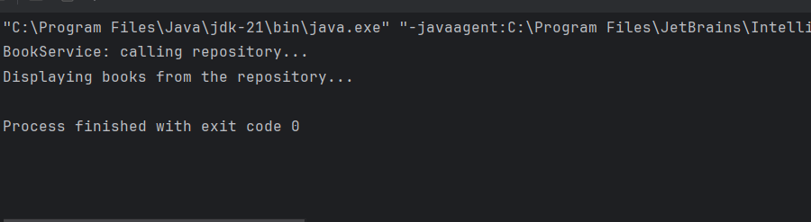

**Exercise 4: Creating and Configuring a Maven Project**

Pom.xml

<project xmlns="http://maven.apache.org/POM/4.0.0"

xmlns:xsi="http://www.w3.org/2001/XMLSchema-instance"

xsi:schemaLocation="http://maven.apache.org/POM/4.0.0

http://maven.apache.org/xsd/maven-4.0.0.xsd">

<modelVersion>4.0.0</modelVersion>

<groupId>com.library</groupId>

<artifactId>LibraryManagement</artifactId>

<version>1.0-SNAPSHOT</version>

<properties>

<!-- Java version -->

<maven.compiler.source>1.8</maven.compiler.source>

<maven.compiler.target>1.8</maven.compiler.target>

<project.build.sourceEncoding>UTF-8</project.build.sourceEncoding>

</properties>

<dependencies>

<!-- Spring Core (includes context) -->

<dependency>

<groupId>org.springframework</groupId>

<artifactId>spring-context</artifactId>

<version>5.3.34</version>

</dependency>

<!-- Spring AOP -->

<dependency>

<groupId>org.springframework</groupId>

<artifactId>spring-aop</artifactId>

<version>5.3.34</version>

</dependency>

<!-- Spring Web MVC -->

<dependency>

<groupId>org.springframework</groupId>

<artifactId>spring-webmvc</artifactId>

<version>5.3.34</version>

</dependency>

</dependencies>

<build>

<plugins>

<!-- Maven Compiler Plugin -->

<plugin>

<groupId>org.apache.maven.plugins</groupId>

<artifactId>maven-compiler-plugin</artifactId>

<version>3.11.0</version>

<configuration>

<source>1.8</source>

<target>1.8</target>

</configuration>

</plugin>

</plugins>

</build>

</project>

**Hands on 4**

**Difference between JPA, Hibernate and Spring Data JPA**   
   
Employee.java  
  
package com.example.employeeapp.model;

import jakarta.persistence.*;

@Entity

public class Employee {

@Id

@GeneratedValue(strategy = GenerationType.IDENTITY)

private int id;

private String name;

private String department;

// Getters and Setters

public int getId() {

return id;

}

public void setId(int id) {

this.id = id;

}

public String getName() {

return name;

}

public void setName(String name) {

this.name = name;

}

public String getDepartment() {

return department;

}

public void setDepartment(String department) {

this.department = department;

}

}

EmployeeRepository.java  
  
package com.example.employeeapp.repository;

import org.springframework.data.jpa.repository.JpaRepository;

import com.example.employeeapp.model.Employee;

public interface EmployeeRepository extends JpaRepository<Employee, Integer> {

}

EmployeeController.java  
  
package com.example.employeeapp.controller;

import com.example.employeeapp.model.Employee;

import com.example.employeeapp.service.EmployeeService;

import org.springframework.beans.factory.annotation.Autowired;

import org.springframework.web.bind.annotation.*;

@RestController

@RequestMapping("/employees")

public class EmployeeController {

@Autowired

private EmployeeService employeeService;

@PostMapping

public String createEmployee(@RequestBody Employee employee) {

employeeService.addEmployee(employee);

return "Employee created successfully!";

}

}

EmployeeService.java  
  
package com.example.employeeapp.service;

import com.example.employeeapp.model.Employee;

import com.example.employeeapp.repository.EmployeeRepository;

import org.springframework.beans.factory.annotation.Autowired;

import org.springframework.stereotype.Service;

import org.springframework.transaction.annotation.Transactional;

@Service

public class EmployeeService {

@Autowired

private EmployeeRepository employeeRepository;

@Transactional

public void addEmployee(Employee employee) {

employeeRepository.save(employee);

}

}

OUTPUT:  
