**Create a Spring Web Project using Maven**   
SpringLearnApplication.java  
package com.cognizant.springlearn;

import org.springframework.boot.SpringApplication;

import org.springframework.boot.autoconfigure.SpringBootApplication;

@SpringBootApplication

public class SpringLearnApplication {

public static void main(String[] args) {

System.out.println("SpringLearnApplication started...");

SpringApplication.run(SpringLearnApplication.class, args);

}

}

OUTPUT:  
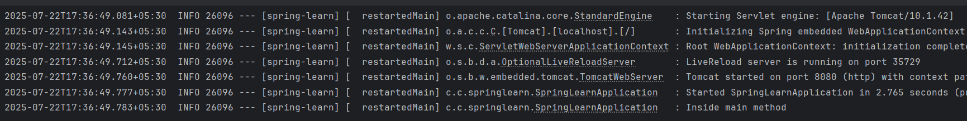

**Spring Core – Load Country from Spring Configuration XML**   
   
Country.java

package com.cognizant.springlearn;

import org.slf4j.Logger;

import org.slf4j.LoggerFactory;

public class Country {

private String code;

private String name;

private static final Logger LOGGER = LoggerFactory.getLogger(Country.class);

public Country() {

LOGGER.debug("Inside Country Constructor.");

}

public String getCode() {

LOGGER.debug("Inside getCode()");

return code;

}

public void setCode(String code) {

LOGGER.debug("Inside setCode()");

this.code = code;

}

public String getName() {

LOGGER.debug("Inside getName()");

return name;

}

public void setName(String name) {

LOGGER.debug("Inside setName()");

this.name = name;

}

@Override

public String toString() {

return "Country [code=" + code + ", name=" + name + "]";

}

}

SpringLearnApplication.java  
package com.cognizant.springlearn;

import org.slf4j.Logger;

import org.slf4j.LoggerFactory;

import org.springframework.context.ApplicationContext;

import org.springframework.context.support.ClassPathXmlApplicationContext;

public class SpringLearnApplication {

private static final Logger LOGGER = LoggerFactory.getLogger(SpringLearnApplication.class);

public static void main(String[] args) {

displayCountry();

}

public static void displayCountry() {

ApplicationContext context = new ClassPathXmlApplicationContext("country.xml");

Country country = context.getBean("country", Country.class);

LOGGER.debug("Country : {}", country.toString());

}

}

OUTPUT:  
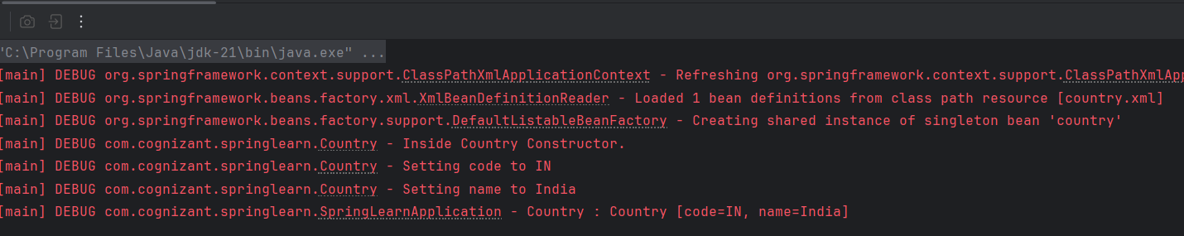

**REST - Get country based on country code**

**REST - Country Web Service**

Country.java  
package com.cognizant.springlearn.model;

import lombok.AllArgsConstructor;

import lombok.NoArgsConstructor;

import lombok.Data;

@Data

@NoArgsConstructor

@AllArgsConstructor

public class Country {

private String code;

private String name;

}

Country.xml  
  
<beans xmlns="http://www.springframework.org/schema/beans"

xmlns:xsi="http://www.w3.org/2001/XMLSchema-instance"

xsi:schemaLocation="http://www.springframework.org/schema/beans

http://www.springframework.org/schema/beans/spring-beans.xsd">

<bean id="countryList" class="java.util.ArrayList">

<constructor-arg>

<list>

<bean class="com.cognizant.springlearn.model.Country">

<property name="code" value="IN"/>

<property name="name" value="India"/>

</bean>

<bean class="com.cognizant.springlearn.model.Country">

<property name="code" value="US"/>

<property name="name" value="United States"/>

</bean>

<bean class="com.cognizant.springlearn.model.Country">

<property name="code" value="DE"/>

<property name="name" value="Germany"/>

</bean>

</list>

</constructor-arg>

</bean>

</beans>

CountryService.java  
  
package com.cognizant.springlearn.service;

import com.cognizant.springlearn.model.Country;

import org.springframework.context.support.ClassPathXmlApplicationContext;

import org.springframework.stereotype.Service;

import java.util.List;

@Service

public class CountryService {

public Country getCountry(String code) {

// Load XML context

ClassPathXmlApplicationContext context = new ClassPathXmlApplicationContext("country.xml");

// Get list of countries

List<Country> countryList = (List<Country>) context.getBean("countryList");

// Close context

context.close();

// Find the country with case-insensitive match

return countryList.stream()

.filter(country -> country.getCode().equalsIgnoreCase(code))

.findFirst()

.orElse(null);

}

}

CountryController.java  
  
package com.cognizant.springlearn.controller;

import com.cognizant.springlearn.model.Country;

import com.cognizant.springlearn.service.CountryService;

import org.springframework.beans.factory.annotation.Autowired;

import org.springframework.web.bind.annotation.*;

@RestController

public class CountryController {

@Autowired

private CountryService countryService;

@GetMapping("/countries/{code}")

public Country getCountry(@PathVariable String code) {

return countryService.getCountry(code);

}

}

SpringLearnApplication.java  
package com.cognizant.springlearn;

import org.springframework.boot.SpringApplication;

import org.springframework.boot.autoconfigure.SpringBootApplication;

@SpringBootApplication

public class SpringLearnApplication {

public static void main(String[] args) {

SpringApplication.run(SpringLearnApplication.class, args);

}

}

OUTPUT:  
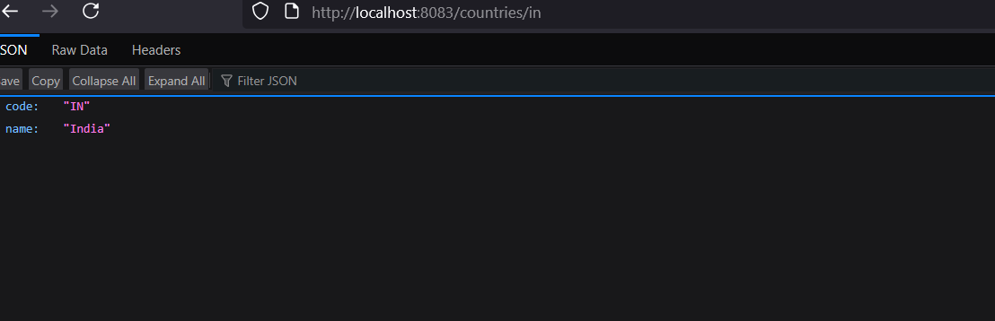

**Create authentication service that returns JWT**   
  
SpringLearnApplication.java  
package com.cognizant.springlearn;

import org.springframework.boot.SpringApplication;

import org.springframework.boot.autoconfigure.SpringBootApplication;

@SpringBootApplication

public class SpringLearnApplication {

public static void main(String[] args) {

SpringApplication.run(SpringLearnApplication.class, args);

}

}

SecurityConfig.java  
package com.cognizant.springlearn.config;

import org.springframework.context.annotation.Bean;

import org.springframework.context.annotation.Configuration;

import org.springframework.security.config.annotation.web.builders.HttpSecurity;

import org.springframework.security.core.userdetails.User;

import org.springframework.security.core.userdetails.UserDetails;

import org.springframework.security.core.userdetails.UserDetailsService;

import org.springframework.security.provisioning.InMemoryUserDetailsManager;

import org.springframework.security.web.SecurityFilterChain;

@Configuration

public class SecurityConfig {

@Bean

public UserDetailsService userDetailsService() {

UserDetails user = User.builder()

.username("user")

.password("{noop}pwd") // {noop} = plain text password

.roles("USER")

.build();

return new InMemoryUserDetailsManager(user);

}

@Bean

public SecurityFilterChain filterChain(HttpSecurity http) throws Exception {

http.csrf().disable()

.authorizeHttpRequests()

.requestMatchers("/authenticate").permitAll()

.anyRequest().authenticated()

.and()

.httpBasic(); // Enables Basic Auth

return http.build();

}

}

AuthenticationController.java  
package com.cognizant.springlearn.controller;

import org.springframework.web.bind.annotation.GetMapping;

import org.springframework.web.bind.annotation.RequestHeader;

import org.springframework.web.bind.annotation.RequestMapping;

import org.springframework.web.bind.annotation.RestController;

import java.util.Base64;

import java.util.HashMap;

import java.util.Map;

@RestController

@RequestMapping("/authenticate")

public class AuthenticationController {

@GetMapping

public Map<String, String> authenticate(@RequestHeader("Authorization") String authHeader) {

System.out.println("=== Inside authenticate ===");

System.out.println("Authorization Header: " + authHeader);

// Example: "Basic dXNlcjpwd2Q="

String base64Credentials = authHeader.substring("Basic ".length());

byte[] decodedBytes = Base64.getDecoder().decode(base64Credentials);

String credentials = new String(decodedBytes);

String[] values = credentials.split(":", 2);

String username = values[0];

String password = values[1];

System.out.println("Decoded username: " + username);

System.out.println("Decoded password: " + password);

Map<String, String> response = new HashMap<>();

response.put("token", "dummy-jwt-token-for-" + username);

return response;

}

}

OUTPUT:  
