Car Rental Application Using Java

10.Program
import java.util.*;
class Car {
private String carId;
private String brand;
private String model;
private double basePricePerDay;
private boolean isAvailable;
public Car(String carId, String brand, String model, double basePricePerDay) {
this.carId = carId;
this.brand = brand;
this.model = model;
this.basePricePerDay = basePricePerDay;
this.isAvailable = true;
}
public String getCarId() { return carId; }
public String getBrand() { return brand; }
public String getModel() { return model; }
public double calculatePrice(int rentalDays) { return basePricePerDay * rentalDays; }
public boolean isAvailable() { return isAvailable; }
public void rent() { isAvailable = false; }
public void returnCar() { isAvailable = true; }
@Override
public String toString() {
return "🔑 " + carId + " - " + brand + " " + model + " | 💸 ₹" + basePricePerDay + "/day | " + (isAvailable ? "✅ Available" : "❌ Rented");
}
}
class Customer {
private String customerId;
private String name;
public Customer(String customerId, String name) {
this.customerId = customerId;
this.name = name;
}
public String getCustomerId() { return customerId; }
public String getName() { return name; }
@Override
public String toString() {
return "🧍 " + customerId + " - " + name;
}
}
class Rental {
private Car car;
private Customer customer;
private int days;
private Date rentalDate;
public Rental(Car car, Customer customer, int days) {
this.car = car;
this.customer = customer;
this.days = days;
this.rentalDate = new Date();
}
public Car getCar() { return car; }
public Customer getCustomer() { return customer; }
public int getDays() { return days; }
@Override
public String toString() {
return "📝 " + customer.getName() + " rented " + car.getBrand() + " " + car.getModel() +
" (ID: " + car.getCarId() + ") for " + days + " days 📆 on " + rentalDate;
}
}
class CarRentalSystem {
private List<Car> cars = new ArrayList<>();
private List<Customer> customers = new ArrayList<>();
private List<Rental> rentals = new ArrayList<>();
private Scanner scanner = new Scanner(System.in);
public void addCar(Car car) {
cars.add(car);
}
public void addCustomer(Customer customer) {
customers.add(customer);
}
public Customer findOrCreateCustomer(String name) {
for (Customer c : customers) {
if (c.getName().equalsIgnoreCase(name)) return c;
}
Customer newCustomer = new Customer("CUS" + (customers.size() + 1), name);
addCustomer(newCustomer);
return newCustomer;
}
public void rentCar(Car car, Customer customer, int days) {
if (car.isAvailable()) {
car.rent();
rentals.add(new Rental(car, customer, days));
System.out.println("\n✅ Car rented successfully! 🎉");
} else {
System.out.println("❌ Sorry! Car is not available for rent.");
}
}
public void returnCar(Car car) {
car.returnCar();
Rental rentalToRemove = null;
for (Rental rental : rentals) {
if (rental.getCar() == car) {
rentalToRemove = rental;
break;
}
}
if (rentalToRemove != null) {
rentals.remove(rentalToRemove);
System.out.println("✅ Car returned successfully by 🧍 " + rentalToRemove.getCustomer().getName());
} else {
System.out.println("❌ Car was not rented.");
}
}
public void displayAllCars() {
System.out.println("\n📋 All Cars in Fleet:");
for (Car car : cars) {
System.out.println(car);
}
}
public void displayAvailableCars() {
System.out.println("\n🚗 Available Cars:");
for (Car car : cars) {
if (car.isAvailable()) {
System.out.println(car);
}
}
}
public void displayCustomers() {
System.out.println("\n👤 Registered Customers:");
for (Customer customer : customers) {
System.out.println(customer);
}
}
public void searchCar() {
System.out.print("🔍 Enter brand or model to search: ");
String keyword = scanner.nextLine().toLowerCase();
boolean found = false;
for (Car car : cars) {
if (car.getBrand().toLowerCase().contains(keyword) || car.getModel().toLowerCase().contains(keyword)) {
System.out.println("🔎 Match: " + car);
found = true;
}
}
if (!found) System.out.println("❗ No car found for the keyword.");
}
public void viewRentalHistory() {
System.out.println("\n🕓 Rental History:");
if (rentals.isEmpty()) {
System.out.println("📭 No rentals yet.");
} else {
for (Rental rental : rentals) {
System.out.println(rental);
}
}
}
public void menu() {
while (true) {
System.out.println("\n===============================");
System.out.println("🚗 Welcome to Car Rental System");
System.out.println("===============================");
System.out.println("1️⃣ Rent a Car");
System.out.println("2️⃣ Return a Car");
System.out.println("3️⃣ View All Cars");
System.out.println("4️⃣ View Available Cars");
System.out.println("5️⃣ Search Car");
System.out.println("6️⃣ View Customers");
System.out.println("7️⃣ Rental History");
System.out.println("8️⃣ Exit");
System.out.print("👉 Enter your choice: ");
int choice = Integer.parseInt(scanner.nextLine());
switch (choice) {
case 1: rentCarFlow(); break;
case 2: returnCarFlow(); break;
case 3: displayAllCars(); break;
case 4: displayAvailableCars(); break;
case 5: searchCar(); break;
case 6: displayCustomers(); break;
case 7: viewRentalHistory(); break;
case 8:
System.out.println("👋 Thank you for using the Car Rental System! Have a great day 🚘💨");
return;
default:
System.out.println("❌ Invalid choice. Please try again.");
}
}
}
private void rentCarFlow() {
System.out.print("\n👤 Enter your name: ");
String name = scanner.nextLine();
Customer customer = findOrCreateCustomer(name);
displayAvailableCars();
System.out.print("\n🔑 Enter Car ID to rent: ");
String carId = scanner.nextLine();
Car selectedCar = null;
for (Car car : cars) {
if (car.getCarId().equalsIgnoreCase(carId) && car.isAvailable()) {
selectedCar = car;
break;
}
}
if (selectedCar == null) {
System.out.println("❌ Invalid Car ID or the car is not available.");
return;
}
System.out.print("📆 Enter rental days: ");
int days = Integer.parseInt(scanner.nextLine());
double total = selectedCar.calculatePrice(days);
System.out.printf("💰 Total Price: ₹%.2f%n", total);
System.out.print("📝 Confirm rental? (Y/N): ");
if (scanner.nextLine().equalsIgnoreCase("Y")) {
rentCar(selectedCar, customer, days);
} else {
System.out.println("❌ Rental cancelled.");
}
}
private void returnCarFlow() {
System.out.print("\n🔁 Enter Car ID to return: ");
String carId = scanner.nextLine();
Car selectedCar = null;
for (Car car : cars) {
if (car.getCarId().equalsIgnoreCase(carId) && !car.isAvailable()) {
selectedCar = car;
break;
}
}
if (selectedCar == null) {
System.out.println("❌ Car not found or not rented.");
} else {
returnCar(selectedCar);
}
}
}
public class Main {
public static void main(String[] args) {
CarRentalSystem rentalSystem = new CarRentalSystem();
rentalSystem.addCar(new Car("C001", "Toyota", "Camry", 1200.0));
rentalSystem.addCar(new Car("C002", "Honda", "Accord", 1500.0));
rentalSystem.addCar(new Car("C003", "Mahindra", "Thar", 5000.0));
rentalSystem.addCar(new Car("C004", "BMW", "X5", 10000.0));
rentalSystem.addCar(new Car("C005", "Audi", "Q7", 15000.0));
rentalSystem.addCar(new Car("C006", "Ferrari", "296 GTB", 25000.0));
rentalSystem.menu();
}
}

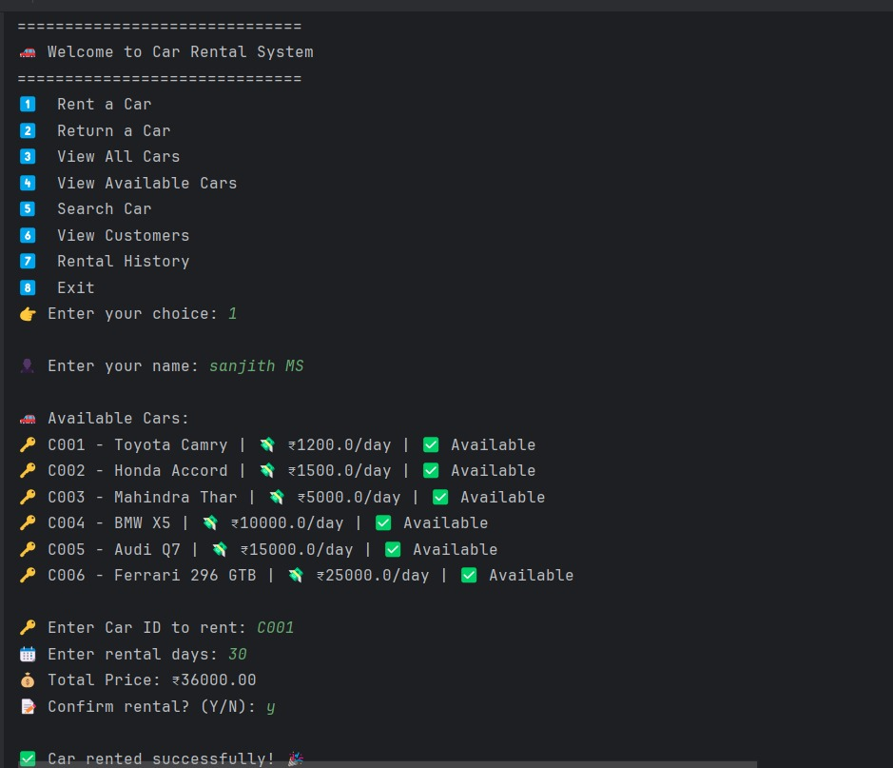
Output

