**2. Requirement Engineering**

The process of gathering and specifying what features the system should deliver is considered as requirement engineering. It is a key process that includes understanding the specific problem and needs. Requirement elicitation and specification, analysis, documentation, verification and validations are the four primary aspects of the requirement engineering process.

**2.1 Elicitation Activities**

This is the method of identifying the client’s requirements of the proposed software component, and it implies a conversation with the stakeholders to ascertain their special needs as well as our planned goal. At first, a collaborative group was setup to analyze the problem domain’s characteristics and requirements using interview plans. As an elicitation activity, an interview with stakeholders is conducted. Some of the difficulties which we may encounter while gathering requirements from stakeholders are as follows:

* Stakeholders might also not discuss all of the proposed system’s detailed information.
* Stakeholders could be unfamiliar with the technical specifications and might have unrealistic requirements.
* Stakeholders might have different perspectives and there may be a disagreement between the requirements in the coming days.

**2.1.1 Interview Plans**

The interview plans have been used as our first elicitation strategy in this section. This session was used to identify necessary problem domain characteristics, such as stakeholder needs. All stakeholders involved will have engaged in a brainstorming to develop the high-level needs for the new software system using this method. This will have allowed official discussions with stakeholders regarding their current problem domain characteristics but also how to solve them in a computerized system.

**Preparation**

On 8th May, 2022, an interview with stakeholders had been arranged. For a preparation of interview questions, a discussion with our team members had been timetabled. Each team member is given the task of preparing question that addressed the stakeholder’s required objectives. It covers all the aspects of design, functionality, speed, compatibility and future prospects in comparison to certain other systems.

**Agenda**

**Time**: 8:00 PM

**Date**: 8th May,2022

**Venue**: Google Meet (Virtual Meet)

**Expected Interview Duration:** 30 Minutes

* Confirm the presence of all required members.
* Clients’ introduction along with their designations.
* Group members introduction stating their role.
* Formal interaction with Simon White to learn about the main aspects of the specific problem, present business value and its resolution.
* Formal discussion with Raj Singh regarding his expectation from the new software system.
* Formal discussion with Mark Williams about the present university experience.
* Discussion on budget, timescale and two-party contract agreements.
* Other important final requirements discussion.

**Rules**

* People with a broad understanding of the problem domain has to be there.
* Everybody’s opinions and viewpoints are fully considered and prioritized equally.
* Everyone should show up on time without being late.
* There must be no side conversations.
* The topic must stay within the context of objectives and goals.

**2.1.2 Interview Findings**

**Woodlands University College’s Course Management Software System Client Interview Plans (Objectives and Key Questions)**

**2.1.2.1 Interview: Dr. Simon White (Computing Course Leader)**

**Objectives:**

1. **To acquire a motivational problem domain characteristic**

Question 1 – As a course leader, what is the primary motto that you want to achieve shifting from clerical-based course management system to a software version?

1. **To acquire the current business models**

Question 1 – Could you explain the present clerical system of the computing department?

1. **To acquire the required software functionality**

**Site Content**

Question 1 – Could you elaborate the provisional system functionality mentioned in your requirement paper?

Question 2 – How many users are required for this system and what are their access rights and limitations?

Question 3 – Could you describe the pilot system that you wanted initially? Will it be fully implemented in the organization?

**Additional Features**

Question 1 – Is there any new additional features would you like to include or any section would you like to redesign?

Question 2 – Would you like to develop this software in mobile application version too?

**Presentation Style**

Question 1 – Could you please clarify about the logos, text-color and font that you would like to add in the system?

Question 2- What theme color would you like to include in the system?

**Navigation Style**

Question 1- Please recommend any navigation style of menus, buttons that would you like to add in your system? If you are unsure about it then a sample picture is listed below.

|  |
| --- |
| Fig1.1 Standard Horizontal Navigation Menu |
| Fig 1.2 An embedded vertical local navigation menu |

1. **To acquire the project milestone and budget**

Question 1 - When would you want the software to be completed?

Question 2 – What is your total budget allocated for this project?

**2.1.2.2 Interview: Dr. Raj Singh (A senior lecturer, module leader, personal tutor)**

**Objectives**

1. **To acquire the performance of the proposed software system**

Question 1 – How many numbers of students do you have now and anticipate in the upcoming years that will be using this system?

Question 2 - How many courses can each student enroll in a year? How much will the content of your course change?

Question 3 - How often do you want to make changes to the new system?

Question 4 - For what purposes will students use this software?

1. **To acquire the software features and functionality**

Question 1 - Who has the authority to change the module's details and content?

Question 2 - What issues have you encountered in a clerical-based system?

Question 3 - How do you believe the digital system will address the issues?

Question 4 - What, in your opinion, are the most important functions that should be implemented in this system to make it more useful?

Question 5 - What are the steps involved from providing assignments till the assignments are submitted?

Question 6 - Who should have access to the assignments submitted by the students and be able to examine them?

Question 7 - What type of file format will the students be submitting?

1. **To acquire the existing software details**

Question 1 - Have you ever used similar software before?

1. **To acquire the additional information on the system**

Question 1 - What legalities must we follow to develop this system?

Question 2 - Would you like to provide any thoughts or information that would be beneficial to us and is there anything more we should have discussed?

**2.1.2.3 Interview: Dr. Adam Blake (Course Administrator)**

**Objectives**

1. **To acquire motivation**

Question 1 – What are three qualities that distinguish you as an excellent systems administrator?

Question 2 - What are your goal methods as a course administrator after the new system?

1. **To acquire business model**

Question 1 - Could you kindly clarify your task organization, planning, and prioritization methods?

1. **To acquire administrative functionality**

Question 1 – What are the benefits are you looking from this system and what are the changes you would like to featured?

Question 2 – What will your access limitation on this system?

Question 3 – Is there any discussion I forget to mention in the system?

**2.1.2.4 Interview: Mr. Mark Williams (Computing Student)**

**Objectives**

1. **To acquire the current information**

Question 1 - Can you explain your experience being as student?

Question 2 - What are the university facilities in computing courses?

Question 3 - What opportunities must be there for you to widen and expand your knowledge of the subject matter?

1. **To acquire the existing software review**

Question 1 - Have you ever used the course management system before? if yes, what new features should be added to enhance the system as being student?

Question 2 - What is your expectation from the system?

Question 3 – Is there any suggestion and recommendation for the new system?

**Interview Date**

|  |
| --- |
| **Interview Date**: 8th May ,2022 |
| **Duration:** 30 Minutes |
| **Attendees: Koshi Group Members** |
| * Sanjiv Tamang * Milan Tamang * Alishan Dhimal * Aayush Dahal * Abhishek Suwal * Rajan Kumar Yadav |

**Interview Subject:**

**Initial Interview with Computing Course Leader- Dr. Simon White**

|  |  |
| --- | --- |
| Topic Area | To acquire a motivational problem domain characteristic, current business models, software functionality, project milestone and budget |

|  |  |  |
| --- | --- | --- |
| **Interviewers** | **Question Number** | **Client Questions and Answers** |
| Sanjiv Tamang | 001 | **Question: As a course leader, what is the primary motto that you want to achieve shifting from clerical-based course management system to software version?**  Answer: |
|  | 002 | **Question: Could you explain the present clerical system of the computing department?**  Answer: |
|  | 003 | **Question: Could you elaborate the provisional system functionality mentioned in your requirement paper?**  Answer: |
|  | 004 | **Question: How many users are required for this system and what are their access rights and limitations?**  Answer**:** So normally, we are expecting to have maximum 10 departments in the university who use this system and each department could have at least 100 faculty team members including module leaders and tutors and besides that 1000 active students would be there who might be accessing the system at the same time but you can consider 50% average user will be using the system. |
|  | 005 | **Question: Could you describe the pilot system that you wanted initially? Will it be fully implemented in the organization?**  Answer:  In the implementation point of view, so you finish the list of the modules and module verification can be done by limited test users and there might be 5-10 individual team members in each department and they will verify the functionality and once it is done than we can pilot it in one department and once they give the positive signal than we can ensure there will not be major issue and roll out for whole university. |
|  | 006 | **Question: Is there any new additional features would you like to include or any section would you like to redesign?**  Answer**:** Not really, we have very limited time frame 5 weeks delivery so considering that timeline so I’m good with the functionality I have provided in document and discussed in this interview. |
|  | 007 | **Question: Would you like to develop this software in mobile application version too?**  Answer: Due to the time constraints, you can keep the mobile application version outside the book and let’s focus on the web part only. |
| Rajan Kumar Yadav | 008 | **Question: What theme colour would you like to include in the system?**  Answer: Answered in earlier question. |
|  | 009 | **Question: Could you please clarify about the logos, text-colour and font that you would like to add in the system?**  Answer: Answered in earlier question. (You can refer the Nile website for it.) |
|  | 010 | **Question: When would you want the software to be completed?**  Answer**:** Let’s consider the software to be delivered in the 5weeks time. |
|  | 011 | **Question: What is your total budget allocated for this project?**  Answer: So, regarding the budget I don’t have hard and fast budget volume in my mind at the moment so what I would like to suggest is you propose the budget along with list of features that you can deliver in that amount of budget and I will go through it and negotiations will start. |

**Interview Subject:**

**Interview with Dr. Raj Singh- Senior lecturer, module leader, personal tutor**

|  |  |
| --- | --- |
| Topic Area | To acquire the performance, features, functionality of software and existing software details and additional information on system |

|  |  |  |
| --- | --- | --- |
| **Interviewers** | **Question Numbers** | **Client Questions and Answers** |
| Milan Tamang | 001 | **Question: How many numbers of students do you have now and anticipate in the upcoming years that will be using this system?**  Answer: Each department would have thousand students, so considering that we have like ten thousand students would be there in the system and at the same time others student might not log in or access to the system so 50% users that might be student, teacher, admin. |
|  | 002 | **Question: How many courses can each student enrol in year? How much will the content of your course change?**  Answer: So, this usually depends upon the university policy and as of now university does not allow to enrol in multiple courses at the same time but I would ask you to have configuration page which would tell us like how many courses is allowed to a individual student. The default value would be 1but if the university policy will be been changed in future than 2 or 3 courses at the same time. Then we come in configuration page and increase the course value and the system should be working properly. |
|  | 003 | **Question: How often do you want to make changes to the new system?** Answer: Ideally the changes if the security patch changes than those things to be updated at the earliest and having said that the security patch should be implemented on the same day or the next day and regarding the future update and it would have been fixes and it should be done earliest and new features can be updated in the system. |
|  | 004 | **Question: For what purposes will students use this software?**  Answer: They will be using this particular software system for better student experience with the university courses which includes like their attendance management and then assignment management and their time table management and so on. |
|  | 005 | **Question: Who has the authority to change the module's details and content?**  Answer: Actually, module leaders should have access to it but if the tutor wants to some modifications than he/she will put the changes and send the approval message to the module leader once module leader upload than it will be reflected and will be visible to all the students. |
|  | 006 | **Question: What issues have you encountered in a clerical-based system?**  Answer: Repeat and answered in previous question |
|  | 007 | **Question: How do you believe the digital system will address the issues?**  Answer: I am very excited to use this software which will ultimately replace the existing paper-based system. So, few of the reasons is because it will be easily compared to paper based and another could be it will be secure and next could be like there will be better user experience, it is automated system which will help to increase the efficiency of the study. |
| Abhishek Suwal | 008 | **Question: What, in your opinion, are the most important functions that should be implemented in this system to make it more useful?**  Answer: From the point of delivery point of view, everything is important, all the 10 modules and from the priority point of view than the features which are interfacing to the students are prioritised. |
|  | 009 | **Question: What are the steps involved from providing assignments till the assignments are submitted?**  Answer**:** Ideally tutors will create the assignments and then after assign to the students along with start and end date and the students will go through it and download the attachment the file or fill up the TCA if attachment file is not available and submit it and tutors have functionality to mark it and provide the grading and tutors can publish and it will be visible or access to the particular students of his/her grade. And result will also be accessible to the module leader and admin. |
|  | 010 | **Question: Who should have access to the assignments submitted by the**  **students and be able to examine them?**  Answer**:** So obviously that is tutor. |
|  | 011 | **Question: What type of file format will the students be submitting?**  Answer**:** So ideally it should be pdf format or zip format. |
|  | 012 | **Question: Have you ever used similar software before**?  Answer: Actually, there is no specific system which includes all the functionalities that I have provided in required document but there are few systems which provides partial functionalities like Coursera, Udemy, w3schools and so on. |
|  | 013 | **Question: What legalities must we follow to develop this system?**  Answer**:** There is no hard and fast tool but in terms of legal or difficult issues like do your own coding, development work by yourself, testing by yourself, validation by yourselfand so on. Besides that, like personally information should be secured like tracing the person, that information should not be accessible to unauthorized person. One student should not have personal identifiable information of other students and for tutors and module leader too. While storing PII data in database it should be in encrypted form and should be decrypted while showing information in webpage. |
|  | 014 | **Question: Would you like to provide any thoughts or information that would be beneficial to us and is there anything more we should have discussed?**  Answer**:** Actually due to the constraint time of 5 weeks delivery, so I am not going to put any additional requirement and focus on the requirement given in the document along with the discussion we had just**.** |

**Interview Subject:**

**Interview with Dr. Adam Blake- Course Administrator**

|  |  |
| --- | --- |
| Topic Area | To acquire motivation, business model, administrative functionality |

|  |  |  |
| --- | --- | --- |
| **Interviewer** | **Question Numbers** | **Client Answers and Questions** |
| Aayush Dahal | 001 | **Question: What are three qualities that distinguish you as an excellent systems administrator?**  Answer: At least student lifecycle to be managed properly and all functionality is related to that and another one is course management system like allocating the course and assigning the module leader and tracking the attendance, performance from the module leader. I am expecting this as a major functionality. |
|  | 002 | **Question: What are your goal methods as a course administrator after the new system?**  Answer**:** Already answered previous 001. |
|  | 003 | **Question: Could you kindly clarify your task organization, planning, and prioritization methods?**  Answer**:** All the ten functionality should have been completed, the student interfacing features which I have directly involved to provide to the student is first priority for the module work and its delivery. |
|  | 004 | **Question: What are the benefits are you looking from this system and what are the changes you would like to featured?**  Answer**:** So as the requirements of list of the modules I have provided you in the requirement documents and discussion we are doing in interview session should include and that should be fine. |
|  | 005 | **Question: What will your access limitation on this system?**  Answer**:** Ideally four types of users are there like admin, tutor, module leader and the students. Four kinds of role will be there so whoever access to the particular role then they should have access to the functionality which have been allocated or permitted to this certain role. |
|  | 006 | **Question: Is there any discussion I forget to mention in the system?**  Answer**:** So, for now it’s good whatever the deliveries which we have targeted and discussed. So due to the timeline I would not add any other requirements here just stick with the requirements I have provided. |

**Interview Subject:**

**Interview with Mr. Mark Williams- Computing student**

|  |  |
| --- | --- |
| Topic Area | To acquire the current information and the existing software review |

|  |  |  |
| --- | --- | --- |
| **Interviewer** | **Question Numbers** | **Client Answers and Questions** |
| Alishan Dhimal | 001 | **Question: Can you explain your experience being as student?**  Answer: So currently its manual and it is very bad user experience. |
|  | 002 | **Question: What are the university facilities in computing courses?**  Answer: That means it learning, you will graduate and then get a degree and get a good job. |
|  | 003 | **Question: What opportunities must be there for you to widen and expand your knowledge of the subject matter?**  Answer: I shall document my knowledge based in the file and share with others and also put it somewhere in the centralized location from where gets benefited and others can access too and beside that it will good and it will have like video and also if I provide the training than that would be great for others to take knowledge in my experience. |
|  | 004 | **Question: Have you ever used the course management system before? if yes, what new features should be added to enhance the system as being student?**  Answer: For now, I am not going to add the further requirements here, so the requirement provided in the documents should be sufficient. |
|  | 005 | **Question: What is your expectation from the system?**  Answer: The system should be very easy to use and provide good user experience and also has robust system that means there is no proper backup system in the backend side and also there should be good learning materials. |
|  | 006 | **Question: Is there any suggestion and recommendation for the new system?**  Answer: Actually, the functional part we have already discussed and the non-functional part would be like the easy to use and it should be complex and second one is it should be like up and running all the time and higher reliability should be there in the system and each loading time should not be exceeded more than 3 seconds. |

**2.1.3 Other Problem Domain Research**

Further problem domain studies on comparable software systems and suggested relevant legislation have been included in this section which will provide more information.

**2.1.3.1 Comparable Software System Review**

This Section covers further multiple possible domain research for our appropriate elicitation method. To suit our client’s practical needs, a thorough research of different software systems was required. These following key points have been gathered from this review:

* A summary of the primary features of existing software was evaluated, including record management and staff, students’ details.
* Importing proper screenshots of the online software emphasized the essential functionality.
* On the user’s behalf experience, the positive and negatives aspects of the software were identified.
* The final view as well as the detailed comparison for each feature were analyzed.

**2.1.3.1.1 Record Management System**

The record management system of different course management system has been reviewed as one of the elicitation techniques for possible problem domain characteristics. The NILE course management system of University of Northampton is taken as a comparable reference.

|  |  |
| --- | --- |
| **System**  **Requirement** | **Description** |
| STUDENT RMS  www.  northampton.  ac.uk | Fig1.2: Student Dashboard    Fig1.3: Module Course RMS |

|  |  |
| --- | --- |
| Pros | cons |
| In dashboard, user and institution profile has been placed in simple and basic level which is sign of good interface design. | The dashboard can be more beautiful in terms of design with more clarity. |
| Vertical side bar navigation consists different required items for student RMS. | Hiding user control like: stream activity, assignment, etc. can be place in dashboard which make system visibility clearer for students |
| Each menu item has its content managed in system level. | The search engine functionality is missing in main layout. |

**2.1.3.1.2 Student Records/ Information Portal**

|  |  |
| --- | --- |
| System Requirements | Description |
| Student User  Portal |  |
| Student Assignment  Portal |  |

|  |  |
| --- | --- |
| Pros | cons |
| The system visibility of a student profile has a good design. |  |
|  |  |
|  |  |

#### **2.1.3.2 Development Relevant Legislation**

Information regarding students, tutors and module leaders will be stored in proposed course management system. The data must be used responsibly and only kept when absolutely necessary. The General Data Protection Regulation (GDPR) has been implanted in the United Kingdom as the Data Protection Act 2018. The following is the rule regarding the use of private data store with in the system (GOV.UK,2018).

* Used in a fair, legal and transparent manner.
* Used for specific, stated objectives
* Accurate and when applicable, updated.
* Managed in a secure manner, including a security against unauthorized or unethical processing, access, loss, destruction or harm.

Legislation, the preparing and enacting of laws by local, state, or national legislatures. Software engineers are required to behave in the public interest or on behalf of the people they serve. Legislation is continually and profoundly altering how software developers construct and distribute software systems to their customers.

##### 2.1.3.2.1 Equality Act

Since the Equality Act came into effect, website owners have been required by law to make their sites accessible to all visitors, as it is illegal to discriminate against people with disabilities. All service providers are subject to the Equality Act's restrictions. However, just because you're not a government body doesn't mean the regulations don't apply to you. While the exact meaning of several terms in the Equality Act can be ambiguous, most people agree that the term "supply of a service" applies to commercial web services just as much as it does to traditional government services.

The key for website owners is to utilize a design and layout that is simple enough for the most of users to understand. Through a range of adjustable accessibility and language options, technology solutions like the Recite Me assistive toolbar enable websites are fully inclusive.

Reference*:* [*https://en.wikipedia.org/wiki/Equality_Act_2010/ Accessed Date 2022/05/12*](https://en.wikipedia.org/wiki/Equality_Act_2010/%20Accessed%20Date%202022/05/12) *4:30 PM*

##### 2.1.3.2.2 General Data Protection Regulations (GDPR)

GDPR is an EU law that establishes necessary guidelines for how organizations and businesses must handle personal data in an ethical manner. Every entity that handles personal data (which includes businesses with workers and customers) must guarantee that the personal data they use complies with the GDPR's obligations. Its main requirements are:

* Use personal data must be in line with integrity friendly principle.
* Use of personal data must be legal.
* Use of personal data must be respectful to individual's rights.
* Personal data breach must be reported within 72 hours.
* Businesses are responsible for their suppliers.

*Reference:* [*https://www.gdprsummary.com/gdpr-summary/*](https://www.gdprsummary.com/gdpr-summary/) *Accessed Date 2022/05/12 4:30 PM*

##### 2.1.3.2.3 Educational Relevant Legislation

1. Intellectual property, copyright and piracy

The rules governing intellectual property, copyright, and piracy differ greatly by market. If you break local laws in many markets, you may face legal consequences. International copyright rules, such as the TRIPS Agreement of 1994 and/or the Berne Convention of 1928, have been signed by several countries. When using another entity's components, whether open-source or not, it's critical to understand and follow the license agreement linked with that code.

2. Encryption Declaration

Cryptography rules differ from country to country. Some countries prohibit the use of encryption in communications, while others demand a license to use encrypted software or those police officers have decryption keys in case they are needed during an investigation.

3. Entry to Market

Before your software may be distributed or sold in some markets, you may need to register it. Market conditions and procedures differ from country to country.

*Reference:* [*https://docs.microsoft.com/en-us/globalization/design/international-laws-and-standards/*](https://docs.microsoft.com/en-us/globalization/design/international-laws-and-standards/) *Accessed Date 2022/05/12 5:00 PM*

#### **2.1.3.3 Academic literature Review**

**2.2 Requirement Specification**

This part is a document that describes the system's exterior behavior as well as its operational limits. The solution system's functional and non-functional features are described in the specification requirement.

**2.2.1 Problem Domain Description**

This section contains flowcharts depicting present working procedures as well as constraints in the current clerical system. The purpose of this part was to give an overview of the issue domain analysis.

**2.2.1.1 Existing Business Description**

The following are vital factors of the present business activity in a clerical system based on this project:

*Student staff and course record management*

All the records are manually kept and written down in the present clerical system. This type of data is difficult to handle (accessing it necessitates a lot of manual searching, and changing it may need rewriting the details from scratch, which is tiresome). A pilot system has been created that includes complete student, staff, and course record management. It also includes assignment, module, report, and timetable management.

**2.2.1.1.1 Student Life-Cycle**

The flowchart below displays Woodland University College's present business practice of using a clerical system to manually keep student records in the form of written documents. Following such lengthy record management procedures wastes a lot of time and necessitates a lot of manuals searching anytime information has to be updated.

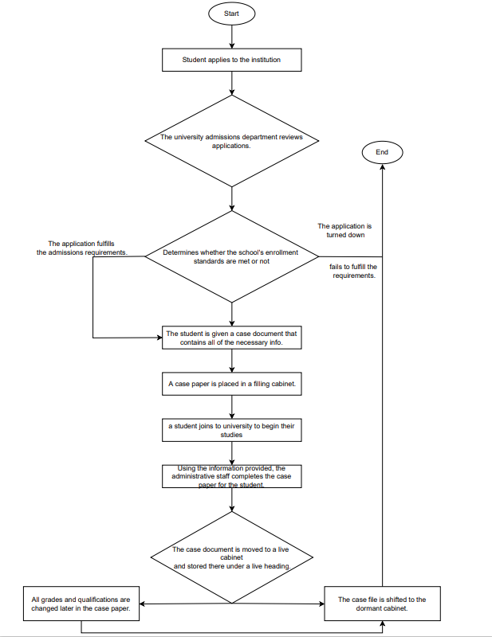

Fig: Student life-cycle flowchart

**2.2.1.1.2 Personal Tutorial Life-Cycle**

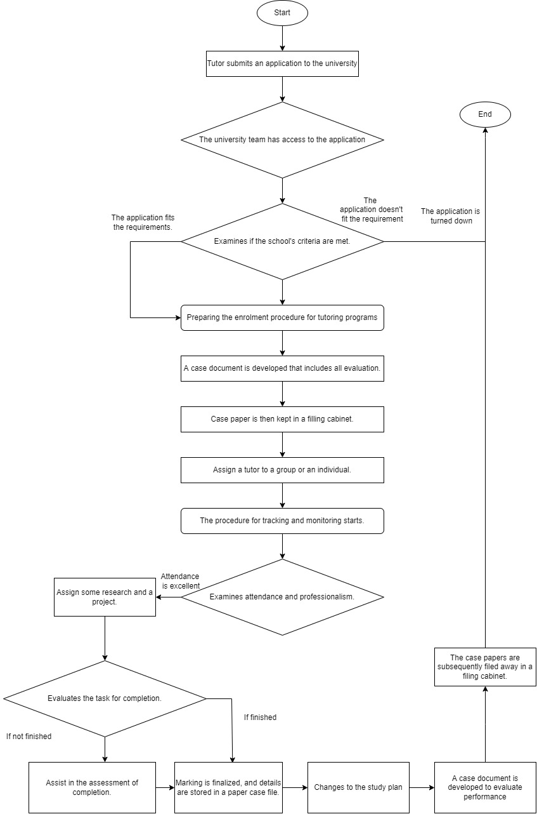

The above flowchart displays the review processes and agreement arrangements are all done on paper. Physical letters must be sent, and paper-based forms are presently being used. To summarize, paperwork is involved in the majority of existing business practices that require a significant amount of physical labor.

**2.2.1.2 Summary of existing business limitations requiring resolution and existing strengths**

Several limitations in present operations were revealed during the workshops and must be addressed. The following are the major drawbacks:

* Managing and storing staff and student records is a time-consuming and laborious procedure.
* Physical letters are an old system that might be lost along the route.
* Using physical letters to communicate is quite expensive. You'll need extra printers, photocopiers, stationery, and other office supplies in addition to plenty of paper. These expenses might quickly add up to a large sum.
* Paper files may take up a lot of space, and the amount of paper used is growing every day.
* Paper is one of the most significant information security threats for businesses, since printed papers are readily lost, mistreated, or destroyed, but digital data may be protected and safely stored on hard drives or electronic devices.

## 2.2.2 Functional Requirements

It's a kind of service which that software must provide. It describes software system or a component of one. A function is just the inputs, behavior, and outputs of a software system. It can be a computation, manipulation of data, project management, user interfaces, or any other function that determines what a process is supposed to do. Functional Requirements are also known as Functional Specifications in Software Engineering. It includes such as:

* The **Software features** need enhanced properly.
* **Access Tiers** must be given to the functional features.
* **Data attributes** need to be identified thoroughly.
* Software **output formats** should be done.
* **New software handling.**

### 2.2.2.1.1 Records Management System

The record management system should control the development, maintenance, and destruction of records, as well as the business transactions related with them, in a systematic and effective manner.

**Student Record Management**

* The student record management system should allow the university administration, module leader, and staff to remove, add, and renew the changes that need to be made, with only the administrator having access to manage the records.
* Student details are stored and should easily retrieve.
* When update or any kind of changes made in the student record management, there should be a notification saying, “changes made” and listing them.
* Parents, non-teaching staffs and third person can see all the students record easily.
* While searching for the student, after typing 3 letter start to show list of possible students.

|  |  |  |  |
| --- | --- | --- | --- |
| **Operation** | **Admin** | **Staff** | **Student** |
| Create | Create a new record | No access | No access |
| Amend | change one or more student's information | no access | no access |
| Archive | Move all the record to archive | no access | no access |
| Display | Display all the list of records, when an item is clicked show all the information | Able to see the students name and information | Able to see their own name, level and email |
| Assign | Assign a student to a course | no access | no access |

**Staff Record Management**

The record management should be easily accessed by the administrator and the staffs.

* Administrators have full access to modify the staff record management.
* Students have only view access.
* It contains the teaching staffs as well as non-teaching staff records.

**Course Record Management**

* Should be fully accessed by the administrator, course leader.
* Should be able to view by the student and the staffs.
* It contains the course which students are studying.

**Module Record Management**

* Should be fully accessed by the administrator and module leader.
* Should be able to view by student and the staffs.
* It contains the module which the students are studying.

**Assignment Record Management**

* Should be fully accessed by the administrator, assignment leader and module leader for grading.
* Should be able to view by student and the staffs.
* It contains assignment record for the students.

**Attendance Record Management**

* Should be fully accessed by the administrator, course leader and module staff.
* Should be able to view by students only.
* It contains student, staffs as well as non-teaching staff attendance record.

**Personal Tutor record Management**

* Should be fully accessed by the administrator and specific tutor only.
* Should be view by the students and staffs and they can get an appointment date.
* Stores the details of specific personal tutor.

**Timetable Management**

* Can be easily edited and updated by administrator.
* It contains all the daily routine of the university.
* It contains the course, module timing and the timing of the college.
* It contains the record and timetable of the university.

**Diary Record Management**

* Can be easily accessed by the administrator and library staffs.
* Can view by the students and the staffs.
* In this management the work done, and daily progress are stored.

**Report Generation/Management**

* It contains the report of all the students, staffs**.**
* Progress of all the staffs and students are recorded**.**

**External Output format (for use with e-mail/letters/SMS/reports)**

This is the auto generating emails format when the student apply online for the course in the university.

*Dear First_Name Last_Name*

*Thank you for your concern in Woodland University College (WUD). This email verifies that you have applied for the course in WUC.*

|  |
| --- |
| Details to be Filled  Student Full Name:  Address:  Email:  Faculty:  Contact Number:  Date Of Birth:  Gender:  -------------------------  Student Signature |

### .1.3.1.2 Student Records/Information Portal

A student record management system is a technology that tracks and records students' normal actions at institutes, such as attendance, test performance, and conduct. With a role-based login, students, instructors, administrators, and parents may use the program. It captures all the student data as well as their personal information, which can then be readily searched and retrieved. Years of data are stored online on a cloud platform by the program.

**Student Record Management System Features**

**Easy Report Generation**- The program makes it simple to create reports in the formats necessary.

**Data Search and Retrieval**- The system can assist users in quickly finding and retrieving student data.

**High Data Storage**- The system can store a lot of data without affecting its performance.

Teachers, students, and parents can all have different levels of access to the program.

**Attendance Management**-It aids in the automated recording of daily attendance utilizing a biometric attendance system.

Individuals of all sorts will find the system to be simple to use and straightforward.

**Benefit of Student record Management system**

* Digitalized System
* Integrated platform for Data management
* Student Information protection
* Checking student presence online

**Student Information portal**

Student information portal should contain name, email, university id etc.

Sample for student information portal is given below in fig.2.1.3.1.2.1:

### 2.1.3.1.3 Woodlands University College Corporate Website

According to the problem domain research and the interview from the stakeholder. Following are the requirements that should be done.

## 2.2.3 Performance Requirements

Performance requirements specify how effectively a software system performs various tasks under specified circumstances. The software's response time, speed, processing time, and memory size are all examples.

### 2.2.3.1 Records Management

#### 2.3.1.1 Speed

In Record management speed play very important role. All the pages should load fast. There are two sub classes for the speed they are given below:

* Throughput- The time taken to open the record management should not exceed more than 3 second. All the pages in record management should open smoothly and can be done more than 10000 transactions at a time.
* Response Time- It is the time taken to open the record management should not exceed more than 3 second. Time taken to carry out online searches and respond should not exceed more than 5 second. At a time more than 1000 students can search online.

#### 2.3.1.2 Capacity

For record management capacity is also important to store all the data and information about the staffs and students. All the data are stored in cloud as well as in the university database which should be up to 20gb. At A time 1000 number of data can be store and 1000 number of operations can be run. There should be 5-10 member who can access the record management.

#### 2.3.1.3 Reliability

As an online system there should be assistance to handle the record management system online which should run smoothly. Sometimes the failure occurs on the system due to several reasons such as searching for courses by more than 1000 students, due to server failure. The system should run 164hours out of 168 hours in a week.

#### 2.3.1.4 Usability

The usability of the system should be familiar to all the accessed user by providing them tutorials and can use more easily. Experience user can be familiar in just 30 minutes of tutorial and the non-experience should learn from tutorial.

#### 2.3.1.5 Accessibility

To access to record management, the permission should be taken from the administrator. The specific assistance can access the record management. Staffs and students should not have access to the system.

## 2.2.3.2 Student Records/Information Portal

### 2.2.3.2.1 Speed

In the student records/information portal, there should be fast to loading the pages.

* Throughput- the pages of the student record should open 3-4 seconds. There should be 1000 transaction record of student at a time.
* Response Time- the response time of the student record page should be less than 5 second. Time taken to respond for the online search should no longer than 4 second. At a time 1000 user can search for the record.

### 2.2.3.2.2 Capacity

The capacity of the student record/information portal should be large enough which can store data up to 20gb. At a time 1000 plus student records can stored. Only the Admin can have access to the system.

### 2.2.3.2.3 Reliability

The student record/information portal should be more reliable so that the system can run smoothly without any issue. There should be team to handle the student record / information portal so that there will be easy to use online. The system run for 164hours out of 168 hours a week.

### 2.2.3.2.4 Usability

The student record/information portal system should be easy to use or for new user there should be the tutorial.

### 2.2.3.2.5 Accessibility

The student record / information portal should be accessible by the administrator and staff can have access too. There should be team that assist the student record.