**Detailed Dynamic System Design:**

During detailed design, the data structure and algorithms of various modules are designed. We make decision that will have an impact on the outcome of software development and, more importantly, the simplicity with which the software can be maintained. Its outcome is generally known as module specification document.

**Event Chart:**

|  |  |  |
| --- | --- | --- |
| **Event** | **Performers** | **Attributes** |
| Enroll Staff | Administrative Staff Member  Course | Staff Name  Staff First Name  Staff Last Name  Staff Email  Staff ID  Staff Phone Number  Course ID  Staff Qualification  Staff Designation |
| Enroll Student | Student  Administrative Staff Member  Course | Student Address  Student First Name  Student Last Name  Student Email  Student ID Number  Student Phone Number  Course Name  Course Id  Student Group Id  Staff Name  Staff Id |
| Staff/Student Login | Staff  Student  Staff/Student Login portal | Student Id  Staff Id  Login Password |
| Create Course | Staff  Course  Administrative Staff Member | Course Id  Course Name  Course Duration  Course Tutor  Course Contents |
| Manage Modules | Staff  Course | Staff Id  Staff Name |
| Record Attendance | Staff  Student | Date  Time  Staff Name  Student Name  Staff Id  Student Id |
| Assign Assignment | Staff  Course | Course Name  Course Id  Staff Name  Staff Id  Student Group Id |
| Submit Assignment | Student  Staff  Course | Course Name  Course Id  Student Name  Student Id |
| Report Generation | Staff  Student  Course | Course Name  Course Id  Staff Name  Staff Id  Student Name  Student Id  Student Grade |
| Create Timetable | Staff  Course  Administrative Staff Member | Staff Id  Staff Name  Course Id  Course Name |

**Object Diagrams:**

The object diagram illustrates the system's structure. It demonstrates the system's structure rather than its behavior. Classes and their relationships, as well as other types of dependencies, are the key parts.

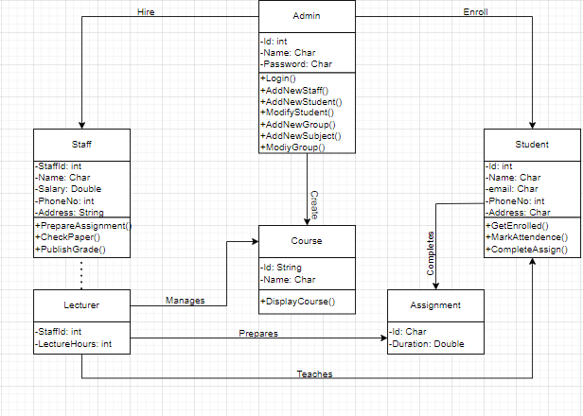

Object Diagram

*Refrence:* [*https://www.freeprojectz.com/uml/school-management-system-class-diagram*](https://www.freeprojectz.com/uml/school-management-system-class-diagram) *accessed date: 2022/05/12 at 5:30 PM*

**System Scenario Charts:**

It describes various user interactions and activities within a system. It also contains a list of the user's actions.

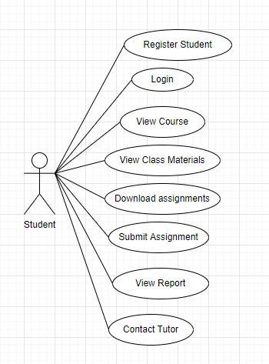

System scenario chart for student

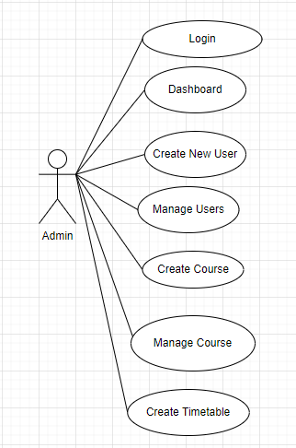

System Scenario Chart for Admin.

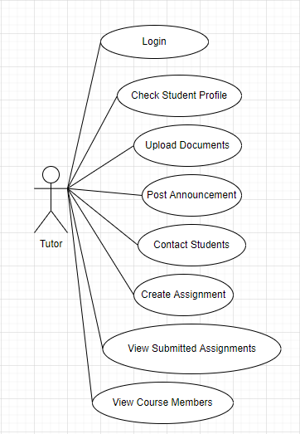

System Scenario Chart for Tutor

**Sequence Diagram:**

A sequence diagram depicts different processes or things that exist simultaneously as parallel vertical lines (lifelines), and the messages passed between them as horizontal arrows, in the order in which they occur. This enables for the graphical specification of simple runtime scenarios.

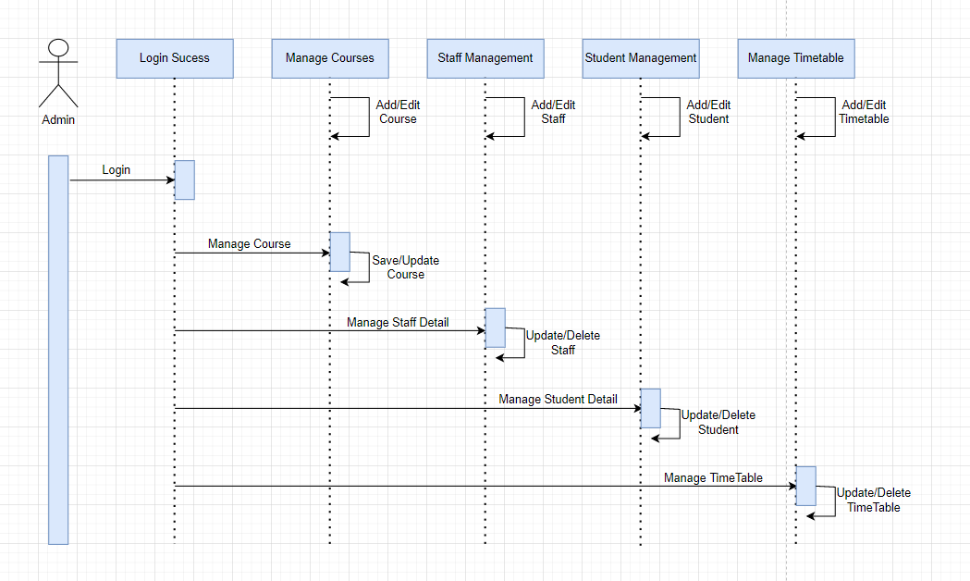Sequence Diagram

*Refrence: https://en.wikipedia.org/wiki/Sequence_diagram accessed date: 2022/05/12 at 6:00 PM*

**System Database Design:**

The structuring of data according to a database model is known as database design. The designer decides what data should be saved and how the data elements should be connected. They can start fitting the data to the database model with this information. A well-designed database is simple to manage, increases data consistency, and save on disk storage space.

**ER Diagram:**

ER diagrams help in the explanation of database logical structure. Entities, attributes, and relationships are the three core ideas used to generate ER diagrams.

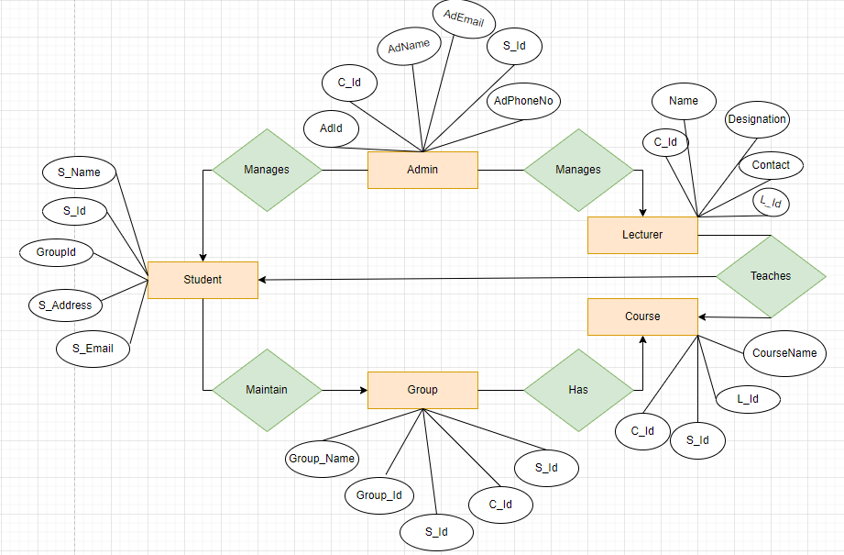

ER-Diagram

**Attribute Listing:**